Discovery

Detecting Network Devices

Port Scanning

traceroute, netcat, nmap, and SuperScan

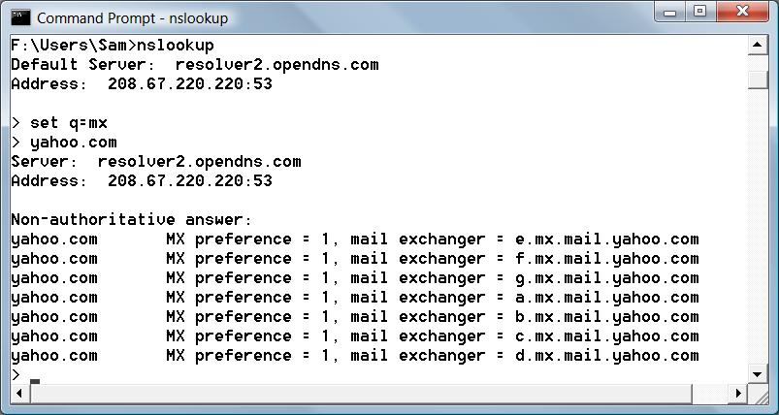
dig

An undated replacement for nslookup in Unix/Linux

If it's not installed by default in your Ubuntu, use

apt-get install dnsutils

Finding Mail Exchanges with nslookup

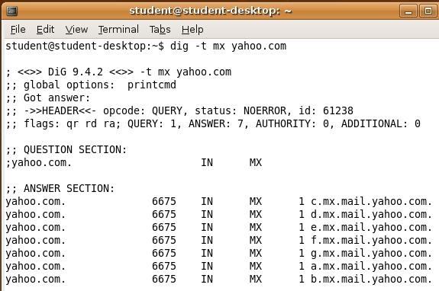
Finding Mail Exchanges with dig

Types of DNS Records

A – maps a hostname to an IPv4 address

AAAA - maps a hostname to an IPv6 address

CNAME - Canonical name - an alias of one name to another

MX - mail exchange record

PTR - maps an IPv4 address to the canonical name for that host (allows reverse DNS lookups)

SOA - start of authority record – the authoritative DNS server for a domain

SRV - a generalized service location record, used for VoIP SIP servers

See link Ch 705

For more about DNS Records, see link Ch 704 (Wikipedia)

dig Countermeasures

Secure your DNS infrastructure

Block or restrict zone transfers

Leave hosts out of your DNS records unless you want direct traffic to them from the Internet

traceroute

Tracert in Windows uses ICMP packets

Traceroute in Unix/Linux uses UDP packets

The packets have low TTLs, starting with 1

When the packet traverses a router, its TTL is decreased by 1

If the TTL ever hits zero, the packet is dropped

A notification is sent back to the originating source host in the form of an ICMP error packet

Finding Routing Devices at CCSF

Hops 10 and 11 both appear to be routing devices on campus
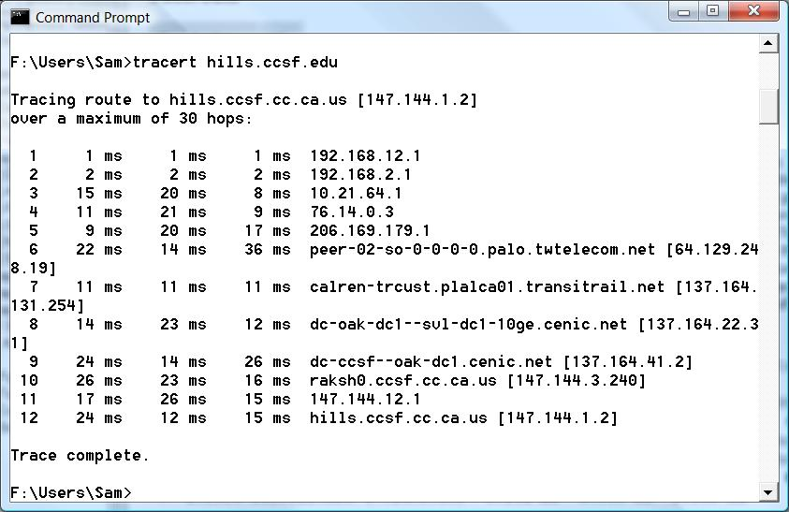

traceroute Countermeasures

Stop your routers from responding to TTL-exceeded packets

Deny all traffic specifically addressed to a router

Permit ICMP only from the LAN, not from the Internet

Autonomous System Lookup

Autonomous Systems

Autonomous System (AS)

A collection of gateways (routers) that controlled by one organization

Autonomous System Number (ASN)

a numerical identifier for networks participating in Border Gateway Protocol (BGP)

Border Gateway Protocol (BGP)

A protocol used to advertise routes worldwide

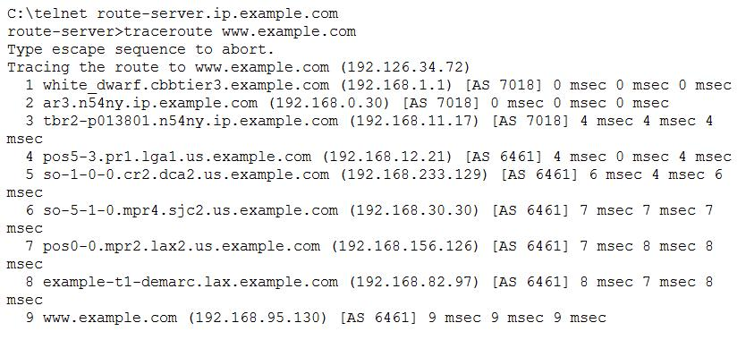
traceroute with ASN Information

Run traceroute from a Cisco router participating in BGP to see the ASNs

Hop 8 is a T-1; hops 4-9 all same company

Demo

Public Looking Glass sites let you test routing from various servers

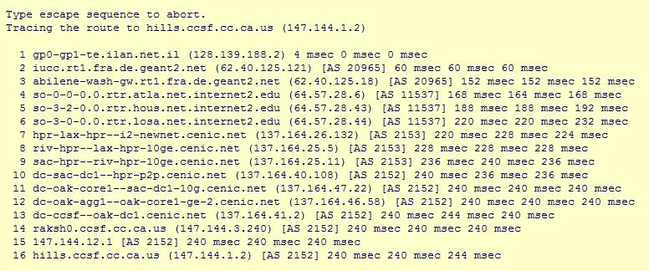
See Links 724-727

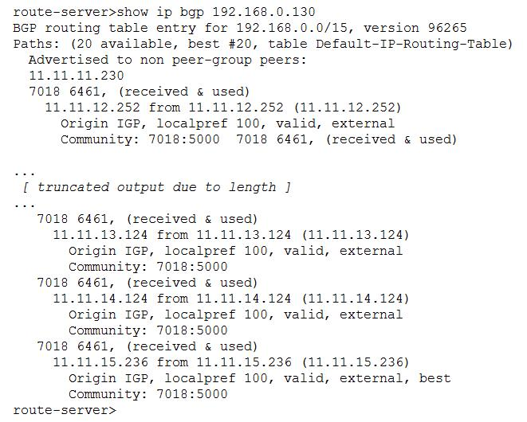
show ip bgp

From a Cisco router, we can find the other possible network paths

Public Newsgroups

Careless Postings

Careless admins may announce network vulnerabilities on newsgroups

Countermeasures:

Be wary of what you say and where you say it
Service Detection

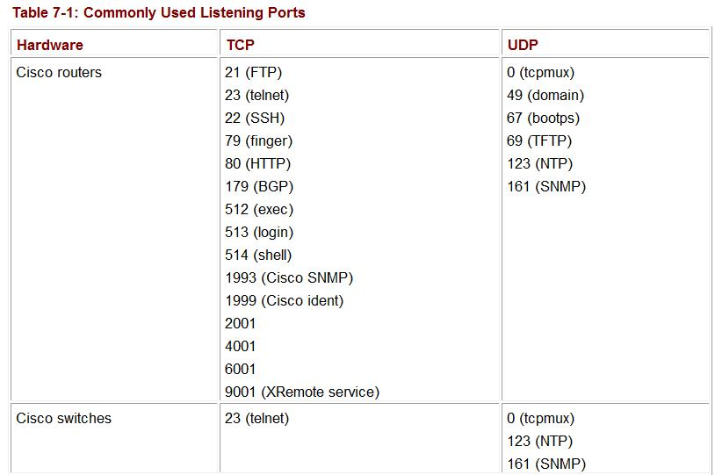
Port Scanning

Common ports are known for each device

Nmap Results

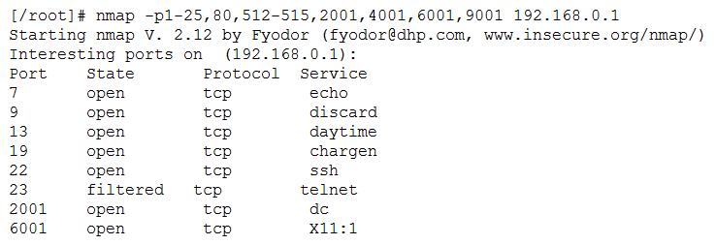
Nmap also does OS detection, as we discussed in a previous chapter

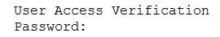

Familiar Prompts

If Telnet is enabled on a Cisco router, you will see this prompt
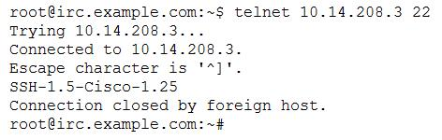

A Cisco router configured for SSH still shows a banner to Telnet

Service Detection Countermeasures

Deny all unwanted traffic at network borders

PortSentry will detect port scans and block traffic from that IP

But PortSentry itself could be used to perform a DoS attack if you don't check for spoofed packets
Network Vulnerability

The OSI Model
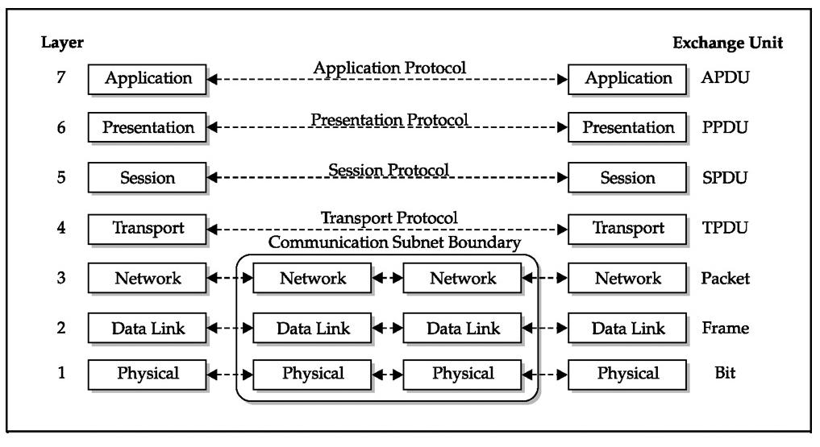

Data Units

APDU - Application Protocol Data Unit

PPDU - Presentation Protocol Data Unit

SPDU - Session Protocol Data Unit

TPDU - Transport Protocol Data Unit

But our focus is on the first 3 layers

OSI Layer 1: Physical

Physical media that carry data: usually copper or fiber optics

Traffic can be intercepted with a physical man-in-the-middle attack

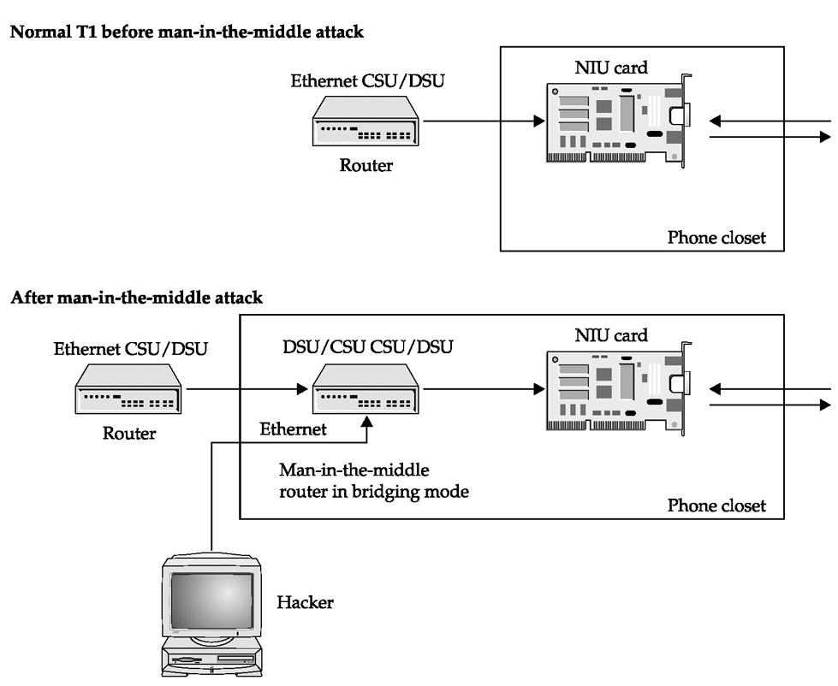
The next slide shows a T1 man-in-the-middle attack (copper lines)

Fiber Optic Physical MITM Attack

See link Ch 709
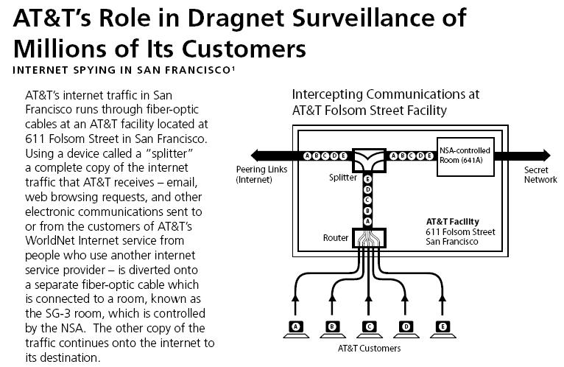
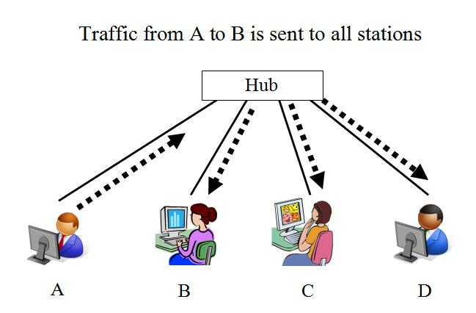

OSI Layer 2: Data Link

Layer 2 is the layer where the electrical impulses from Layer 1 have MAC addresses associated with them

Early Ethernet sent traffic to every node connected to the hub or backbone

Modern switched networks don't do that

Unswitched Ethernet

Most wired networks use switches instead of hubs now

Wi-Fi networks still work this way

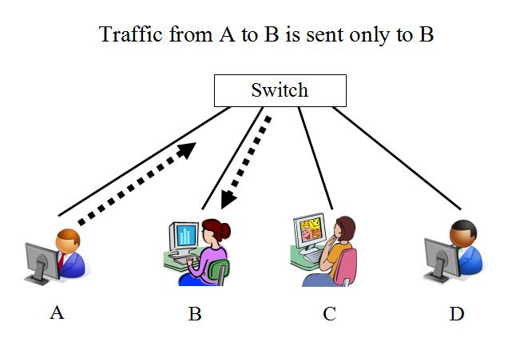

Switched Ethernet

Switches make sniffing harder

They also make networks faster

Switch Sniffing

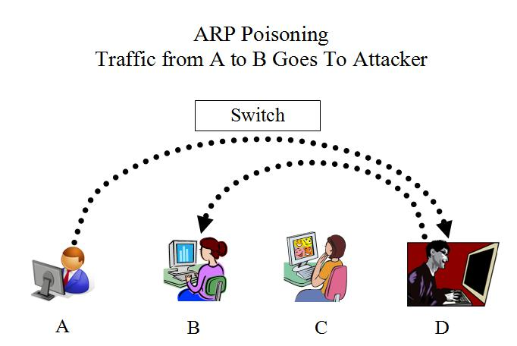
Some switches allow an administrator to monitor all traffic on a special port

ARP cache poisoning is the most common way to sniff traffic on a switch

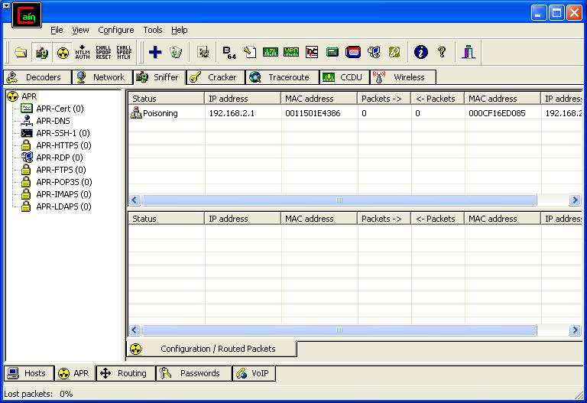

ARP Poisoning with Cain

Easy to do

Part of Project X1: SideJacking Gmail in a Switched Network

ARP Poisoning Countermeasures

Use static ARP routes, with manually entered MAC addresses

This prevents abuse of ARP redirection, but it is a LOT of tedious work

Every time you change a NIC, you need to manually add the new MAC address to the tables

ARPwatch

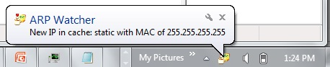
Monitors ARP cache to detect poisoning

Windows version crashed on my Win 7

But DecaffeinatID by Irongeek works great!

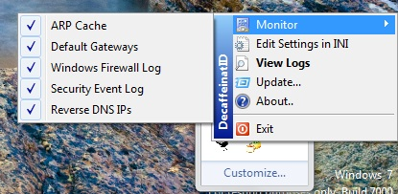
Links Ch 729-733

Broadcast Sniffing

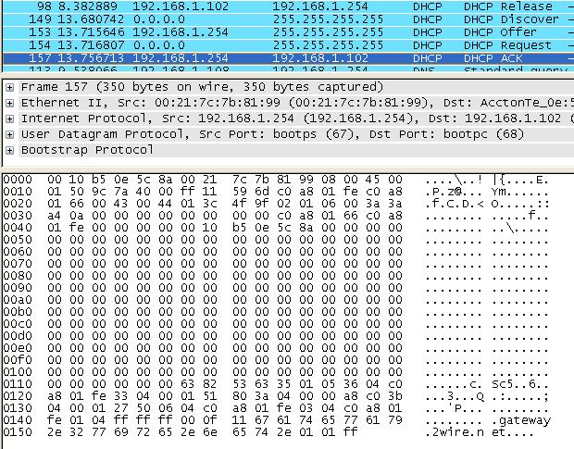
Connect to a port

It doesn't matter what your IP address is

Just sniff for broadcast packets

Using Wireshark or any other sniffer

DHCP Packets

Give out IP addresses, and may also contain brand of router

DEMO:

Start Wireshark

Open Command Prompt

ipconfig /release

ipconfig /renew

ARP Packets

These give you IP addresses and MAC addresses

WINS Packets

Note Computer Description field at the end "Accounting"
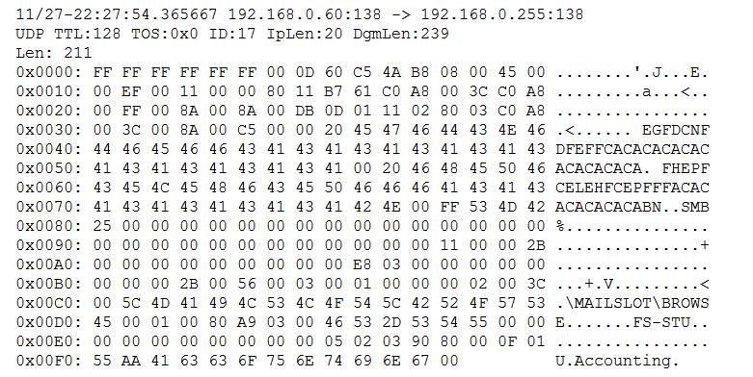

Broadcast Sniffing Countermeasures

To limit broadcasts, split your network into different segments

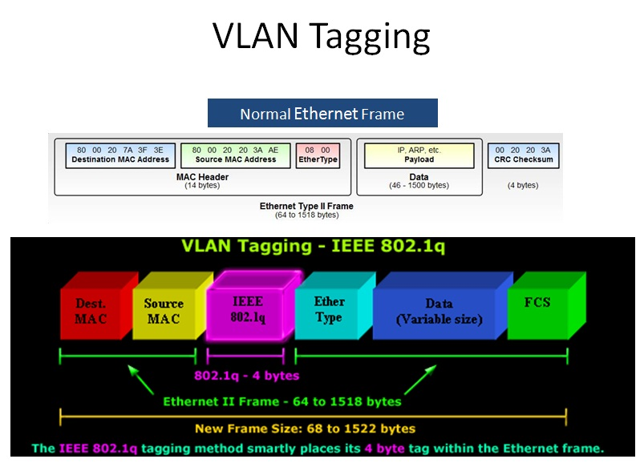
Use VLANS – Virtual Local Area Networks

Switches add a VLAN tag to each frame

Broadcasts only reach machines on the same VLAN

Link Ch 710

VLANs

Virtual LANs are logically separate LANs on the same physical medium

Each VLAN has its own VLAN Number

802.1q is the standard for VLAN Tagging

VLAN Tagging

Links Ch 712, 713

Port-Based VLANs

Each port on the switch is assigned to a VLAN by the administrator

The clients send in normal Ethernet frames, and the VLAN tag is added by the switch

When tagged frames are received, the switch removes the VLAN tags

This is the most secure method

Native VLANs

Suppose you want to use a single network link to carry traffic from multiple VLANs?

For example, a long line connecting two buildings

One VLAN can be defined as the "Native VLAN" or "Management VLAN"

Frames belonging to the "Native VLAN" are not modified—no VLAN header is added to them, or removed

VLAN Jumping

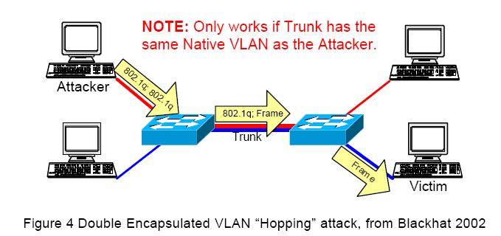
This allows an attacker to craft a frame with two VLAN tags

The first switch removes one tag

The second switch sees the extra tag, so the frame hops from one VLAN to another

VLAN Jumping Countermeasures

Don't trust VLANS to enforce network security boundaries

Restrict access to the native VLAN port (VLAN ID 1)

We'll skip these sections

Internetwork Routing Protocol Attack Suite (IRPAS) and Cisco Discovery Protocol (CDP)

Spanning Tree Protocol (STP) Attacks

VLAN Trunking Protocol (VTP) Attacks

OSI Layer 3

Internet Protocol Version 4 (IPv4)

Has no built-in security measures

TCP Sequence Numbers

Example: tcpdump showing a Telnet connection

S = SYN, A = ACK; note increasing Sequence and Acknowledgement numbers

Demonstration of Sequence Numbers

Use Ubuntu

In one Terminal window:

sudo apt-get install tcpdump

sudo tcpdump –tnlS | tee capture

(no timestamps, numerical IP addresses, line buffered, absolute sequence numbers )

In another Terminal window:

telnet 147.144.1.2

In first Terminal window:

pico capture

Attacks Using Sequence Numbers

Attacker on target LAN

Sequence numbers can be sniffed

Session can be hijacked with ARP cache poisoning

Attacker not on target LAN

If sequence numbers can be predicted

Attacker can forge packets and hijack a later session

Vulnerabilities to ISN Prediction

Windows NT4 SP3 Attack feasibility: 97.00%

Windows 98 SE Attack feasibility: 100.00%

Windows 95 Attack feasibility: 100.00%

AIX 4.3 Attack feasibility: 100%

HPUX11 Attack feasibility: 100%

Solaris 7 Attack feasability: 66.00%

MacOS 9 Attack feasability: 89.00%

See links Ch 718, 719, 720

IP Version 6 (IPv6)

Long addresses like this

ABCD:EF01:2345:6789:0123:4567:8FF1:2345

Native security

IPSec encryption framework has two modes:

Tunnel mode encrypts whole packet (most secure)

Transport mode just encrypts the data, not the IP header

Both modes are much more secure than IPv4

Sniffing Attacks

Steal passwords or hijack sessions

Generally require access to the LAN

Tools: Wireshark, tcpdump, Cain, ettercap, hamster, ferret

Older tools: dsniff, webmitm, mail snarf, webspy

Sniffing Countermeasures

Segment network with switches, routers, or VLANS

Use encrypted protocols like SSL/TLS

Cisco Vulnerabilities

Older routers allow anyone on the LAN to download the configuration file with TFTP

Passwords in the config were weakly encrypted

The newer MD5 hash is stronger, although it can still be brute-forced with Cain

See Proj X4: Cracking Cisco Passwords

Last modified 3-25-09

