Equipment

Windows x. Linux

Windows

Wireless NIC drivers are easy to get

Wireless hacking tools are few and weak

Unless you pay for AirPcap devices (link Ch 819) or OmniPeek

Linux

Wireless NIC drivers are hard to get and install

Wireless hacking tools are much better

OmniPeek


WildPackets now packages AiroPeek & EtherPeek together into OmniPeek

A Windows-based sniffer for wireless and wired LANs

Only supports a few wireless NICs

See links Ch 801, Ch 802

Prism2 Chipsets

For Linux, the three best chipsets to use are Orinoco, Prism2.x/3, and Cisco

Links Ch 803, 804, 805

Antennas

Omnidirectional antenna sends and receives in all directions

Directional antennas focus the waves in one direction

The Cantenna shown is a directional antenna
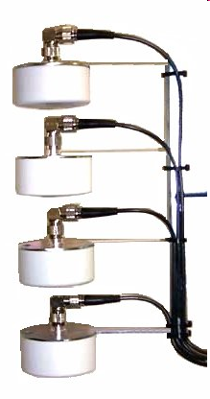

Stacked Antennas

Quad stacked antenna

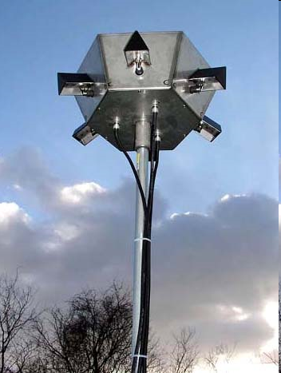
Four omnidirectional antennas combined to focus the beam away from the vertical

Beamwidth: 360° Horizontal, 15° Vertical

Can go half a mile

Link Ch 806

WISPer

Uses "multi-polarization" to send through trees and other obsctructions

Link Ch 807

Global Positioning System (GPS)


Locates you using signals from a set of satellites

Works with war-driving software to create a map of access points

Link Ch 808

Pinpoint your Location with Wi-Fi (not in book)

Skyhook uses wardriving to make a database with the location of many Wi-Fi access points

Can locate any portable Wi-Fi device

An alternative to GPS

Link Ch 809

iPhone

The iPhone combines GPS, Wi-Fi, and cell tower location technology to locate you

Link Ch 820

You can wardrive with the Android phone and Wifiscan

Links Ch 821-823
War-Driving Software

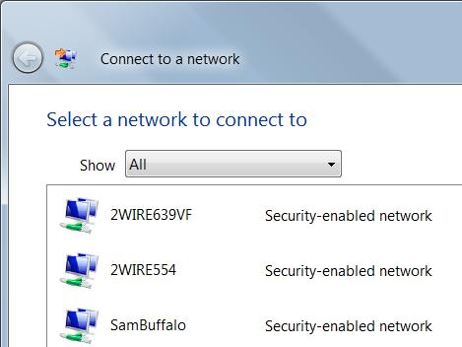
Terms

Service Set Identifier (SSID)

An identifier to distinguish one access point from another

Initialization Vector (IV)

Part of a Wired Equivalent Privacy (WEP) packet

Used in combination with the shared secret key to cipher the packet's data

NetStumbler

Very popular Windows-based war-driving application

Analyzes the 802.11 header and IV fields of the wireless packet to find:

SSID

MAC address

WEP usage and WEP key length (40 or 128 bit)

Signal range

Access point vendor

How NetStumbler Works

NetStumbler broadcasts 802.11 Probe Requests

All access points in the area send 802.11 Probe Responses containing network configuration information, such as their SSID and WEP status

It also uses a GPS to mark the positions of networks it finds

Link Ch 810

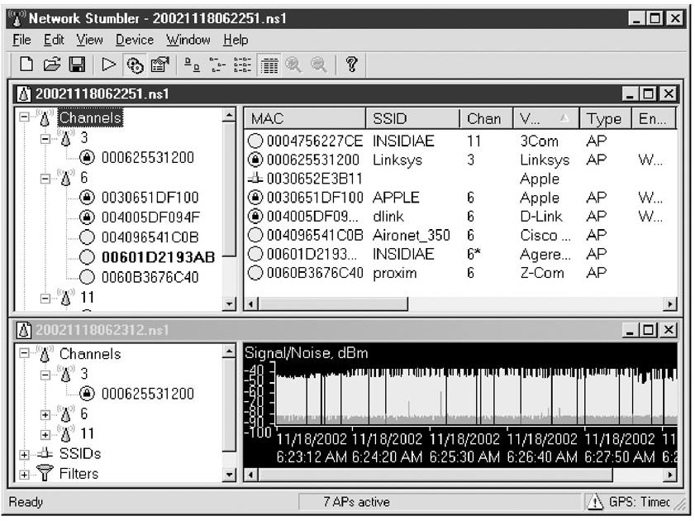
NetStumbler Screen

NetStumbler Countermeasures

NetStumbler's relies on the Broadcast Probe Request

Wireless equipment vendors will usually offer an option to disable this 802.11 feature, which effectively blinds NetStumbler

But it doesn't blind Kismet

Kismet

Linux and BSD-based wireless sniffer

Allows you to track wireless access points and their GPS locations like NetStumbler

Sniffs for 802.11 packets, such as Beacons and Association Requests

Gathers IP addresses and Cisco Discovery Protocol (CDP) names when it can

Kismet Countermeasures

There's not much you can do to stop Kismet from finding your network

Kismet Features

Windows version

Runs on cygwin, only supports two types of network cards

Airsnort compatible weak-iv packet logging

Runtime decoding of WEP packets for known networks

Kismet Screenshot
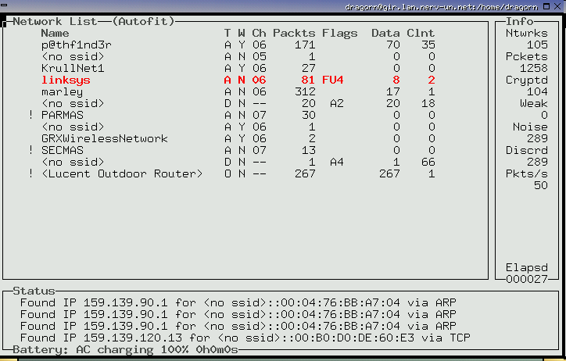

For Kismet, see link Ch 811

Kismet Demo

Use the Linksys WUSB54G ver 4 nics

Boot from the Backtrack 2 CD

Start, Backtrack, Radio Network Analysis, 80211, All, Kismet
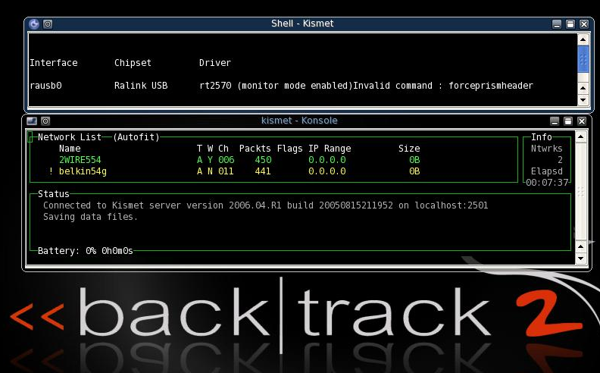

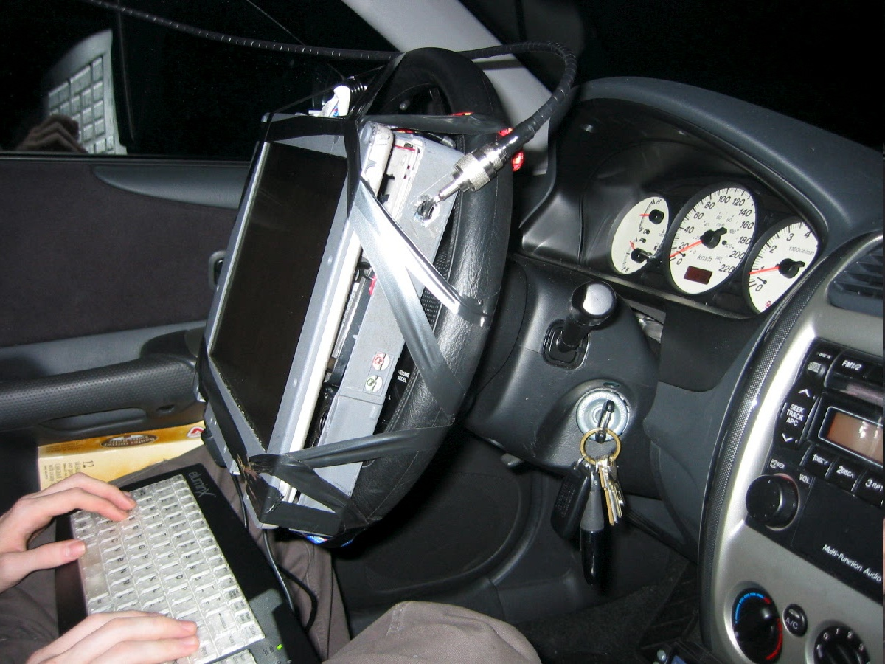
Wardriving

Finding Wireless networks with a portable device

Image from overdrawn.net

Vistumbler

Link Ch 818

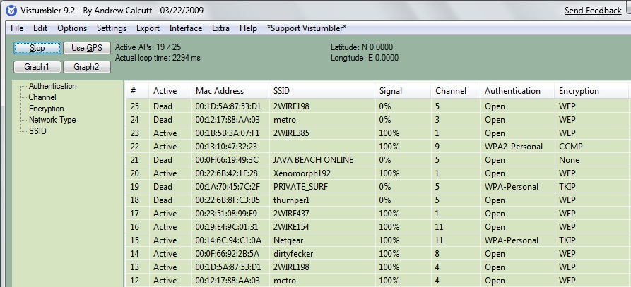

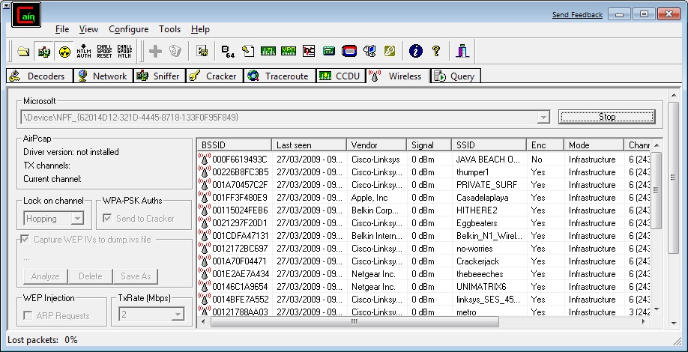
Cain

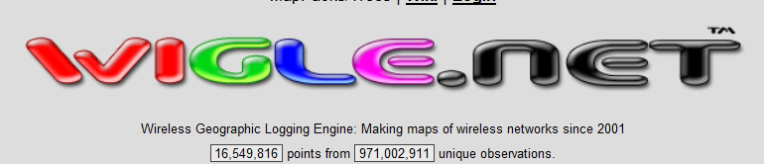
WiGLE

Collects wardriving data from users

Has over 16 million records

Link Ch 825

Wireless Scanning and Enumeration

Goal of Scanning and Enumeration

To determine a method to gain system access

For wireless networks, scanning and enumeration are combined, and happen simultaneously

Wireless Sniffers

Not really any different from wired sniffers

There are the usual issues with drivers, and getting a card into monitor mode

Wireshark WiFi Demo

Use the Linksys WUSB54G ver 4 nics

Boot from the Backtrack 2 CD

In Konsole:

ifconfig rausb0 up

iwconfig rausb0 mode monitor

wireshark
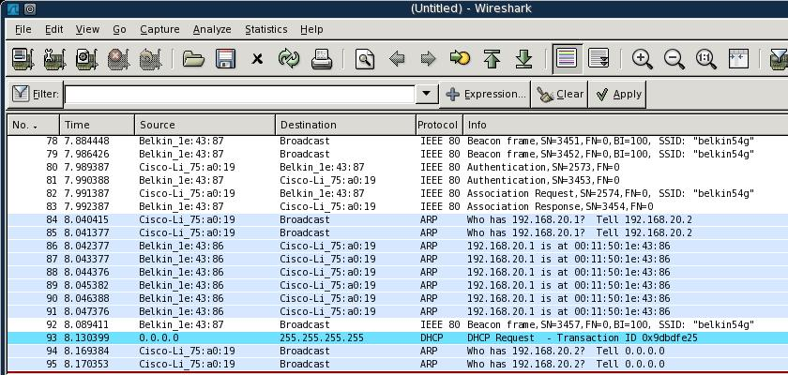
Identifying Wireless Network Defenses

SSID

SSID can be found from any of these frames

Beacons

Sent continually by the access point (unless disabled)

Probe Requests

Sent by client systems wishing to connect

Probe Responses

Response to a Probe Request

Association and Reassociation Requests

Made by the client when joining or rejoining the network

If SSID broadcasting is off, just send adeauthentication frame to force a reassociation

MAC Access Control

CCSF uses this technique

Each MAC must be entered into the list of approved addresses

High administrative effort, low security

Attacker can just sniff MACs from clients and spoof them
Gaining Access (Hacking 802.11)

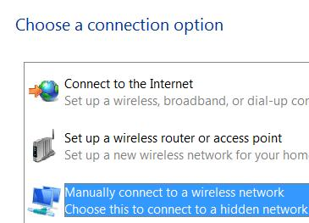
Specifying the SSID

In Windows, just select it from the available wireless networks

In Vista, right-click the network icon in the taskbar tray and click "Connect to a Network"

If the SSID is hidden, click "Set up a connection or network" and then click "Manually connect to a wireless network"

Changing your MAC

Bwmachak changes a NIC under Windows for Orinoco cards

SMAC is easy

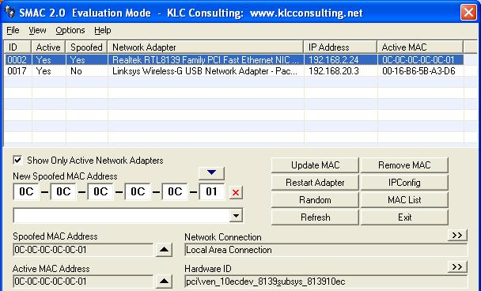
link Ch 812

Device Manager

Many Wi-Fi cards allow you to change the MAC in Windows' Device Manager
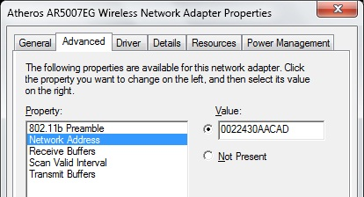

Attacks Against the WEP Algorithm

Brute-force keyspace – takes weeks even for 40-bit keys

Collect Initialization Vectors, which are sent in the clear, and correlate them with the first encrypted byte

This makes the brute-force process much faster

Tools that Exploit WEP Weaknesses

AirSnort

WLAN-Tools

DWEPCrack

WEPAttack

Cracks using the weak IV flaw

Best countermeasure – use WPA

HotSpotter

Hotspotter--Like SSLstrip, it silently replaces a secure WiFi connection with an insecure one

Works because Windows allows it, apparently happy to accept an insecure network as part of the same WLAN

Link Ch 824
Lightweight Extensible Authentication Protocol (LEAP)

What is LEAP?

A proprietary protocol from Cisco Systems developed in 2000 to address the security weaknesses common in WEP

LEAP is an 802.1X schema using a RADIUS server

As of 2004, 46% of IT executives in the enterprise said that they used LEAP in their organizations

The Weakness of LEAP

LEAP is fundamentally weak because it provides zero resistance to offline dictionary attacks

It solely relies on MS-CHAPv2 (Microsoft Challenge Handshake Authentication Protocol version 2) to protect the user credentials used for Wireless LAN authentication

MS-CHAPv2

MS-CHAPv2 is notoriously weak because

It does not use a SALT in its NT hashes

Uses a weak 2 byte DES key

Sends usernames in clear text

Because of this, offline dictionary and brute force attacks can be made much more efficient by a very large (4 gigabytes) database of likely passwords with pre-calculated hashes

Rainbow tables

Cisco's Defense

LEAP is secure if the passwords are long and complex

10 characters long with random upper case, lower case, numeric, and special characters

The vast majority of passwords in most organizations do not meet these stringent requirements

Can be cracked in a few days or even a few minutes

For more info about LEAP, see link Ch 813

LEAP Attacks

Anwrap

Performs a dictionary attack on LEAP

Written in Perl, easy to use

Asleap

Grabs and decrypts weak LEAP passwords from Cisco wireless access points and corresponding wireless cards

Integrated with Air-Jack to knock authenticated wireless users off targeted wireless networks

When the user reauthenticates, their password will be sniffed and cracked with Asleap

Countermeasures for LEAP

Enforce strong passwords

Continuously audit the services to make sure people don't use poor passwords

WPA

WPA is strong

No major weaknesses

However, if you use a weak Pre-Shared Key, it can be found with a dictionary attack

Tool: Aircrack-ng

Denial of Service (DoS) Attacks

Radio Interference

802.11a, 11b, and 11g all use the 2.4-2.5GHz ISM band, which is extremely crowded at the moment

Unauthenticated Management Frames

An attacker can spoof a deaauthentication frame that looks like it came from the access point

wlan_jack in the Air-Jack suite does this

Last modified 3-27-09

