Getting in the Door

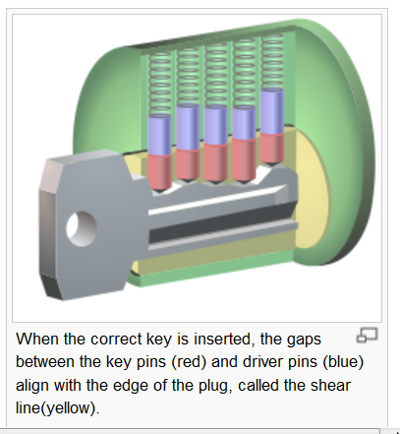
Normal Key

Link Ch 920

(At bottom of my CNIT 124 page)

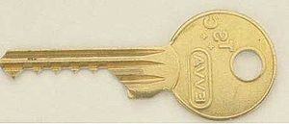
Bump Key

Every key pin falls to its lowest point

The key is hit with a screwdriver to create mechanical shocks

The key pins move up and briefly pass through the shear line

The lock can be opened at the instant the key pins align on the shear line

Results of Bump Key Use

A experienced bumper can open the lock as quickly as a person with the correct key

Bumping does not damage the lock

Unless it is done many times, or clumsily

Bumping leaves no evidence behind

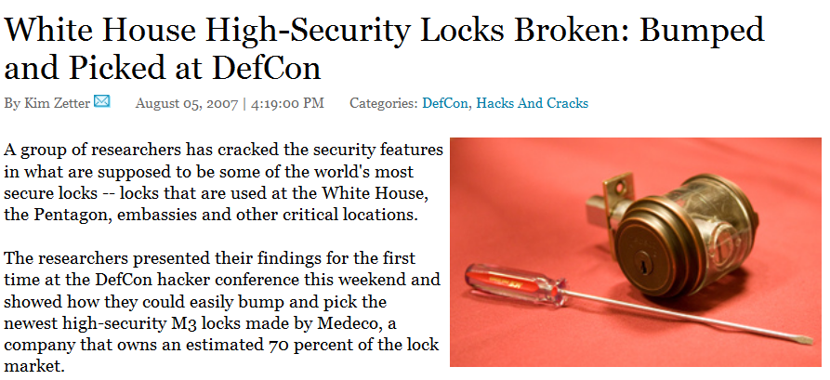
Even Medeco locks used in the White House can be bumped

Link Ch 921

Bump Key Countermeasures

Some locks (like Medeco) are designed to make bumping difficult

They use a sidebar and angled pins to make normal picking and bumping ineffective

Don't trust their claims too far

Don't rely solely on locks: use two-factor authentication

PIN keypad

Fingerprint

Security guard

etc.

Cloning Access Cards

Two Varieties

Magnetic stripe cards

RFID (Radio Frequency Identification) cards
Magstripe Cards

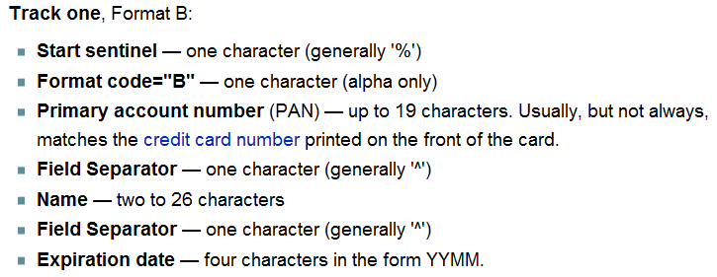
ISO Standards specify three tracks of data

There are various standards, but usually no encryption is used

Link Ch 922

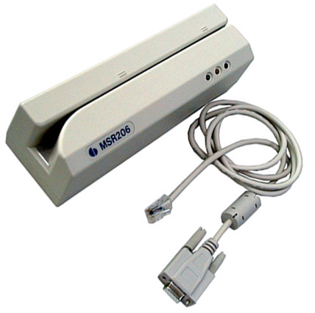

Magstripe Card Reader/Writer

USB connector

About $35o

Link Ch 923

Magnetic-Stripe Card Explorer

Software

Link Ch924 for more images
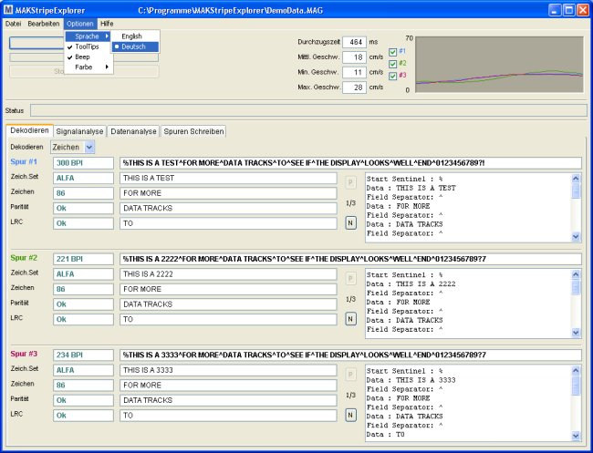

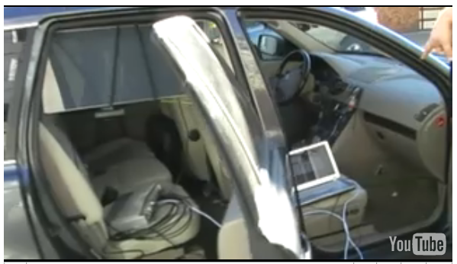
Hacking RFID Cards

RFID cards use radio signals instead of magnetism

Now required in passports

Data can be read at a distance, and is usually unencrypted

Cloning Passports

$250 in equipment

Can steal passport data from a moving car

Link Ch 925

MiFare Classic

Mifare is most widely deployed brand of secure RFID chips

Dutch researchers found weaknesses have been found in its proprietary encryption in 2008

Don't roll your own crypto!

Links Ch 926 & 927

Boston Subway Hack

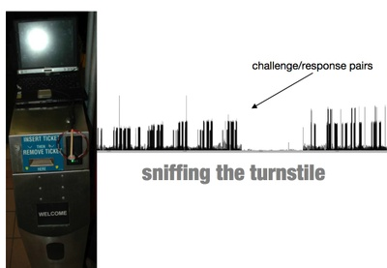
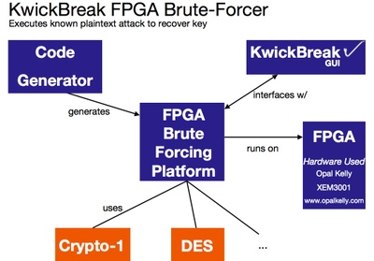
The Massachusetts Bay Transportation Authority claims that they added proprietary encryption to make their MiFare Classic cards secure

But Ron Rivest's students from MIT hacked into it anyway

Link Ch 928

Countermeasures for Cloning Access Cards

We are at the mercy of card vendors

Newer cards have a full challenge-response algorithm

Resists cloning and replay attacks

Some use open algorithms, others are proprietary

Hacking Devices

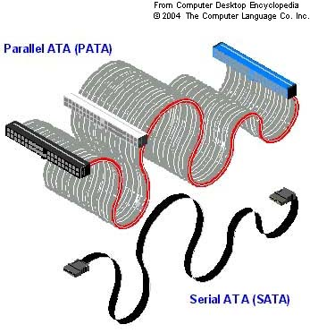
ATA Interfaces for Hard Drives

Two kinds of ATA (AT Attachment ) interfaces are used

PATA (Parallel ATA)

IDE is now called PATA

SATA (Serial ATA)

Newer and faster than PATA

ATA Security

Requires a password to access the hard disk

Virtually every hard drive made since 2000 has this feature

It is part of the ATA specification, and thus not specific to any brand or device.

Does not encrypt the disk, but prevents access

ATA Password Virus

ATA Security is used on Microsoft Xbox hard drives and laptops

BUT desktop machines' BIOS is often unaware of ATA security

An attacker could turn on ATA security, and effectively destroy a hard drive, or hold it for ransom

The machine won't boot, and no BIOS command can help

This is only a theoretical attack at the moment

Bypassing ATA Passwords

Hot Swap

With an unlocked drive plugged in, enter the BIOS and navigate to the menu that allows you to set a HDD Password

Plug in the locked drive and reset the password

Use factory default master password

Not easy to find

Some examples given in 2600 magazine vol 26 #1

Bypassing ATA Passwords

Vogon Password Cracker POD

Changes the password from a simple GUI

Allows law enforcement to image the drive, then restore the original password, so the owner never knows anything has happened

Works by accessing the drive service area

A special area on a disk used for firmware, geometry information, etc.

Inaccessible to the user

ATA Security Sources

Hacking Exposed 6th Ed.

Links Ch 929 - 931

2600 Magazine

ATA Password Bypass Countermeasure

Don't trust ATA Security

Encrypt the drive with Bitlocker, TrueCrypt, PGP, etc.
U3 Drives

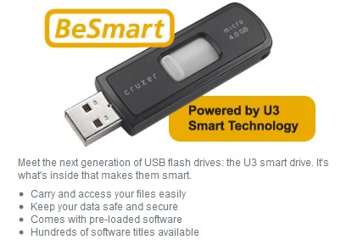
U3: Software on a Flash Drive

Carry your data and your applications in your pocket!

It’s like a tiny laptop!

U3 Launchpad

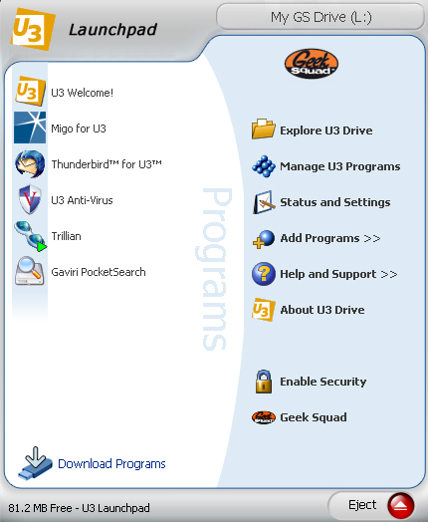
Just plug it in, and the Launchpad appears

Run your applications on anyone’s machine

Take all data away with you

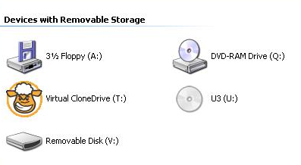

How U3 Works

The U3 drive appears as two devices in My Computer

A “Removable Disk”

A hidden CD drive named “U3”

The CD contains software that automatically runs on computers that have Autorun enabled

For more details, see http://www.everythingusb.com/u3.html

Hak9’s PocketKnife

Software On The Disk Partition

PocketKnife is a suite of powerful hacking tools that lives on the disk partition of the U3 drive

Just like other applications

U3 PocketKnife

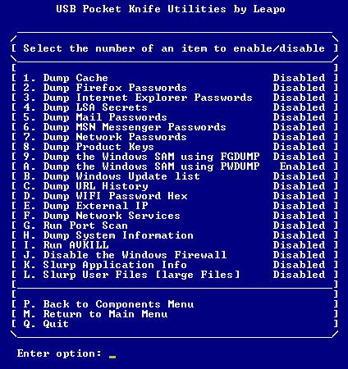
Steal passwords

Product keys

Steal files

Kill antivirus software

Turn off theFirewall

And more…

For details see http://wapurl.co.uk/?719WZ2T

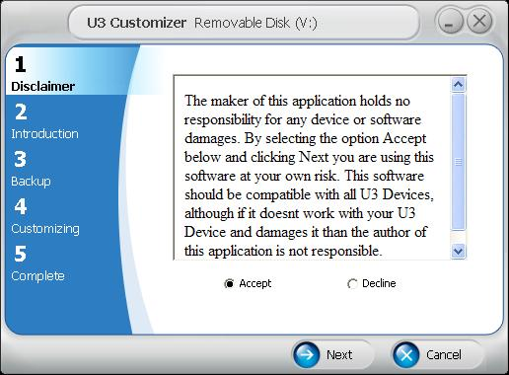

Custom Launchpad

Customizing U3

You can create a custom file to be executed when a U3 drive is plugged in

Automatically Run PocketKnife

The custom U3 launcher runs PocketKnife

So all those things are stolen and put on the flash drive

Defense

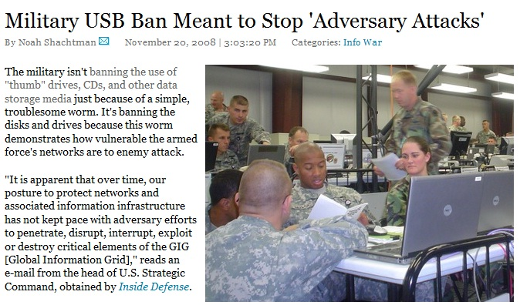
Military Bans USB Thumb Drives

Immediate Risk Reduction

Block all USB devices in Group Policy

Disable AutoRun

Glue USB ports shut

Better Solution: IEEE 1667

Standard Protocol for Authentication in Host Attachments of Transient Storage Devices

USB devices can be signed and authenticates, so only authorized devices are allowed

Will be implemented in Windows 7

See http://wapurl.co.uk/?QXASJBK
Default Configurations (Pre-0wned)

ASUS Eee PC Rooted Out of the Box

The Eee PC 701 shipped with Xandros Linux

The Samba file-sharing service was on by default

It was a vulnerable version, easily rooted by Metasploit

Easy to learn, Easy to work, Easy to root

Link Ch 933

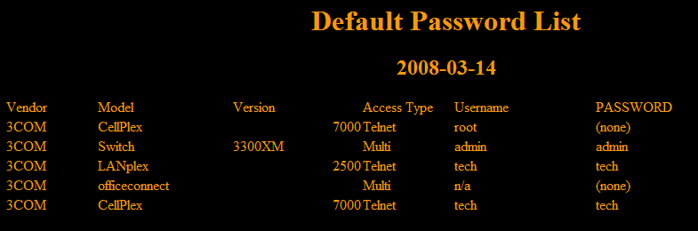
Default Passwords

Many devices ship with default passwords that are often left unchanged

Especially routers (see link Ch 934)
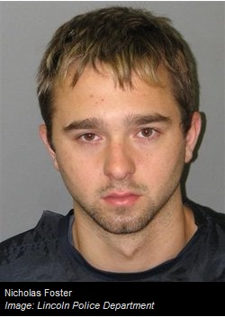
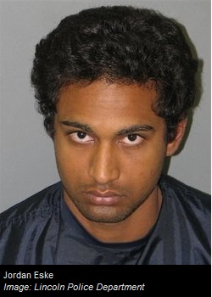

ATM Passwords

In 2008, these men used default passwords to reprogram ATM machines to hand out $20 bills like they were $1 bills

Link Ch 936

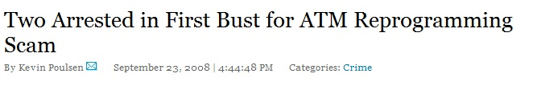
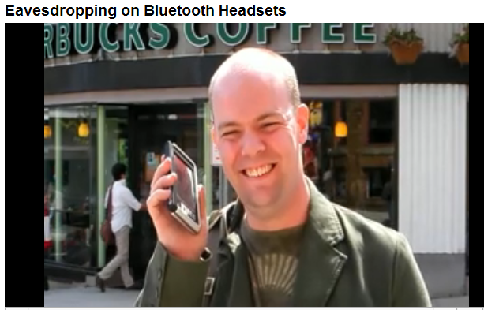

Bluetooth Attacks

Bluetooth supports encryption, but it's off by default, and the password is 0000 by default

Link Ch 935

Reverse Engineering Hardware

We will skip this section

Last modified 4-17-09

