CASE STUDY

TOR (The Onion Router)

Passes packets through proxies, concealing the source IP

Usually installed with Vidalia (the GUI) and Privoxy (Web filtering proxy)

Tor listens on port 9050

Privoxy listens on port 8118

Torbutton Firefox extension controls Tor use

tor-resolve performs DNS resolution through Tor, concealing your IP Address

Proxychains

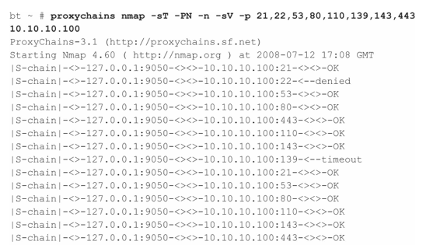
Forces TCP connections to go through a proxy

Requires complete handshake

SYN, SYN/ACK, ACK

nmap through proxychains

socat

Relays bidirectional transfers
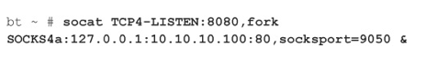

socat

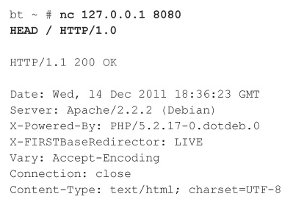
This command opens a proxy listening on localhost:8080 and forwards all requests through Tor to the target 10.10.10.100:80

Using nc as a Web browser

Chapter 1: Footprinting

Google Hacking

Find sensitive data about a company from Google

Completely stealthy—you never send a single packet to the target (if you view the cache)

To find passwords:

intitle:"Index of" passwd passwd.bak

See links Ch 1a, 1b on my Web page (samsclass.info, click CNIT 124)

Other fun searches

Nessus reports (link Ch 1c)

More passwords (link Ch 1d)

Be The Bot

See pages the way Google's bot sees them

Custom User Agents

Add the "User Agent Switcher" Firefox Extension

Footprinting

Gathering target information

"If you know the enemy and know yourself, you need not fear the result of a hundred battles. If you know yourself but not the enemy, for every victory gained you will also suffer a defeat. If you know neither the enemy nor yourself, you will succumb in every battle."

Sun Tzu on the Art of War

Environments and the Critical Information Attackers Can Identify

Internet

Domain name

Network blocks

Specific IP addresses of systems reachable via the Internet

TCP and UDP services running on each system identified

System architecture (for example, Sparc vs. x 86)

Access control mechanisms and related access control lists (ACLs)

Intrusion-detection systems (IDSs)

System enumeration (user and group names, system banners, routing tables, and SNMP information) DNS hostnames

Intranet

Networking protocols in use (for example, IP, IPX, DecNET, and so on)

Internal domain names

Network blocks

Specific IP addresses of systems reachable via the intranet

TCP and UDP services running on each system identified

System architecture (for example, SPARC vs. x 86)

Access control mechanisms and related ACLs

Intrusion-detection systems

System enumeration (user and group names, system banners, routing tables, and SNMP information)

Remote access

Analog/digital telephone numbers

Remote system type

Authentication mechanisms

VPNs and related protocols (IPSec and PPTP)

Extranet

Connection origination and destination

Type of connection

Access control mechanism

Internet Footprinting

Step 1: Determine the Scope of Your Activities

Step 2: Get Proper Authorization

Step 3: Publicly Available Information

Step 4: WHOIS & DNS Enumeration

Step 5: DNS Interrogation

Step 6: Network Reconnaissance
Step 1: Determine the Scope of Your Activities

Entire organization

Certain locations

Business partner connections (extranets)

Disaster-recovery sites
Step 2: Get Proper Authorization

Ethical Hackers must have authorization in writing for their activities

"Get Out of Jail Free"
card

Criminals omit this step

Image from
www.blackhatseo.fr
Step 3: Publicly Available Information

Company web pages

Wget and Teleport Pro are good tools to mirror Web sites for local analysis (links Ch 1o & 1p)

Look for other sites beyond "www"

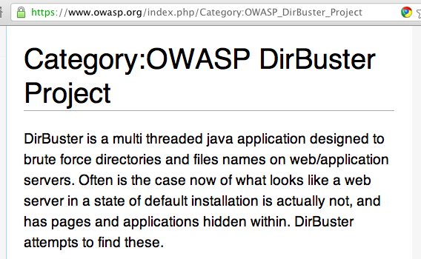
Outlook Web Access

https://owa.company.com or
https://outlook.company.com

Virtual Private Networks

http://vpn.company.com or
http://www.company.com/vpn

OWASP DirBuster

Related Organizations

Physical Address

Dumpster-diving

Surveillance

Social Engineering

Tool: Google Earth (link Ch 1q) and Google Maps Street View

Phone Numbers, Contact Names, E-mail Addresses, and Personal Details

Current Events

Mergers, scandals, layoffs, etc. create security holes

Privacy or Security Policies, and Technical Details Indicating the Types of Security Mechanisms in Place

Archived Information

The Wayback Machine (link Ch 1t)

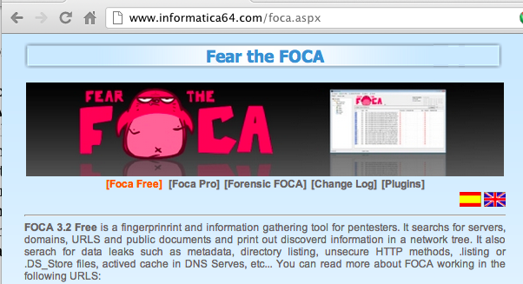
Google Cache

Disgruntled Employees

SiteDigger (Link Ch 1z7) -- Searches Google's Cache

Wikto - Nikto Vulnerability Scanner for Windows

Link Ch 1z8

FOCA

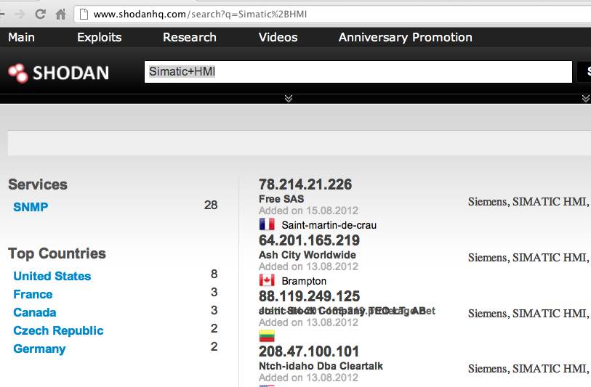
Searches file metadata (link Ch 1z9)

SHODAN

Searches banners

SHODAN finding Vulnerable SCADA Systems

Usenet

Groups.google.com

Resumes

Maltego

Data mining tool

Using Maltego

Link Ch 1z10

Step 4: WHOIS & DNS Enumeration

Two organizations manage domain names, IP addresses, protocols and port numbers on the Internet

Internet Assigned Numbers Authority (IANA; http://www.iana.org)

Internet Corporation for Assigned Names and Numbers (ICANN; http://www.icann.org)

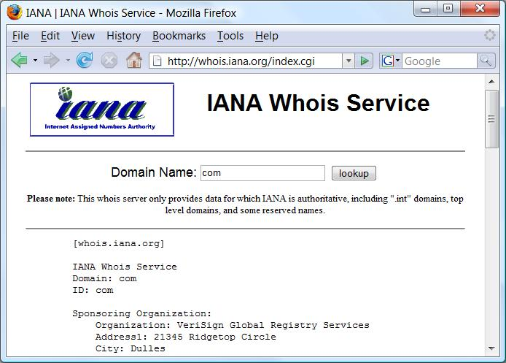
IANA still handles much of the day-to-day operations, but these will eventually be transitioned to ICANN

Domain-Related Searches

Every domain name, like msn.com, has a top-level domain - .com, .net, .org, etc.

If we surf to http://whois.iana.org, we can search for the authoritative registry for all of .com

.com is managed by Verisign

Verisign Whois (link Ch 1v)

Search for ccsf.edu and it gives the Registrar

Whois.educause.net

Three steps:

Authoritative Registry for top-level domain

Domain Registrar

Finds the Registrant

Automated tools do all three steps

Whois.com

Sam Spade

Netscan Tools Pro

They are not perfect. Sometimes you need to do the three-step process manually.

Once you've homed in on the correct WHOIS server for your target, you may be able to perform other searches if the registrar allows it

You may be able to find all the domains that a particular DNS server hosts, for instance, or any domain name that contains a certain string

BUT a court decision in North Dakota just declared this illegal (link Ch 1s) (printed notes have the wrong state & link)

How IP addresses are assigned:

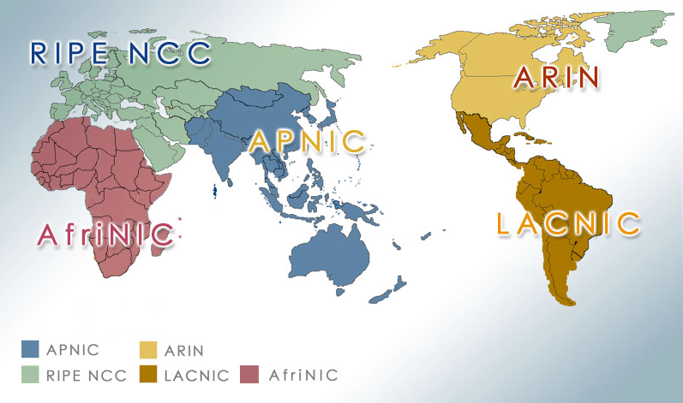
The Address Supporting Organization (ASO http://www.aso.icann.org) allocates IP address blocks to

Regional Internet Registries (RIRs), which then allocate IPs to organizations, Internet service providers (ISPs), etc.

ARIN (http://www.arin.net) is the RIR for North and South America

Internet Registry Regions

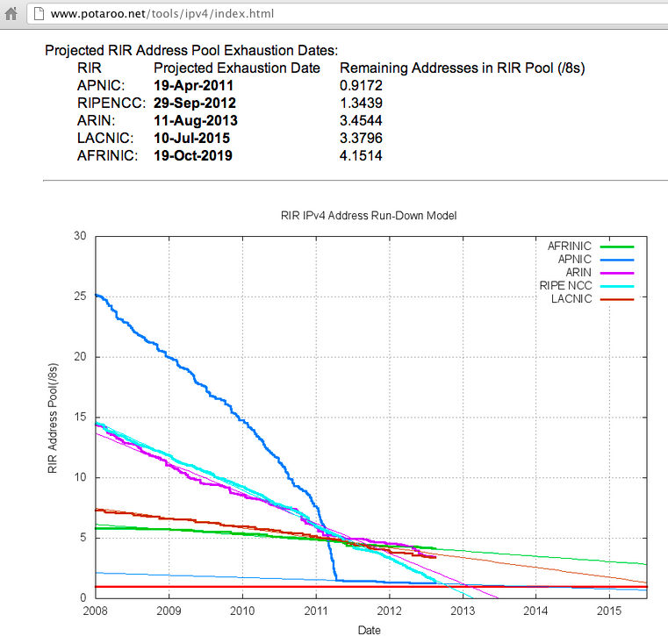

2013: The End (IPv4 Address Exhaustion)

IP-Related Searches

To track down an IP address:

Use arin.net (link Ch 1x)

It may refer you to a different database

Examples:

147.144.1.1

61.0.0.2

IP-Related Searches

Search by company name at arin.net to find IP ranges, and AS numbers

AS numbers are used by BGP (Border Gateway Protocol) to prevent routing loops on Internet routers (link Ch 1y)

Examples: Google, CCSF

Administrative contact gives you name, voice and fax numbers

Useful for social engineering

Authoritative DNS Server can be used for Zone Transfer attempts

But Zone Transfers may be illegal now (link Ch 1s)

Public Database Security Countermeasures

When an administrator leaves an organization, update the registration database

That prevents an ex-employee from changing domain information

You could also put in fake "honeytrap" data in the registration

eBay's domain was hijacked (link Ch 1z1)
Step 5: DNS Interrogation

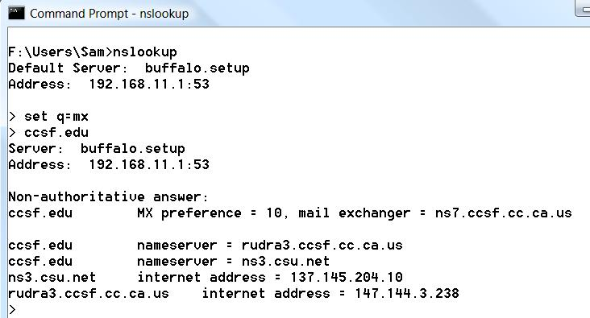
Zone Transfers

Gives you a list of all the hosts when it works

Usually blocked, and maybe even illegal now

14% of 1 million tested domains were vulnerable (link Ch 1z12)

Determine Mail Exchange (MX) Records

You can do it on Windows with NSLOOKUP in Interactive mode

Excellent Tutorial

Link Ch 1z11

DNS Security Countermeasures

Restrict zone transfers to only authorized servers

You can also block them at the firewall

DNS name lookups are UDP Port 53

Zone transfers are TCP Port 53

Note: DNSSEC means that normal name lookups are sometimes on TCP 53 now

DNS Security Countermeasures

Attackers could still perform reverse lookups against all IP addresses for a given net block

So, external nameservers should provide information only about systems directly connected to the Internet

Step 6: Network Reconnaissance

Traceroute

Can find route to target, locate firewalls, routers, etc.

Windows Tracert uses ICMP

Linux Traceroute uses UDP by default

Tracert

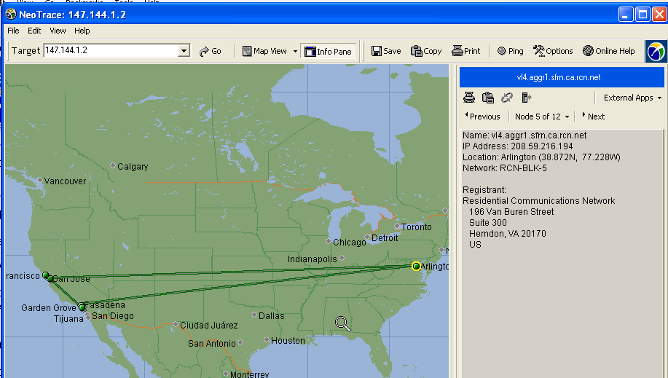
NeoTrace

NeoTrace combines Tracert and Whois to make a visual map (link Ch 1z2)

Firewalk uses traceroute techniques to find ports and protocols that get past firewalls

Uses low TTL values and gathers data from ICMP Time Exceeded messages

This should be even more effective with IPv6 because ICMPv6 is mandatory and cannot be blocked as well

Countermeasures

Many of the commercial network intrusion-detection systems (NIDS) and intrusion prevention systems (IPS) will detect this type of network reconnaissance

Snort – the standard IDS(link Ch 1z5)

Bro-IDS is another open source free NIDS

Countermeasures

You may be able to configure your border routers to limit ICMP and UDP traffic to specific systems, thus minimizing your exposure

Last modified 8-17-12

