Determining If The System Is Alive
Cain

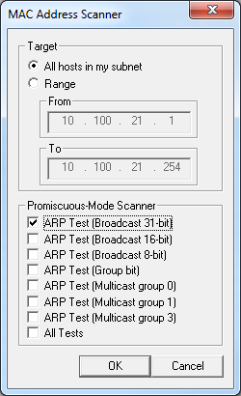
Network Ping Sweeps

Ping is traditionally used to send ICMP ECHO (Type 8) packets to a target system

Response is ICMP ECHO_REPLY (Type 0) indicating the target system is alive

Traffic can be ICMP, ARP, TCP, or UDP

ARP Host Discovery

Advantages

Operates at layer 2

A firewall will not conceal a device from an ARP scan

Disadvantage

Must be on target’s network segment

Cannot scan through routers

ARP Scanning Tools

arp-scan

Linux command-line tool

Nmap

-PR to do ARP scan

-sn to skip host discovery

Cain

Sniffer tab

Enable sniffer

Click +

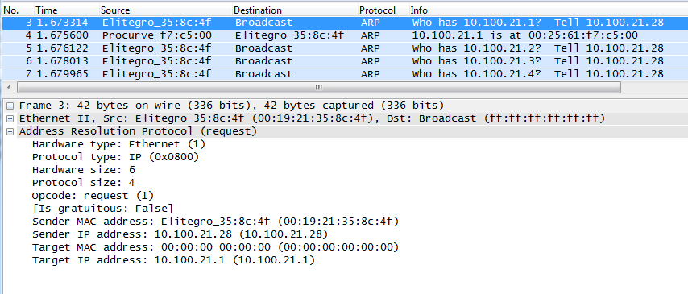

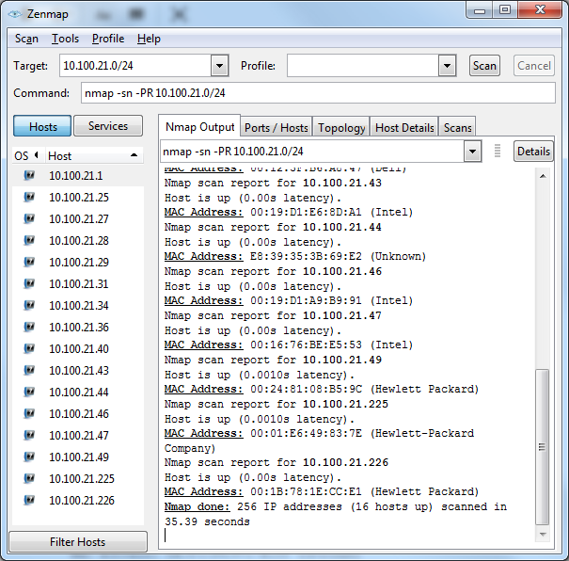
Nmap

ICMP Packet Types

Message Type: 0 - Echo Reply

Message Type: 3 - Destination Unreachable

Message Type: 4 - Source Quench

Message Type: 5 - Redirect

Message Type: 8 – Echo Request

Message Type: 11 - Time Exceeded

Message Type: 12 - Parameter Problem

Message Type: 13 - Timestamp

Message Type: 14 - Timestamp Reply

Message Type: 15 - Information Request

Message Type: 16 - Information Reply

Message Type: 17 – Address Mask Request

Message Type: 18 – Address Mask Reply

ICMP Queries

icmpquery uses ICMP type 13 (TIMESTAMP) to find the system time, which shows its timezone

ICMP type 17 (ADDRESS MASK REQUEST) shows the subnet mask

Link Ch 2n
Network Discovery Tools

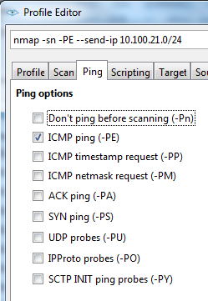
Nmap ICMP Options

nping (Included with Nmap)
Command-line tool

SuperScan

Windows freeware

Not so fast anymore

Does PING scanning, using several types of ICMP packets

Also does port scanning, banner grabbing, whois, and enumeration

Unix Ping Detection Tools

Scanlogd

Courtney

Ippl

Protolog

ICMP Blocking

ICMP is often blocked these days

Blocked by default in Win XP SP2, Win 2003 SP 1, and Vista

If ICMP is blocked, use port scanning

Slower than ping sweeping

SuperScan for Windows

Nmap for Linux, Unix, or Windows

Hping2 for Unix (can fragment packets)

Ping Sweeps Countermeasures

Detecting Ping Sweeps

Network-based Intrusion Detection Systems like Snort detect ping sweeps

Ping scans will be in the host logs

Firewalls can detect ping scans

Blocking ICMP

Routers may require some ICMP packets, but not all types

Safest procedure would be to allow ICMP only from your ISP, and only to public servers on your DMZ

Other ICMP Threats

ICMP can be used for a Denial of Service attack

ICMP can be used as a covert channel with Loki

Allowing unauthorized data transfer

Such as control signals for a back-door trojan

Links Ch 2l, Ch 2m

Determining Which Services are Running or Listening

Determining Which Services Are Running Or Listening

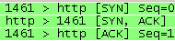
Normal TCP Handshake

Client SYN → Server

Client ← SYN/ACK Server

Client ACK → Server

After this, you are ready to send data

SYN Port Scan

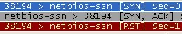
Client SYN → Server

Client ← SYN/ACK Server

The server is ready, but the client decided not to complete the handshake

Types of Port Scans

SYN scan

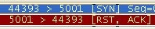
Stealthy scan, because session handshakes are never completed

Three states

Closed

Open
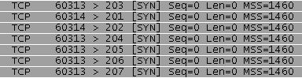
Filtered

Connect scan

Completes the three-way handshake

Not stealthy--appears in log files

Three states

Closed

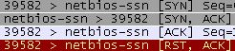

Open

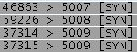

Filtered

Other Scan Types

TCP FIN scan

TCP Xmas Tree scan (FIN, URG, and PUSH)

TCP Null scan

Handled differently by Linux and Windows

TCP ACK scan

Returns RST unless the port is filtered

UDP Scanning

No handshake, so less useful than TCP scans

Much more powerful in newer versions of Nmap

Sends valid UDP requests to well-known ports

Send a DNS query to port 53, etc.

Response indicates open UDP port

TCP Header

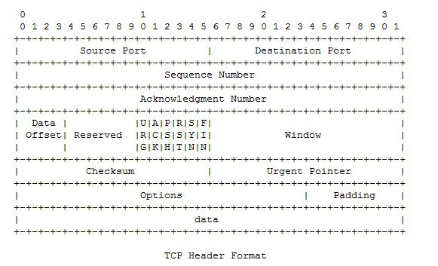
WINDOW indicates the amount of data that may be sent before an acknowledgement is required

TCP Window Scan

Sends ACK packets

Both open and closed ports reply with RST packets

But on some operating systems, the WINDOW size in the TCP header is non-zero for open ports, because the listening service does sometimes send data

Link Ch 2x

RPC Scan

SunRPC (Sun Remote Procedure Call) is a common UNIX protocol used to implement many services including NFS (Network File System)

The RPC scan works on Unix systems, including Solaris

Enumerates RPC services, which are rich in exploitable security holes

See link Ch 2y

Nmap

Interesting options

-f fragments packets

-D Launches decoy scans for concealment

-I IDENT Scan – finds owners of processes

(on Unix systems)

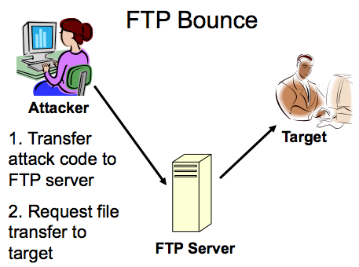
-b FTP Bounce

FTP Bounce

Old FTP servers allowed a request for a file transfer to a third IP address

This could be used to send email or other data to the third computer from the FTP server

Very old attack, from 1995

Almost unusable today

Windows-Based Port Scanners

SuperScan

Four different ICMP host-discovery techniques

Accurate UDP scan sending "Data+ICMP"

Banner grabbing

Many other tools

Nmap with the Zenmap GUI

Powerful, runs on Windows

Command-line Scanners

Scanline

For Windows

netcat

For Windows and Linux

nmap

Can be run on the command line, on Windows or Linux

Port Scanning Countermeasures

Snort (http://www.snort.org) is a great free IDS (Intrusion Detection System)

[**] spp_portscan: PORTSCAN DETECTED from 192.168.1.10 [**] 05/22-18:48:53.681227 [**] spp_portscan: portscan status from 192.168.1.10: 4 connections across 1 hosts: TCP(0), UDP(4) [**] 05/22-18:49:14.180505 [**] spp_portscan: End of portscan from 192.168.1.10 [**] 05/22-18:49:34.180236

Other Detection Tools

Scanlogd

Detects TCP Port Scans on Unix

Firewalls can detect port scans

Use threshold logging to limit the volume of email alerts sent by your firewall

That groups similar alerts into a single email

Attacker

Windows tool from Foundstone to detect port scans

Preventing Port Scans

You can't stop the scans from coming in, but you can mimimize your attack surface

Disable unnecessary services
Detecting the Operating System

Banner-Grabbing

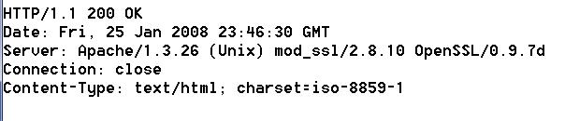
Many services announce what they are in response to requests

Banner grabbers just collect those banners

But they could be spoofed

Active Stack Fingerprinting

Details of the TCP Packets are used to identify the operating system

Nmap does this, using these probes:

FIN probe

Bogus Flag probe

Initial Sequence Number (ISN) sampling

"Don't fragment bit" monitoring

TCP initial window size

And many others

Operating System Detection Countermeasures

IDS can detect operating system detection scans

Hacking the OS to change its TCP stack is dangerous, and not recommended

Best policy: Accept that your firewalls and proxy servers will be scanned and fingerprinted, and harden them against attackers who know the OS

Passive Operating System Identification

Sniff traffic and guess the OS from that

Examine these features

TTL (time-to-live)

Window size

DF (Don't fragment bit)

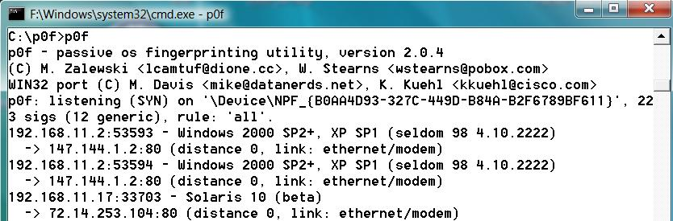
siphon was the first tool to do this, it's out of date

p0f is a newer one (link Ch 2z6)

p0f on Vista

Run p0f in a Command Prompt Window

Open a Web page

It fingerprints any OS it can see on the LAN

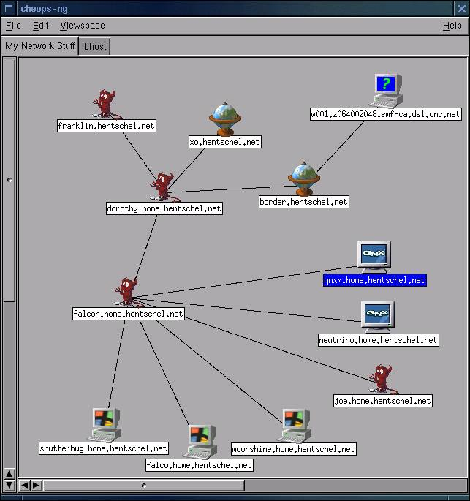
Nmap Plus Metasploit

Nmap scans can be imported into Metasploit for further exploitation

Details at end of chapter 2

Automated Discovery Tool: Cheops-ng

Combines Ping, Traceroute, Port Scans, and OS Detection to draw a network map

Link Ch 2z7

Windows 7's "Network Map" is similar

Last modified 8-23-12

