Definition

Scanning identifies live hosts and running services

Enumeration probes the identified services more fully for known weaknesses

Enumeration is more intrusive, using active connections and directed queries

Enumeration will usually be logged and noticed
Goals of Enumeration

User account names

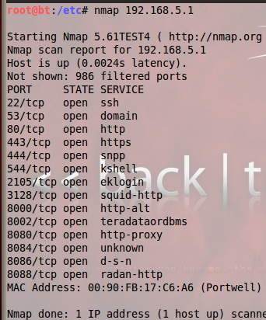
to inform subsequent password-guessing attacks

Oft-misconfigured shared resources

for example, unsecured file shares

Older software versions with known security vulnerabilities

such as web servers with remote buffer overflows

Pen-Test Video

Link Ch 3a: Droop's Box: Simple Pen-test Using Nmap, Nikto, Bugtraq, Nslookup and Other Tools by IronGeek

Normal nmap Scan

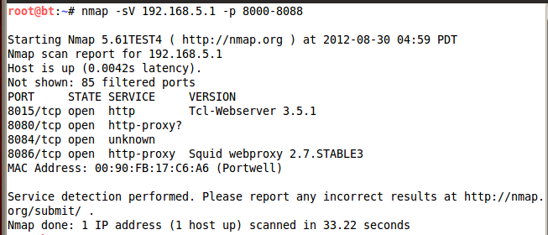

nmap Version Scanning

Vulnerability Scanners

Very noisy and easy to detect

Thorough and slow

Nessus

OpenVAS

Cenzic Hailstorm

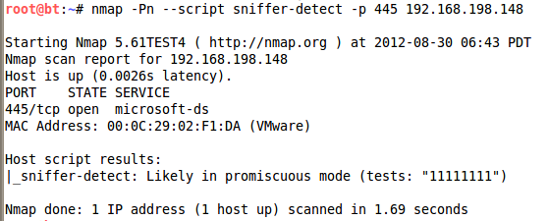
Accunetrix

Many others

nmap NSE Scripting

Nmap Scripting Engine

nmap –script-help all

When running script, -v helps

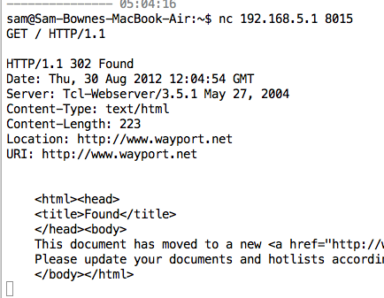
Banner Grabbing with netcat

Telnet in Vista and Windows 7

First you need to install Telnet

In Control Panel, Programs and Features, Turn Windows Features on or off, check Telnet Client

Banner Grabbing

Connecting to remote applications and observing the output

Simple way, at a command prompt

telnet www.ccsf.edu 80

On the next blank screen type in

GET / HTTP/1.1

Press Enter twice

Making Characters Visible

In Windows XP and Vista, you can't see what you type in the Telnet session

Do this:

At a command prompt, type

telnet hills.ccsf.edu 80

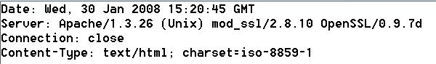
Press Enter. Press Ctrl+]. Then type

set localecho

Link Ch 3z11

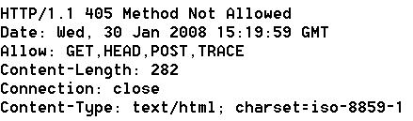
Example Banners

www.ccsf.edu tells you too much

cnn.com is better

Netcat Banner Grabs

Get Netcat for Windows at links Ch 3d, 3d1, 3d2

Banner-Grabbing Countermeasures

Turn off unnecessary services

Disable the presentation of the vendor and version in banners

Audit yourself regularly with port scans and raw netcat connects to active ports
Enumerating Common Network Services

FTP, TCP 21

Telnet, TCP 23

SMTP, TCP 25

DNS, TCP/UDP 53

TFTP, TCP/UDP 69

Finger, TCP/UDP 79

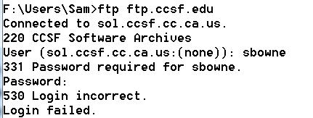
HTTP, TCP 80

FTP Enumeration, TCP 21

CCSF doesn't give away much information

FTP is becoming obsolete, see ftp.sun.com

FTP passwords are sent in the clear

Don't allow anonymous uploads

Turn it off, use secure FTP instead

Googling for FTP Servers

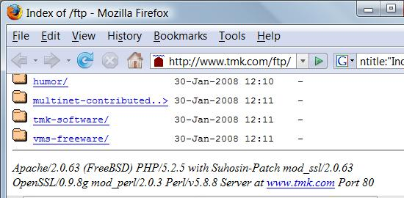
Search for

intitle:"Index of ftp://"

Here's an overly informative HTTP banner

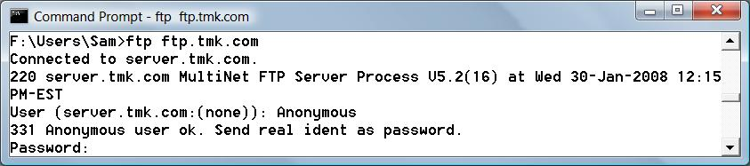
FTP Banner

Here's the corresponding overly informative FTP banner

Eliminate FTP

Plaintext password transmission!

Alternatives:

SFTP (over SSH)

FTPS (over SSL)

Public content should be served over HTTP, not FTP

Enumerating Telnet, TCP 23

Telnet sometimes has banners, and allows bruteforce username enumeration

It sends passwords in cleartext

Telnet should be eliminated if possible

Use SSH instead

If you must use Telnet, restrict it to proper source IP addresses

Or run it through a VPN

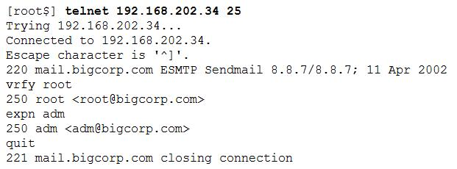
Enumerating SMTP, TCP 25

SMTP can be enumerated with Telnet, using these commands

VRFY confirms names of valid users

EXPN reveals the actual delivery addresses of aliases and mailing lists

Antivirus Note

McAfee antivirus blocks telnets to port 25

"Prevent mass mailing worms from sending mail"

SMTP Enumeration Countermeasures

Disable the EXPN and VRFY commands, or restrict them to authenticated users

Sendmail and Exchange both allow that in modern versions

DNS Zone Transfers, TCP 53

Zone transfers dump the entire contents of a given domain's zone files

Restricted to authorized machines on most DNS servers now

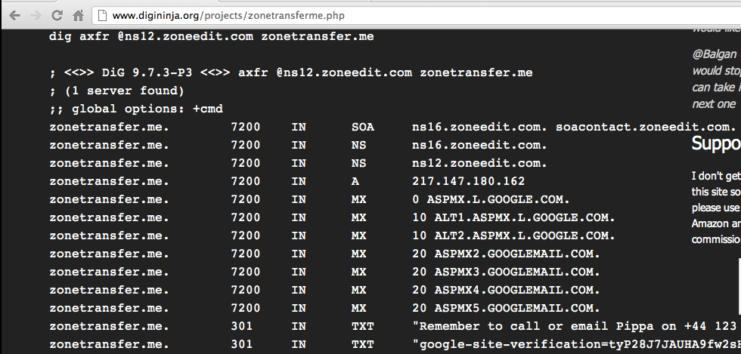
Zone Transfer Example

Link Ch 1z14

Bind Version Now Disabled

DNS Cache Snooping

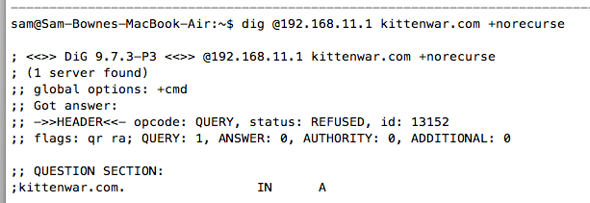
+norecurse – examines only the local DNS data (note ANSWER: 0)

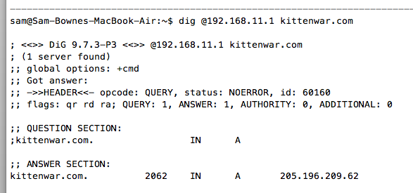

Recursive DNS

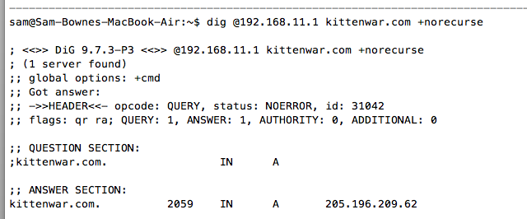

Now It's in the Cache

DNS Enumeration Tools

dnsenum

Google scraping

Brute forcing

More

Links Ch 3a,3b

Fierce

Link Ch 3c

DNS Enumeration Countermeasures

Use separate internal and external DNS servers

Block or restrict DNS zone transfers

Restrict DNS queries to limit cache snooping (Link Ch 3d)

Enumerating TFTP, TCP/UDP 69

TFTP is inherently insecure

Runs in cleartext

No authentication at all

Anyone can grab any file (even /etc/passwd in the worst cases)

Used in routers and VoIP Telephones to update firmware

TFTP Enumeration Countermeasures

Wrap it to restrict access

Using a tool such as TCP Wrappers

TCP Wrappers is like a software firewall, only allowing certain clients to access a service

Links Ch 3e, 3f

Limit access to the /tftpboot directory

Make sure it's blocked at the border firewall

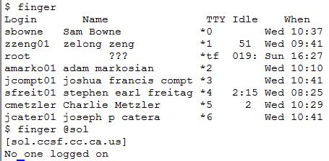
Finger, TCP/UDP 79

Shows users on local or remote systems, if enabled

Useful for social engineering

Countermeasure: block remote access to finger

Enumerating HTTP, TCP 80

Grab banners with netcat or telnet

Crawl Web sites with Sam Spade

Grendel-Scan

Crawls sites and reports on vulnerabilities

In BackTrack, very slow

Link Ch 3e

HTTP Enumeration Countermeasures

Change the banner on your web servers

URLScan for IIS v 4 and later

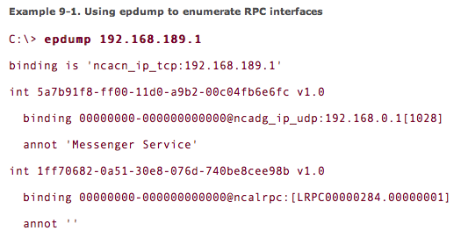
Link Ch 3h

Microsoft RPC Endpoint Mapper (MSRPC), TCP 135

Remote Procedure Call (RPC) endpoint mapper (or portmapper) service on TCP 135

Querying this service can yield information about applications and services available on the target machine

epdump

From Microsoft's Windows Resource Kit

Shows services bound to IP addresses

It takes some research to interpret the results

Link Ch 3f

rpcdump

In Backtrack, similar results

winfingerprint

Does RPC enumeration and much more

Link Ch 3g

MSRPC Enumeration Countermeasures

Block port 135 at the firewall, if you can

But some Microsoft Exchange configurations require access to the endpoint mapper

You can avoid that by using Virtual Private Networks, or

Outlook Web Access (OWA) which works over HTTPS

Exchange 2003 and later implements RPC over HTTP

NetBIOS Name Service, UDP 137

NetBIOS Name Service (NBNS) is Microsoft's name service, an alternative to DNS

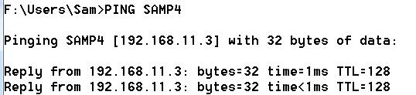
What is Name Resolution?

Suppose you issue a command that refers to a computer by name, such as PING

Name Resolution

Windows needs to change a computer name to an IP address to send data packets

Windows uses two naming systems:

DNS (the preferred method)

NetBIOS Name Resolution (still used by all versions of Windows)

Standard Name Resolution Methods

Charts from link Ch 3h
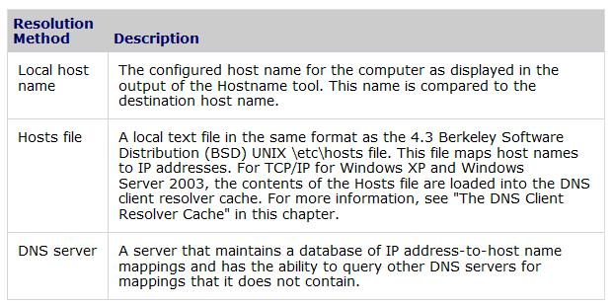

Additional Name Resolution Methods
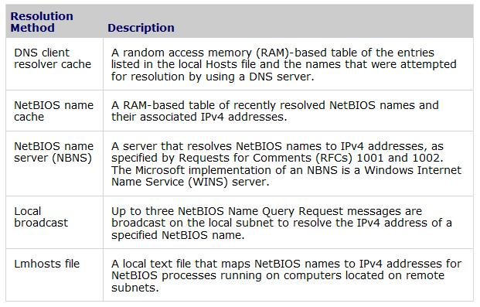

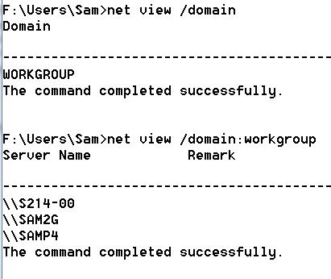

NET VIEW

NET VIEW can list the domains, or the computers in each domain

NBNS over TCP/IP

Normally NBNS only works on the local network segment

It is possible to route NBNS over TCP/IP, allowing enumeration from a remote system

Other Tools to Enumerate NBNS

NLTEST and NETDOM can find domain controllers

NETVIEWX finds specific services

NBTSTAT collects information from a single system

NBTSCAN scans a whole range of addresses, and dumps the whole NetBIOS name table

Link Ch 3i

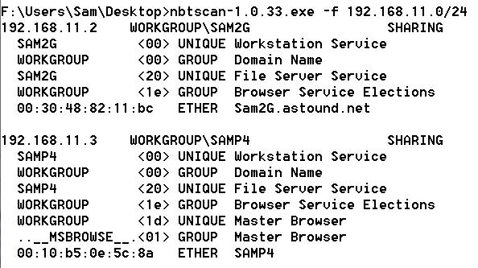
nmbscan in BackTrack

NBTSCAN

Stopping NetBIOS Name Services Enumeration

All the preceding techniques operate over the NetBIOS Naming Service, UDP 137

Block UDP 137 at the firewall, or restrict it to only certain hosts

To prevent user data from appearing in NetBIOS name table dumps, disable the Alerter and Messenger services on individual hosts

Blocking UDP 137 will disable NBNS name authentication, of course

NetBIOS Session, TCP 139

These are the notorious Null Sessions

The Windows Server Message Block (SMB) protocol hands out a wealth of information freely

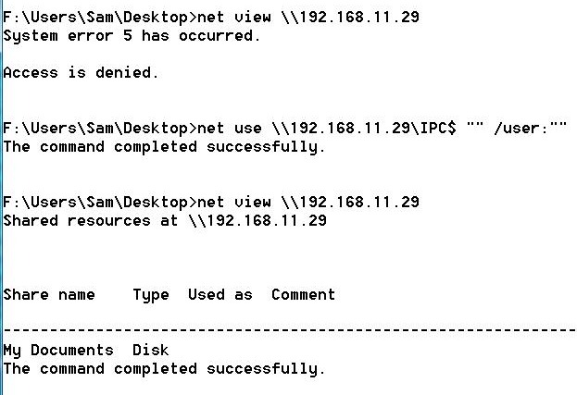
Null Sessions are turned off by default in Win XP and later versions, but open in Win 2000 and NT

They aren't available in Win 95, 98, or Me

Null Session Against Win 2000

Information Available

Null sessions on Win 2000 and NT provide information about:

Shares

User accounts

Password policies

DumpSec

Free from link Ch 3j

Runs on Vista (and earlier Windows)

Registry Enumeration

The Registry can be viewed remotely with reg or DumpSec

Requires Administrator privileges by default on Windows servers

You can't do it with null sessions

Gary McKinnon used remote registry access to hack into the Pentagon

Link Ch 3k

user2sid/sid2user

These utilities can get user account names and SIDs remotely, even if the registry key RestrictAnonymous is set to 1

They can find the Administrator's account name, even if it's renamed, by changing the last 3 numbers of another account's SID to 500

Works against Win 2003, but not Win XP SP2

See link Ch 3l

All-in-One Null Session Enumeration Tools

winfingerprint

Winfo

NBTEnum 3.3

Link Ch 3m

SMB Null Session Countermeasures

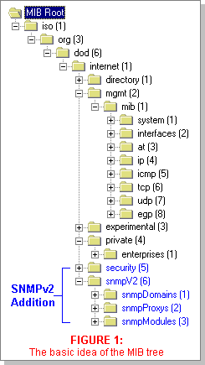
Block TCP 139 and 445 at the router

Set the RestrictAnonymous registry key to 1 or 2

HKLM\SYSTEM\CurrentControlSet\Control\LSA

Ensure the Registry Is Locked Down

http://support.microsoft.com/kb/153183 (link Ch 3n)

SNMP, UDP 161

Simple Network Management Protocol (SNMP) is intended for network management and monitoring

Administrators use SNMP to remotely manage routers and other network devices

Community Strings

SNMP is not a very secure protocol.

It has a minimal security system called SNMP Community Strings

Community strings act like passwords

There are three kinds of SNMP Community strings: Read-Only, Read-Write, and Trap (Trap is rarely used)

But the community strings are often left at obvious defaults like "public" and "private"

Management Information Bases (MIBs)

The MIB contains a SNMP device's data in a tree-structured form, like the Windows Registry

Vendors add data to the MIB

Microsoft stores Windows user account names in the MIB

Image from link Ch 3o

Data Available Via SNMP Enumeration

Running services

Share names

Share paths

Comments on shares

Usernames

Domain name

SNMP Enumeration Tools

snmputil from the Windows NT Resource Kit

snmpget or snmpwalk for Unix

IP Network Browser

Part of the Engineer's Toolset, link Ch 2d

Worse than Enumeration

Attackers who guess the SNMP community string may be able to remotely control your network devices

That can be used for DoS attacks, or other attacks

SNMP Enumeration Countermeasures

Remove or disable unneeded SNMP agents

Change the community strings to non-default values

Block access to TCP and UDP ports 161 (SNMP GET/SET)

Restrict access to SNMP agents to the appropriate management console IP address

Use SNMP V3—much more secure than V1 or 2

Provides enhanced encryption and authentication mechanisms

Adjust Win NT registry keys to make SNMP less dangerous

BGP, TCP 179

Border Gateway Protocol (BGP) is the de facto routing protocol on the Internet

Used by routers to help them guide packets to their destinations

It can be used to find all the networks associated with a particular corporation

That may give you more targets to attack

A small risk, but there is no countermeasure

Windows Active Directory LDAP, TCP/UDP 389 and 3268

Active Directory contains all user accounts and other information on Windows domain controllers

If the domain is made compatible with earlier versions of Windows, such as Win NT4 Server, any domain member can enumerate Active Directory

Active Directory Enumeration Countermeasures

Filter access to ports 389 and 3268 at the network border

Use "Native" domains—don't allow Win NT4 Domain Controllers

Other Services Vulnerable to Enumeration

UNIX RPC, TCP/UDP 111 and 32771

rwho (UDP 513) and rusers (RPC Program 100002)

NIS, RPC Program 100004

Oracle TNS, TCP 1521/2483

SQL Resolution Service, UDP 1434

NFS, TCP/UDP 2049

IPSec/IKE, UDP 500

Last modified 9-6-12

