What is an APT?

Advanced Persistent Threat (APT)

Advanced

Uses sophisticated methods, such as zero-day exploits

Persistent

Attacker returns to target system over and over again

Attacker has a long-term objective

Attacker works to achieve goals without detection

APT Goals

Non-APT Attacks

Non-APT attacks are against "targets of opportunity"—vulnerable systems

Non-APT attacks are brief: smash and grab

APT

Used to steal large amounts of data from a corporation over a long period of time

Long-term goals, not simple theft

Crime v. Espionage

Two types of APTs

Crime

Steal PII, financial information, or corporate data just to use it for fraud

Espionage

Gather intellectual property or trade secrets

To gain competitive advantage

APT goal is to gain and maintain access to information

APT Attacks

Don't destroy systems

Don't interrupt normal operation

Try to stay hidden and keep the stolen data flowing

Most often starts from spear phishing

Trick a user into installing malware

Other APT Techniques

Cut-outs

Attacks are routed through other compromised computers to conceal attacker's location

Spam delivery services

"Pay per install" or "Leased" campaigns

Other APT Techniques

SQL injection to add malware to websites

Infected USB stick "drops"

Infected hardware or software

Less often: compromised human insiders

APT Phases

Targeting

Access/compromise

Reconnaissance

Lateral movement

Data collection and exfiltration

Administration and Maintenance

Detecting APTs

Email logs

Lateral movement may leave artifacts from misuse of access credentials or identities

Exfiltration may leave traces in

Firewall and IDS logs

Data Loss Prevention logs

Application history logs

Web server logs

Forensics

Artifacts of APT may be found in

Live file systems (RAM)

Hard disk image
Historical APT Campaigns

Historical APT Attacks

Aurora

Nitro

ShadyRAT

Lurid

Night Dragon

Stuxnet

DuQu
Operation Aurora

2009

Targets: U.S. Technology and Defense Industries

Google

Juniper

Adobe

At least 29 other companies lost data over a period as long as six months

Spear-Phishing and RAT

Email with a link to a Taiwanese website with malicious JavaScript

Exploited Internet Explorer vunerability

Undetected by antivirus

Trojan Downloaders placed on victim computers

Installed a Backdoor Trojan Remote Administration Tool (RAT)

Accessed through SSL

Lateral Movement

Network reconnaissance

Compromised Active Directory credentials

Access to computers and network shares with valuable intellectual property

China?

Spear-phishing and downloader linked to Taiwan

Backdoor Command & Control servers were traced to two schools in China

Google blamed China

No proof that Chinese government or industry sponsored or supported the attacks

Other APT Campaigns

"Night Dragon" in 2010

"RSA Breach" in 2011

"Shady RAT" spanned several years

All commonly attributed to China, but not proven
Anonymous

2011

Targets

Government agencies at all levels

Schools

Bart

Sony

Mastercard & Visa

Many, many more

Techniques

SQL injection

Cross-site scripting

Web service vulnerability exploits

Social engineering

Goals

Revolution: demonstrate that people can strike back at powerful organizations

Expose corruption

Primary goal: expose information

Not to use it for financial gain
RBN

Russian Business Network

Criminal syndicate

Operates botnets for hire

Phishing

Malware distribution

Porn, including child porn

Goal is identity theft and financial theft

Sophisticated malware

APT Tools and Techniques

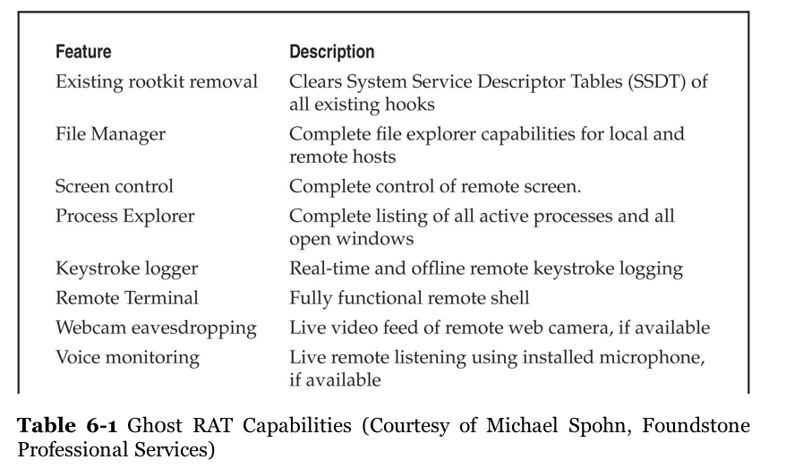
Ghost Attack

GhostRAT used in the "Ghostnet" attacks 2008-2010

Targeted the Dalai Lama and Tibetan enterprises

GhostNET Phishing

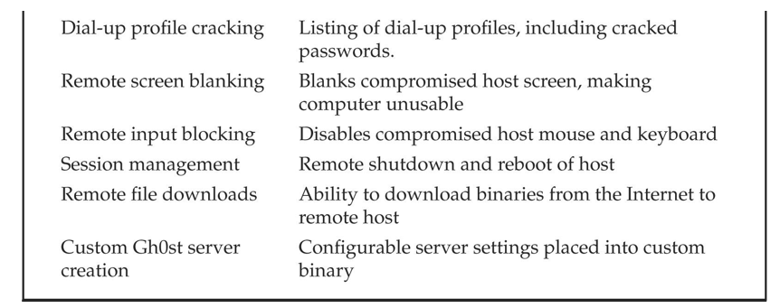
Attack started with an email from a server on several blacklists for spamming

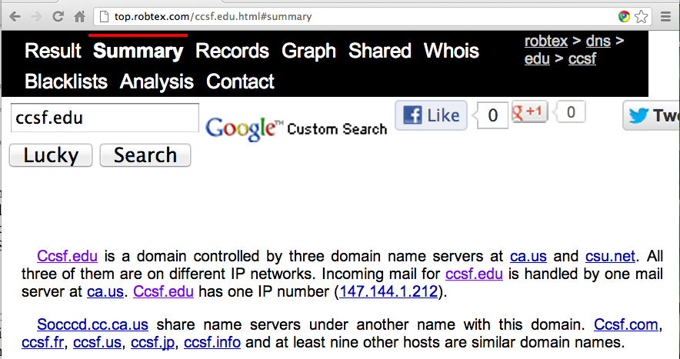
Tools used to research source of email

Whois

Robtex

Phishtank

Robtex

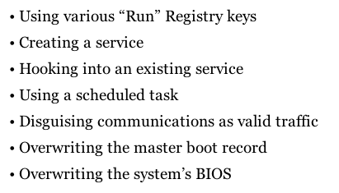

Indicators of Compromise

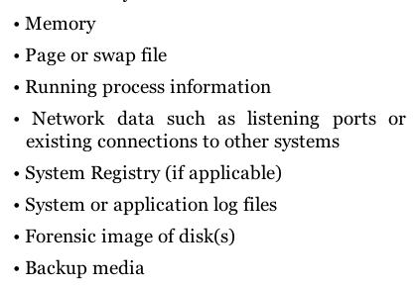
Order of Volatility

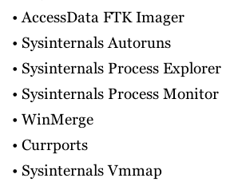

Forensic Tools

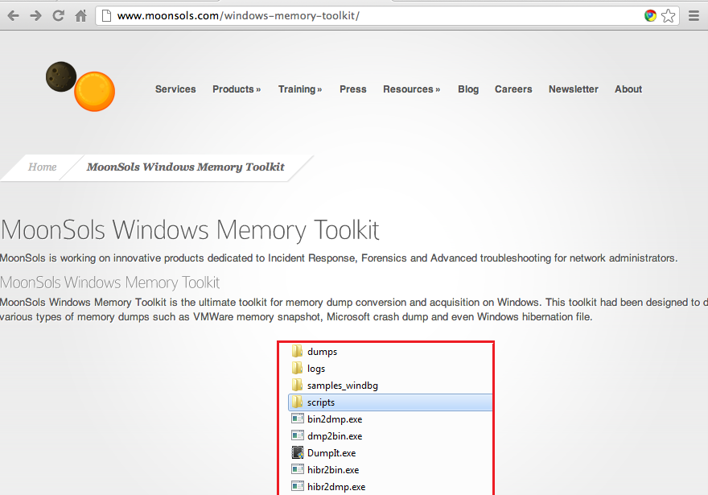

Memory Analysis

Crucial for APT analysis because many APT methods use process injection or obfuscation

Analyzing RAM data guarantees that the data are unencrypted

Pagefile/Swapfile Analysis

Virtual memory

Also Hiberfil

Tools:

HBGary FDPro

Mandiant Memoryze

Volatility Framework

Results

Using Volatility Framework Tool (open source) to analyze memory

Processes

Network connections

DLLS from suspicious process

Use strings on the DLL
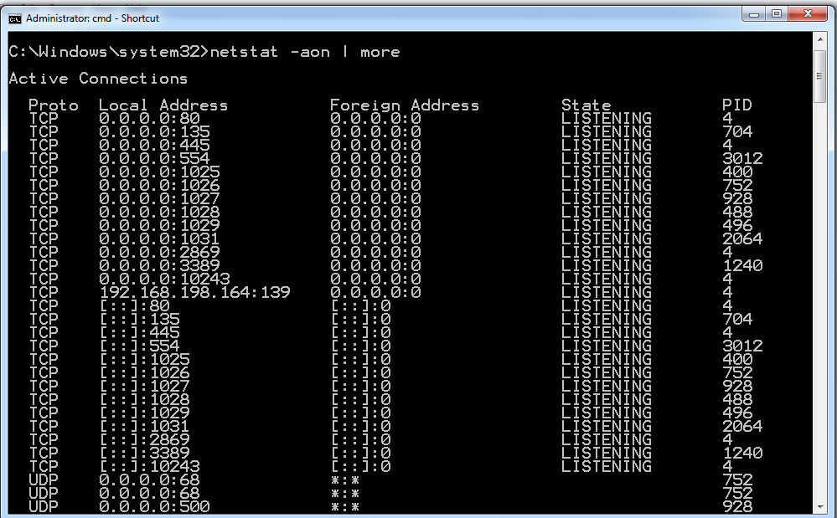

Netstat -aon

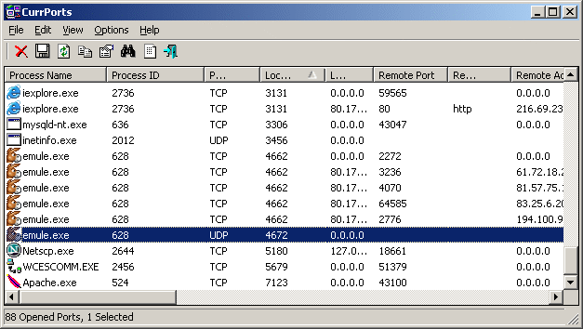

CurrPorts

Link Ch 6d

Process Explorer

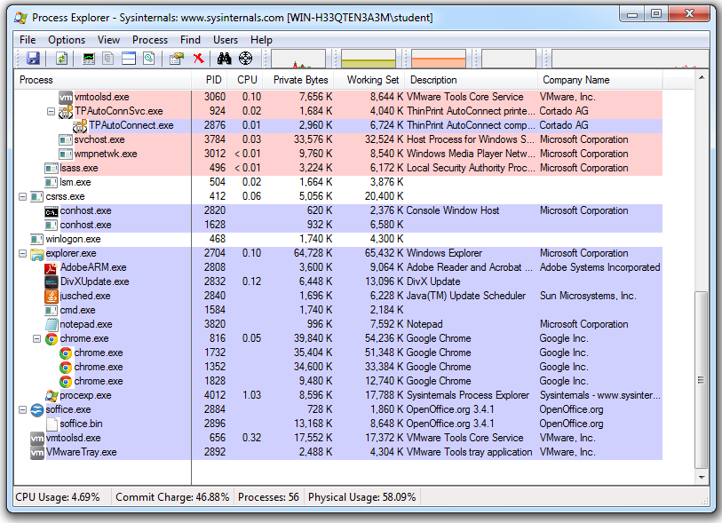
Link Ch 6e

Other SysInternals Tools

Process Monitor

View all kernel interactions that processes make as the system runs

Very useful to run during malware infection

VMMap

Analyzes virtual memory and physical memory used by a process

Can extract strings from the processes
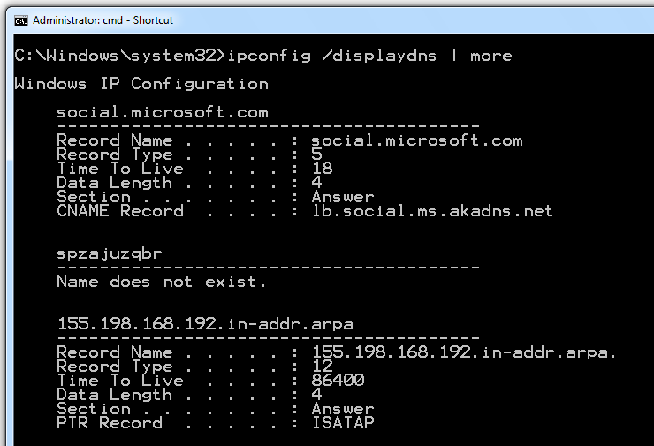

DNS Cache

Registry Query for Run and RunOnce Keys

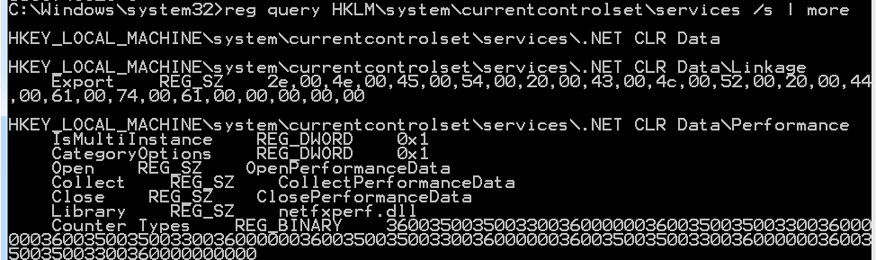

Other Tests

Scheduled Tasks

Event Viewer

Prefetch Directory

Records the last 128 "unique" programs executed on the system

Prefetch
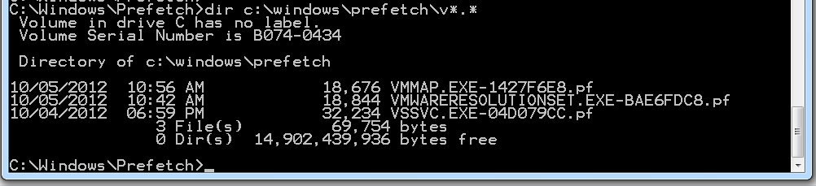

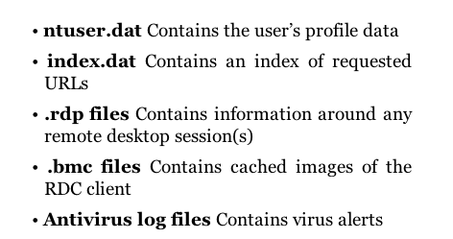

Collecting Interesting Files

BMC Viewer
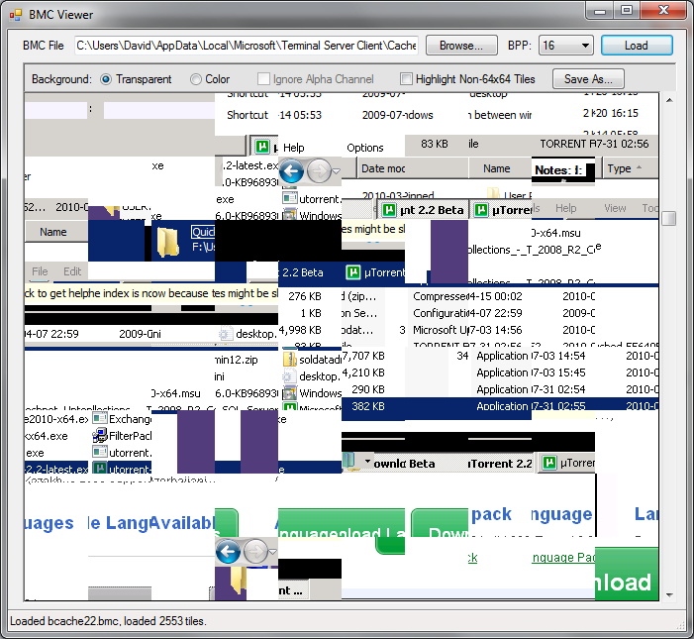

Antivirus Exclusions

The antivirus may have been reconfigured to allow the malware

Packing the file is a common technique to evade antivirus
Linux APT Attack

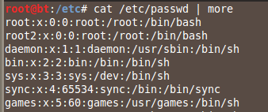
Target

Linux running Apache Tomcat with weak credentials, copied from an example page

Exploit it with Metasploit through Tomcat

cat /etc/passwd reveals usernames

Escalating to root

One way: find a user with an obvious password; like their last name

Become superuser with

sudo su -

Backdoor

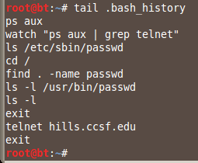
Attackers upload a PHP backdoor

Create a SUID root shell for getting root back in case a password is changed

Bash History

In each user's home directory

.bash_history

Remembers the previous 2000 lines by default in BackTrack 5 R2

HISTFILESIZE

Controlled by .bashrc in each user's home directory

HISTFILESIZE controls this

HISTSIZE is just a RAM buffer

Tomcat Log File

Shows PUT being used to upload suspicious files

Commands to Check Network Connections

To check network connections, use

netstat –anlp

lsof –i -P

Shows all open files, without converting port numbers to text

lsof –i :80

Shows all files connecting to port 80

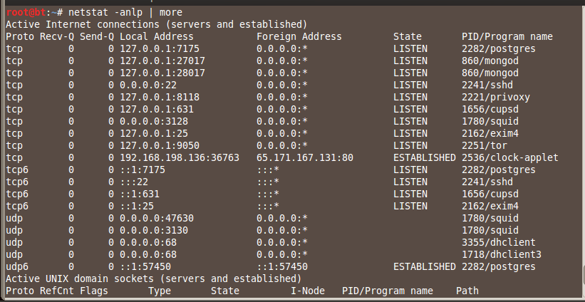
A rootkit could cause these programs to lie
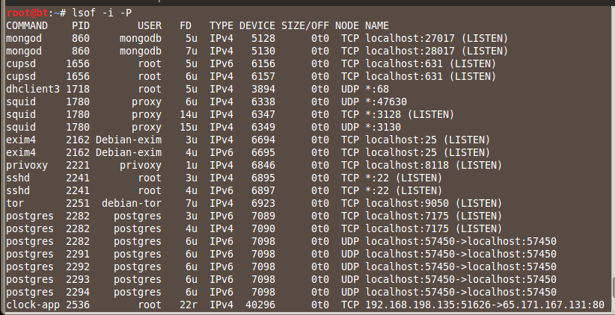

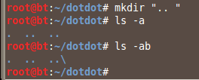
Where to Hide Files

RAM drives

Drive slack space

/dev

Directories named ".. " (dot-dot-space)

/tmp and /var/tmp

RAM Drives

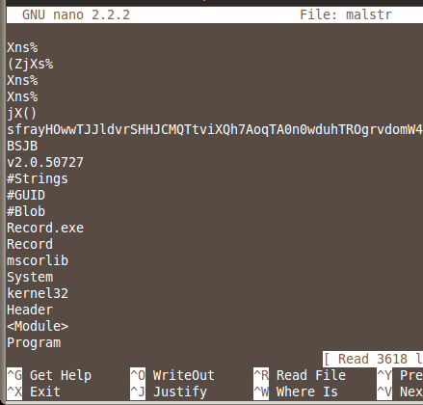
/dev/shm is already mounted by default

You can make your own with

mkdir -p /tmp/ram

sudo mount -t ramfs -o size=512M ramfs/tmp/ram/

To see Ram drives, use

df -a

Strings

To get readable strings from a file

strings malware.exe > malfile

To view results

nano malfile

Poison Ivy

Very Common

Poison Ivy is a RAT used very often in APT attacks

Used by the Microsoft IE exploit that led to the out-of-band patch in Sept, 2012

Also used in

Aurora

RSA attacks

Nitro

TDSS (TLD1-4)

TDSS

A botnet with 5 million compromised hosts

Sophisticated malware

Rootkit

Encrypted files and communications

Many C&C servers

Four variants: TDL 1, 2, 3, 4

Derivatives Zero Access and Purple Haze

Malware as a Service

TDSS bots are rented to criminals

DDoS attacks

Click fraud

To install Trojans

Common APT Indicators

Encrypted communications

Services registered to Windows NETSVCS keys

See link Ch 6k

Many more indicators in textbook, at location 6394

APT Method of Attack

Spear-phishing email

User clicks link; opens an application and redirects to a hidden address with a base64-encoded key

Hidden address is a Dropsite; finds browser vulns & drops a Trojan downloader

APT Method of Attack

Downloader sends a base64-encoded instruction to a different dropsite, which installs a Trojan backdoor

Trojan backdoor goes to c:\windows\system32 and registers in NETSVCS

Uses a filename slightly different from Windows filenames

Uses SSL communication with C&C server

APT Method of Attack

Attacker interacts with Trojan with SSL-encrypted traffic

Attacker lists Computername and User Accounts; uses pass-the-hash, gets local and Active Directory account information

Service privilege escalation to gain lateral movement in network

Offline password hash cracking

APT Method of Attack

Lateral movement by using RDP (Terminal Services), SC.exe (to create services), or NET commands (to connect to shares)

Installs additional backdoor Trojans

Stolen files are packaged in ZIP or RAR packages, renamed as GIFs

Detecting APTs

Audit changes to the file system

SMS alerts on administrative logfins

Firewalls that monitor inbound RDP/VNC/CMD.EXE

AV, HIPS, file system integity checking

NIDS, NIPS; Snort

Security Information/Events Management (SIEM)

APT Countermeasures

Will be covered in Chapter 12

Last modified 10-5-12

