Wardialing

Hardware

If using dial-up modems, use COM ports

Multiple lines make it easier to dial ranges of numbers more quickly

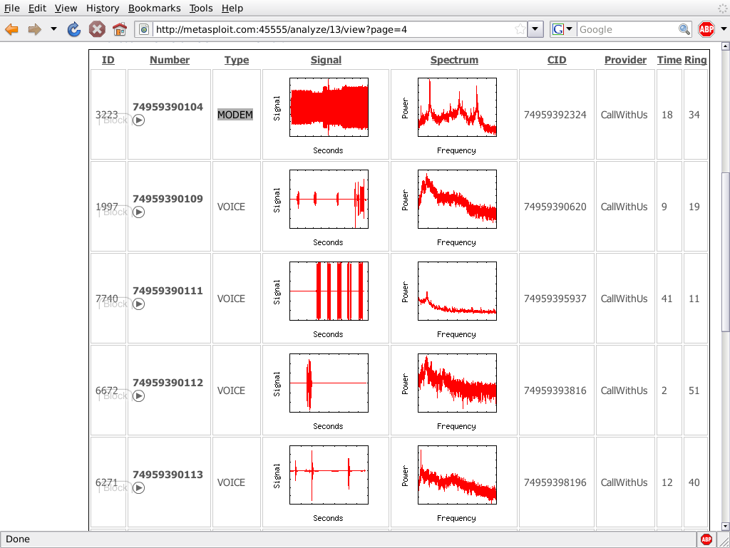
One call per minute per modem

A 10,000-number range takes a whole week of 24-hour dialing for a single modem

Legal Issues

There are a lot of laws restricting telephone hacking

Get written permission, specifying the phone number ranges

WarVOX records calls; may be illegal to use

Software

Old school

ToneLoc ,THC-Scan, TeleSweep, PhoneSweep

HD Moore's New Tool

WarVOX

Uses VoIP

Captures audio

Dials ranges of numbers

Records 53 seconds of audio from each one

Captured audio analyzed with Digital Signal Processing – Fast Fourier Transform to create a signature

Dial-Up Security Measures

Inventory dial-up lines

Consolidate all dial-up connectivity to a central modem bank in the DMZ, with an IDS, firewall, and logging

Make analog lines harder to find

Physically secure telecommunications closets

Monitor dial-up logs

Don't use a company banner; just a warning to unauthorized users

Require multifactor authentication

Require dial-back authentication

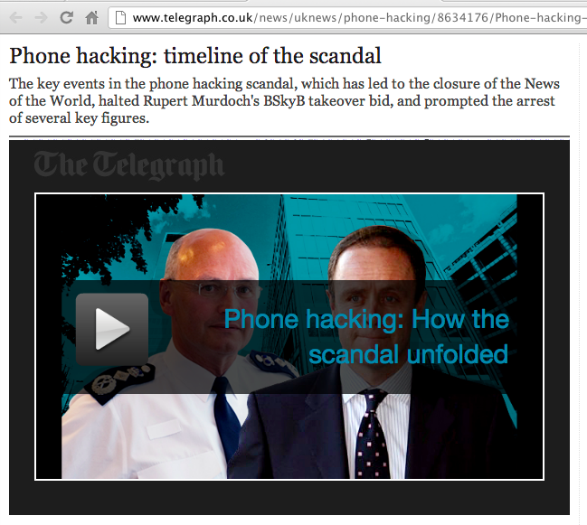
Train help desk to be cautious giving out or resetting access credentials

Centralize provisioning of dial-up connectivity

Establish firm policies for dial-up access

Return to step 1: wardial your network every six months

Voicemail Hacking

Brute-force attack tools are available

But usually users leave the password at an obvious default

Virtual Private Network (VPN) Hacking

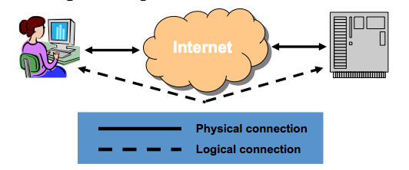
Virtual Private Network (VPN)

A VPN connects two computers securely over an insecure network (usually the Internet), using tunneling

Tunneling

An Ethernet frame is encapsulated in an IP packet, so it can be sent over the Internet

It can be done with other protocols too

Usually the frame is also encrypted, so that only the intended recipient can read it

The end result is like you used a long cable to connect the two computers

Cost Savings

You could use a T-1 line or a POTS phone call with a modem, to make a secure connection between two computers

But a VPN is much cheaper, requiring only an Internet connection at each end

Two Common VPN Standards

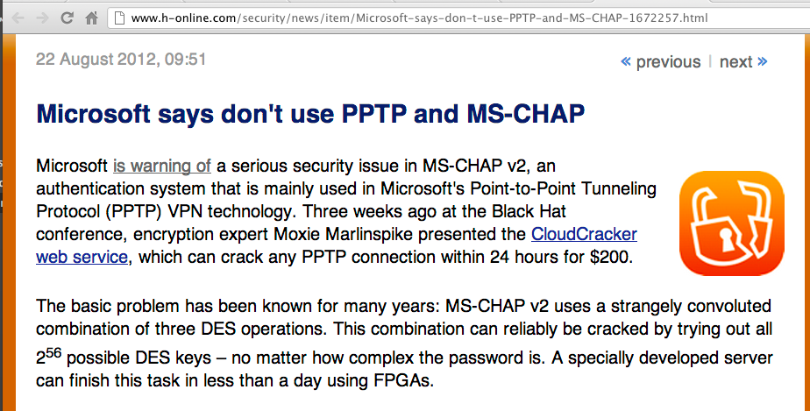
IPsec/L2TP (IP Security with Layer 2 Tunneling Protocol)

Most secure and modern method

PPTP (Point-to-Point Tunneling Protocol)

Microsoft proprietary

PPTP is Less Secure than IPsec/L2TP

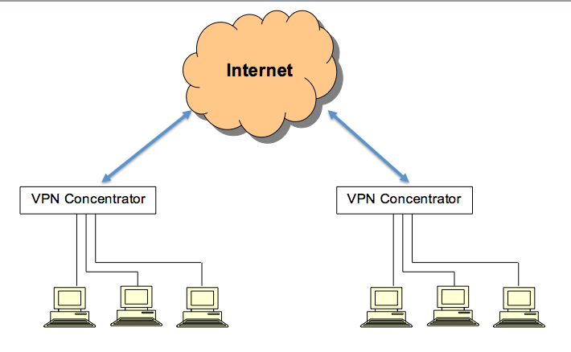
Links Ch 7e, 7f

Site-to-Site VPN

VPN Concentrators also called VPN Gateways

Cisco VPN Concentrators allow IPsec to be used without L2TP

No client interaction required

No login or credentials; to users, it's just another network link

Client-to-Site VPN

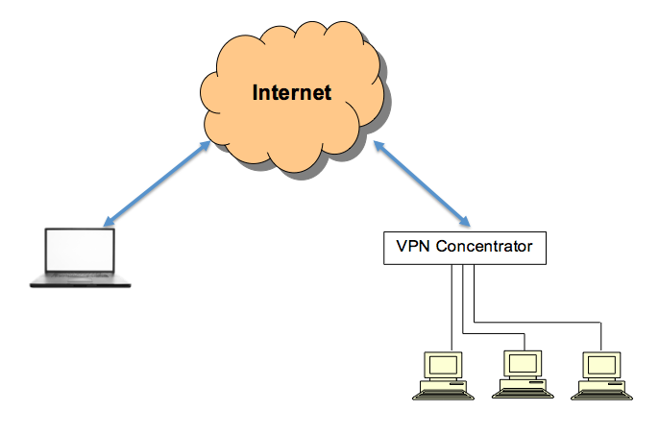
Remote user needs a software VPN client

Cisco VPN "thick client"

Web browser for SSL VPNs

Two modes

All traffic from client system goes through VPN

"Split Tunnel" – Internet traffic does not pass through VPN

Split Tunnels bridge corporate network to Internet and should be avoided

Authentication and Tunnel Establishment in IPsec

IKE (Internet Key Exchange) Phase 1

Mutual authentication (both client & server)

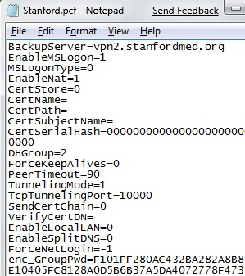
Main mode

Three separate 2-way handshakes

Aggressive mode

Only three messages

Faster but less secure

Authentication and Tunnel Establishment in IPsec

IKE (Internet Key Exchange) Phase 2

Establishing the IPsec tunnel

Google Hacking for VPN

Search for filetype:pcf

Stored profile settings for the Cisco VPN client

You get encrypted passwords in this file

I truncated the hash in this example

Cracking VPN Password with Cain

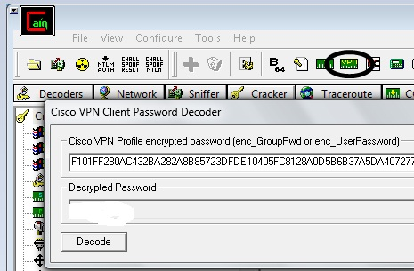
It cracked instantly for me

Password removed from figure

It’s obfuscated, not encrypted

Link Ch 625

Probing IPsec VPN Servers

UDP port 500

Tools

Nmap

Basic detection

ike-scan

Fingerprinting

IKEProber

Older tool

Allows attacker to create IKE initiator packets

Attacking IKE Aggressive Mode

IKEProbe can identify whether a VPN server is in Aggressive Mode

IKECrack can capture authentication messages and perform an offline brute force attack

Cain can also do this
Hacking Citrix VPNs

Citrix is Popular

100% of Fortune 100 companies

Citrix Access Gateway

Common Citrix Deployments

Remote Desktop

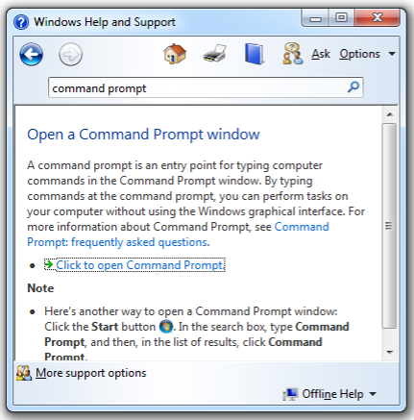
Whole computer desktop accessed remotely

Commercial Off-The-Shelf (COTS) application

Often Microsoft Office

Custom application

Often too insecure to expose to the Internet

Kiosk Mode

Limited access to desktop

Only one application window displayed

Microsoft calls this "kiosk-mode"

Intended to prevent launching arbitrary code

Help

Windows OS Help easily gives you a shell

Menu bar

F1 key

Logo+F1

Microsoft Office

Ways to spawn a shell

Help

Printing

Hyperlinks

Saving

Visual Basic for Applications (VBA)

Using VBA in MS Office to Spawn a Shell

Alt+F11 opens a VBA editor

Right-click in left pane, Insert, Module

Enter this script

Sub getCMD()

Shell "cmd.exe /c cmd.exe"

End Sub

Press F5 to run it

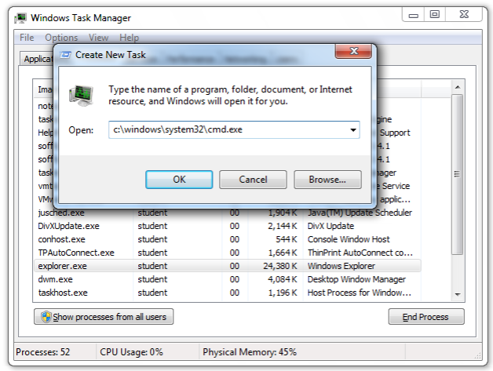
Internet Explorer Shells

Help

Print

Internet access

Text editors

Save

Local file exploration

Enter a local path in the URL like

C:\Windows\System32\cmd.exe

Microsoft Games and Calculator

Help

"About Calculator"

Task Manager

Windows shortcut: Ctrl+Shift+Esc

Citrix shortcut: Ctrl+F3 or Ctrl+F1

File, "New Task (Run…)"

Printing

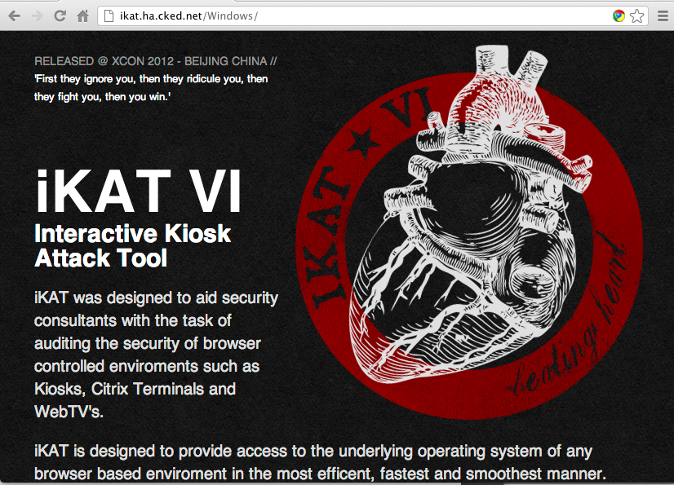
"Find Printer", then navigate to CMD

Hyperlinks

Just type into the application

file:///c:/windows/system32/cmd.exe

Enter, Shift+Click to launch CMD

Internet Access

Post cmd.exe on a Web site

Download & run it

Use SET to post a malicious Java applet & run it

EULAs/Text Editors

If EULA is spawned in Notpad, Wordpad, or a similar text editor

Help

Print

Click a link

Save

Save As

Navigate to the binary

Create a shortcut, Web shortcut, VBS file, or WSF file

Citrix Hacking Countermeasures

Place Citrix instances in a segmented VPN

Multifactor authentication

Voice Over IP (VoIP) Attacks

Voice over IP (VoIP)

Voice on an IP Network

Most VoIP solutions rely on multiple protocols, at least one for signaling and one for transport of the encoded voice traffic

The two most common signaling protocols are
H.323 and Session Initiation Protocol (SIP)

Their role is to manage call setup, modification, and closing

H.323

H.323 is a suite of protocols

Defined by the International Telecommunication Union (ITU

The deployed base is larger than SIP

Encoding is ASN.1 – different than text, a bit like C++ Data Structures (link Ch 618)

Designed to make integration with the public switched telephone network (PSTN) easier

Session Initiation Protocol (SIP)

The Internet Engineering Task Force (IETF) protocol

People are migrating from H.323 to SIP

Used to signal voice traffic, and also other data like instant messaging (IM)

Similar to the HTTP protocol

The encoding is text (UTF8)

SIP uses port 5060 (TCP/UDP) for communication

SIP Methods

INVITE Start a new conversation

ACK Acknowledges an INVITE

BYE Terminate session

CANCEL Cancel pending requests

OPTIONS Identify server capabilities

REGISTER SIP location registration

SIP Responses

SIP 1xx Informational response messages

SIP 2xx Successful response messages

SIP 3xx Redirection

SIP 4xx Client request failure

Real-time Transport Protocol (RTP)

Transports the encoded voice traffic

Control channel for RTP is provided by the Real-time Control Protocol (RTCP)

Consists mainly of quality of service (QoS) information (delay, packet loss, jitter, and so on)

Timing is more critical for VoIP than other IP traffic

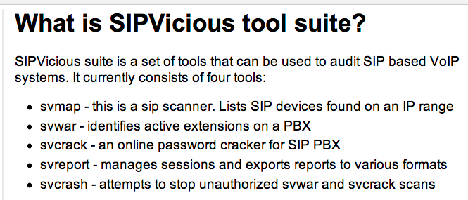
SIPVicious

Link Ch 7c

Pillaging TFTP

SIP phones load configuration settings from TFTP servers on boot-up

Files contain usernames, passwords, etc.

Security through obscurity: filenames are "secret"

Scan for UDP port 69 to find TFTP server

Brute force the filenames

Pillaging TFTP Countermeasures

Network-layer access restrictions

Only allow known VoIP phones to access the TFTP server

Disable access to the settings menu on IP phones

Disable Web server on IP phones

Use signed configuration files to prevent tampering

Enumerating VoIP Users

Wardialing works, of course

But there are other techniques for VoIP, specific to the SIP Gateway

Two open source SIP Gateways

Asterisk

SIP Express Router

Cisco VoIP Systems

Asterisk REGISTER Messages 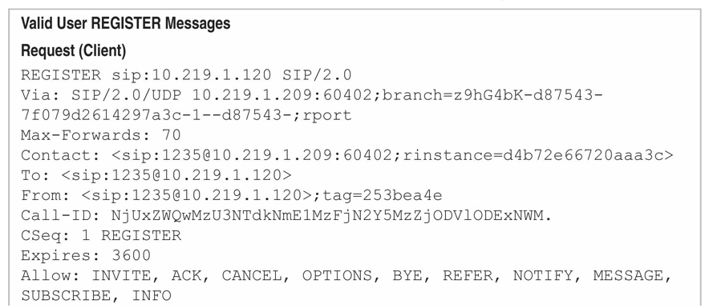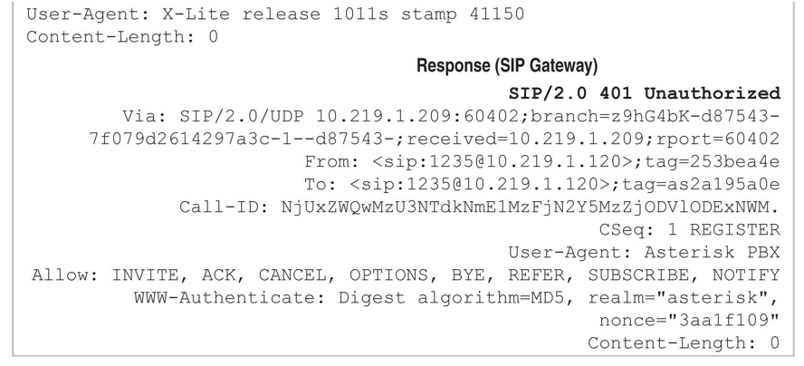

Asterisk REGISTER User Enumeration

User agent identifies the server

REGISTER request with a valid username but unauthorized returns 401 error

REGISTER request with invalid username returns 403 error

User enumeration is easy :)

SIP Express OPTIONS User Enumeration

Same trick works

OPTIONS with valid user returns 200

OPTIONS with invalid user returns 404: User Not Found

SIPVicious svwar

Enumerates users with OPTIONS, REGISTER, and INVITE techniques

Other tools

SiVuS

SIPScan

sipsak

Cisco IP Phone Boot Process

Phone sends Cisco Discovery Protocol (CDP) Voice VLAN Query request

A Cisco device in range responds with the Voice VLAN information

The phone configures that VLAN on its Ethernet port

Phone sends DHCP request to find TFTP server

DHCP server tells the phone the TFTP server's address

Phone downloads Certificate Trust List, Initial Trust List, and phone configuration from the TFTP server

Configuration file contains all settings needed to register the phone with the call server

Cisco User Enumeration

Cisco Directory Services can be dumped completely with Automated Corporate Enumerator

VoIP Enumeration Countermeasures

Segment networks

Place IDS/IPS systems in strategic areas

Software developers need to fix these vulns

Interception Attacks

Use ARP poisoning to get in the middle

Sniff UDP traffic

Identify RTP codec

G.711 is "toll quality" but uses a lot of bandwidth

G.729 uses less bandwidth but lowers call quality

G.722 is common in enterprises today; same bandwidth consumed as G.711 but better quality

Interception Attack

Sniff the IP Packets

With ARP poisoning

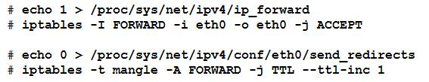
Attacker is set to route traffic, but not decrement the TTL

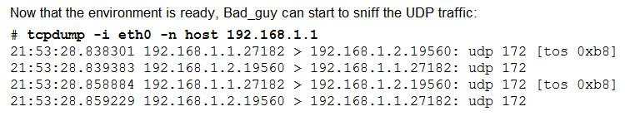

Captured RTP Traffic

It's compressed with a codec

Common codecs

G.711 (uses up a lot of bandwidth)

G.729 (uses less bandwidth)

VOMIT

vomit - voice over misconfigured internet telephones

Converts G.711 to WAV

It works because many IP phones don't or can't encrypt traffic

Link Ch 620

Scapy is an even better tool, plays traffic from eth0 right out the speakers

Link Ch 621

Playing the Captured Traffic

Wireshark

VOMIT

scapy

UCSniff handles many codecs

Offline Analysis

Wireshark can play streams

Dialed numbers appear in Wireshark packet parsing

Interception Countermeasures

Encryption: Secure RTP, TLS, and Multimedia Internet Keying (MIKEY)

Often disabled for performance

Layer 7 firewall can block rogue RTP traffic and DoS attacks

Signed configuration and firmware files

Denial of Service

SIP INVITE flood

Flood with any sort of traffic

Countermeasures

Network segmentation

Encrypted protocols

Skype Information Leak

Variable-bitrate encoding leaks information

Link Ch 7d
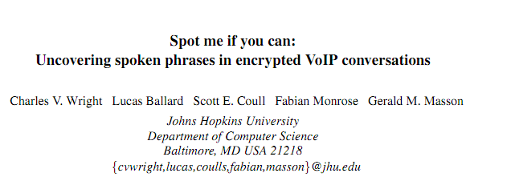

Last modified 10-12-12

