Session Establishment

Infrastructure v. Ad Hoc

Infrastructure

Uses an access point

Most common mode

Ad Hoc

Devices connect peer-to-peer

Like an Ethernet crossover cable

Probes

Client sends a probe request for the SSID (Service Set Identifier) it is looking for

It repeats this request on every channel, looking for a probe response

After the response, client sends authentication request

Authentication

If system uses open authentication, the AP accepts any connection

The alternate system, shared-key authentication, is almost never used

Used only with WEP

WPA security mechanisms have no effect on authentication—they take effect later

Association

Client sends an association request

AP sends an association response
Security Mechanisms

Basic Security Mechanisms

MAC filtering

"Hidden" networks

Omit SSID from beacons

Microsoft recommends announcing your SSID

Because Vista and later versions of Windows look for beacons before connecting

This makes Vista more secure, because it is not continuously sending out probe requests, inviting AP impersonation attacks

Responding to Broadcast Probe Requests

Clients can send broadcast probe requests

Do not specify SSID

APs can be configured to ignore them

WPA v. WPA2

802.11i specifies encryption standards

WPA implements only part of 802.11i

TKIP (Temporal Key Integrity Protocol)

WPA2 implements both

TKIP

AES (Advanced Encryption Standard)

PSK v. 802.1x

WPA-PSK (Wi-Fi Protected Access Pre-Shared Key)

Uses Pre-Shared Key

WPA-Enterprise

Uses 802.1x and a RADIUS server

EAP (Extensible Authentication Protocol), which may be one of

EAP-TTLS

PEAP

EAP-FAST

Four-Way Handshake

Both WPA-PSK and WPA Enterprise use

Four-way handshake

Pairwise transient key

Used for unicast communication

Group temporal key

Used for multicast and broadcast communication

Three Encryption Options

WEP (Wired Equivalent Privacy)

Uses RC4

Flawed & easily exploited

TKIP

A quick replacement for WEP

Runs on old hardware

Still uses RC4

No major vulnerabilities are known

AES-CCMP (Advanced Encryption Standard with Cipher Block Chaining Message Authentication Code Protocol)

Most secure, recommended
Equipment

Chipset

Manufacturer's chipset driver limits your control of the wireless NIC

Most NICs can't be used for wireless hacking

Recommended Network Cards

Ubuiquiti SRC, Atheros chipset, USB

Alfa AWUS050NH, Ralink RT2770F chipset, USB

Both support 802.11a/b/g/n and external antennas

Link Ch 8a

Windows x. Linux

Windows

Wireless NIC drivers are easy to get

Wireless hacking tools are few and weak

Unless you pay for AirPcap devices (link Ch 819) or OmniPeek

Linux

Wireless NIC drivers are hard to get and install

Wireless hacking tools are much better

BackTrack

Includes many drivers already ☺

Can be used from a virtual machine with a USB NIC

For other NIC types, you can't use VMware for wireless hacking

Install BackTrack on the bare metal


Boot from a USB with BackTrack on it

Boot from a LiveCD of BackTrack

OmniPeek

WildPackets now packages AiroPeek & EtherPeek together into OmniPeek

A Windows-based sniffer for wireless and wired LANs

Only supports a few wireless NICs

See links Ch 801, Ch 802

Antennas

Omnidirectional antenna sends and receives in all directions

Directional antennas focus the waves in one direction

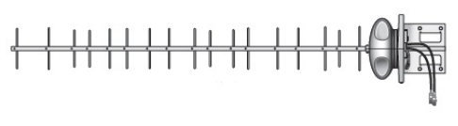
The Cantenna shown is a directional antenna

Yagi

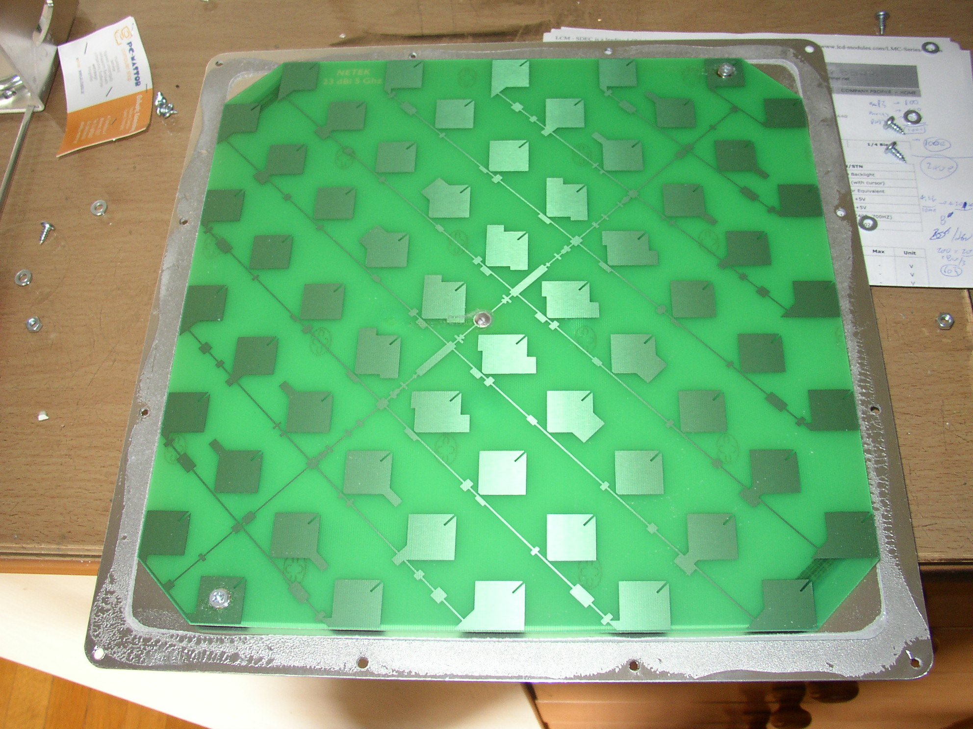

Panel (or Panel) Antenna

From digdice.com

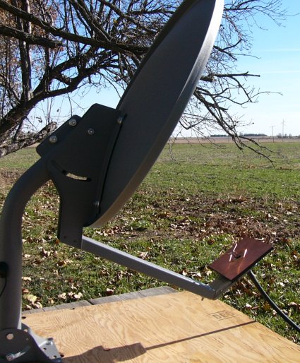

Dish Antenna

Link Ch 8b

Global Positioning System (GPS)

Locates you using signals from a set of satellites

Works with war-driving software to create a map of access points

Discovery and Monitoring

Discovery tools use 802.11 management frames

Probe requests/responses

Beacons

Source and destination addresses of an 802.11 frame is always unencrypted

Tools can map associations between clients and APs

Finding Wireless Networks

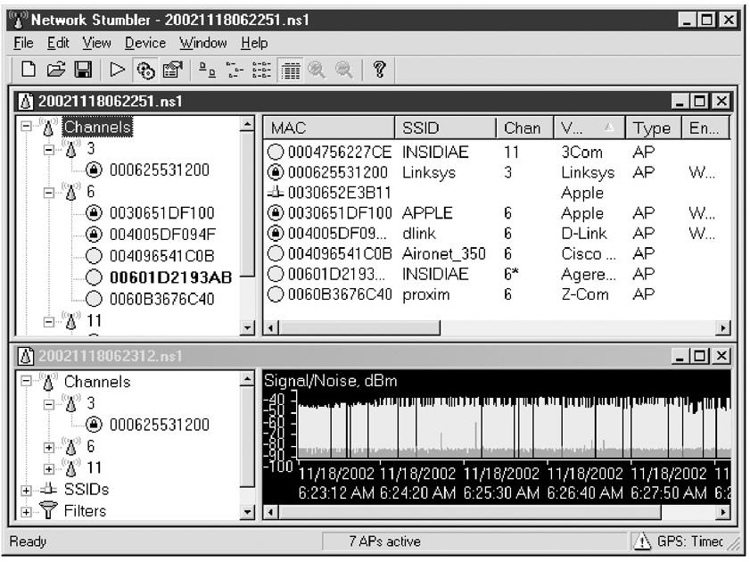
Active Discovery

Send out broadcast probe requests

Record responses

Misses APs that are configured to ignore them

NetStumbler does this

Passive Discovery

Listen on every channel

Record every AP seen

Much better technique

NetStumbler Screen
Wardriving


Wardriving

Finding Wireless networks with a portable device

Vistumbler

Link Ch 8j
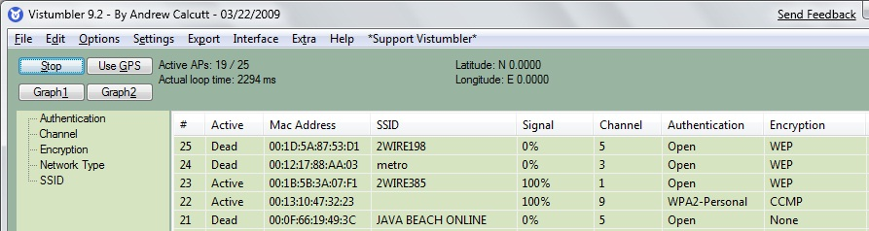

Google Sniffing Lawsuits

Link Ch 8k

iPhone

The iPhone combines GPS, Wi-Fi, and cell tower location technology to locate you

You can wardrive with the Android phone and Wifiscan

WiGLE

Collects wardriving data from users

Has over 16 million records

Link Ch 825

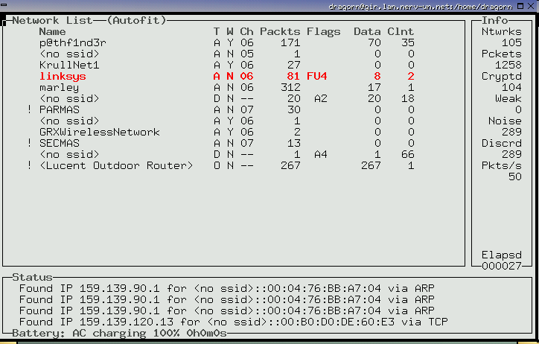
Kismet (Included in BackTrack)

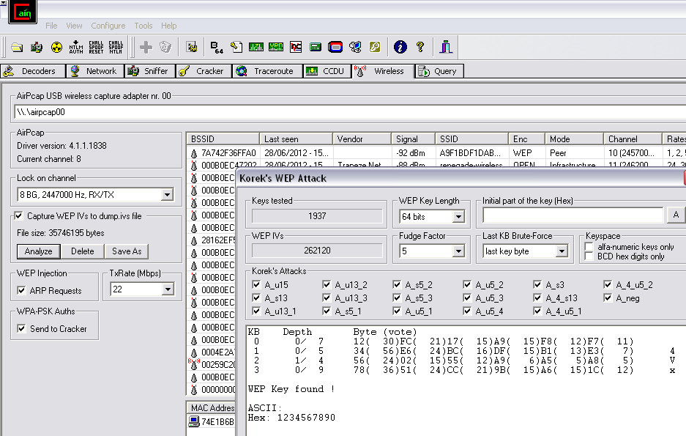
WEP Crack with Cain

You need an AirPCap Wi-Fi card

Sniffing Wireless Traffic

Easy if traffic is unencrypted

Man-in-the-middle (MITM) attacks common and easy

May violate wiretap laws

If you can't get you card into "Monitor mode" you'll see higher level traffic but not 802.11 management frames

De- authentication DoS Attack

Unauthenticated Management Frames

An attacker can spoof a de-authentication frame that looks like it came from the access point

aireplay-ng can do this

Rogue AP Suppression
Identifying Wireless Network Defenses

SSID

SSID can be found from any of these frames

Beacons

Sent continually by the access point (unless disabled)

Probe Requests

Sent by client systems wishing to connect

Probe Responses

Response to a Probe Request

Association and Reassociation Requests

Made by the client when joining or rejoining the network

If SSID broadcasting is off, just send a deauthentication frame to force a reassociation

MAC Access Control

CCSF uses this technique

Each MAC must be entered into the list of approved addresses

High administrative effort, low security

Attacker can just sniff MACs from clients and spoof them
Gaining Access (Hacking 802.11)

Specifying the SSID

In Windows, just select it from the available wireless networks

In Vista, right-click the network icon in the taskbar tray and click "Connect to a Network"

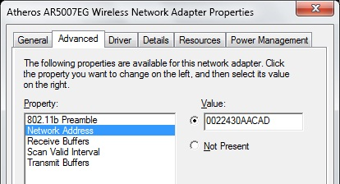
If the SSID is hidden, click "Set up a connection or network" and then click "Manually connect to a wireless network"

Changing your MAC

Bwmachak changes a NIC under Windows for Orinoco cards

SMAC is easy

link Ch 812

Device Manager

Many Wi-Fi cards allow you to change the MAC in Windows' Device Manager

HotSpotter

Hotspotter--Like SSLstrip, it silently replaces a secure WiFi connection with an insecure one

Less effective since Windows XP SP2, because Windows machines no longer probe for known networks as much

Link Ch 8e

Attacks Against the WEP Algorithm

Brute-force keyspace – takes weeks even for 40-bit keys

Collect Initialization Vectors, which are sent in the clear, and correlate them with the first encrypted byte

This makes the brute-force process much faster

Tools that Exploit WEP Weaknesses

AirSnort

WLAN-Tools

DWEPCrack

WEPAttack

Cracks using the weak IV flaw

Best countermeasure – use WPA

WPA

WPA is strong

No major weaknesses

However, if you use a weak Pre-Shared Key, it can be found with a dictionary attack

But

PSK is hashed 4096 times, can be up to 63 characters long, and includes the SSID

Tools: Airodump-ng, coWPAtty, rainbow tables

WPS (Wi-Fi Protected Setup)

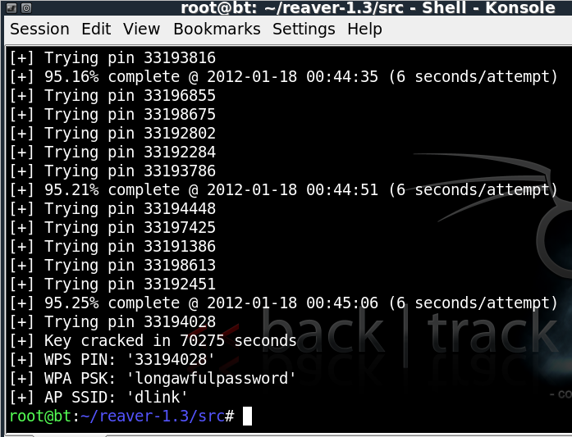
Intended to make WPA easier to use

Included in almost all modern Wi-Fi routers

Uses a key with only 10,500 possible values

Subject to a trivial brute-force attack

Cracking WPS

Link Ch 8d

Attacking WPA Enterprise

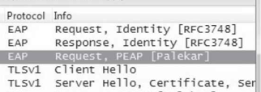
This means attacking EAP

Techniques depend on the specific EAP type used

LEAP

EAP-TTLS and PEAP

Detecting EAP type with Wireshark

Lightweight Extensible Authentication Protocol (LEAP)

What is LEAP?

A proprietary protocol from Cisco Systems developed in 2000 to address the security weaknesses common in WEP

LEAP is an 802.1X schema using a RADIUS server

As of 2004, 46% of IT executives in the enterprise said that they used LEAP in their organizations

The Weakness of LEAP

LEAP is fundamentally weak because it provides zero resistance to offline dictionary attacks

It solely relies on MS-CHAPv2 (Microsoft Challenge Handshake Authentication Protocol version 2) to protect the user credentials used for Wireless LAN authentication

MS-CHAPv2

MS-CHAPv2 is notoriously weak because

It does not use a SALT in its NT hashes

Uses a weak 2 byte DES key

Sends usernames in clear text

Because of this, offline dictionary and brute force attacks can be made much more efficient by a very large (4 gigabytes) database of likely passwords with pre-calculated hashes

Rainbow tables

Cisco's Defense

LEAP is secure if the passwords are long and complex

10 characters long with random upper case, lower case, numeric, and special characters

The vast majority of passwords in most organizations do not meet these stringent requirements

Can be cracked in a few days or even a few minutes

Asleap

Grabs and decrypts weak LEAP passwords from Cisco wireless access points and corresponding wireless cards

Integrated with Air-Jack to knock authenticated wireless users off targeted wireless networks

When the user reauthenticates, their password will be sniffed and cracked with Asleap

CloudCracker

Kills PPTP and, apparently, LEAP dead

Link Ch 8f

Microsoft: Don't Use PPTP and MS-CHAP

Microsoft recommends PEAP, L2TP/IPsec, IPSec with IKEv2, or SSTP instead

Link Ch 8g

EAP-TTLS and PEAP

TLS Tunnel

EAP-TTLS and PEAP both use a TLS tunnel to protect a less secure inner authenticated protocol

Inner authentication protocols

MS-CHAPv2

EAP-GTC (one-time passwords)

Cleartext

Attacking TLS

No known way to defeat the encryption

But AP impersonation can work

Trick target into connecting to MITM instead of server

Misconfigured clients won't validate the identity of the RADIUS server so it can be spoofed

FreeRADIUS-WPE does this (link Ch 8h)

Protecting EAP-TTLS and PEAP

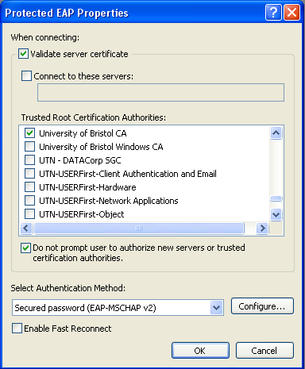
Check the "Validate the Server Certificate" on all wireless clients

Link Ch 8i

Last modified 10-19-12

