Web Server Hacking

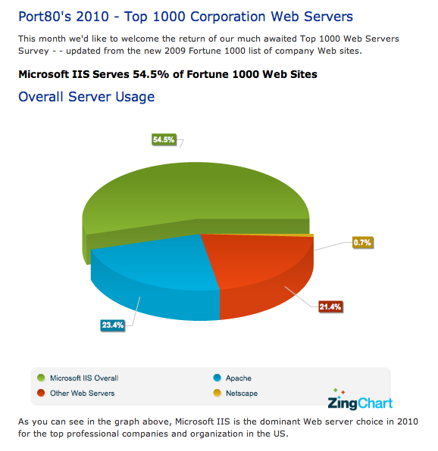
Popular Web Servers

Microsoft IIS/ASP/ASP.NET

LAMP (Linux/Apache/MySQL/PHP)

Oracle WebLogic

Link Ch 10j

IBM WebSphere

Link Ch 10k

IIS is Popular at Big Companies

Link Ch 10l

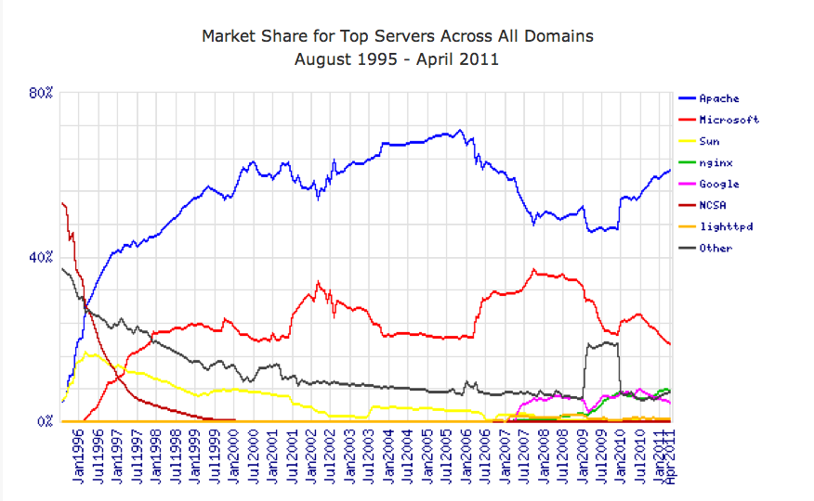

Link Ch 10m

Attacking Web Server Vulnerabilities

An attacker with the right set of tools and ready-made exploits can bring down a vulnerable web server in minutes

Some of the most devastating Internet worms have historically exploited these kinds of vulnerabilities

Code Red and Nimda attacked IIS vulnerabilities

Why the Risk is Decreasing

The risk of such attacks is decreasing, because:

Newer versions of Web servers are less vulnerable

System administrators are better at configuring the platforms

Vendor's "best practices" documents are better

Patches come out more rapidly

Why the Risk is Decreasing

Countermeasures are available, such as:

Sanctum/Watchfire's AppShield

A Web application firewall (link Ch_12n)

Microsoft's URLScan

Built in to IIS 6 and IIS 7

Link Ch_12o

Automated vulnerability-scanning products and tools are available

Web Server Vulnerabilities

Sample files

Source code disclosure

Canonicalization

Server extensions

Input validation (for example, buffer overflows)

Denial od Service

Sample files

Sample scripts and code snippets to illustrate creative use of a platform

In Microsoft's IIS 4.0

Sample code was installed by default

showcode. asp and codebrews.asp

These files enabled an attacker to view almost any file on the server like this:

http://192.168.51.101/msadc/Samples/SELECTOR/showcode.asp?source=/../.. /../../../boot.ini

http://192.168.51.101/iissamples/exair/howitworks/codebrws.asp?source= /../../../../../winnt/repair/setup.log

Sample Files Countermeasure

Remove sample files from production webservers

If you need the sample files, you can get patches to improve them

ColdFusion Expression Evaluator patch

Link Ch 10p

Source Code Disclosure

IIS 4 and 5 could reveal portions of source code through the HTR vulnerability (Link Ch 10q)

Apache Tomcat and Oracle WebLogic had similar issues

Attack URLs:

http://www.iisvictim.example/global.asa+.htr

http://www.weblogicserver.example/index.js%70

http://www.tomcatserver.example/examples/jsp/num/
numguess.js%70

Source Code Disclosure Countermeasures

Apply patches (these vulnerabilities were patched long ago)

Remove unneeded sample files

Never put sensitive data in source code of files

You can never be sure source code is hidden

Canonicalization Attacks

There are many ways to refer to the same file

C:\text.txt

..\text.txt

\\computer\C$\text.txt

The process of resolving a resource to a standard (canonical) name is called canonicalization

ASP::$DATA Vulnerability

Affected IIS 4 and earlier versions

Just adding ::$DATA to the end of an ASP page's URL revealed the source code

http://xyz.com/myasp.asp::$DATA

Link Ch 10r

Apache Canonicalization Vulnerability (from 2006)

When installed on Windows, capitalizing CGI-BIN revealed source code for scripts

http://target.com/CGI-BIN/script.pl

Countermeasure

Store scripts in a directory outside the document tree

Link Ch 10z10

Unicode/Double Decode Vulnerabilities (from 2000)

Strings like %c0%af could be used to sneak characters like \ past URL filters

Attack URL example:

http://10.1.1.3/scripts/..%c0%af..%c0%af..%c0%af../winnt/system32/cmd.exe?/c+dir

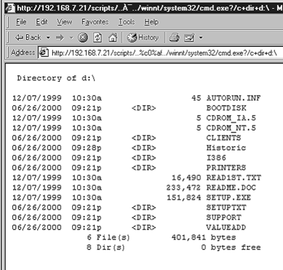
Exploited by the Nimda worm

Image from Link Ch 10z11 (http://webhacking.org.ua/042.htm)

Canonicalization Attack Countermeasures

Patch your Web platform

Compartmentalize your application directory structure

Limit access of Web Application user to minimal required

Clean URLs with URLScan and similar products

Remove Unicode or double-hex-encoded characters before they reach the server

Server Extensions

Code libraries tacked on to the core HTTP engine to provide extra features

Dynamic script execution (for example, Microsoft ASP)

Site indexing

Internet Printing Protocol

Web Distributed Authoring and Versioning (WebDAV)

Secure Sockets Layer (SSL)

Server Extensions

Each of these extensions has vulnerabilities, such as buffer overflows

Microsoft WebDAV "Translate: f" problem

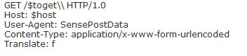
Add "translate: f" to header of the HTTP GET request, and a \ to the end of the URL

Reveals source code

Links Ch 10u, v

Server Extensions Exploitation Countermeasures

Patch or disable vulnerable extensions

The Translate: f problem was patched long ago

Buffer Overflows

Web servers, like all other computers, can be compromised by buffer overflows

The Web server is easy to find, and connected to the Internet, so it is a common target

Famous Buffer Overflows

IIS HTR Chunked Encoding Transfer Heap Overflow

Affects Microsoft IIS 4.0, 5.0, and 5.1

Leads to remote denial of service or remote code execution at the IWAM_ MACHINENAME privilege level

IIS's Indexing Service extension (idq.dll)

A buffer overflow used by the infamous Code Red worm

Internet Printing Protocol (IPP) vulnerability

Apache mod_rewrite vulnerability

Affects all versions up to and including Apache 2.2.0

Results in remote code execution at the web server context

Apache mod_ssl vulnerability

Also known as the Slapper worm

Affects all versions up to and including Apache 2.0.40

Results in remote code execution at the super-user level

Apache also suffered from a vulnerability in the way it handled HTTP requests encoded with chunked encoding

Resulted in a worm dubbed "Scalper"

Thought to be the first Apache worm

Buffer Overflow Countermeasures

Apply software patches

Scan your server with a vulnerability scanner

Denial of Service

Hacktivism is the new ego-driven attack

Low Orbit Ion Cannon

Simple attack tool

th3j3st3r's XerXes

Appears to perform layer 7 attacks, like SlowLoris and RUDY
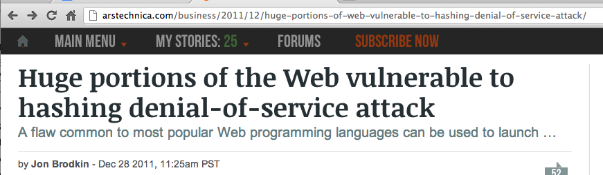

Link Ch 10z_12

Web Server Vulnerability Scanners

Nikto checks for common Web server vulnerabilities

It is not subtle—it leaves obvious traces in log files

Link Ch 10z01

Nessus/OpenVAS

Not directly focused on web servers
Web Application Hacking

Attacks on applications themselves, as opposed to the web server software upon which these applications run

The same techniques

Input-validation attacks

Source code disclosure attacks

etc.

Finding Vulnerable Web Apps with Google Dorks

You can find unprotected directories with searches like this:

"Index of /admin"

"Index of /password"

"Index of /mail"

You can find password hints, vulnerable Web servers with FrontPage, MRTG traffic analysis pages, .NET information, improperly configured Outlook Web Access (OWA) servers…

And many more

Link Ch 1a

Web Crawling

Examine a Web site carefully for Low Hanging Fruit

Local path information

Backend server names and IP addresses

SQL query strings with passwords

Informational comments

Look in static and dynamic pages, include and other support files, source code

Web-Crawling Tools

wget is a simple command-line tool to download a page, and can be used in scripts

Available for Linux and Windows

Link Ch 10z03

HTTrack Website Copier

Free cross-platform application

Link Ch 10z13

Web Application Assessment

Once the target application content has been crawled and thoroughly analyzed

Probe the features of the application

Authentication

Session management

Database interaction

Generic input validation

Application logic

Tools for Web Application Hacking

Browser plug-ins

Free tool suites

Commercial web application scanners

Tamper Data Project

Acts like a proxy server

You can see POST data and alter it

This will defeat client-side validation

JavaScript Debugger

Examine and step through JavaScript

Tool Suites

Proxies sit between client and Web application server, like a man-in-the-middle attack

Microsoft Fiddler can intercept and log requests and responses

Tools for Web Application Assessment

WebScarab

Allows user to intercept and alter HTTP

Includes spidering and fuzzing

Runs on any platform

Free, from OWASP

Burp Suite

Proxy, Repeater, Sequencer, Spider, Intruder

Powerful tool to craft automated attacks

Free version is limited

Expensive Commercial Tools

HP WebInspect and Security Toolkit

Rational AppScan

Cenzic Hailstorm

Cenzic Hailstorm

Highly rated commercial Web applicaion vulnerability scanner

Links Ch 11o, 11p

WebGoat Demo of HTTP Response Splitting
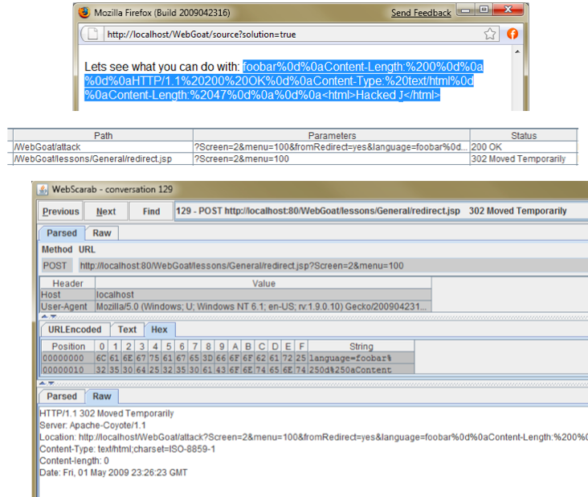

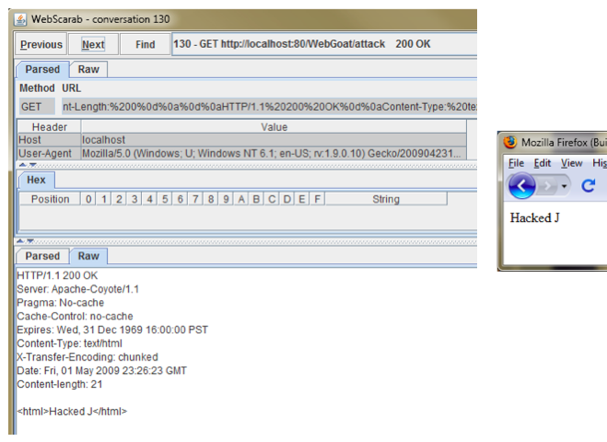

Common Web Application Vulnerabilities

Cross-Site Scripting (XSS)

SQL Injection

Cross-Site Request Forgery (CSRF)

HTTP Response Splitting

Cross-Site Scripting (XSS) Attacks

One user injects code that attacks another user

Common on guestbooks, comment pages, forums, etc.

Caused by failure to filter out HTML tags

These characters < > " &

Also watch out for hex-encoded versions

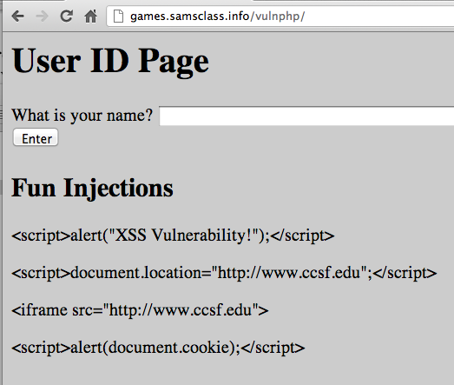
%3c instead of <

%3e instead of >

%22 instead of "

XSS Scripting Effects

Steal another user's authentication cookie

Hijack session

Harvest stored passwords from the target's browser

Take over machine through browser vulnerability

Redirect Webpage

Many, many other evil things…

Common XSS Payloads

See Link Ch 10z06

Cross-Site Scripting Countermeasures

Filter out < > ( ) # & and the variants of them

HTML-encode output, so a character like < becomes &lt; -- that will stop scripts from running

In IE 6 SP1 or later, an application can set HttpOnly Cookies, which prevents them from being accessed by scripts

Analyze your applications for XSS vulnerabilities

Fix the errors you find

SQL Injection Comic

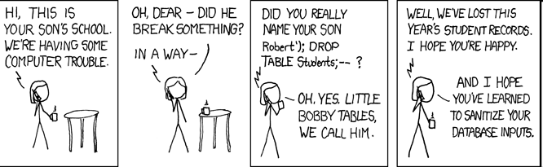
xkcd.org – a great comic Link Ch 10i

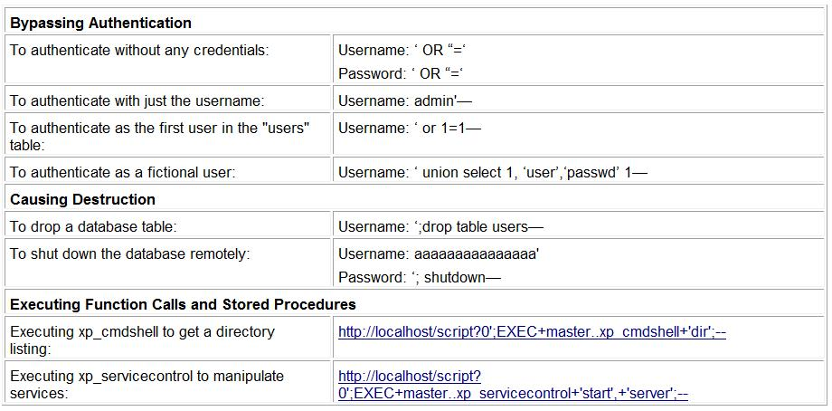
SQL Injection

Automated SQL Injection Tools

Havij

sqlmap

SQL Power Injector

Absinthe

Sqlninja

SQL Injection Countermeasures

Perform strict input validation

Replace direct SQL statements with stored procedures, prepared statements, or ADO command objects

That way they can't be modified

Implement default error handling

Use a general error message for all errors

SQL Injection Countermeasures

Lock down ODBC

Disable messaging to clients. Don't let regular SQL statements through. This ensures that no client, not just the web application, can execute arbitrary SQL.

Lock down the database server configuration

Specify users, roles, and permissions, so even if SQL statements are injected, they can't do any harm

SQL Injection Countermeasures

Use Programmatic Frameworks

Tools such as Hibernate or LINQ

Encourage the use of bind variables

Microsoft's Source Code Analyzer for SQL Injection tool

Link Ch 10z14

Cross-Site Request Forgery (CSRF)

Hijack a session by stealing cookies

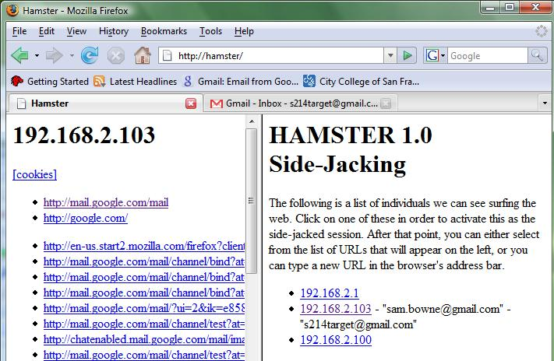
We did this with hamster and ferret

HTTP Response Splitting

Trick user into clicking on a malicious URL

If server response contains user input, the HTTP response can be prematurely terminated and a extra code can be inserted

Result similar to XSS

Countermeasures:

Validate input

Other Attacks

Misuse of hidden tags

Server Side Includes
Database hacking

Database discovery

Database vulnerabilities

Network attacks

Database engine bugs

Vulnerable built-in stored objects

Weak or default passwords

Last modified 10-29-12

