Web Server Hacking

Popular Web Servers

Microsoft

Chapter 11

Mobile Hacking
Hacking Android

Android's Position

Android had 40% of market share for smartphones in 2Q 2011

Not truly open-source; Google and other developers haven't released the source code for

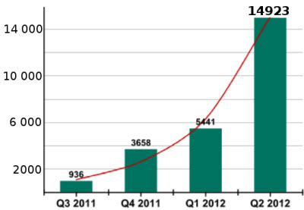
Honeycomb (Android 3.0)

Gtalk, Gmail, YouTube, Google Maps

Uses Linux kernel, developers can use C and C++

Fragmentation

Many Android users are using out-of-date OS versions

Only 1.8% of Android devices were using the latest version on Oct 1, 2012 (Link Ch 11a)

Android Malware

Explosive growth

You need antivirus on your Android

Such as LookOut

Link Ch 11n
Android Fundamentals

Architecture

Core is ARM cross-compiled Linux kernel

Libraries to draw 2D/3D graphics, use GPS, etc.

SQLite database engine stores application data on the device without encryption (Link Ch 11b)

Dalvik Virtual Machine

Java libraries

Application framework

Applications

Dalvik Virtual Machine

Each application runs in its own instance of Dalvik VM

Makes applications work on many devices

Very limited power, memory, storage

Apps are written in Java, transformed to dex (Dalvik Executable)

Dalvik is open source

Sandbox

Each application runs in a separate process with a unique User ID

Apps cannot interact with each other

Sandbox is implemented in kernel

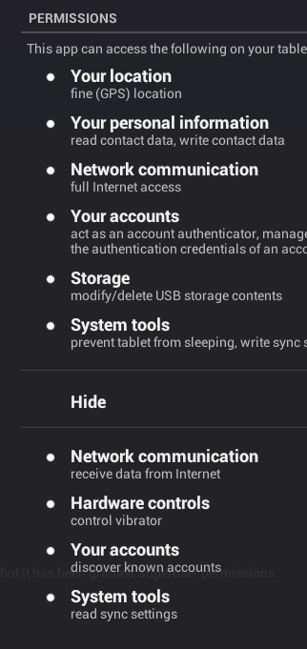
File System Security

Android 3.0 and later encrypts file system with AES 128 to protect data on a stolen phone

System partition is read-only, unless user is root

Files created by one app can't be modified by a different app

Memory Security

Address Space Layout Randomization (ASLR)

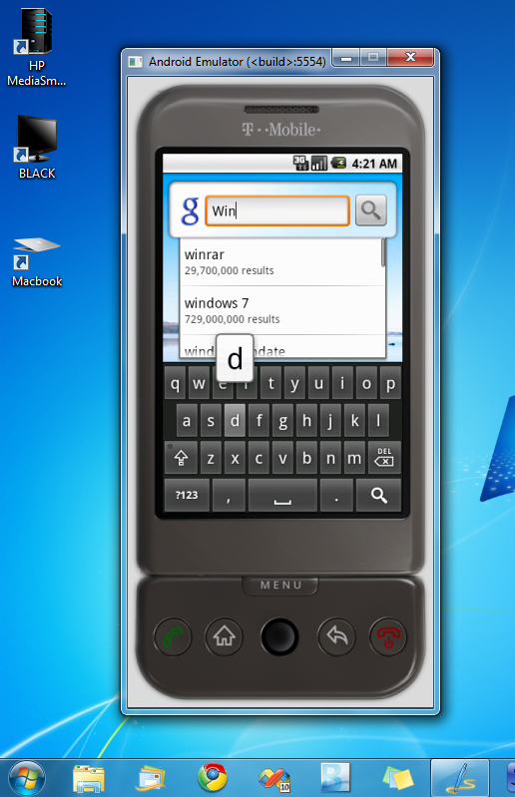
NX bit (No eXecute)

Protected APIs

User must agree to grant an app permissions

Certificates

All apps must be signed with a certificate

BUT it can be self-signed (no CA)

SDK (Software Development Kit)

Android Emulator

Image from redmondpie.com

Android Debug Bridge

Command-line tool to communicate with emulator or physical device

Dalvik Debug Monitor Server

Link Ch 11c
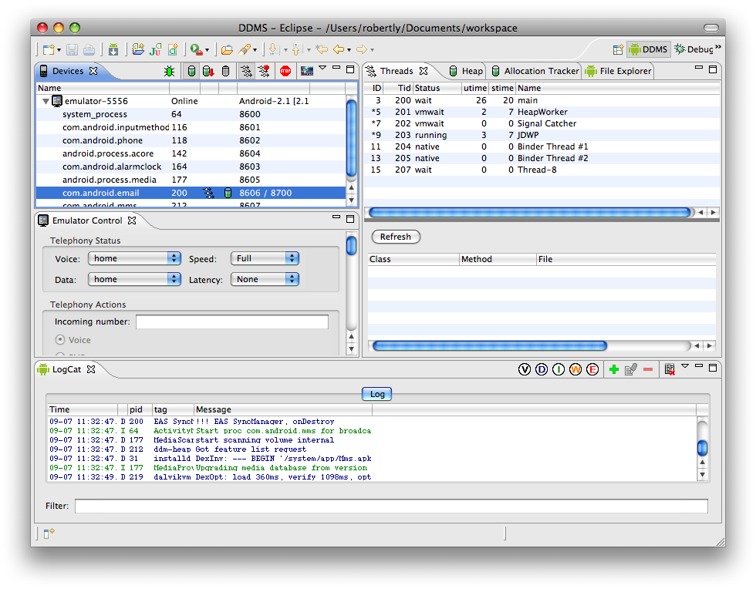

Hacking Your Android

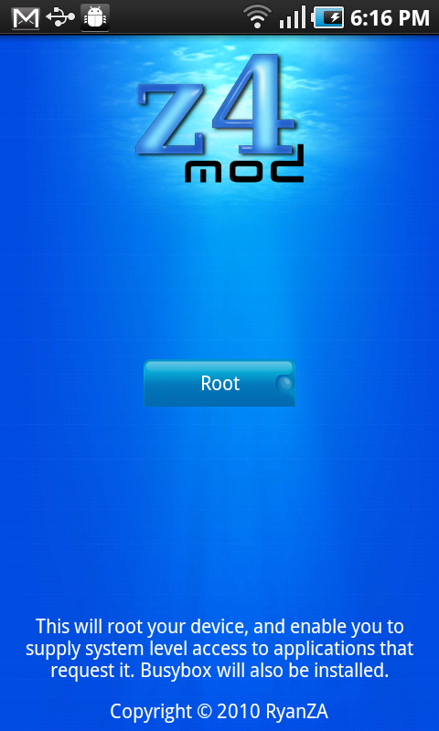
Rooting

Privilege escalation attack

Exploit a vulnerability to gain root privileges

(Called jailbreaking on iOS)

RISKS:

Bricking your phone, by corrupting the OS

You may need to buy a new phone

Compromises security of OS, enabling more malware

Android Rooting Tools

SuperOneClick

Native Windows application, runs on Linux and Mac with Mono

Run SuperOneClick on a computer

Connect phone with USB cable

Turn on "USB Debugging"

Most universal

Link Ch 11d

Z4Root

Android app

Link Ch 11e

GingerBreak

Doesn't work on all devices

Link Ch 11f

Rooting a Kindle Fire

Kindle Fire OS is a customized version of Android 2.3

Cannot access the Android Market

BurritoRoot Link Ch 11g

Cool Apps for Rooted Android

Superuser

Controls applications that use root privileges

Pops up asking for permission each time an app uses the su binary

ROM Manager

Manage custom ROMS, so you can have the latest Android version on your device

Cool Apps for Rooted Android

Market Enabler

Lets you use apps that are restricted to certain countries, regions, or carriers

ConnectBot

SSH client

Screenshot

ES File Manager

SetCPU

Overclock or underclock

Native Apps on Android

Cross-Compiling

Develop apps on a PC, but compile them for ARM

Android Native Development Kit

Lets you develop apps for the Dalvik Virtual Machine

Useful Security Tools for Rooted Android

BusyBox

Unix tools like tar, dd, wget

Tcpdump

Nmap ^& Ncat

Trojan Apps

Easy to modify APK files (Android Applications)

Open APK with 7-zip

Manifest

XML file defining components and permissions

Classes.dex

Dalvik executable with compiled code

App Entry Points

Android apps don't have a single point of entry

Broadcast receiver

Enables apps to receive "intents" from system

Like interrupts

Example: Run when an SMS is received

Services

Run in background, no GUI shown to user

apktool

Disassembles dex code into smali

Raw Dalvik VM bytecode

Can be used to embed malicious code into apps

Link Ch 11i
Hacking Other Androids

Remote Shell via WebKit

WebKit is an open-source Web browser engine

Handled floating point data types incorrectly (patched in Android 2.2)

Drive-by download from a malicious Web server

Gains a shell (but not root)

Countermeasures: updates & antivirus

Root Exploits

To gain root on the exploited device

exploid

RageAgainstTheCage

Countermeasures: Updates & Antivirus

Data Stealing Vulnerability

Steal data from the SD card and from the device itself

As long as root privileges not required

User must click a malicious link

Exploit is a PHP file with embedded JavaScript

User sees a notification, which may warn them

Attacker must know name & path to file

Data Stealing Vulnerability Countermeasures

Use latest version of Android

CyanogenMod custom ROM enables you to use a new version even if your carrier blocks the update

Install antivirus

Disable JavaScript

Use a third-party browser like Firefox or Opera

Remote Shell with Zero Permissions

Using carefully chosen functions, it's possible to open a remote shell with no permissions from the user at all

Works in all versions of Android, even 4.0, Ice Cream Sandwich

Link Ch 11j

Capability Leaks

Stock software exposes permissions to other applications

Enables untrusted apps to gain privileges the user didn't allow

Carrier IQ

Pre-installed on devices

Monitors activity and sends it back to the carrier

Not entirely malicious, intended to improve performance by measuring diagnostic data

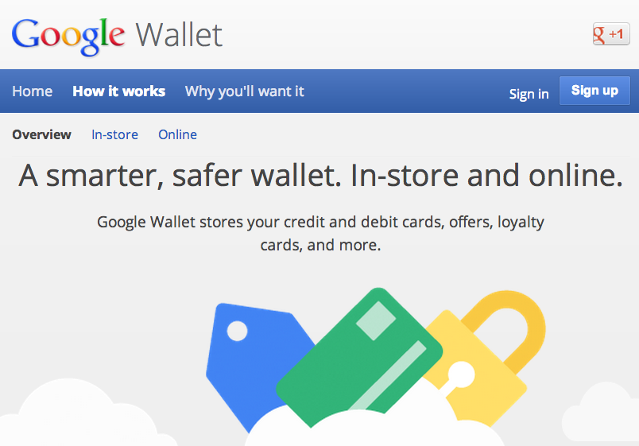
Huge privacy controversy

Google Wallet PIN

Currently works on six phones

Link Ch 11k

Stores encrypted data in a Secure Element (SE)

Requires user-defined 4-digit PIN

Five incorrect PIN entries locks the application

But PIN is not in the SE

Hashed PIN can be broken by brute-force

Countermeasure: Don't root your Wallet phone

Android as a Portable Hacking Platform

Android Hacking Tools

Network sniffer (Shark for Root)

Network Spoofer (ARP spoofing)

Connect Cat (like netcat)

Nmap for Android
Defending Your Android

Maintain physical security

Lock your device (PIN or password)

Avoid installing apps from unknown sources

Install antivirus software

Enable full internal storage encryption

Available in Android 3.0 and later

Update to latest Android version

May require custom ROM
iOS

iOS History

1980s

Steve Jobs, recently expelled from Apple, founded NeXT

NeXTSTEP was the OS

Derived from Carnegie Mellon Universities' CMU Mach kernel plus BSD Unix

Used Objective-C

1996

Apple purchased NeXT

NeXTSTEP was now called OPENSTEP

Modified to adopt Mac OS 9 styling

2001

Mac OS X released

2007

iPhone introduced, with iPhone OS

Later renamed to iOS, confusingly similar to Cisco's IOS

iOS is a pared-down OS X

Mach/BSD-based

Uses Objective-C

iOS Devices

iPhone, iPod Touch, Apple TC, iPad

All use 32-bit ARMv6 or ARMv7 processor

How Secure is iOS?

Originally iPhone allowed no third-party apps at all

Since 2008, the App Store appeared

Early iOS versions were very insecure

All apps ran as root

No sandbox

No code signing

No ASLR

No Position Independent Executable (PIE) support

Security Measures Added in Later Versions

Third-party apps run as "mobile", not root

Sandboxing limits apps to a limited set of system resources

Code signatures

ASLR for system components and libraries

PIE causes apps to load at different base address upon every execution

Jailbreaking

What is Jailbreaking?

Taking full control of an iOS device

Allows

Customization of the device

Extensions to apps

Remote access via SSH ror VNC

Arbitrary software

Compiling software on the device

Risks of Jailbreaking

Worries about trojans in jailbreak apps

Never yet observed for well-known jailbreak apps

Jailbroken phones lose some functionality

Vendors can detect jailbreaks and block function

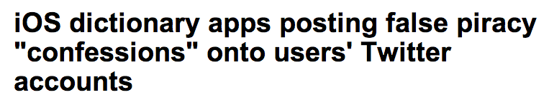
iBooks did this (Link Ch 11l)

Code signature verification is disabled by jailbreaking

Link Ch 11m
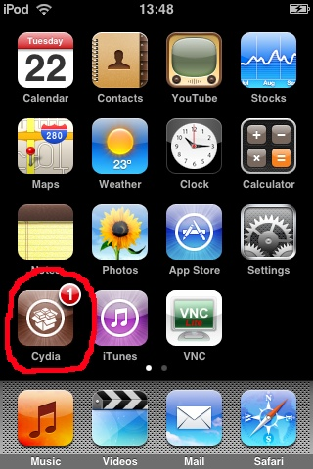

Boot-based Jailbreak Process

Obtain firmware image (IPSW) for iOS version and device model

From Apple servers

Obtain jailbreak software

redsnow, greenpoison, limera1n

Connect computer to ihone with USB cable

Launch jailbreak app

Select IPSW and wait for customizing

Switch iPhone into Device Firmware Update (DFU) mode

Power iPhone off

Hold Power+Home buttons for 10 sec.

Release Power but hold Home down for 5-10 more seconds

Jailbreak software completes the process

Cydia

The App Store for jailbroken devices

Image from bindapple.com

Remote Jailbreak

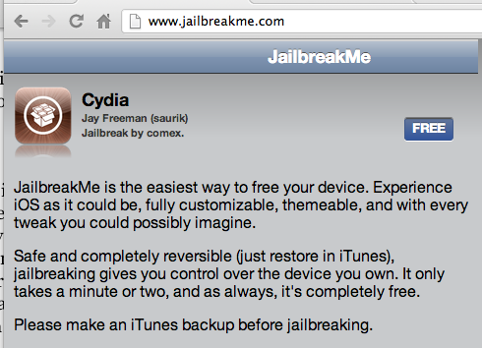
Jailbreakme.com

Just load a PDF file

It exploits and jailbreaks the OS

Much easier than boot-based jailbreak
Hacking Other iPhones

Attack Options

Local network-based attacks

Wireless MITM requires physical proximity

Attacker with physical access to device

Boot-based jailbreak

Client-side attacks

App vulnerabilities, mainly MobileSafari


Far more practical

But exploiting an app only grants access to data in the app's sandbox

Attack Options

Breaking out of the sandbox

Requires a kernel-level vulnerability

Exploits used in Jailbreakme can be re-purposed for attack tools

Jailbreakme3.0 Vulnerabilities

Uses a PDF bug and a kernel bug

Link Ch 11o

Countermeasure: Update iOS to latest version

If you jailbreak, you can't update iOS

In order to jailbreak, you must use a vulnerable iOS version

iKEE Attacks!

People jailbroke iPhones, installed OpenSSH, and left the default password 'alpine' unchanged

2009: First iPhone worm rickrolled victims

Later versions made an iPhone botnet

Link Ch 11p

iPhone Remote Attacks

If you don't jailbreak your iPhone, it's very safe

Only one port is open

TCP 62087

No known attacks

Tiny attack surface

No SSH, SMB, HTTP…

Almost impossible to gain unauthorized access from the network


Remote Vulnerabilities

ICMP request causes device reset

CVE-2009-1683

Link Ch 11q

SMS message arbitrary code execution exploit

By Charlie Miller

Image from techpatio.com

CVE-2009-2204

Link Ch 11r

iKee Worm Countermeasures

Don't jailbreak!

Change the password

Enable SSH only when needed

SBSettings makes this easy

Upgrade iOS to the latest jailbreakable version

Install patches made available by the community

FOCUS 11 Wireless MITM Attack

Malicious wireless access point simulated with a Mac and two network cards

Certificate chaiin validation vull exploited to MITM SSL connections

PDF used JailBreakMe3.0 attack to silently root the device

SSH and VNC installed

Countermeasures

Update

Configure your iPhone to "Ask to Join Networks"

Don't store sensitive data on your phone

Malicious Apps

Handy Light

2010

Supposedly a flashlight

Contained a hidden tethering feature

Apple removed it once they found out

InstaStock

Posed as stock ticker, but ran unsigned, unauthorized code

From Charlie Miller

Malicious Apps Countermeasures

Apple doesn't allow antivirus in the Apple store

All you can do is be careful about what apps you install

Vulnerable Apps

Citi Mobile app vuln

Stored banking data on the iPhone

Information disclosure risk if phone stolen

CVE-201-02913

PayPal App

X.509 certificate validation error

Allowed MITM attacks

CVE-2011-4211

Skype XSS

Embed JavaScript in FullName

Physical Access

Boot-based jailbreak

Install SSH server

Access to data, including passwords in keychain

Takes 6 min. to do

Countermeasure

Encrypt data

Countermeasures

Encrypt data using Apple features and third-party tools from McAfee, Good, etc.

Use a passcode of 6 digits or more

Install remote-tracking software to recover a stolen or lost device, or remotely wipe it

Last modified 11-16-12
Title fixed 4-28-14

