Get a Solaris Virtual Machine
- You can either copy a Solaris machine from the S214 machines or make your own. Project X1 is making your own—it takes more than an hour to do. A Solaris VM is available on the VMs drive in S214, in the "Adv Hacking" folder. Copy it to your own folder before using it.

Logging In
- At the "Welcome to unknown" screen, enter a user name of root and a password of P@ssw0rd

Adjusting Desktop Size
- The default resolution is 1280x1024, which is really the best to use. If possible, adjust your host Windows XP system to 1280x1024 and use Solaris in full-screen mode. If you can't do that, you can lower the Solaris resolution. To lower it, right-click the desktop and click "Change Desktop Resolution". Choose 1024x768 and click Apply. In the box that pops up, click "Keep Resolution".

Turning Off the Screen Saver
- Click Launch, Preferences, "Desktop Preferences", Display, Screensaver. On the "Display Modes" box, set the "Blank After" value to 60 minutes and clear both the "Lock Screen After" and "Timeout Unlock After" check boxes. On the Advanced tab, clear the "Power Management Enabled" check box. Close the XScreenSaver box.

Opening the Solaris Management Console
- Click Launch, Applications, Utilities, Terminal.
- A Terminal window opens, with the # prompt indicating that you are running as root.
- Type in this command, and then press the Enter key:
smc
- A "Solaris Management Console" window opens, with an "Open Toolbox" box on top of it.

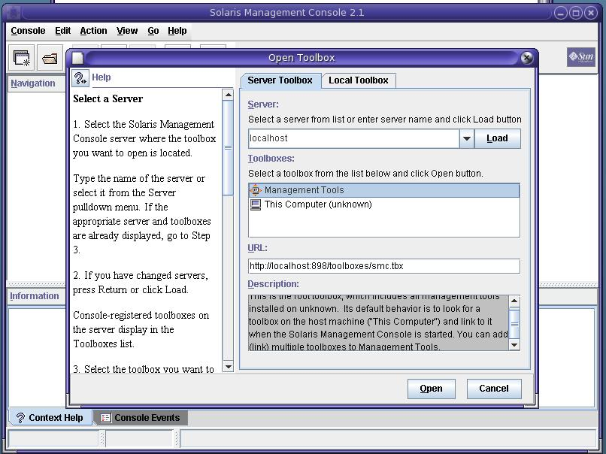
- In the "Open Toolbox" box, in the Toolboxes section, click "Management Tools", as shown below on this page. Click Open.

- In the left pane of the "Management Tools: Solaris Management Console 2.1" window, expand "This Computer (127.0.0.1)". Expand "System Configuration". Click the Users container.
- A "Log In: User Name" box pops up, with the User Name: already filled in with root. In the Password box, enter P@ssword and then click OK.
- In the right pane of the "Management Tools: Solaris Management Console 2.1" window, double-click "User Accounts".
- From the menu bar, click Action, "Add User", "With Wizard".
- In the "Add User Wizard" box titled "Step 1: Enter a user name.", enter a User Name: of Student. Click Next.
- In the "Add User Wizard" box titled "Step 2: Enter a user identification number.", accept the default selection of 100 and click Next.
- In the "Add User Wizard" box titled "Step 3: Enter the user's password.", click the "User Must Use This Password At First Logon" radio button. Enter a password of P@ssw0rd in both password boxes. Click Next.
- In the "Add User Wizard" box titled "Step 4: Select the user's primary group.", select sysadmin and click Next.
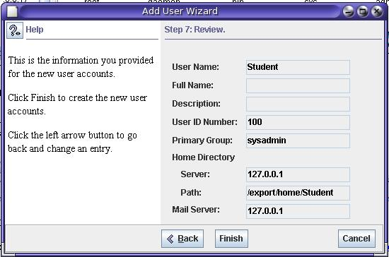
- In the "Add User Wizard" box titled "Step 5: Create the user's home directory.", accept the default path of /export/home and click Next.
- In the "Add User Wizard" box titled "Step 6: Specify the mail server.", accept the default and click Next.
- In the "Add User Wizard" box titled "Step 7: Review.", compare what you see with the image shown to the right on this page. If everything is OK, click Finish.
- You should see an icon for Student in the right pane of the "Management Tools: Solaris Management Console 2.1" window, as shown below on this page.

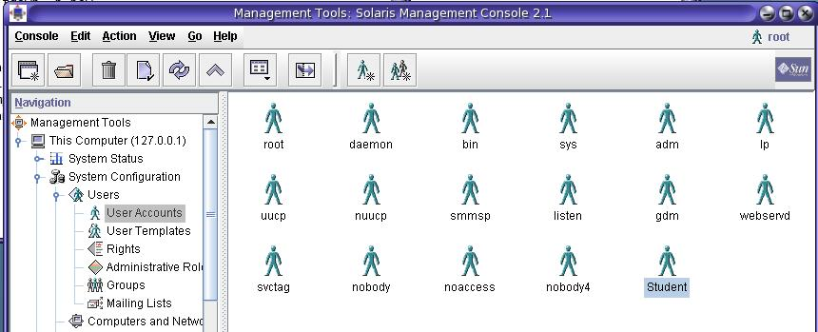
- Close the "Management Tools: Solaris Management Console 2.1" window.

Downloading pkg-get
- The pkg-get utility makes it a lot easier to install software on Solaris. It's comparable to the apt-get utility Ubuntu has.
- Click Launch, "Firefox Web Browser".
- Type this URL into the Address bar, and then press Enter:
blastwave.org/pkg_get.pkg
- Click "Save File" to save the pkg_get.pkg file on your desktop. Close all Firefox windows.

Installing pkg-get
- Click Launch, Applications, Utilities, Terminal.
- A Terminal window opens, with the # prompt indicating that you are running as root.
- Type in this command, and then press the Enter key:
pwd
This command prints the working directory. The result is / which shows that you are in the root of the file system.
- Type in this command, and then press the Enter key:
ls
Note that the first character is a lowercase L, not the numeral one. This command lists the files and directories in the working directory. Several directories are here, including Desktop.
- Type in this command, and then press the Enter key:
cd Desktop
This command changes the working directory to /Desktop.
- Type in this command, and then press the Enter key:
ls
This command lists the files and directories in the working directory. One of them is the file you just downloaded, pkg_get.pkg.
- Type in this command, and then press the Enter key:
pkgadd -d pkg-get.pkg
- This question appears: "Select package(s) you wish to process (or 'all' to process all packages). (default: all) [?.??.q]:". Press the Enter key.
- This question appears: "The selected base directory </opt/csw> must exist before installation is attempted. Do you want this directory created now [y,n,?,q]:" Press y and press the Enter key.
- This message appears: "Do you want to continue with the installation of <CSWpkgget>[y,n,?]:" Press y and press the Enter key.
- This message appears: "Installation of <CSWpkgget> was successful."

Running pkg-get
- Type in this command, and then press the Enter key:
/opt/csw/bin/pkg-get
This shows a brief help message from pkg-get, confirming that it is installed and working.

Adjusting the PATH Environment Variable
- Type in this command, and then press the Enter key:
pkg-get
The response is "pkg-get: not found". We know pkg-get is there, but it's not in the PATH, so Solaris can't find it.
- Type in this command, and then press the Enter key:
echo $PATH
The response is "/usr/sbin:/usr/bin:/usr/ioenwin/bin:/usr/ucb". Those are the directories Solaris will look in for files. We need to add these two additional directories to that list:
/opt/csw/bin
/opt/csw/sbin
- Type in this command, and then press the Enter key:
gedit /etc/profile
- The gedit (Gnome Edit) text editor opens, showing the profile file that adjusts system settings during logon. Scroll to the bottom of the file, and add this line, as shown below on this page:
PATH=/usr/sbin:/usr/bin:/usr/openwin/bin:/usr/ucb:/opt/csw/bin:/opt/csw/sbin

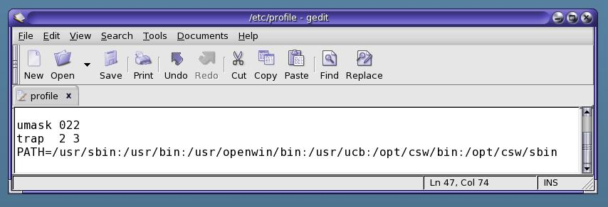

- In the gedit window, click the Save button.
- Close the gedit window.
- Close the Terminal window.
- Click Launch, "Log Out root". In the "Are you sure you want to log out?" box, click the "Restart the computer" radio button and click OK.
- When the Solaris machine restarts, log in as root with the password P@ssw0rd
- Click Launch, Applications, Utilities, Terminal.
- In the Terminal window, type in this command, and then press the Enter key:
echo $PATH
The path now includes /opt/csw/bin.

Editing the pkg-get.conf File to Access a Closer Mirror
- Just like Ubuntu, the software repositories tend to be slow and busy. Hopefully we can get better response by selecting a closer mirror. The list of mirrors is at blastwave.org/mirrors. Here's how to use the one I used, which seems OK. Type in this command, and then press the Enter key:
gedit /opt/csw/etc/pkg-get.conf
- In the gedit window, find the #default site, in USA line. Add a # to the start of the url= line below that line, and type in this line, as shown below on this page:
url=http://ftp.ussg.iu.edu/pub/blastwave/stable
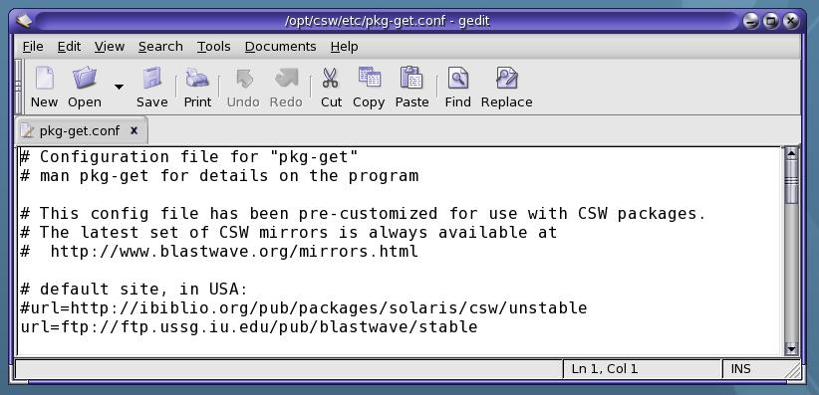

- In the gedit window, click the Save button.
- Close the gedit window.

Installing sudo
- sudo is our friend from Ubuntu, allowing a user to elevate privileges temporarily. It's not included in Solaris by default, but it is in the blastwave archives. Type in this command, and then press the Enter key:
pkg-get -i sudo
- A message appears, saying "The following files are already installed on the system and are being used by another package … <attribute change only>…Do you want to install these conflicting files [y,n,?,q]", press y and then press Enter.
- A message appears, saying "This package contains scripts which will be executed with super-user permission during the process of installing this package. Do you want continue with the installation of <CSWsudo-common> [y,n,?]", press y and then press Enter.
- A message appears, saying "The following files are being installed with setuid and/or setguid permissions:… Do you want install these as setuid/setgid files [y,n,?,q]", press y and then press Enter.
- A message appears, saying "This package contains scripts which will be executed with super-user permission during the process of installing this package. Do you want continue with the installation of <CSWsudo> [y,n,?]", press y and then press Enter.
- You should see the message "Installation of <CSWsudo> was successful!".

Adding Student to the sudoers File
- Type in this command, and then press the Enter key:
cd /opt/csw/etc
This command changes the working directory to the location of the sudoers file, which lists the accounts who are permitted to use sudo.
- Type in this command, and then press the Enter key:
ls
This command shows the files and directories in the current working directory. One of them is sudoers.
- Type in this command, and then press the Enter key:
cp sudoers sudoers.bak
This is just a backup copy of the file in case we damage it.
- Type in this command, and then press the Enter key:
gedit sudoers
- The Gnome Editor opens, showing the sudoers file. Add this line to the end of the file, as shown below on this page:
Student ALL=(ALL) SETENV: ALL

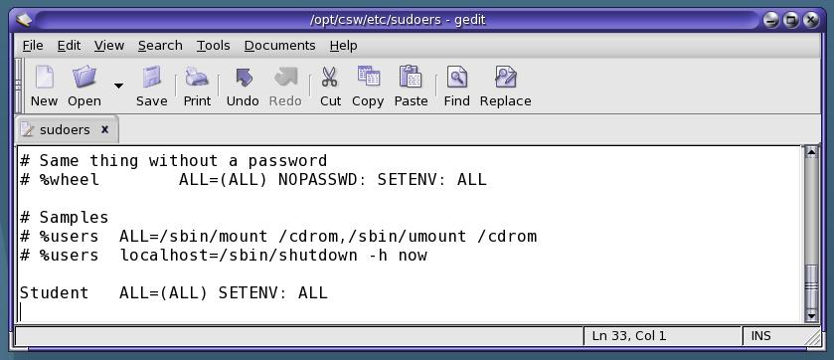
- In the gedit window, click Save. Close gedit.

Log in as Student
- Click Launch, "Log out root", "Log out". Click OK.
- Log in with a user name of Student and a password of P@ssw0rd
- A box asks you which desktop you want. Accept the default selection of "Java Desktop System, Release 3" and click OK.
- Click Launch, Applications, Utilities, Terminal.
- A Terminal window opens, with the $ prompt indicating that you are running as a normal user, not root.

Adjusting the PATH Environment Variable
- Type in this command, and then press the Enter key:
pkg-get
The response is "pkg-get: not found". Although we adjusted the PATH for the root user, we did not adjust it for Student.
- Type in this command, and then press the Enter key:
gedit .profile
- The gedit (Gnome Edit) text editor opens, showing the profile file that adjusts system settings during logon. Scroll to the bottom of the file, and add this line, as shown below on this page:
PATH=/usr/sbin:/usr/bin:/usr/openwin/bin:/usr/ucb:/opt/csw/bin:/opt/csw/sbin/etc:.
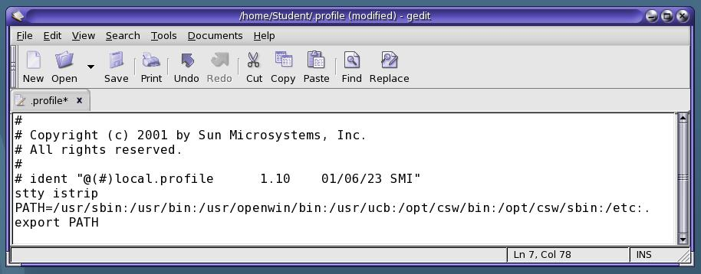

- In the gedit window, click the Save button. Close the gedit window. Close the Terminal window.
- Click Launch, "Log Out Student". In the "Are you sure you want to log out?" box, click OK.
- Log in with a user name of Student and a password of P@ssw0rd
- Click Launch, Applications, Utilities, Terminal.

- In the Terminal window, type in this command, and then press the Enter key:
pkg-get
Now you get a help message, showing that Solaris can find pkg-get.

Installing fping
- Type in this command, and then press the Enter key:
pkg-get –i fping
It should fail, with a "Permission denied" error, because you are not root.
- Type in this command, and then press the Enter key:
sudo pkg-get –i fping
Enter your password when prompted to. You should see the message "Installation was successful!".

Finding your IP Address
- Type in this command, and then press the Enter key:
ifconfig pcn0
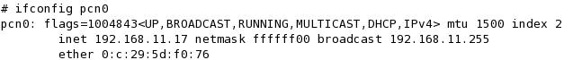
pcn0 is the name Solaris assigns to the Ethetnet network adapter. The reply should contain your IP address, labeled "inet" as shown below on this page.

Scanning your Local Subnet
- Type in this command, and then press the Enter key:
sudo fping –a –g 192.168.11.0/24
Replace 192.168.11 with the first three numbers in your own IP address. This will scan your local subnet, as shown below on this page. The –a option shows only hosts that are alive.
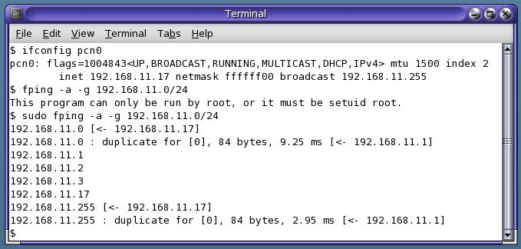

Saving the Screen Image
- Make sure the Terminal window is open, showing the fping scan, with at least one host alive, as shown on the previous page .
- Press Ctrl+Alt to release the mouse, and click on the host Windows XP desktop. Press the PrntScn key to copy whole screen to the clipboard.
- On the host Windows XP desktop, open Paint and paste in the image. Save it as a JPEG, with the filename Your Name Proj 4.
Turning in your Project
- Email the JPEG image to me as an attachment. Send the message to cnit.123@gmail.com with a subject line of Proj 4 From Your Name. Send a Cc to yourself.

Installing wireshark (Warning! This is Really Slow!)
- I recommend that you start this process, and just leave your machine on to run when you leave the lab. It's dull, and it takes an hour or two. Type in this command, and then press the Enter key:
pkg-get –f –i wireshark
This is a slow process, because it has to download and install several packages Wireshark depends on. The –f switch tells it not to ask any questions. That way you can leave it running while you do something else, and just check later to see if it's done. When it finishes, you should see the message "Installation was successful!".

Last modified 1-28-08

