What You Need for This Project
- A computer running a vulnerable version of Linux. All tested Ubuntu Linux versions seem to be vulnerable as of 2-11-08, and many other Linux versions as well. For a list of vulnerable versions, check this link, which is link "Linux Exploit A" on my CNIT 124 page (samsclass.info):
https://bugs.launchpad.net/ubuntu/+source/linux-source-2.6.22/+bug/190587
- An account that is not a local Administrator on your Linux box. Ubuntu users normally work that way.

Verifying that you are not Already Root
- Click Start, Accessories, Terminal. Look at the prompt. If you see $, you are not root. If you see #, you are already root, and this exploit won't have any effect—go make a normal user account and log in with that one.

Finding your Kernel Version
- In the Terminal window, type this command and then press the Enter key:
uname -a
- The output should tell you which Linux kernel version you have. In the example below, the version number is 2.6.17.

Choosing the Correct Exploit
- There are two exploits, for different Linux kernel versions:
Linux 2.6.23 - 2.6.24 - milw0rm.com/exploits/5093
Linux 2.6.17 - 2.6.24.1 - milw0rm.com/exploits/5092
- I used the second one, since I have the 2.6.17 kernel.

Getting the Exploit Source Code
- When I tried it today, the milw0rm pages were already down, but I was still able to get them from the Google cache. I did a Google search for milw0rm.com/exploits/5092 anc clicked the cached link. So you could do that also. But if that doesn't work, you can get them from the CNIT 124 Forum, as explained below:
- From your Linux desktop, open Firefox. Go to https://mail.google.com. Sign in to your Gmail account.
- In the upper left of the Gmail page, click Groups.
- On the "Google Groups" page, in the "My groups" section, click "CNIT 124: Advanced Ethical Hacking".
- On the "CNIT 124: Advanced Ethical Hacking" page, in the Files section, click the appropriate exploit. In my case, it's "LinuxExploit5092.txt".
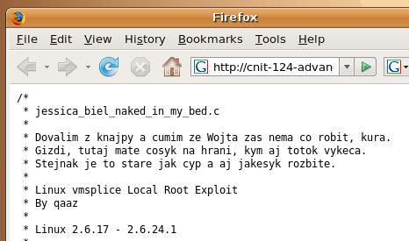
- The Firefox window should show a page full of C code, as shown to the right on this page.
- From the Firefox menu bar, click File, Save As….
- Save the file on your desktop with the filename exploit.c

Compiling the Exploit
- In the Terminal window, type this command and then press the Enter key:
cd
This command changes your working directory to your home directory.
- In the Terminal window, type this command and then press the Enter key:
cd Desktop
This command changes your working directory to your Desktop.
- In the Terminal window, type this command and then press the Enter key:
gcc –o exploit exploit.c
This command compiles the exploit source code, creating an executable file named exploit. If you don't have a compiler installed in your Ubuntu machine, you can install one with this command sudo apt-get install build-essential

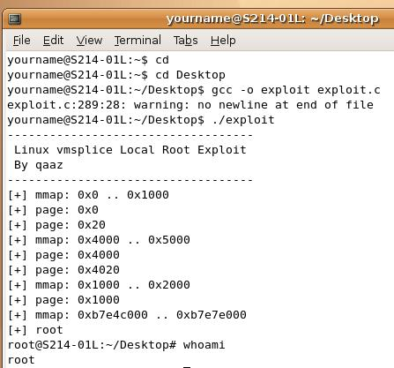
Running the Exploit
- In the Terminal window, type this command and then press the Enter key:
./exploit
This command changes your working directory to your home directory.
- The output should show you the # prompt, as shown below. You just elevated yourself to root!

Capturing a Screen Image
- Make sure you can see a line with the $ prompt before the exploit, and a line with the # prompt after it, as shown in the image on the previous page.
- If you are working in a virtual machine, press Ctrl+Alt to exit from it.
- Press the PrintScrn key in the upper-right portion of the keyboard.
- Click Start, Programs, Accessories, Paint. In the untitled - Paint window, select Edit, Paste from the menu bar.
- In the untitled - Paint window, click File, Save. Select a Save as type of JPEG. Save the document with the filename Your Name Proj 9.

Turning in Your Project
- Email the JPEG image to me as attachments to one e-mail message. Send it to: cnit.124@gmail.com with a subject line of Proj 7 From Your Name, replacing Your Name with your own first and last name. Send a Cc to yourself.

Last Modified: 2-11-08

