What You Need for This Project
- A computer running Windows Vista or XP to be the Host Machine. In S214, use Vista, and log in as Student with no password, or a password of P@ssw0rd
If someone has been so foolish as to attempt to prevent you from using a Vista partition in S214, laugh at them and hack in with the UBCD or any other method you like. If they have used BitLocker, boot to another Vista partition—I don't know any way to defeat BitLocker encryption.
- VMware Player to run the Solaris virtual machine. If VMware Player is not installed on the Vista partition you want to use in S214, install it from the VMs drive in the Install folder. If it's not there, download it from vmware.com

Setting up Apache Web Server on Solaris 10
- Start your Solaris virtual machine.
- Log in with a user name of Student and a password of P@ssw0rd
- Click Launch, Applications, Utilities, Terminal.
- Solaris 10 comes with Apache already installed and running as a service. We just need to adjust the configuration.
- In the Terminal window, type in this command, and then press the Enter key:
sudo svcadm disable svc:/network/http:apache2
Enter your password when you are prompted to. This command stops the Web server.
- In the Terminal window, type in this command, and then press the Enter key:
sudo cp /etc/apache2/httpd.conf-example /etc/apache2/httpd.conf
This makes a copy of the sample configuration file so we can customize it.
- In the Terminal window, type in this command, and then press the Enter key:
sudo gedit /etc/apache2/httpd.conf
- The /etc/apache2/httpd.conf file opens in the Gedit editor. This is a long file with many settings that control Apache.

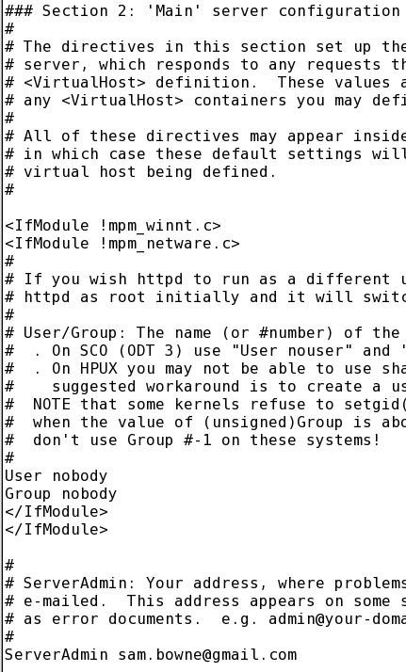
- Scroll about 1/3 of the way through this file and find the section titled:
### Section 2: 'Main' server configuration
- There are three things to change on the first screen below that header, as shown to the right on this page:
Change the User from webservd to nobody
Change the Group from webservd to nobody
Change the ServerAdmin from you@yourhost.com to your real email address
- Scroll down about one screen below the ServerAdmin line and find the UseCanonicalName line. Change the UseCanonicalName from Off to On, as shown below on this page.
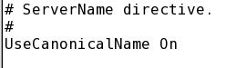

- Scroll down about one screen below the UseCanonicalName line and find the Options Indexes FollowSymLinks line. Add the word MultiViews to the end of this line, as shown below on this page.
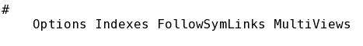

- Scroll down about half a screen and find the # UserDir section. Remove the User webservd line and replace it with these three lines:
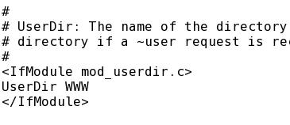
<IfModule mod_userdir.c>
UserDir WWW
</IfModule>
- Your # UserDir section should now look like the figure to the right on this page.

- In the gedit window, click Save to save the file. Close the gedit window. You may see a lot of CRITICAL errors in the Terminal window—they seem to be harmless.
- In the Terminal window, type in this command, and then press the Enter key:
sudo svcadm enable svc:/network/http:apache2
Enter your password when you are prompted to. This command stops the Web server.

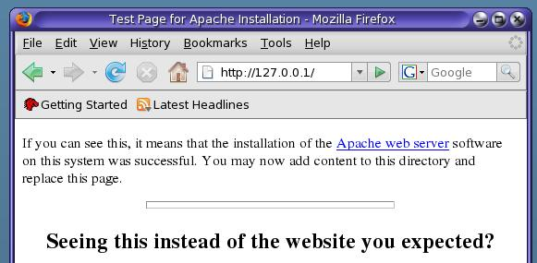
Testing the Apache Web Server
- On the Solaris desktop, click Launch, Firefox Web Browser.
- In Firefox, enter the address 127.0.0.1 and press the Enter key. You should see the default Apache screen shown to the right on this page.

Creating a Web Page
- In the Terminal window, type in this command, and then press the Enter key:
cd
This command changes the working directory to your home directory.
- In the Terminal window, type in this command, and then press the Enter key:
mkdir WWW
This command creates a WWW directory in your home directory, which is where Apache expects your Web pages to be.
- In the Terminal window, type in this command, and then press the Enter key:
chmod 755 WWW
This command assigns permissions to the WWW directory that let the owner perform read, write, and execute operations on it, and everyone else read and execute but not write.
- In the Terminal window, type in this command, and then press the Enter key:
ls -l
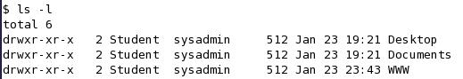
This command is a lowercase LS –L. It displays the files and directories in your working directory in the long form, with permissions. You should see the WWW directory with the permissions as shown to the right on this page.
- In the Terminal window, type in this command, and then press the Enter key:
cd WWW
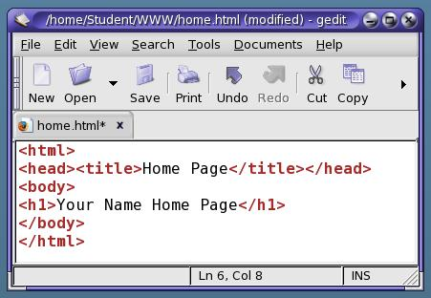
This command changes the working directory to your WWW directory.
- In the Terminal window, type in this command, and then press the Enter key:
gedit home.html
- A Question box pops up asking if you want to create a file. Click Yes.
- In the gedit window, type in the text shown to the right on this page. Click Save. Close gedit.
- In the Terminal window, type in this command, and then press the Enter key:
chmod 644 home.html
This command assigns permissions to the home.html file that let the everyone read it. If you don't do this, it won't be visible in a Web browser.
- In the Terminal window, type in this command, and then press the Enter key:
ls -l
This command is a lowercase LS –L. You should see the home.html file with the permissions as shown below on this page.
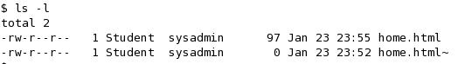

- In the Terminal window, type in this command, and then press the Enter key:
cd
This command changes the working directory to your home directory.
- In the Terminal window, type in this command, and then press the Enter key:
cd ..
This command changes the working directory to the directory above your home directory.
- In the Terminal window, type in this command, and then press the Enter key:
chmod 755 Student
This command assigns permissions to the Student directory that let the owner perform read, write, and execute operations on it, and everyone else read and execute but not write.

- In the Terminal window, type in this command, and then press the Enter key:
ls -l
You should see the Student directory with the permissions as shown below on this page.
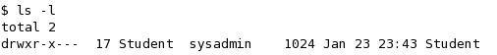

Viewing Your Home Page from the Solaris Web Server
- In Firefox, enter this address and then press the Enter key:
127.0.0.1/~Student/home.html
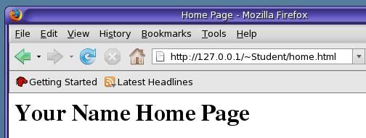
- You should see your home page as shown to the right on this page.

Finding the IP Address of your Solaris Web Server
- In the Terminal window, type in this command, and then press the Enter key:

IP: _______________________
ifconfig pcn0
Find your IP address in the result and write it in the box to the right on this page.

Viewing Your Home Page from the Host Windows System
- On the Windows host system, open Firefox, enter this address and then press the Enter key:
IP/~Student/home.html
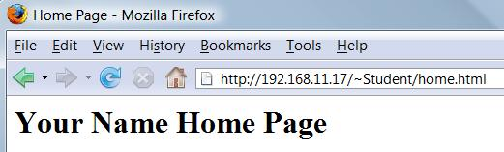
Replace IP with the IP you wrote in the box in the previous step.
- You should see your home page as shown to the right on this page.

Installing Nmap on your Host Windows System
- First check to see if Nmap is already installed. Click Start, "All Programs" and look for Nmap. If Nmap is there, skip to the next section, "Scanning your Solaris Web Server with Nmap". If Nmap is not installed, do the steps below to install it.
- On the Windows host system, open Firefox, enter this address and then press the Enter key:
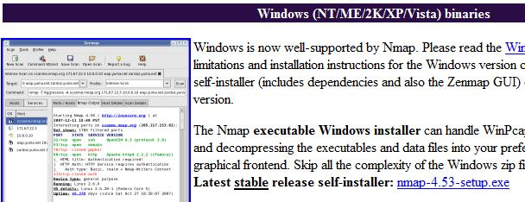
nmap.org
- In the top center, click Download.
- On the next page, find the Windows section, as shown to the right on this page. Find the line that says "Latest stable release self-installer". Click the blue link in that line, which was nmap-4.53-setup.exe when I did it.
- Save the file on your desktop. Double-click it to run it. Install it with the default options. It will also install WinPCap—that's fine.

Scanning your Solaris Web Server with Nmap
- Click Start, "All Programs", Nmap. If you are using a Vista host, right-click "Nmap – ZenMap GUI" and click "Run as Administrator". In the "User Account Control" box, click Allow. (If your host is Windows XP, you don't need to run Zenmap as Administrator.)
- In the Zenmap window, enter your Solaris Web Server's IP address in the Target box. Click Scan.
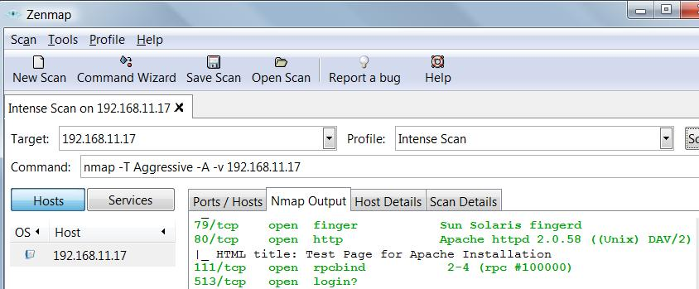
- When the scan completes, you will see a lot of ports open, including ports 79 and 80, as shown below on this page. Port 79 is the Sun Solaris Finger daemon, and port 80 is the Apache Web server.

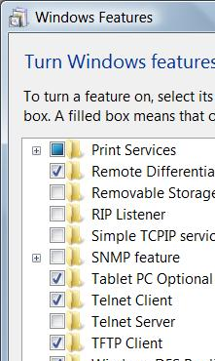
Enabling Telnet on Vista
- If you are using a Vista host, telnet is not enabled. To enable it, click Start, "Control Panel".
- In Control Panel, if you see about ten categories, click "Classic View".
- In Control Panel, double-click "Programs and Features".
- In the "Control Panel ► Programs and Features" box, in the left pane, click "Turn Windows features on or off". In the "User Account Control" box, press Alt+C or click Continue.
- In the "Windows Features" box, scroll down and check "Telnet Client" as shown to the right on this page. Click OK.

Grabbing the Web Server's Banner
- On the host Windows machine, click Start. In the Search box, type CMD and press the Enter key.
- In the Command Prompt window, type this and then press the Enter key:
telnet IP 80
Replace IP with your Solaris Web Server's IP you wrote in the box on a previous page. This opens a connection to your Web server on port 80.
- A box appears titled "Telnet IP". Hold down the Ctrl key and press the ] key. This exits the Telnet screen and gives you a Microsoft Telnet> prompt so you can adjust the settings.
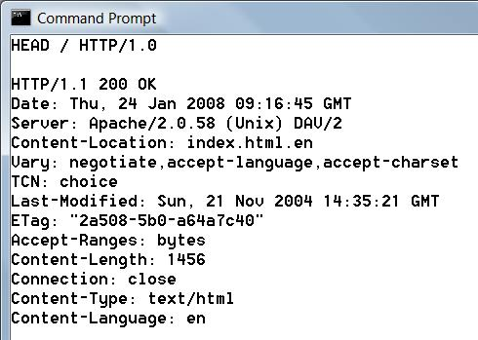
- In the "Telnet IP"window, at the Microsoft Telnet> prompt, type this command and then press the Enter key:
set localecho
- In the "Telnet IP"window, at the Microsoft Telnet> prompt, press the Enter key again.
- The "Telnet IP"window clears. Type this command, then press the Enter key twice:
HEAD / HTTP/1.0
- You see a status of "HTTP/1.1 200 OK", as shown to the right on this page. Below this line is the banner, including the exact Apache version you are running.

Adjusting the Banners on the Solaris Apache Web Server
- On your Solaris machine, in the Terminal window, type in this command, and then press the Enter key:
sudo gedit /etc/apache2/httpd.conf
Enter your password when you are prompted to.
- The /etc/apache2/httpd.conf file opens in the Gedit editor.
- Scroll down about halfway through the file and find the ServerTokens line. Change the ServerTokens from Full to Prod, as shown below on this page.
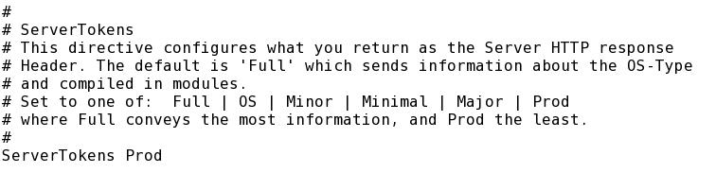

- In the gedit window, click Save to save the file. Close the gedit window. You may see a lot of CRITICAL errors in the Terminal window—they seem to be harmless.
- In the Terminal window, type in this command, and then press the Enter key:
sudo svcadm restart svc:/network/http:apache2
This command restarts the Web server.

Grabbing the Web Server's Banner Again
- On the host Windows machine, in the Command Prompt window, type this and then press the Enter key:
telnet IP 80
Replace IP with your Solaris Web Server's IP you wrote in the box on a previous page.
- A box appears titled "Telnet IP". Hold down the Ctrl key and press the ] key.
- In the "Telnet IP"window, at the Microsoft Telnet> prompt, type this command and then press the Enter key:
set localecho
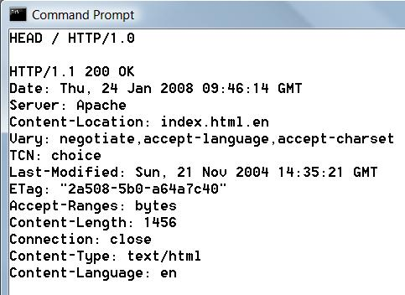
- In the "Telnet IP"window, at the Microsoft Telnet> prompt, press the Enter key again.
- The "Telnet IP"window clears. Type this command, then press the Enter key twice:
HEAD / HTTP/1.0
- You see a status of "HTTP/1.1 200 OK", as shown to the right on this page. Now the banner says Server: Apache but it no longer specifies the version number. This is more secure.

Capturing a Screen Image
- Make sure "Server: Apache" is visible on the screen.
- Press the PrintScrn key in the upper-right portion of the keyboard.
- Click Start, Programs, Accessories, Paint. In the untitled - Paint window, select Edit, Paste from the menu bar.
- In the untitled - Paint window, click File, Save. Select a Save as type of JPEG. Save the document with the filename Your Name Proj 10.

Turning in Your Project
- Email the JPEG image to me as an attachment to an e-mail message. Send it to: cnit.124@gmail.com with a subject line of Proj 10 From Your Name, replacing Your Name with your own first and last name. Send a Cc to yourself.

Last Modified: 2-19-08

