What You Need for This Project
- The Solaris VM running Apache you set up in the previous project.

Starting the Solaris Apache Web Server
- Start your Solaris virtual machine.
- Log in with a user name of Student and a password of P@ssw0rd
- Click Launch, Applications, Utilities, Terminal.

Configuring the httpd.conf File to Allow CGI Scripts
- In the Terminal window, type in this command, and then press the Enter key:
sudo cp /etc/apache2/httpd.conf /etc/apache2/httpd.conf.bak
Enter your password when you are prompted to. This makes a backup copy of the configuration file.
- In the Terminal window, type in this command, and then press the Enter key:
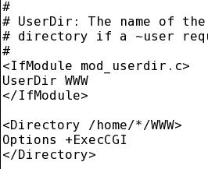
sudo gedit /etc/apache2/httpd.conf
- The /etc/apache2/httpd.conf file opens in the g edit editor.
- Scroll about 1/2 of the way through this file and find the # UserDir section. Add these three lines:
<Directory /home/*/WWW>
Options +ExecCGI
</Directory>
- Your # UserDir section should now look like the figure to the right on this page.
- Scroll almost to the bottom of the file, and find the # AddHandler section. Change this line:
#AddHandler cgi-script .cgi
To this:
AddHandler cgi-script .cgi .pl
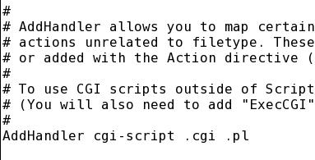
- Your # AddHandler section should now look like the figure to the right on this page.
- In the gedit window, click Save to save the file. Close the gedit window. You may see a lot of CRITICAL errors in the Terminal window—they seem to be harmless.
- In the Terminal window, type in this command, and then press the Enter key:
sudo svcadm restart svc:/network/http:apache2
Enter your password when you are prompted to. This command restarts the Web server.

Creating a Perl CGI Script
- In the Terminal window, type in this command, and then press the Enter key:
cd
This command changes the working directory to your home directory.
- In the Terminal window, type in this command, and then press the Enter key:
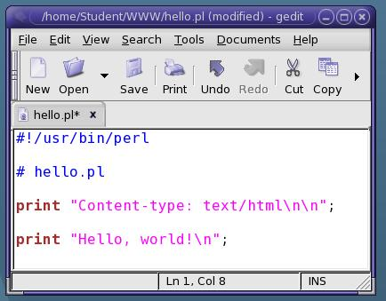
cd WWW
This command changes the working directory to your WWW directory.
- In the Terminal window, type in this command, and then press the Enter key:
gedit hello.pl
- A Question box pops up asking if you want to create a file. Click Yes.
- In the gedit window, type in the text shown to the right on this page. Click Save. Close gedit.
- In the Terminal window, type in this command, and then press the Enter key:
chmod 755 hello.pl
This command assigns permissions to the hello.pl file that let everyone read it, and execute it.
- In the Terminal window, type in this command, and then press the Enter key:
ls -l
This command is a lowercase LS –L. You should see the home.html file with the permissions as shown below on this page.
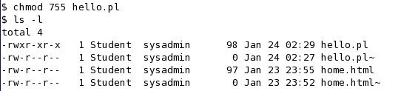

Viewing the CGI Script from a Web Browser
- On the Solaris desktop, click Launch, Firefox Web Browser.
- In Firefox, enter this address and press the Enter key:
127.0.0.1/~Student/hello.pl
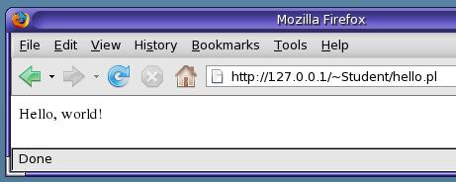
- You should see the message "Hello, world!", as shown to the right on this page. This demonstrates that CGI scripts are being properly handled by the Apache Web server.

Creating an HTML Form
- In the Terminal window, type in this command, and then press the Enter key:
pwd
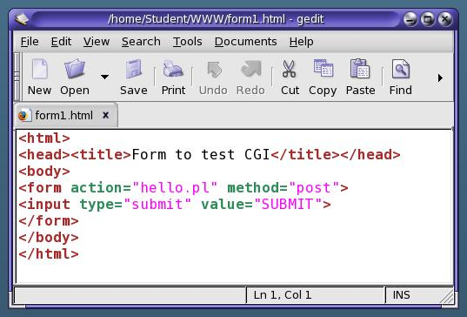
This command displays the working directory. It should be /home/Student/WWW. If it is something else, use the two commands cd and cd WWW to correct it.
- In the Terminal window, type in this command, and then press the Enter key:
gedit form1.html
- A Question box pops up asking if you want to create a file. Click Yes.
- In the gedit window, type in the text shown to the right on this page. Click Save. Close gedit.
- In the Terminal window, type in this command, and then press the Enter key:
chmod 644 form1.html
This command assigns permissions to the file that let everyone read it.

Viewing the HTML Form from a Web Browser
- In Firefox, enter this address and press the Enter key:
127.0.0.1/~Student/form1.html
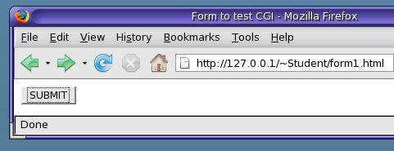
- You should see a page containing only a SUBMIT button, as shown to the right on this page.

- Click the SUBMIT button. You should see the message "Hello, world!", as shown to the right on this page. The HTML form executes the CGI script correctly.

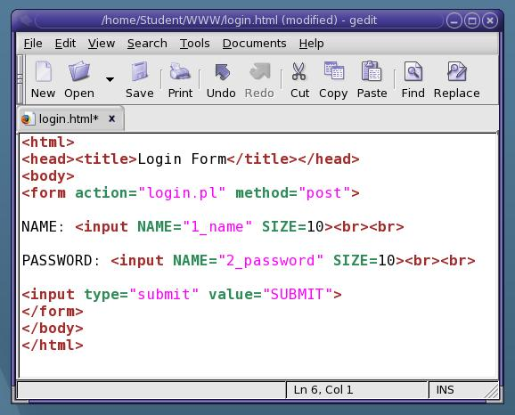
Creating a Login Form
- In the Terminal window, type in this command, and then press the Enter key:
gedit login.html
- A Question box pops up asking if you want to create a file. Click Yes.
- In the gedit window, type in the text shown to the right on this page. Click Save. Close gedit.
- In the Terminal window, type in this command, and then press the Enter key:
chmod 644 login.html
This command assigns permissions to the file that let everyone read it.

Creating a Login CGI Script
- In the Terminal window, type in this command, and then press the Enter key:
gedit login.pl
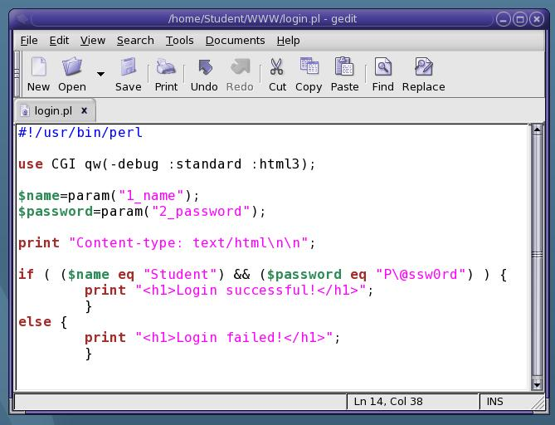
- A Question box pops up asking if you want to create a file. Click Yes.
- In the gedit window, type in the text shown to the right on this page. Click Save. Close gedit.
- In the Terminal window, type in this command, and then press the Enter key:
chmod 755 login.pl
This command assigns permissions to thefile that let everyone read it, and execute it.

Viewing the HTML Form from a Web Browser
- In Firefox, enter this address and press the Enter key:
127.0.0.1/~Student/login.html
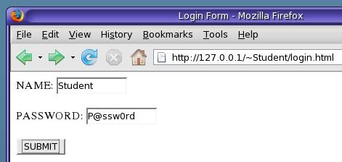
- You should see a page containing fields for NAME and PASSWORD, and a SUBMIT button, as shown to the right on this page.
- Enter a NAME of Student and a PASSWORD of P@ssw0rd and then click the SUBMIT button.
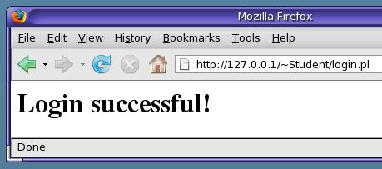
- You should see the message "Login successful!", as shown to the right on this page.

Capturing a Screen Image
- Make sure "Login successful!" is visible on the screen.
- Press the PrintScrn key in the upper-right portion of the keyboard.
- Click Start, Programs, Accessories, Paint. In the untitled - Paint window, select Edit, Paste from the menu bar.
- In the untitled - Paint window, click File, Save. Select a Save as type of JPEG. Save the document with the filename Your Name Proj 11a.

Turning in Your Project
- Email the JPEG image to me as an attachment to an e-mail message. Send it to: cnit.124@gmail.com with a subject line of Proj 11 From Your Name, replacing Your Name with your own first and last name. Send a Cc to yourself.

Last Modified: 2-19-08

