What You Need for This Project
- A computer running Windows Vista. It can be a real or virtual machine.

Starting the Vista Machine
- If you are working in S214, boot your PC to Vista and log in as Student. This will be your Attacker machine.
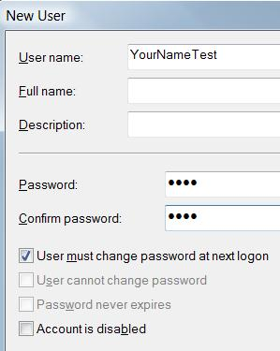
  - If there is a password, try P@ssw0rd. If that doesn't work, use the Ultimate Boot CD to create a new administrator account for yourself. Everyone using computers in S214 has been warned that their machine may be hacked. Of course, don't delete their homework files or anything nasty, but have no reluctance to create admin accounts and use their machines.

Creating a Test Password to Crack
- Click Start, right-click Computer, and click Manage. In the "User Account Control" box, press Alt+C or click Continue.
- In Computer Management, in the left pane, expand the Local Users and Groups container.
- In the left pane of Computer Management, right-click Users and click New User.
- In the NewUser box, enter a user name of YourNameTest
- In the NewUser box, in both Password boxes, enter a four-letter password such as abcd and click Create. Click Close. Close Computer Management.

Downloading ophcrack
- Open Firefox and go to sourceforge.net/projects/ophcrack
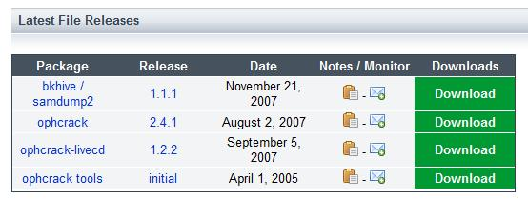
- Click the green "Download ophcrack" button.
- On the next page, in the Packages column, find the ophcrack line, as shown to the right on this page. Click the "Download" button in the ophcrack line.
- On the next page click the "ophcrack-win32-installer-2.4.1.exe" link. Save the ophcrack-win32-installer-2.4.1.exe file on your desktop.

Installing ophcrack
- Double-click the ophcrack-win32-installer-2.4.1.exe file to your desktop. In the "User Account Control" box, press Alt+A or click Allow.
- In the "Welcome to the ophcrack Setup Wizard" box, click Next..
- In the "Select Destination Location" box, click Next..
- In the "Select Components" box, click the "Continue without installing the tables" button, as shown below on this page, and click Next. This will install Ophcrack so that we can capture the local password hashes, but we won't be able to crack them with Ophcrack. That's OK, we will be using Elcomsoft Distributed Password Recovery to crack the hashes.
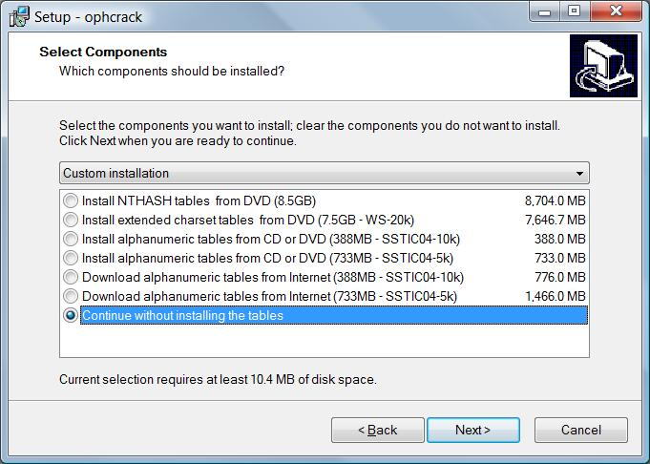

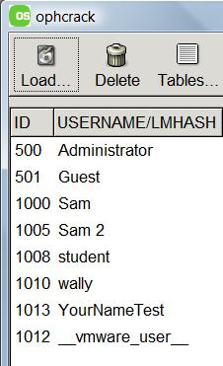
- In the "Select Start Menu Folder" box, click Next..
- In the "Ready to Install" box, click Install..
- In the "Completing the ophcrack Setup Wizard" box, click Finish..

Capturing the Local Password Hashes with ophcrack
- Click Start, "All Programs", ophcrack. Right click ophcrack and click "Run as Administrator". In the "User Account Control" box, press Alt+A or click Allow.
- In the ophcrack window, click the Load button. In the drop-down list, click "From local SAM".
- A list of usernames appears, as shown to the right on this page. No hashes are visible, but they were captured.
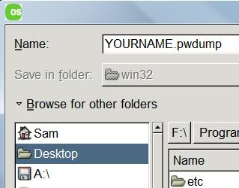
- In the ophcrack window, click the "Save As" button. In the box that appears, enter a name of YOURNAME.pwdump as shown to the right on this page. Click the "Browse for other folders" link and click Desktop. Click the Save button.
- Close ophcrack.

Viewing the Password Hashes
- On your desktop, right-click the YOURNAME.pwdump file and click Open. In the Windows box, click "Select a program from a list of installed programs". Click OK.
- In the "Open With" box, double-click Notepad.
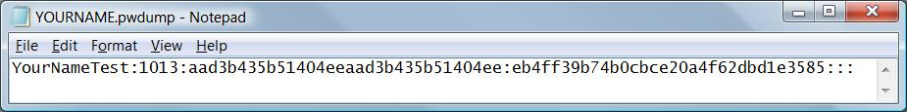
- A file opens with user names and password hashes. Delete all the lines except the YourNameTest line, as shown below on this page. Click File, Save to save the file. Close Notepad.

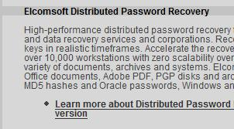
Downloading Elcomsoft Distributed Password Recovery
- Open Firefox and go to elcomsoft.com
- In the center of the page, click the yellow "PASSWORD RECOVERY SOFTWARE" link.
- On the next page, scroll down to the "Elcomsoft Distributed Password Recovery" section, as shown to the right on this page. Click the "Learn more about…" link.
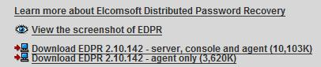
- On the next page scroll down to the "Download" links, as shown to the right on this page. Click the "Download EDPR 2.10.142 - server, console and agent (10,103K)" link. Save the epdr_setup.exe file on your desktop.
- Double-click the epdr_setup.exe file on your desktop. Install the software with the default options.

Running Elcomsoft Distributed Password Recovery
- When the software is installed, it will run. A large "Elcomsoft Distributed Password Recovery" window opens.
- In the "Elcomsoft Distributed Password Recovery" window, click the "+ New Task" button.
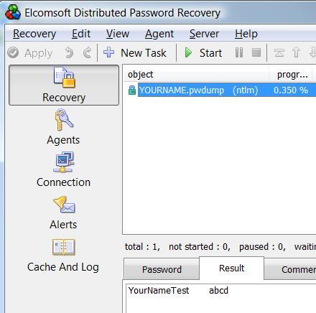
- In the "Select Document" box, double-click the YOURNAME.pwdump file.
- In the "Select Object" box, click NTLM. Click OK.
- In the "Elcomsoft Distributed Password Recovery" window, click the "► Start" button.
- Wait a minute or two. The progress percentage should increase, and the status should change to recovered.
- Click the YOURNAME.pwdump line. In the middle of the window, click the Result tab. You should see the password, as shown to the right on this page.

Capturing a Screen Image
- Make sure you can see the recovered password on the Result tab.
- Press the PrintScrn key in the upper-right portion of the keyboard.
- Click Start, Programs, Accessories, Paint. In the untitled - Paint window, select Edit, Paste from the menu bar.
- In the untitled - Paint window, click File, Save. Select a Save as type of JPEG. Save the document with the filename Your Name Proj 7.

Turning in Your Project
- Email the JPEG image to me as an attachment to an e-mail message. Send it to: cnit.124@gmail.com with a subject line of Proj 12 From Your Name, replacing Your Name with your own first and last name. Send a Cc to yourself.

Last Modified: 2-20-08

