What You Need for This Project
- A computer running Windows Vista or XP. It can be a real or virtual machine. You will need administrative privileges, about 6 GB free on a hard disk.
- An andLinux CD, which I handed out in class. If you prefer to download it yourself, you can get it here http://www.andlinux.org/downloads.php (download the KDE version, 665 MB).

Purpose
- Once you have andLinux, your Windows machine is also an Ubuntu Linux machine at the same time. andLinux runs Ubuntu as an application on top of Windows, making Linux commands, scripts, and applications available to you all the time. That is a really handy thing.
- andLinux gives you a complete Ubuntu machine, but no desktop. You use the Windows desktop, and launch applications inside KDE windows. This is a bit different than the way we used Ubuntu previously, and it is a good thing to get used to.

Starting the Vista Machine
- If you are working in S214, boot your PC to Vista and log in as Student. This will be your Attacker machine.
  - If there is a password, try P@ssw0rd. If that doesn't work, use the Ultimate Boot CD to create a new administrator account for yourself. Everyone using computers in S214 has been warned that their machine may be hacked. Of course, don't delete their homework files or anything nasty, but have no reluctance to create admin accounts and use their machines.

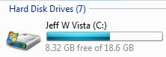
Finding a Drive with Enough Available Space
- Click Start, Computer. Look at the C: drive and see how much space is available—in the example to the right on this page, there are 8.32 GB available.
- If there are 6 GB or more available, you can install andLinux on the C drive. If not, find another drive with 6 GB available and remember that drive’s letter.

Installing andLinux
- Insert the andLinux CD. Click Start, Computer. Right-click the CD icon and click Open to open it.
- Drag the andlinux-beta1rc6-kde.exe file to your desktop and drop it. Wait until the file is copied.
- I was unable to install andLinux from the desktop. I think there is some Vista incompatibility in the installer. But installing it from an Administrator Command Prompt works, so do this:
- Click Start. In the Search box, type in CMD and press Ctrl+Alt+Enter. In the "User Account Control" box, click Continue.
- In the Administrator Command Prompt window, type in this command and then press the Enter key:
cd \users\Student\desktop
Replace Student with your logon name.
- In the Administrator Command Prompt window, type in and and press the Tab key. The complete filename andlinux-beta1rc6-kde.exe should appear. (This is called "tab completion".) Press the Enter key.
- In the "Welcome to the andLinux Setup Wizard" box, click Next.
- In the "License Agreement" box, click "I accept the agreement". Click Next.
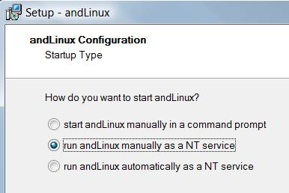
- In the "Select Destination Location" box, accept the default if there was enough room on your C drove, or specify the other location you found with enough room. Click Next.
- In the "andLinux Configuration: Memory Size" box, accept the default of "256 MB" and click Next.
- In the "andLinux Configuration: Sound" box, accept the default of "yes" and click Next.
- In the "andLinux Configuration: Startup Type" box, check "run andLinux manually as a NT service", as shown to the right on this page, and click Next. This is important! andLinux won't start automatically on Vista!
- In the "andLinux Configuration: File Access Using CoFS" box, accept the default of "C:\" and click Next.
- In the "andLinux Configuration: Start Menu Folder" box, accept the default and click Next.
- In the "Select Additional Tasks" box, accept the defaults and click Next.
- In the "Ready to Install" box, click Install. It took six minutes on my home system.
- In the "Completing the andLinux Setup Wizard" box, click Finish. Your computer will restart.

Creating a "Start andLinux" Desktop Icon with Administrative Rights
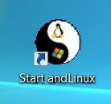
- Click Start, "All Programs", andLinux. Point to the "Start andLinux" item, hold down the right mouse button, and drag it to the desktop. Release the right mouse button and click "Create Shortcuts Here". You should now have a shortcut titled "Start andLinux" on your desktop, as shown to the right on this page.
- Right click the "Start andLinux" shortcut and click Properties. On the Shortcut tab, click the Advanced button.
- In the "Advanced Properties" box, check "Run as Administrator". Click OK.
- In the "Start andLinux Properties" box, click OK.

Starting andLinux
- Double-click the "Start andLinux" shortcut on your desktop. In the "User Account Control" box, press Alt+C or click Continue.

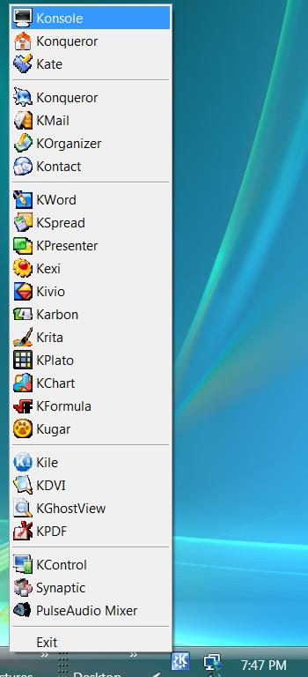
Using Konsole
- Look in the lower right corner of your desktop, in the Notification Area, for a blue icon with a K on a gear. That is your andLinux Start button. Click it to display the andLinux start menu, as shown to the right on this page.
- In the andLinux start menu, click Konsole. A "Shell - Konsole" window appears, giving you command-line Linux control. If you get an error message saying it cannot connect to the server, just wait a couple of minutes and try again.
- In the "Shell - Konsole" window, type in this command and press the Enter key:
ifconfig
- Scroll back to the top in the "Shell - Konsole" window. You should see two network adapters: eth0 with an IP address starting with 10, and eth1 with an IP address starting with 192.168, as shown below on this page
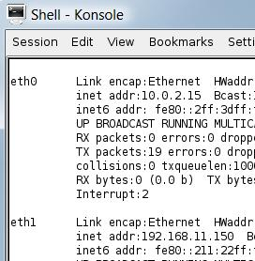

- The eth1 adapter is used to control andLinux—the commands you type in to the Konsole and the other Linux windows are sent through this adapter from Windows to Linux.
- The eth0 adapter is andLinux's gateaway to the Internet. It acts like a router. On the andLinux side, the address starts with 10. Write the eth0 adapter's IP address in the box to the right on this page.

andLinux IP: _________________
- To see the other side of the andLinux networking device, click Start, Network. In the Network window, click "Network and Sharing Center".

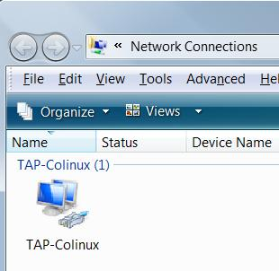
- In "Network and Sharing Center", click "Manage network connections". You should see a TAP-Colinux adapter, as shown to the right on this page.

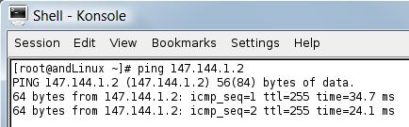
Configuring andLinux Networking
- In the "Shell - Konsole" window, type in this command and press the Enter key:
ping 147.144.1.2
- You should see replies, as shown to the right on this page. Press Ctrl+C to stop the pings. That shows that your andLinux is connected to the Internet.
- In the "Shell - Konsole" window, type in this command and press the Enter key:
ping yahoo.com
- You do not see should see replies, as shown to the right on this page. Press Ctrl+C to stop the pings. The reason you cannot ping Yahoo is that the DNS server is not correct..
- Click the blue andLinkux K button in the Notification Area. Click KControl.
- In the "KDE Control Center", in the left pane, expand "Internet & Network". Click "Network Settings".
- In the right pane, click the Domain Name System tab. Click the Add button. In the ""Add New D…" box, enter 208.67.220.220 and click the Add button. Your "Network Settings" window should now look like the figure shown below on this page. Click the Apply button.
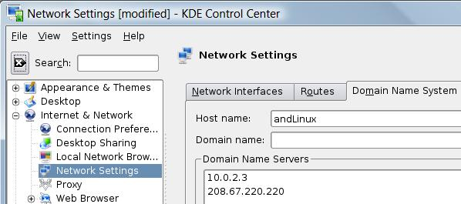

- In the "Shell - Konsole" window, type in this command and press the Enter key:
ping yahoo.com
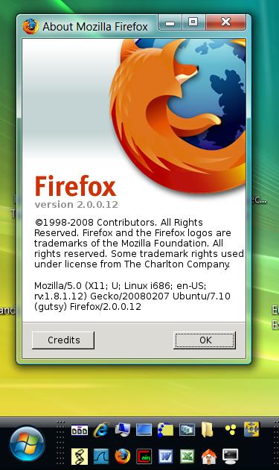
- The IP address is found from DNS, but there are still no replies. I don't know why this happens. The andLinux networking is strange.

Using Firefox in andLinux
- In the "Shell - Konsole" window, type in this command and press the Enter key:
firefox
- Do a Google Search in your Firefox window to verify that you have Internet access.
- From the Firefox menu bar, click Help, "About Mozilla Firefox". You should see "Linux" and "Ubuntu/7.10" at the bottom of the "About Mozilla Firefox" box.

Capturing a Screen Image
- The Windows Start button and the "About Mozilla Firefox" box should both be visible.
- Press the PrintScrn key in the upper-right portion of the keyboard.
- Click Start, Programs, Accessories, Paint. In the untitled - Paint window, select Edit, Paste from the menu bar.
- In the untitled - Paint window, click File, Save. Select a Save as type of JPEG. Save the document with the filename Your Name Proj 13.

Turning in Your Project
- Email the JPEG image to me as an attachment to an e-mail message. Send it to: cnit.124@gmail.com with a subject line of Proj 13 From Your Name, replacing Your Name with your own first and last name. Send a Cc to yourself.

References
http://onecomputerguy.com/networking/vista_vpn_server.htm

Last Modified: 3-7-08

