What You Will Need
- A router that can accept the OpenWrt firmware. In S214, use a WRT54GL router. If you are working with your own router, BE WARNED – YOU MAY DESTROY YOUR ROUTER! Replacing the firmware with OpenWrt voids your warranty, and can completely destroy your router. You do it at your own risk.
- A computer to act as the router's wired client. That computer can run any OS, but I wrote the instructions for Vista.

Downloading the OpenWRT Firmware
- On your computer, open Firefox and go to openwrt.org
- Click Downloads. Click whiterussian. Click 0.9. Click default.
- Click openwrt-brcm-2.4-squashfs.trx
- Save the openwrt-brcm-2.4-squashfs.trx file on your desktop.

Verifying the MD5 Hash
- In the OpenWRT Web page, click "Parent Directory"
- Click MD5SUMS. Find the default/openwrt-brcm-2.4-squashfs.trx line and highlight that MD5 value.
- You need to have Hashcalc installed on your computer. Click Start, All Programs, and look for Hashcalc. If it is not there, go to slavasoft.com/hashcalc to download it and install it.
- Click Start, All Programs, Hashcalc, Hashcalc.
- From your desktop, drag the dd-wrt.v23_mini_generic.bin icon and drop it in the Hashcalc window. The MD5 sum appears. Compare it to the value you saw on the OPenWRT Web page. It should match exactly.

Resetting the Router to Factory Defaults
- Start with the router turned off. Hold down the INIT button on the bottom of the router with a paper clip, plug in the router's power, and continue to hold down the reset button for 30 seconds. Then unplug the router's power again, and plug it back in to let it boot normally.

Connecting the Wired Client to the Router Through a Hub
- Unplug the blue Ethernet cable from the back of your computer.
- Connect your computer to a hub with a patch cord. Connect another port on the hub to port 1 on the back of the router with a second patch cord. Leave all the other ports on the router disconnected. The final network should be as shown below on this page.

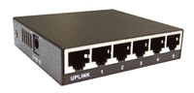
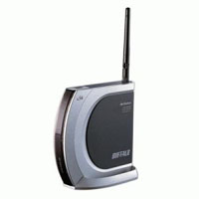
Hub
Router

- Plug in the power cord to start the router.

Using DHCP
- Click Start, Network. In the Network window, click "Network and Sharing Center". In the "Network and Sharing Center" window, click "Network and Sharing Center".
- In "Network and Sharing Center", click "Manage Network Connections".
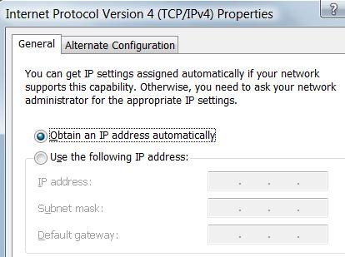
- In the "Network Connections" window, right-click "Local Area Connection" and click Properties. In the "User Account Control" box, click Continue. Click "Internet Protocol Version 4 (TCP/IP)" to select it. Click the Properties button.
- In the "Local Area Connection Properties" box, make sure the "Obtain an IP address automatically" button is selected, as shown to the right on this page. The DNS server settings don't matter for now. Click OK. Click OK.

Finding the Router's IP Address
- Click Start, type in CMD, and press Ctrl+Shift+Enter. In the "User Account Control" box, click Continue.
- In the Administrator Command Prompt window, type in this command and then press Enter:
IPCONFIG

Router IP: _________________________
Find the default gateway of the "Local Area Connection" and write it in the box on this page. It may require scrolling up through the many virtual network connections Vista creates. It may be 192.168.1.1, or some other number like 192.168.11.1.

Setting a Manual IP Address
- The router will stop working during the upgrade, so you can't trust DHCP to assign its address.
- Click Start, Network. In the Network window, click "Network and Sharing Center". In the "Network and Sharing Center" window, click "Network and Sharing Center".
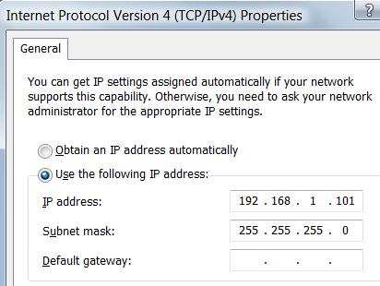
- In "Network and Sharing Center", click "Manage Network Connections".
- In the "Network Connections" window, right-click "Local Area Connection" and click Properties. In the "User Account Control" box, click Continue. Click "Internet Protocol Version 4 (TCP/IP)" to select it. Click the Properties button.
- In the "Local Area Connection Properties" box, enter an IP address on the same subnet as the "Router IP" you wrote in the box above on this page. The Default Gateway and DNS server settings don't matter for now. Click OK. Click OK.

Enabling the TFTP and Telnet Clients on your Computer
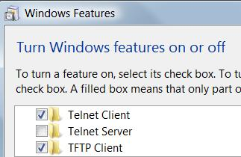
- This is only required for Vista. Click Start, "Control Panel". If it's not already in Classic View, click "Classic View". Double-click "Programs and Features". On the left side, click "Turn Windows features on or off". In the "User Account Control" box, click Continue.
- In the "Windows Features" box, check "TFTP Client" and check "Telnet Client", as shown to the right on this page. Click OK.

Replacing the Router's Firmware with OpenWRT
- Some firmware allows you to update it using the Web interface, but not the Buffalo, because it requires an encrypted firmware image. So you need to use the TFTP method.
- Click Start, type in CMD, and press the Enter key to open a Command Prompt window.
- In the Command Prompt window, type in this command and then press Enter:
cd desktop
This changes your working directory to your desktop.
- In the Command Prompt window, type in this command, but do NOT press Enter yet!
TFTP –i 192.168.1.1 PUT openwrt-wrt54g-squashfs.bin
Replace 192.168.1.1 with the Router IP you wrote in the box on a previous page of these instructions.
- Pull the power plug out of the router. Wait 5 seconds.
- This is the tricky part. The reason it is so difficult is that the router only waits a few seconds after powering up to start running its current firmware, and it is only listening for a TFTP firmware upgrade for those few seconds.
- Plug the router's power back in, and and watch the router's front panel instead—there is a red light labeled DIAG that looks like a big asterisk ☼. As soon as that light comes on, press Enter to start the TFTP transfer. This happens really fast, about 5 seconds after plugging the router in. You will probably have to try it a few times to get it right.
- If it works, you will see the "Transfer successful" message, as shown below on this page.

Using DHCP
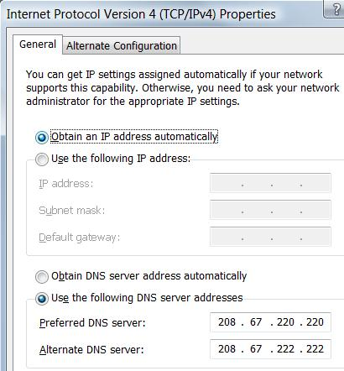
- The router should be working now, so you can set your IP address back to automatic.
- Click Start, Network. In the Network window, click "Network and Sharing Center". In the "Network and Sharing Center" window, click "Network and Sharing Center".
- In "Network and Sharing Center", click "Manage Network Connections".
- In the "Network Connections" window, right-click "Local Area Connection" and click Properties. In the "User Account Control" box, click Continue. Click "Internet Protocol Version 4 (TCP/IP)" to select it. Click the Properties button.
- In the "Local Area Connection Properties" box, make sure the "Obtain an IP address automatically" button is selected, as shown to the right on this page.
- Set the "Preferred DNS server" to 208.67.220.220 and the "Alternate DNS server" to 208.67.222.222. Those are OpenDNS servers, and they are more reliable than the campus DNS servers. Click OK. Click OK.

Restarting the Router
- Remove the power plug from the router and replace it again. Wait 30 seconds for the router to start up.
- Click Start, type in CMD, and press the Enter key. to open another Command Prompt window.
- In the Command Prompt window, type in this command and then press Enter:
IPCONFIG

Router IP: _________________________
Find the default gateway of the Local Area Connection and write it in the box on this page. It may require scrolling up through the many virtual network connections Vista creates. It is probably the same as the Router IP you found previously, but it might be different.

Using the OpenWrt Admin Console
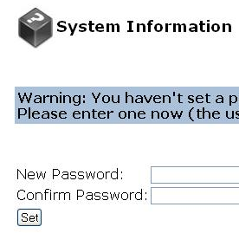
- Open Firefox. Type the Router IP address into the Address bar and press Enter.
- A "System Information" page opens, as shown to the right on this page. Type in a password of P@ssw0rd in both boxes and click the Set button.
- In the upper left of the page, click Info.
- A box pops up asking for you to log in. Use a User Name of root and a Password of P@ssw0rd
- You should see a System Information page, as shown below on this page.

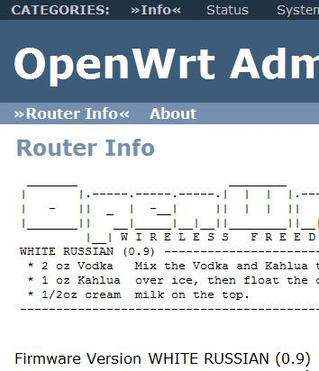

Setting the WAN IP Address
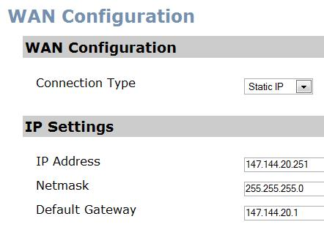
- Connect the router to the WAN Switch near station S214-19 in S214.
- In the OpenWrt White Russian Administrative Console, on the top menu bar, click Network. In the submenu, click WAN.
- Select a "Connection Type" of "Static IP". In the lower section, enter the WAN IP Address written on the side of your router with masking tape. Leave the Netmask at its default, 255.255.255.0, and use a Default Gateway of 147.144.20.1, as shown to the right on this page.
Note: DHCP does not work on the WAN side, not as far as I can tell.
- At the bottom of the page, click "Save Changes".
- In the "DNS Servers" box, type 208.67.220.220 and click the Add button.
- At the bottom of the page, click the "Save Changes" button. Click "Apply Changes".
- Open a new Firefox window. Go to google.com and do a search. You should now have a working Internet connection. If you don't, unplug the power plug from the router and plug it in again to restart it.

Using SSH Secure Shell to Restart the Router
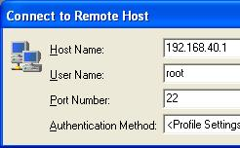
- You need SSH Secure Shell on the client machine. If it is not installed, open Firefox, go to ftp://ftp.ccsf.edu/pub/SSH, and download the sshSecureShellClient-3.2.9.exe file. Install it with the default options.
- On the desktop, Double-click the "Secure Shell Client" icon.
- In the "SSH Secure Shell" window, click the "Quick Connect" button.
- In the "Connect to Remote Host" box, enter your Router IP in the "Host Name" box. Enter a "User Name" of root as shown to the right on this page. Click Connect.
- If a box opens showing a Host ID, press Enter.
- A box appears asking for a password. Enter P@ssw0rd

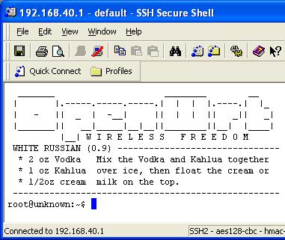
- You should see an OpenWrt banner, and a command-line Linux prompt, as shown to the right on this page.
- At the $ prompt, type this command, then press the Enter key:
reboot
You will lose your connection.

Correcting the System Time
- In the "SSH Secure Shell" window, at the $ prompt, type this command, then press the Enter key:
date
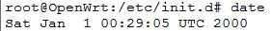
- The result, as shown to the right on this page, has two problems. It's in Greenwich time (UTC), not local, and it's obviously wrong, in January 2000. It will be a lot easier to read log files with accurate times in them, and some tunnel brokers even require accurate times for IPv6 connectivity.
- First we need to set the time zone. In the "SSH Secure Shell" window, at the $ prompt, type this command, then press the Enter key:
echo "PST8PDT,M3.2.0,M11.1.0" > /etc/TZ
- In the "SSH Secure Shell" window, at the $ prompt, type this command, then press the Enter key:
date
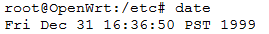
- Now the time shows PST, as shown to the right on this page.
- To make the time accurate, we need to install the openntpd package, which will contact remote time servers and synchronize the router's clock from them.
- In the "SSH Secure Shell" window, at the $ prompt, type this command, then press the Enter key:
ipkg install openntpd
- In the "SSH Secure Shell" window, at the $ prompt, type this command, then press the Enter key:
date
- The date is still wrong, because we have not started the openntpd service yet. The installation has already configured it to start at each reboot, by placing a startup script in the /etc/init.d directory. Scripts in this directory that start with the letter S are automatically executed at each bootup in alphabetical order.
- In the "SSH Secure Shell" window, at the $ prompt, type this command, then press the Enter key:
cd /etc/init.d
- In the "SSH Secure Shell" window, at the $ prompt, type this command, then press the Enter key:
ls
- The result is a list of executable files in an unreadable light green font. To make them visible, from the SSH Secure Shell menu, click Edit, Settings. In the Settings box, on the left side, in the "Global Settings" group, in the "Appearance" subgroup, click Colors. On the right side, clear the 'Enable ANSI colors" check box. Click OK.
- In the "SSH Secure Shell" window, at the $ prompt, type this command, then press the Enter key:
ls

- Now the filenames are more readable, as shown above on this page. To see how these files work, type this command, then press the Enter key:
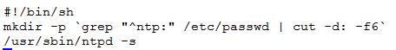
nano S55ntpd
- This script just makes a home directory for the ntp user, if one is not already present, and then executes the /usr/sbin/ntpd command to set the clock. Press Ctrl+X to exit nano.
- Type this command, then press the Enter key:
./S55ntpd start
This runs the script and sets the clock.
- Type this command, then press the Enter key:
date
Now the date and time are correct.

Viewing the OpenWrt Admin Console
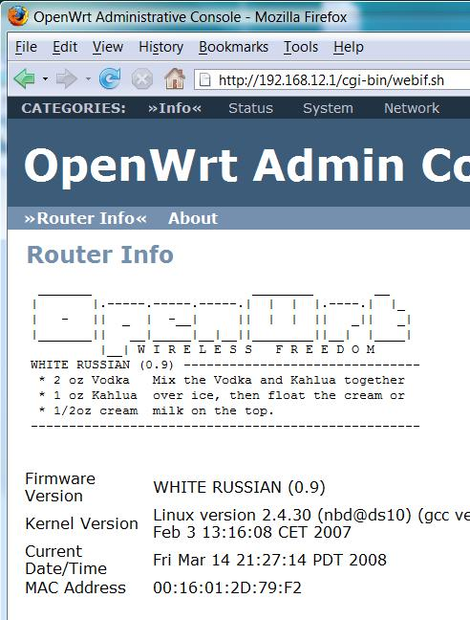
- If Firefox is still open showing the "OpenWrt Admin Console", click View, Refresh to refresh it.
  - If Firefox is not open, open Firefox. Type the Router IP address into the Address bar and press Enter.
- You should see the "OpenWrt Admin Console" with the correct date and time, as shown to the right on this page.

Saving the Screen Image
- Make sure you see "OpenWrt Admin Console" with the correct date and time, as shown to the right on this page. Press the PrntScn key to copy whole screen to the clipboard.
- Open Paint and paste in the image. Save it as a JPEG, with the filename Your Name Proj 14.
Replacing the Cables
- Before you leave, put the router and patch cables back in the wooden closet and replace the original blue network cable in the onboard NIC in the back of your computer.
Turning in your Project
- Email the JPEG image to me as an attachment. Send the message to cnit.123@gmail.com with a subject line of Proj 14 From Your Name. Send a Cc to yourself.

Last modified 3-14-08

