Setup in S214
This was not easy to set up. I am not sure of the exact steps to do it in VMware Workstation. So I recommend that you do it with VMmanager and VMware Player. If you are working in S214, log in to a Vista partition. Every Vista should have a Student account with no password, or possibly a password of P@ssw0rd. If it does not, use the Ultimate Boot CD to create an account for yourself. Once you are in Vista, install VMmanager and VMware Player. The installers for those programs are on the VMs drive in the Install folder.

Creating a New Virtual Machine with VMmanager
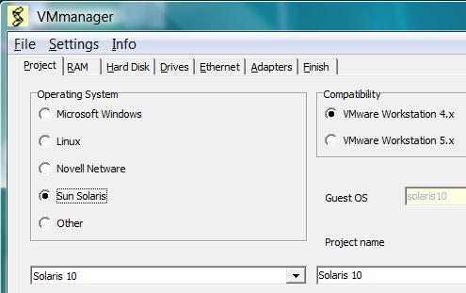
- Click Start, "All Programs", VMmanager, VMmanager.
- In the VMmanager window, click the New button.
- In the VMmanager window, on the Project tab, in the operating Systems section, click the "Sun Solaris" radio button. In the drop-down list, select "Solaris 10", as shown to the right on this page.
- In the VMmanager window, click the RAM tab. Increase the RAM to 512 MB.
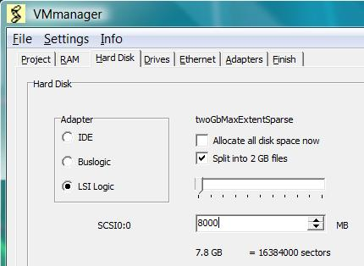
- In the VMmanager window, click the Hard Disk tab. In the Adapter section, click the "LSI Logic" radio button. Clear the "Allocate all disk space now" box. Check the "Split into 2 GB files" box. Enter a size of 8000 MB, as shown to the right on this page.
- In the VMmanager window, click the Drives tab. In the CD-ROM section, select "use ISO image". In the Open box, navigate to the sol-10-u4-ga-x86-dvd.iso file. You can find the sol-10-u4-ga-x86-dvd.iso file on the DVD labeled Kiosk that was handed out in class, or download it from Sun at this link
http://www.sun.com/software/solaris/get.jsp
- In the VMmanager window, click the Ethernet tab. In the Ethernet 0 section, click Bridged.
- In the VMmanager window, click the Finish tab. Click the OK button. In the Save As box, navigate to a drive and folder you want your VM to live in. I recommend creating a separate folder for each VM, and labeling it with the OS name. Make sure it's on a drive with enough space—Solaris requires about 4 GB. Click Save. In the VM Manager box, click OK.

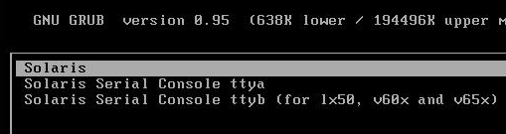
Installing Solaris X
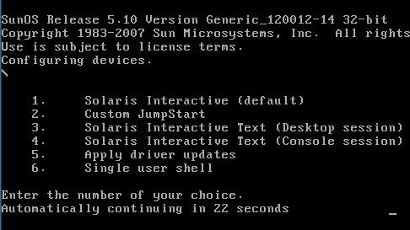
- Start your virtual machine. The virtual machine should boot from the ISO image, and show you the Solaris starting screen shown to the right on this page. Click in the virtual machine to redirect keyboard input to it, and press the Enter key to accept the default selection of Solaris.
- At the next screen, press 1 or wait to accept the default selection of "Solaris Interactive (default)", as shown to the right on this page.
- The next screen is titled "Configure Keyboard Layout". Accept the default of "US-English" and press F2.
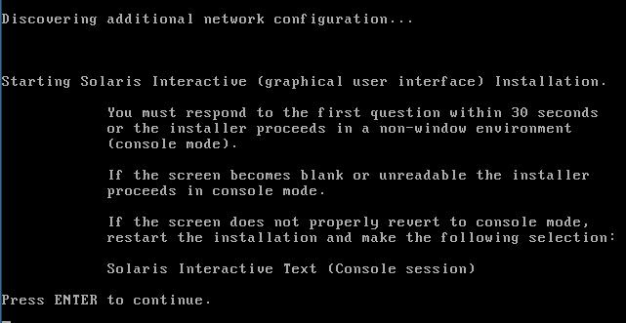
- The next screen is titled "Select a Language". Press 0 and then press the Enter key to select English.
- The next screen is titled "Starting Solaris Interactive (graphical user interface) Installation.", as shown to the right on this page. Press Enter.
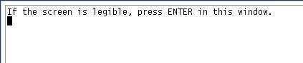
- A graphical user interface appears, with a light purple background, a X-shaped cursor, and a text box in the top left, as shown to the right on this page. Click in that box and press Enter.
- A Welcome box appears. Click Next.
- In the "Network Connectivity" box, click Networked. Click Next.
- In the "DHCP for pcn0" box, click Yes. Click Next.
- In the "IPv6 for pcn0" box, accept the default selection of No and click Next.
- In the "Enable Kerberos" box, accept the default selection of No and click Next.
- In the "Name Service" box, accept the default selection of None and click Next.
- In the "NFSv4 Domain Name" box, accept the default selection of "Use the NVSv4 comain derived by the system" and click Next.
- In the "Time Zone" box, accept the default selection of "Geographic Continent/Country/Region" and click Next.
- In the "Continent and Country" box, expand Americas, expand "United States", and click "Pacific Time" to select it. Then click Next.
- In the "Date and Time" box, accept the defaults and click Next.
- In the "Root Password" box, enter P@ssw0rd in both fields and click Next. (Of course, if this were an important installation of a mission-critical server, you would need to use a more secure password.)
- In the "Enabling remote services" box, accept the default selection of Yes and click Next.
- In the "Confirm Information" box, click Next.
- In the "Welcome" box, click Next.
- In the "Installer Options" box, accept the default selections and click Next.
- A Notice box pops up, saying "You must manually eject the CD/DVD…". Click OK.
- In the "Specify Media" box, accept the default selection of CD/DVD and click Next.
- An Initializing box appears with a slowly moving progress bar. Wait for it to finish—it should only take a minute or two.
- In the "License" box, check the Accept box and click Next.
- In the "Select Type of Install" box, accept the default selection of "Default Install" and click Next.
- In the "Ready to Install" box, click "Install Now". It will now take about one hour to install.

Logging in as root
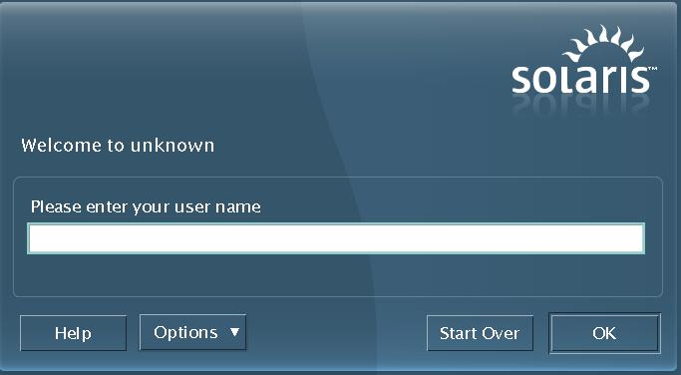
- When the installation is complete, the "Welcome to unknown" screen appears, as shown to the right on this page.
- Type a user name of root and press Enter.
- Type a password of P@ssw0rd and press Enter.
- A gray box asks you to choose a desktop. Accept the default of "Java Desktop System, Release 3" and click OK.
- A desktop appears, with a "This Computer" icon and several others, and a little box showing the names of the developers.
- After a few minutes, a small box appears saying "Loading System Information". Wait for it to vanish.
- A "Registration" box appears. Select "Run the Solaris software without registering" and click Next. In the "Never Register?" box, click "Never Register".
Opening a Terminal Window
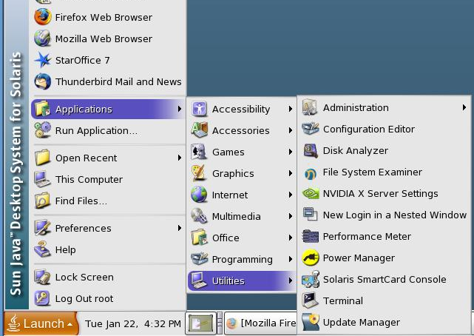
- Press Ctrl+Alt+Enter to maximize your Solaris virtual machine's window. That should make the Launch button visible at the bottom of the desktop, as shown to the right on this page.
- Click Launch, Applications, Utilities, Terminal.
- A Terminal window opens, with the # prompt indicating that you are running as root.
Viewing the Install Logs
- Type this command into the Terminal window, and then press the Enter key:
ls /var/sadm/system/logs
Note that the first character is a lowercase L, not the numeral one.
Saving the Screen Image
- Make sure the Terminal window is open, showing the install_launch files that show when you installed your Solaris system, as shown below on this page.
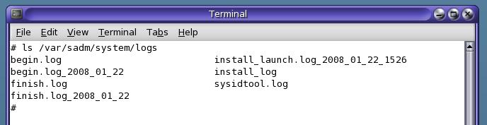

- Press Ctrl+Alt to release the mouse, and click on the host Windows XP desktop. Press the PrntScn key to copy whole screen to the clipboard.
- On the host Windows XP desktop, open Paint and paste in the image. Save it as a JPEG, with the filename Your Name Proj X1.
Turning in your Project
- Email the JPEG image to me as an attachment. Send the message to cnit.123@gmail.com with a subject line of Proj X1 From Your Name. Send a Cc to yourself.
Last modified 1-25-08

