What You Need for This Project
- A computer running any version of Windows to be the Attacker. It can be a real or virtual machine.
- A second physical computer, connected to the Attacker by a switch, not a hub. In S214, I recommend that you use a different workstation booted to Vista for this role. However, the Target can run any operating system at all, Windows, Mac, Linux, Unix, whatever. It can be a real or virtual machine.
- Do the "SideJacking Gmail Accounts" project first, so you have Nmap, and Hamster, Ferret installed on your Attacker machine.

Starting the Attacker Machine
- If you are working in S214, boot your PC to Vista and log in as Student. This will be your Attacker machine.

Starting the Target Machine
- Start a second physical computer in S214 and boot to Vista. That will be your Target machine.
- Open a browser on your Target machine and make sure you can connect to the Internet.

Finding the Target Machine's IP Address
- On your Target machine, click Start, Run. Type in CMD and press the Enter key.
- In the Command Prompt window, type in IPCONFIG and press the Enter key. Find your IP address and write it in the box to the right on this page. In S214, your IP address will start with 192.168.1.

Target IP: _________________

Running the Ferret Cookie Sniffer on the Attacker Machine
- On the Vista Attacker machine's desktop, hold down the Shift key and right-click the Sidejacking folder. In the context menu, click "Open Command Window Here".
- In the Command Prompt window, type the following command, then press the Enter key:
ferret –i 0
- Open Firefox and go to www.ccsf.edu. You should see a message saying 'Traffic seen proto="HTTP", op="GET", Host="www.ccsf.edu", URL="/"'.

Running the Hamster Proxy Server on the Attacker Machine
- On the Vista Attacker machine's desktop, double-click Sidejacking folder to open it.
- In the Sidejacking widow, double-click hamster.exe/
- If a "Windows Security Alert" box pops up, saying "Windows Firewall has blocked some features of this program", click Unblock. In the "User Account Control" box, press Alt+C or click Continue.
- A Command Prompt window opens, showing the message "HAMPSTER side-jacking tool".

Configuring Firefox to Use the Proxy Server on the Attacker Machine
- Warning: the Hamster documentation says it will screw up the cookies in your browser. I didn't see any problem when I did it, however. You may want to create a different Firefox profile just for this project, however. I didn't bother.
- On the Vista Attacker machine, from the Firefox window's menu bar, click Tools, Options.
- In the Options box, click the Advanced button. Click the Network tab.
- In the Connection section, click the Settings button.
- In the "Connection Settings" box, click the "Manual proxy configuration" radio button. Enter an HTTP Proxy: of 127.0.0.1 and a Port of 3128.
- In the "Connection Settings" box, click OK.
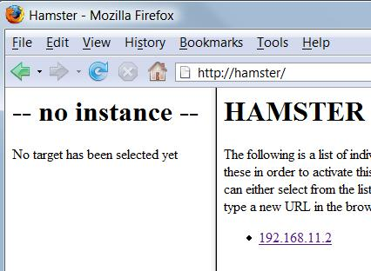
- In the Options box, click OK.

Using the Hamster Web Interface on the Attacker Machine
- On the Vista Attacker machine, in the Firefox address bar, type in http://hamster and press the Enter key.
- The HAMSTER 1.0 Side-Jacking page should open, as shown to the right on this page.
- But there's a problem! The Target IP address is not there. That's because the switch is not sending any packets from the Target to the Attacker.
Installing Cain on the Attacker Machine
- On the Vista Attacker machine , open a Web browser. Go to http://www.oxid.it/cain.html
- Click the " Download Cain & Abel v4.9.10 for Windows NT/2000/XP" link. Install the software. When it asks about installing WinPcap, click "Don't Install" – you already have WinPCap.
Turning off the Firewall on the Attacker Machine
- Click Start, "Control Panel". If necessary, click "Classic View". Double-click "Windows Firewall".
- In the "Windows Firewall" box, click "Turn Windows Firewall on or off". In the "User Account Control" box, press Alt+C or click Continue.
- In the "Windows Firewall Settings" box, click the "Off (not recommended)" radio button. Click OK.
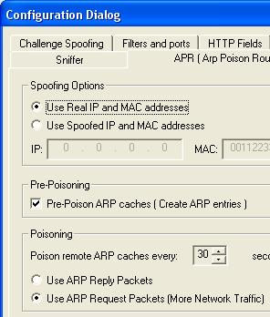
Sniffing for Targets
- Click Start, "All Programs", Cain. Point to Cain, right-click, and click "Run as Administrator". In the "User Account Control" box, press Alt+A or click Allow.
- In the Cain window, from the top menu, click Configure.
- In the “Configuration Dialog” box, on the Sniffer tab, verify that the interface with the IP address that goes to the Internet is highlighted.
- In the “Configuration Dialog” box, on the APR tab, click the “Use ARP Request Packets (More Network Traffic)” radio button at the bottom, as shown to the right on this page. Click OK.
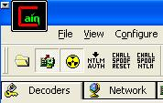
- In the upper left of the Cain window, click the “Start/Stop Sniffer” button (the second button from the left), and the “Start/Stop APR” button (third from the left) so they are both depressed, as shown to the right on this page.
- If a "Windows Security Alert" box pops up, saying "Windows Firewall has blocked some features of this program", click Unblock.
- At the top of the screen, click the Sniffer tab. On the toolbar, click the+ icon.
- In the “Mac Address Scanner” box, check the “All Tests” box. Click OK. Wait while several progress bars move across the screen.
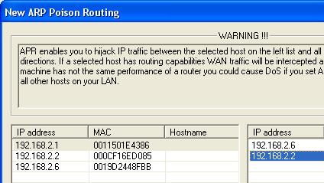
- Click the APR tab at the bottom. Click in the empty upper right hand table. Click the + icon on the toolbar.
Starting the ARP Poison Routing
- In the “New APR poison Routing” box, click the gateway IP in the left pane. Then click the Target IP in the right pane, as shown to the right on this page. Click OK.

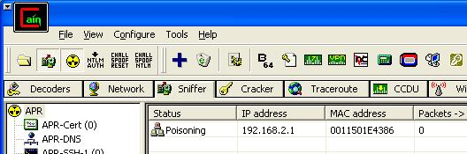
- Wait 30 seconds. You should see a Status of Poisoning, as shown below on this page. If you see a status of "Idle", toggle the the “Start/Stop Sniffer” button and the “Start/Stop APR” buttons, leaving them both depressed.

Capturing a Screen Image
- Press the PrintScrn key in the upper-right portion of the keyboard.
- Click Start, Programs, Accessories, Paint. In the untitled - Paint window, select Edit, Paste from the menu bar.
- In the untitled - Paint window, click File, Save. Select a Save as type of JPEG. Save the document with the filename Your Name Proj X2a.

Opening Gmail on the Target Machine
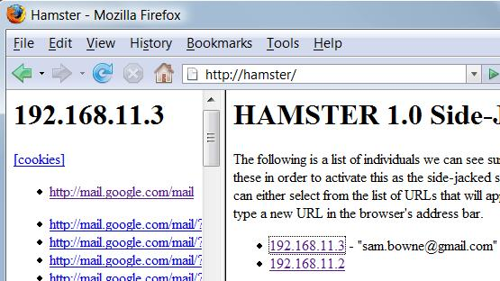
- On the Target machine, in the Firefox window, go to gmail.com
- Log in with a Gmail account. If you don't want to use your own account, use this one: User name S214Target password hackmenow
- On the Vista Attacker machine, in the Firefox window, click the Refresh button.
- On the right side, you should now see the Target IP address. Click it.
- In the left pane, click the http://mail.google.com/mail link.

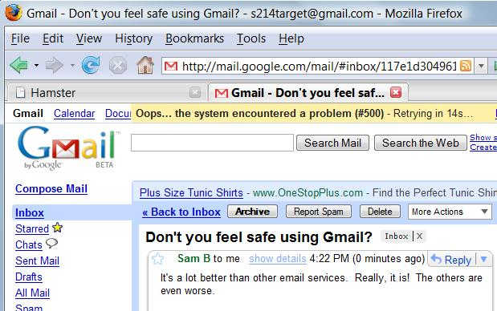
- On the Vista Attacker machine, in the Firefox window, a Gmail page opens, as shown to the right on this page.

Capturing a Screen Image
- Make sure both the Hamster and Gmail tabs are visible on the screen.
- Press the PrintScrn key in the upper-right portion of the keyboard.
- Click Start, Programs, Accessories, Paint. In the untitled - Paint window, select Edit, Paste from the menu bar.
- In the untitled - Paint window, click File, Save. Select a Save as type of JPEG. Save the document with the filename Your Name Proj X2b.

Turning in Your Project
- Email the JPEG image to me as attachments to one e-mail message. Send it to: cnit.124@gmail.com with a subject line of Proj X2 From Your Name, replacing Your Name with your own first and last name. Send a Cc to yourself.

Returning Firefox to Normal Function
- On the Vista Attacker machine, from the Firefox window's menu bar, click Tools, Options.
- In the Options box, click the Advanced button. Click the Network tab.
- In the Connection section, click the Settings button.
- In the "Connection Settings" box, click the "Direct connection to the Internet" radio button.
- In the "Connection Settings" box, click OK.
- In the Options box, click OK.

Last Modified: 2-3-08 11 PM

