What You Need for This Project
Warning! "Ethical Hacking and Network Defense" students will capturing passwords in room S214. Don't do online shopping, personal e-mailing, or any other private computer work in that lab. Make up a new password just for that lab. Nothing you do in that lab is private!
- A trusted computer running any version of Windows, with Internet access. This can be either a real or virtual machine.
- You need administrator privileges on the trusted machine.
- The trusted machine must have Firefox installed on it.
- The instructions below assume you are working in the S214 lab. If you are working at home, you will have to adapt the steps to match your situation.

Start Your Host Machine
- Power on a computer and log on with CCSF Student ID and the password you chose previously.

Starting VMware
- Double-click the VMware Workstation icon on the desktop. In the VMware Workstation window, from the menu bar, click View, Go to Home Tab.
- On the Home tab, click the Open Existing VM or Team icon. Navigate to the V: drive, open your folder, open the Win XP Pro for Hacking folder, and double-click the Windows XP Professional.vmx file.

Starting Your Virtual Machine
- In the Windows XP Professional – VMware Workstation window, on the left side, click the Start this virtual machine link.
- If you see a message saying “The location of this virtual machine’s configuration file has changed…,” accept the default selection of Create and click OK.
- When your machine starts up, click the Student account to log in. There is no password, and the Student account has Administrative privileges.
Installing the Wireshark Packet Sniffer
- Open Firefox and go to WireShark.org
- At the top left of the WireShark main page, click the Download link.
- In the "Download a stable release" section, in the "Windows 2000/XP/2003/Vista Installer (.exe)" section, click the SourceForge.net link.
- Download the installer and save it on your desktop.
- Double-click the installer file, and install the software with the default selections. It will also install WinPCap.

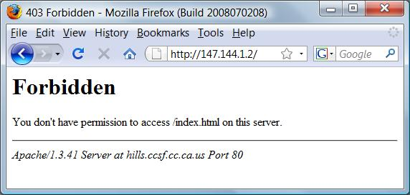
Opening the Test Page
- In the Firefox Address bar, type 147.144.1.2 and press the Enter key. You should see an error message, as shown to the right on this page. It doesn't matter if there is a page there or not—your browser still sends an HTTP GET message, and that's what we want to see.
Starting a Packet Capture
- Click Start, All Programs, Wireshark, Wireshark.
- From the Wireshark menu bar, click Capture, Interfaces. Find the Interface with an IP address starting with 192.168.1. That’s the interface that connects to the room’s LAN. Click the Start button in that interface’s line.
- If you see a message saying "Save capture file before starting a new capture? ", click "Continue Without Saving".
Reloading the Test Web Page
- In the Firefox window, click View, Reload.
Stopping the Packet Capture
- In the Wireshark window, click Capture, Stop.
- In the captured packets, find the one with a Destination of 147.144.1.2 and an Info of "GET / HTTP/1.1", as shown below on this page.
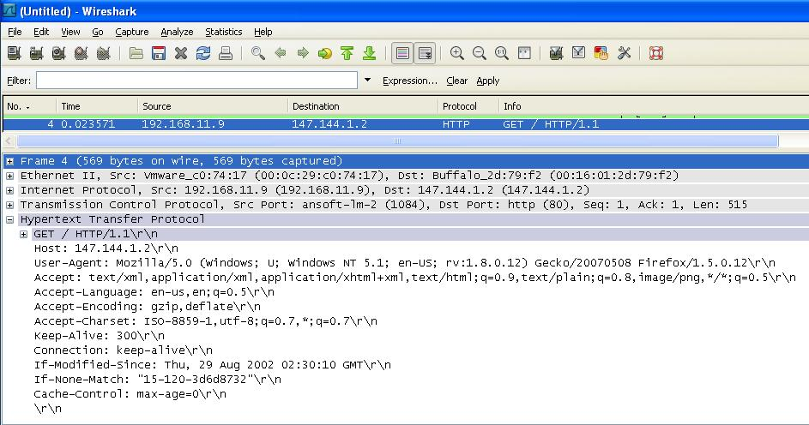

- Expand the Hypertext Transfer Protocol section in the center pane of the Wireshark window, to show the information that was sent to the server in this packet. You should see these items, as show on the previous page:
Item Explanation
- GET / HTTP/1.1\r\n HTTP Command
- Host: 147.144.1.2\r\n Host – the domain being requested
- User-Agent: Mozilla/5.0… Type of browser being used
Many more items…
- This information is the HTTP Header and it is sent to every Web server you use. Normally this information is harmless and helps Web page designers optimize the experience of every user, by modifying a page to suit the capabilities of each browser.
Installing the "User Agent Switcher" Firefox Extension
- You can change all the HTTP Header fields, but the most interesting one to change is User-Agent.
- In the Firefox window, click Tools, Add-ons. In the Extensions box, in the lower-right corner, click "Get More Extensions".
- In the "Firefox Add-ons" page, in the Search field, type "User Agent". Click the Search button.
- In the results page, click "User Agent Switcher".
- On the next page, click the green "Add to Firefox" button.
- In the "Software Installation" box, wait a few seconds, and then click the "Install Now" button.
- Click the "Restart Firefox" button..
Changing the User-Agent to Googlebot
- In the Firefox window, click Tools, "User Agent Switcher", Options, Options.
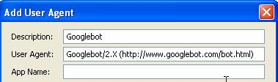
- In the "User Agent Switcher Options" box, in the top left, click "User Agents". Click the Add button.
- In the "Add User Agent" box, enter a Description of Googlebot, as shown to the right on this page.
- In the "Add User Agent" box, enter this User Agent:
Googlebot/2.X (http://www.googlebot.com/bot.html)
- In the "Add User Agent" box, click OK.
- In the "User Agent Switcher Options" box, click OK.
- You have now added Googlebot as an available User Agent, but you have not yet chosen to use it. To do that, in the Firefox window, click Tools, "User Agent Switcher", Googlebot.

Opening the Test Page
- In the Firefox Address bar, type 147.144.1.2 and press the Enter key.
Starting a Packet Capture
- In the Wireshark window, click Capture, Interfaces. Find the Interface with an IP address starting with 192.168.1. That’s the interface that connects to the room’s LAN. Click the Start button in that interface’s line.
- If you see a message saying "Save capture file before starting a new capture? ", click "Continue Without Saving".
Reloading the Test Web Page
- In the Firefox window, click View, Reload.
Stopping the Packet Capture
- In the Wireshark window, click Capture, Stop.
- In the captured packets, find the one with a Destination of 147.144.1.2 and an Info of "GET / HTTP/1.1". You should see a User-Agent of "Googlebot/2.X (http://www.googlebot.com/bot.html)", as shown below on this page.
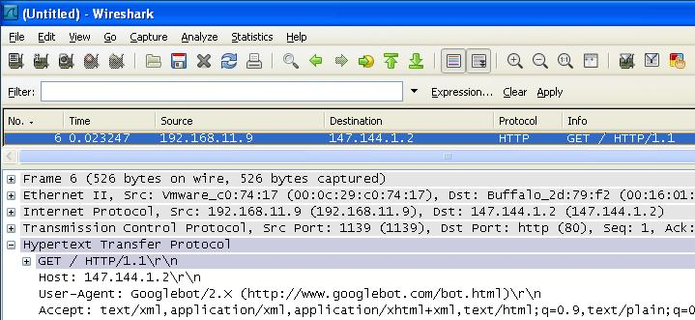

Capturing a Screen Image
- Press Ctrl+ Alt on the keyboard to release the cursor from the Virtual Machine window. Move the mouse pointer out of the VMWare Workstation window. Click an empty portion of the host Windows XP desktop.
- Press the PrintScrn key in the upper-right portion of the keyboard. That will copy the whole desktop to the clipboard.
- Click Start, Programs, Accessories, Paint. In the untitled - Paint window, select Edit, Paste from the menu bar.
- In the untitled - Paint window, click File, Save. Save the document in the My Pictures folder (or any other place you wish, such as a floppy disk) with the filename Your Name Proj 2a. Select a Save as type of JPEG, as shown in the figure to the right on this page.

Opening the Header Test Page
- In the Firefox Address bar, type this address and press the Enter key:
samsclass.info/124/proj/sniffer3.htm
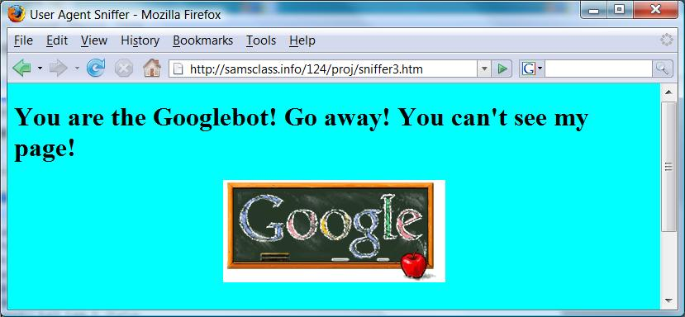
- You should see the message shown to the right on this page, recognizing you as the Googlebot.

Changing the User-Agent to "CNIT 124"
- In the Firefox window, click Tools, "User Agent Switcher", Options, Options.
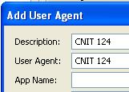
- In the "User Agent Switcher Options" box, in the top left, click "User Agents". Click the Add button.
- In the "Add User Agent" box, enter a Description of "CNIT 124", as shown to the right on this page.
- In the "Add User Agent" box, enter a User Agent of "CNIT 124".
- In the "Add User Agent" box, click OK.
- In the "User Agent Switcher Options" box, click OK.
- You have now added Googlebot as an available User Agent, but you have not yet chosen to use it. To do that, in the Firefox window, click Tools, "User Agent Switcher", "CNIT 124".

Opening the Header Test Page
- In the Firefox Address bar, type this address and press the Enter key:
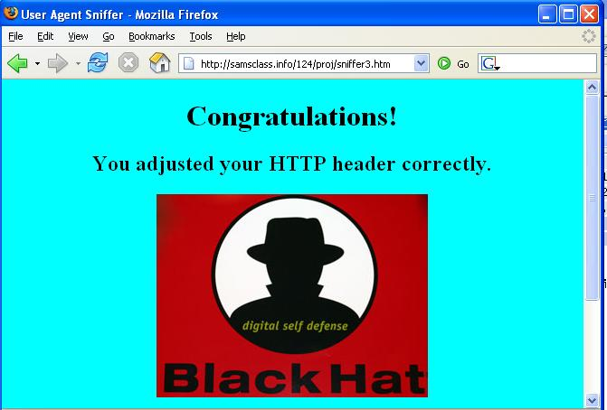
samsclass.info/124/proj/sniffer3.htm
- You should see the message shown below on this page, recognizing you as a CNIT 124 student.

Capturing a Screen Image
- Press Ctrl+ Alt on the keyboard to release the cursor from within the Virtual Machine window. Move the mouse pointer out of the VMWare Workstation window. Click an empty portion of the host Windows XP desktop.
- Press the PrintScrn key in the upper-right portion of the keyboard.
- Click Start, Programs, Accessories, Paint. In the untitled - Paint window, select Edit, Paste from the menu bar.
- In the untitled - Paint window, click File, Save. Save the document in the My Pictures folder (or any other place you wish, such as a floppy disk) with the filename Your Name Proj 2b. Select a Save as type of JPEG, as shown in the figure to the right on this page.

Turning in Your Project
- Email the JPEG image to me as attachments to one e-mail message. Send it to: cnit.124@gmail.com with a subject line of Proj 2 From Your Name, replacing Your Name with your own first and last name. Send a Cc to yourself.

Returning the User Agent to Normal
- You may want to reset your User Agent back to a normal setting.

Last Modified: 9-14-08

