What You Need for This Project
Warning! "Ethical Hacking and Network Defense" students will capturing passwords in room S214. Don't do online shopping, personal e-mailing, or any other private computer work in that lab. Make up a new password just for that lab. Nothing you do in that lab is private!
- The Kiosk virtual machine provided by your instructor. If you are working in S214, the virtual machine should already be on the VMs drive, in the Adv Hacking folder. If you are working at home, you will need the DVD your instructor provided with the Kiosk machine on it.
- You will need a host machine that can run the Kiosk machine, with VMWare Player or something equivalent.

Start the Kiosk Machine
- Copy the entire "Win XP Kiosk" folder to your hard disk, in your folder on the VMs drive.
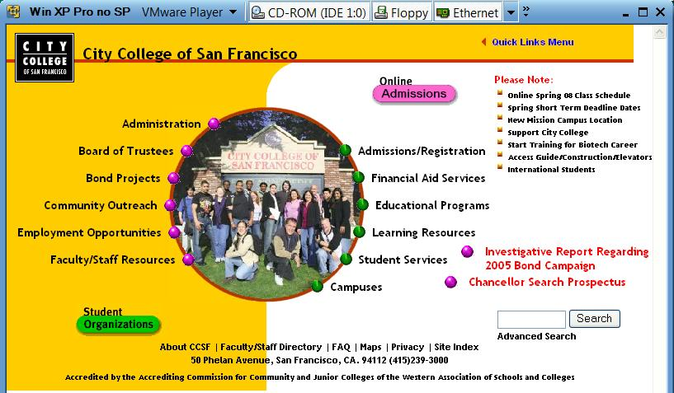
- Start VMware and run the Kiosk machine. You should see a virtual machine in Kiosk mode as shown below—no Start button, no desktop. There is nothing but a browser there, showing the CCSF home page. This is how computers are set up in public kiosks, intended for only one purpose.

Hack in to the Kiosk
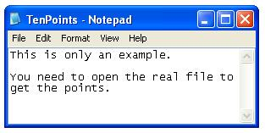
- This project does not give you detailed instructions. Figure out a way into that machine, so you can see the files on the hard drive. When you do, there are two levels of success, as detailed below.

The First Ten Points
- Open the file C:\TenPoints.txt on the Kiosk. Take a screen image of its contents, which will be different from the example shown to the right on this page. Save that image as Project3a.jpg.

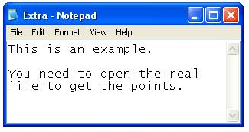
The Second Ten Points
- Open the file C:\Extra.txt on the Kiosk. Take a screen image of its contents, which will be different from the example shown to the right on this page. Save that image as Project3b.jpg.

Turning in Your Project
- Email the JPEG image to me as attachments to one e-mail message. Send it to: cnit.124@gmail.com with a subject line of Proj 3 From Your Name, replacing Your Name with your own first and last name. Send a Cc to yourself.

Last Modified: 9-14-08

