What You Need for This Project
- The Kiosk2 virtual machine provided by your instructor. If you are working in S214, the virtual machine should already be on the VMs drive, in the Adv Hacking folder. If you are working at home, you will need the DVD your instructor provided with the Kiosk machine on it.
- You will need a host machine that can run the Kiosk2 machine, with VMWare Player or something equivalent.

Start the Kiosk Machine
- Copy the entire Kiosk2 folder to your hard disk, in your folder on the VMs drive.
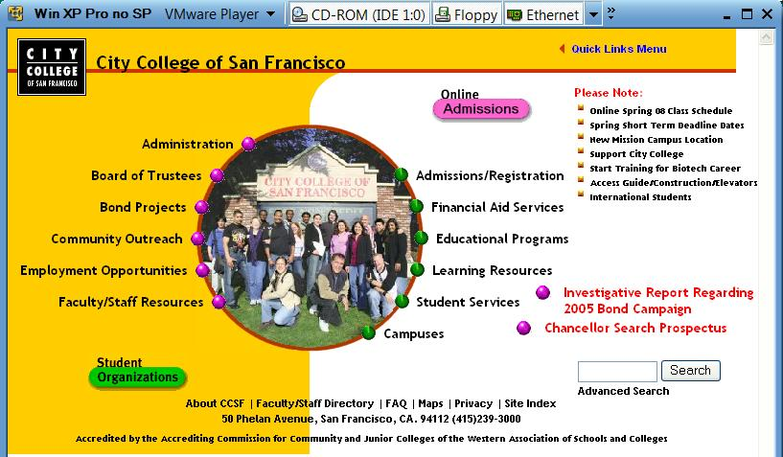
- Start VMware and run the Kiosk2 machine. You should see a virtual machine in Kiosk mode as shown below—no Start button, no desktop. There is nothing but a browser there, showing the CCSF home page. This is how computers are set up in public kiosks, intended for only one purpose.

Hack in to the Kiosk
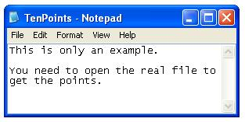
- This project does not give you detailed instructions. Figure out a way into that machine, so you can see the files on the hard drive. When you do, there are two levels of success, as detailed below.

The First Ten Points
- Open the file C:\TenPoints.txt on the Kiosk. Take a screen image of its contents, which will be different from the example shown to the right on this page. Save that image as Project4a.jpg.

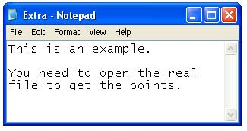
The Second Ten Points
- Open the file C:\MorePoints.txt on the Kiosk. Take a screen image of its contents, which will be different from the example shown to the right on this page. Save that image as Project4b.jpg.

Turning in Your Project
- Email the JPEG image to me as attachments to one e-mail message. Send it to: cnit.124@gmail.com with a subject line of Proj 4 From Your Name, replacing Your Name with your own first and last name. Send a Cc to yourself.

Last Modified: 9-14-08

