What You Need for This Project
- A computer running Ubuntu Linux 8.04, or any other supported version, with Internet access. This can be either a real or virtual machine. If you need one to use in S214, copy the one on the VMs drive, in the "Hacking" folder, but don't use Ubuntu 6.10—it is no longer supported.
- A second computer on the same LAN running any version of Windows. In S214, the simplest way to do this is to use Vista as the host operating system, and Ubuntu in a virtual machine on the Vista host. You may need to install VMware Player on the Vista machine. VMware player is available on the VMs drive in the Install folder. The instructions below assume you are using Vista in S214.

Starting Your Ubuntu Machine
- If you are working in S214, use VMware. Log in to the Ubuntu machine with the user name yourname and a password of P@ssw0rd
Testing the iptables Firewall
- You need iptables for this port knocking technique. It's included in Ubuntu by default.
- On your Ubuntu machine, click Applications, Accessories, Terminal.
- In the Terminal window, type this command, and then press the Enter key:
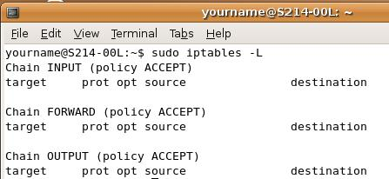
sudo iptables -L
Enter your password when prompted to. In S214, the password is P@ssw0rd
- This will show the current iptables firewall rules, as shown to the right on this page. These rules allow all traffic—the firewall is running, but not blocking anything.
Finding the Ubuntu Machine's IP Address
- On your Ubuntu machine, in the Terminal window, type this command, and then press the Enter key:
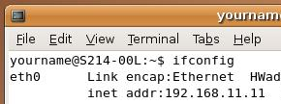
ifconfig
- Your IP address should appear in the eth0 line, as shown to the right on this page. If you don't have eth0, but only eth1, that's a VMware problem that you will need to fix, with the steps below. If you don't know what version of Ubuntu you are using, click System, "About Ubuntu".
For Ubuntu 6.10 (Edgy) and 7.04 (Feisty)
    - Look at the output from the ifconfig command and find the HWaddr for your eth1 interface.
    - In your Ubuntu machine, edit the /etc/iftab file with this command: sudo nano /etc/iftab and change the MAC address to match the one you found in the previous step.
    - Restart the Ubuntu virtual machine.
For Ubuntu 7.10 (Gutsy) and 8.04 (Hardy)
    - Look at the output from the ifconfig command and find the HWaddr for your eth1 interface.
    - In your Ubuntu machine, edit the /etc/udev/rules.d/70-persistent-net.rules file with this command: sudo nano /etc/udev/rules.d/70-persistent-net.rules and change the MAC address to match the one you found in the previous step.
    - Restart the Ubuntu virtual machine.

Ubuntu IP: __________________
- Write your eth0 IP address in the box shown to the right on this page.
Installing SSH on the Ubuntu Machine
- SSH is a secure way to connect remotely to your Ubuntu machine. And we'll make it even more secure by adding port knocking to it.
- On your Ubuntu machine, in the Terminal window, type this command, and then press the Enter key:
sudo apt-get install ssh
Enter your password of P@ssw0rd if you are prompted to. When you are asked "Do you want to continue [Y/n]?", type Y and press the Enter key.
Installing Nmap on the Windows Machine
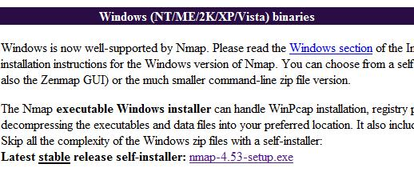
- On the Windows machine, open a Web browser and go to nmap.org
- In the top section of the page, click the Download link.
- Scroll down to the Windows section, as shown to the right on this page. Find the "Latest stable release self-installer" and click the link on that line. Save the installer on your desktop.
- Close all windows and double-click the installer. Install the software with the default options.
Scanning the Ubuntu Machine with Nmap
- On the Windows machine, click Start, "All Programs", Nmap. Right-click "Nmap – Zenmap GUI" and click "Run as Administrator". In the "User Account Control" box, click Allow.

- In the Zenmap window, in the Target: box, enter the Ubuntu machine's IP address. Click the Scan button. You should see port 22/tcp open, as shown below on this page.
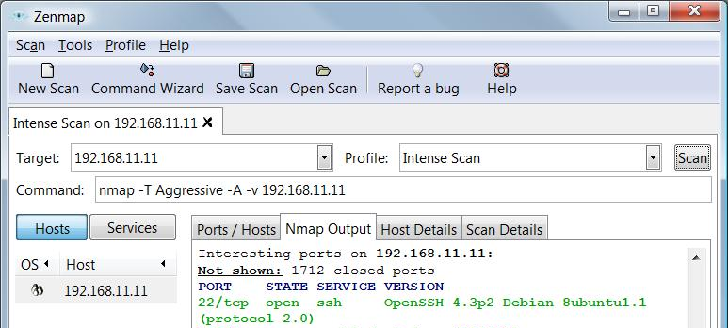

Installing the SSH Secure Shell Client on the Windows Machine
- On the Windows machine, open a Web browser and go to ftp://ftp.ccsf.edu/pub/SSH
- Click the "sshSecureShellClient-3.2.9.exe" link. Save the file on your desktop.
- On your desktop, double-click sshSecureShellClient-3.2.9.exe" file. Install the software with the default options.
Opening a SSH Session from the Windows Machine
- On the Windows machine, click Start, "All Programs", "SSH Secure Shell", "Secure Shell Client". If you see an error message saying a directory could not be opened for a configuration file, just close it. That always happens the first time you use this program.
- In the "- default – SSH Secure Shell" window, click the "Quick Connect" button.
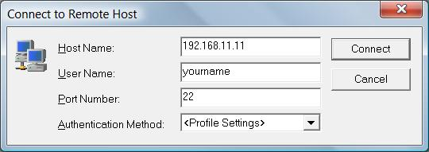
- In the "Connect to Remote Host" box, put your Ubuntu machine's IP address in the "Host Name" box. In the "User Name" box, enter yourname, as shown to the right on this page. Click Connect.
- In the "Host Identification" box, click Yes. The fingerprint shown here gives you protection from a man-in-the-middle attack, but we aren't worrying about that right now.
- In the Password box, enter P@ssw0rd and click OK.

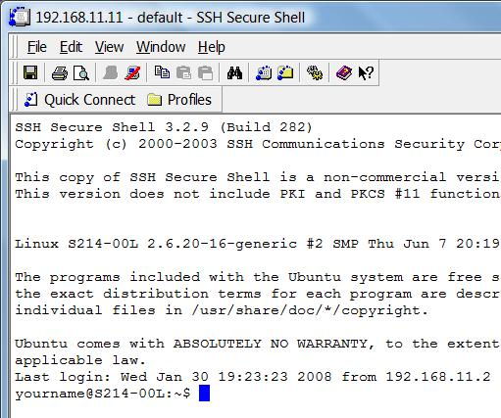
- You should see a window showing a long banner (revealing more than it should), with the warning "Ubuntu comes with ABSOLUTELY NO WARRANTY", ending with a $ prompt, as shown to the right on this page.

Capturing a Screen Image
- Press the PrintScrn key in the upper-right portion of the keyboard.
- Click Start, Programs, Accessories, Paint. In the untitled - Paint window, select Edit, Paste from the menu bar.
- In the untitled - Paint window, click File, Save. Select a Save as type of JPEG. Save the document with the filename Your Name Proj 5a.
Using the SSH Session
- On the Windows machine, in the SSH Secure Shell window, after the $ prompt, type this command, and then press the Enter key:
whoami
You should see the answer yourname.
- You now have complete remote control over your Ubuntu machine. You could even use sudo and gain administrative privileges. Your only protection is your password—if someone cracked that, your Ubuntu machine would be owned. We'll fix that by adding port knocking, to make it more secure.
- Close the SSH Secure Shell window. In the "Confirm Exit" box, click OK.
Configuring the iptables Firewall to Allow Established Traffic
- On the Ubuntu machine, in the Terminal window, type this command, and then press the Enter key:
sudo iptables -A INPUT -m state --state ESTABLISHED,RELATED -j ACCEPT
This rule will allow the machine to act as a client, like the Windows XP Service Pack 2 firewall—traffic initiated by the machine will be allowed. Of course, this won't make any immediate difference because right now all traffic is allowed anyway.
Configuring the iptables Firewall to Block All Other Traffic
- On the Ubuntu machine, in the Terminal window, type this command, and then press the Enter key:
sudo iptables -A INPUT -j DROP
This rule will cause all traffic to be dropped, except the traffic that was allowed by the previous rule.
- In the Terminal window, type this command, and then press the Enter key:
sudo iptables -L
You should see two rules, one beginning with ACCEPT, followed by one beginning with DROP, as shown below on this page.
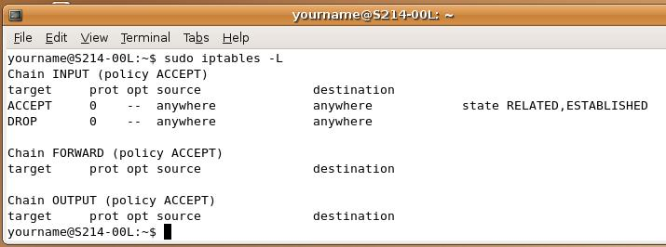

Checking Network Connectivity from the Ubuntu Machine
- On the Ubuntu machine, in the Terminal window, type this command, and then press the Enter key:
firefox
- Firefox opens. View a couple of Web pages. It should work, because those connections are established by the Ubuntu machine, and therefore allowed by the iptables firewall.
Scanning the Ubuntu Machine with Nmap
- On the Windows machine, in the Zenmap window, click the Scan button. The result should say "All 1714 scanned ports…are filtered", as shown below on this page
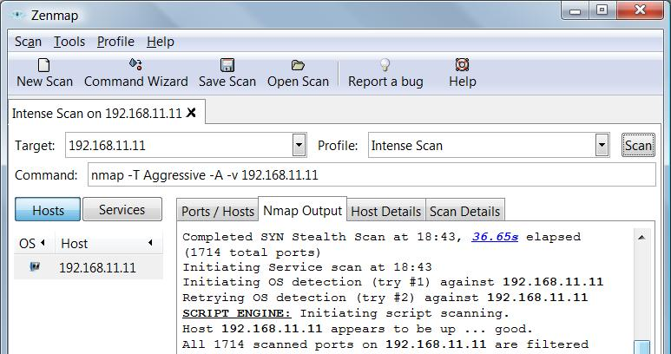

Opening a SSH Session from the Windows Machine
- On the Windows machine, click Start, "All Programs", "SSH Secure Shell", "Secure Shell Client".
- In the "- default – SSH Secure Shell" window, click the "Quick Connect" button.
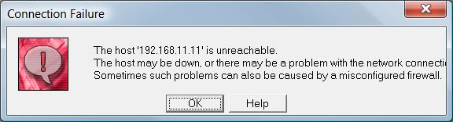
- In the "Connect to Remote Host" box, put your Ubuntu machine's IP address in the "Host Name" box. In the "User Name" box, enter yourname
- Click Connect. After a pause of 30 seconds or so, a "Connection Failure" box appears, as shown to the right on this page. The firewall is not allowing SSH to connect, because all connections originating from the outside are denied.
Installing knockd
- On the Ubuntu machine, in the Terminal window, type this command, and then press the Enter key:
sudo apt-get install knockd
It should download and install from the Ubuntu archives. When the installation is complete, you will see this message: "Not starting knockd. To enable it edit /etc/default/knockd".
Customizing the knockd Configuration File
- On the Ubuntu machine, in the Terminal window, type this command, and then press the Enter key:
sudo pico /etc/knockd.conf
- The file opens in the pico file editor, as shown below on this page. The portion we are most interested in is the [OpenSSH] section. For right now, leave the sequence as it is, but change the seq_timeout to 50. That will give us plenty of time to complete the port knocking—50 seconds.
- You also need to change the command in the [OpenSSH] section to this (thanks to Artem for pointing this out to me):
command = /sbin/iptables –I INPUT 1 –s %IP% -p tcp --dport 22 –j ACCEPT
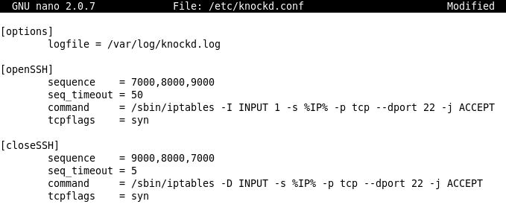
- Your knockd.conf file should now look like the example below.

- Press Ctrl+X. Respond to the "Save modified buffer" message by pressing Y. Respond to the "File Name to write" message by pressing the Enter key.

Starting knockd
- On the Ubuntu machine, in the Terminal window, type this command, and then press the Enter key:
sudo knockd
There will be no response, and no $ prompt. knockd is running—just leave the Terminal window open.
Showing the knockd Log
- On the Ubuntu machine, in the Terminal window, click File, "Open Terminal".
- In the new Terminal window type this command, and then press the Enter key:
tail –f /var/log/knockd.log
This will show the knockd log file, continuously updated, as shown below on this page.
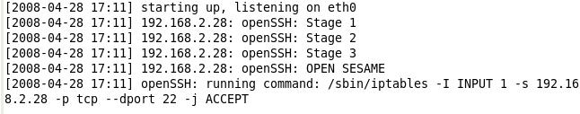
Knocking with Nmap
- On the Windows machine, in the Zenmap window, enter this line into the Command: field:
nmap -p7000 -PN -sS –max-retries 0 192.168.11.11
Replace the IP address at the end of the command with the IP address of your Ubuntu machine.
- Click the Scan button. This will send a SYN packet to port 7000 on the Ubuntu machine.
- Look at your Ubuntu machine. You should see the message "OpenSSH: Stage 1", as shown below on this page. This means that the first stage of port knocking is complete.

- On the Windows machine, in the Zenmap window, enter this line into the Command: field:
nmap –p8000 -PN -sS –max-retries 0 192.168.11.11
Replace the IP address at the end of the command with the IP address of your Ubuntu machine.
- Click the Scan button. This will send a SYN packet to port 8000 on the Ubuntu machine.
- On the Windows machine, in the Zenmap window, enter this line into the Command: field:
nmap –p9000 -PN -sS –max-retries 0 192.168.11.11
Replace the IP address at the end of the command with the IP address of your Ubuntu machine.
- Click the Scan button. This will send a SYN packet to port 9000 on the Ubuntu machine.

- Look at your Ubuntu machine. You should see that all three stages of knocking are complete, and that the iptables command has been run to open the port, as shown below on this page.

Opening a SSH Session from the Windows Machine
- On the Windows machine, click Start, "All Programs", "SSH Secure Shell", "Secure Shell Client". If you see an error message saying a directory could not be opened for a configuration file, just close it. That always happens the first time you use this program.
- In the "- default – SSH Secure Shell" window, click the "Quick Connect" button.
- In the "Connect to Remote Host" box, put your Ubuntu machine's IP address in the "Host Name" box. In the "User Name" box, enter yourname, as shown to the right on this page. Click Connect.
- In the Password box, enter P@ssw0rd and click OK.
- You should connect successfully, and see the warning "Ubuntu comes with ABSOLUTELY NO WARRANTY", ending with a $ prompt. The knocking opened the port!
Viewing the Ubuntu Processes With the SSH Session
- On the Windows machine, widen the SSH Secure Shell window, so that longer lines are visible.
- in the SSH Secure Shell window, after the $ prompt, type this command, and then press the Enter key:
sudo ps aux
Enter your password when you are prompted to.

- You should see a list of active processes on the Ubuntu machine. You should see a knockd process, and at least one sshd process, as shown below on this page.
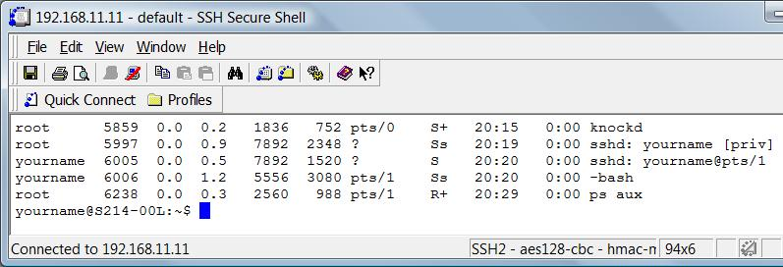

Capturing a Screen Image
- Press the PrintScrn key in the upper-right portion of the keyboard.
- Click Start, Programs, Accessories, Paint. In the untitled - Paint window, select Edit, Paste from the menu bar.
- In the untitled - Paint window, click File, Save. Select a Save as type of JPEG. Save the document with the filename Your Name Proj 5b.

Turning in Your Project
- Email the JPEG image to me as attachments to one e-mail message. Send it to: cnit.124@gmail.com with a subject line of Proj 5 From Your Name, replacing Your Name with your own first and last name. Send a Cc to yourself.

Last Modified: 7-15-09 8 am

