What You Need for This Project
- A computer running any version of Windows to be the Attacker. It can be a real or virtual machine.
- A second computer on the same LAN to be the Target. The Target can run any operating system at all, Windows, Mac, Linux, Unix, whatever. It can be a real or virtual machine.
- The two computers must be connected on a hubbed, not switched network, so the Attacker can capture packets from Target. The instructions below assume you are using a Vista PC as the Attacker, and a Windows XP virtual machine as the Target.

Starting the Attacker Machine
- If you are working in S214, boot your PC to Vista and log in as Student. This will be your Attacker machine.
  - If there is a password, try P@ssw0rd. If that doesn't work, use the Ultimate Boot CD to create a new administrator account for yourself. Everyone using computers in S214 has been warned that their machine may be hacked. Of course, don't delete their homework files or anything nasty, but have no reluctance to create admin accounts and use their machines.
- If VMware Player is not installed, get it from the VMs drive in the Install folder and install it. If you can't find the VMware player, or prefer to use the latest version, go to vmware.com and download it.

Starting the Target Machine
- Use VMware and run any of your virtual machines. That will be your Target machine.
- Open a browser on your Target machine and make sure you can connect to the Internet.

Finding the Target Machine's IP Address
- On your Target machine, click Start, Run. Type in CMD and press the Enter key.
- In the Command Prompt window, type in IPCONFIG and press the Enter key. Find your IP address and write it in the box to the right on this page. In S214, your IP address will start with 192.168.1.

Target IP: _________________

Installing Nmap on the Attacker Machine
- You need to have WinPCap on your Vista Attacker machine. A simple way to do that is to install Nmap, which is something you should have handy anyway.
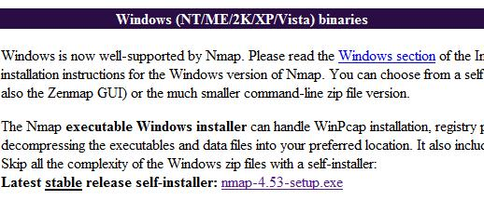
- On the Attacker machine, open a Web browser and go to nmap.org
- In the top section of the page, click the Download link.
- Scroll down to the Windows section, as shown to the right on this page.
- Find the "Latest stable release self-installer" and click the link on that line. Save the installer on your desktop.
- Close all windows and double-click the installer. Install the software with the default options.

Downloading Ferret and Hamster on the Attacker Machine
- On your Vista Attacker machine, open Firefox and go to this URL:
http://www.erratasec.com/sidejacking.zip
- Save the file on your desktop. Double-click it to open it. Drag the Sidejacking folder to your desktop.

Running the Ferret Cookie Sniffer on the Attacker Machine
- On the Vista Attacker machine's desktop, hold down the Shift key and right-click the Sidejacking folder. In the context menu, click "Open Command Window Here".
- In the Command Prompt window, type the following command, then press the Enter key:
ferret –i 0
- Open Firefox and go to www.ccsf.edu. You should see a message saying 'Traffic seen proto="HTTP", op="GET", Host="www.ccsf.edu", URL="/"', as shown below on this page.
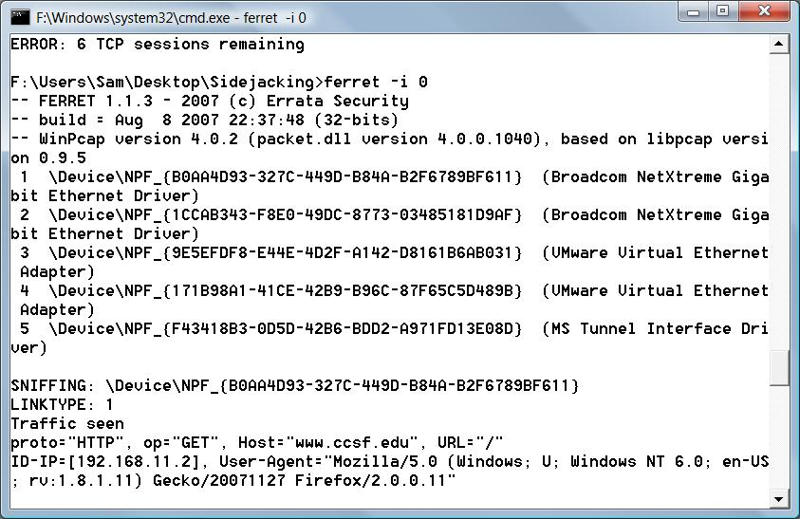
  - If you don't see any traffic, try using a different number after the –i switch to select a different network adapter, such as ferret –i 1

- On the Vista Attacker machine, open some web sites, such as google.com and msn.com. You should see information about each website scroll by as Ferret collects cookies.

Running the Hamster Proxy Server on the Attacker Machine
- On the Vista Attacker machine's desktop, double-click Sidejacking folder to open it.
- In the Sidejacking widow, double-click hamster.exe/
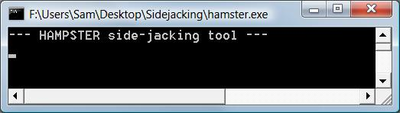
- If a "Windows Security Alert" box pops up, saying "Windows Firewall has blocked some features of this program", click Unblock. In the "User Account Control" box, press Alt+C or click Continue.
- A Command Prompt window opens, showing the message "HAMPSTER side-jacking tool", as shown to the right on this page.

Configuring Firefox to Use the Proxy Server on the Attacker Machine
- Warning: the Hamster documentation says it will screw up the cookies in your browser. I didn't see any problem when I did it, however. You may want to create a different Firefox profile just for this project, however. I didn't bother.
- On the Vista Attacker machine, from the Firefox window's menu bar, click Tools, Options.
- In the Options box, click the Advanced button. Click the Network tab.
- In the Connection section, click the Settings button.
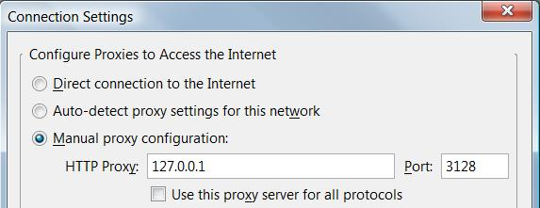
- In the "Connection Settings" box, click the "Manual pro xy configuration" radio button. Enter an HTTP Proxy: of 127.0.0.1 and a Port of 3128, as shown below on this page.
- In the "Connection Settings" box, click OK.
- In the Options box, click OK.

Using the Hamster Web Interface
- On the Vista Attacker machine, in the Firefox address bar, type in http://hamster and press the Enter key.
- The HAMSTER 1.0 Side-Jacking page should open, as shown below on this page. On the right side of this page, find the Target IP address you wrote in the box on a previous page of these instructions and click it.

Opening Gmail on the Target Machine
- On the Target machine, in the Firefox window, go to gmail.com
- Log in with a Gmail account. If you don't want to use your own account, use this one: User name S214Target password hackmenow

Viewing the Captured Cookie on the Attacker Machine
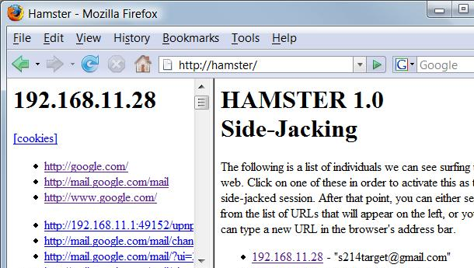
- On the Vista Attacker machine, in the Firefox window, click the Refresh button. On the right side, notice that the Target IP address appears, with the Gmail account name from the Target machine, as shown below on this page

Capturing a Screen Image

- Make sure you can see the HAMSTER title, and an IP address with a Gmail account name, as shown to the right on this page. That shows that you have successfully captured a Gmail logon cookie with Hamster.
- Press the PrintScrn key in the upper-right portion of the keyboard.
- Click Start, Programs, Accessories, Paint. In the untitled - Paint window, select Edit, Paste from the menu bar.
- In the untitled - Paint window, click File, Save. Select a Save as type of JPEG. Save the document with the filename Your Name Proj 6.

Viewing Gmail on the Attacker Machine
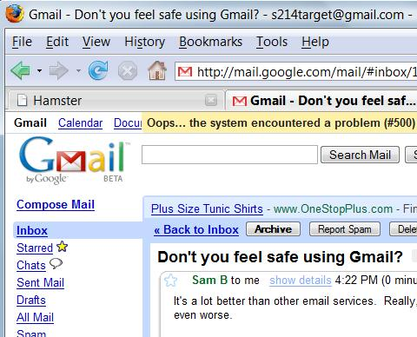
- In the left pane, click the http://mail.google.com/mail link.
- On the Vista Attacker machine, in the Firefox window, a Gmail page opens, as shown to the right on this page. This is the Gmail from the Target machine.
- Click any email in the Inbox to open it.
Trying the Gmail Services
- See how much real functionality you get in the sidejacked Gmail box. When I tried it, this is what I found:
  - I can open and read any message in the Inbox
  - I can't view the Sent Mail or Compose and send a new message.
  - Refreshing the page to see incoming new mail is unreliable. Sometimes it works, sometimes not. But if I want to see new mail, I can just do this: close the Gmail tab, refresh the Hamster window, click on the Target IP, and click on the http://mail.google.com/mail link again to see the new mail.

Trying the Secure Gmail Logon on the Target Machine
- On the Target machine, in the Firefox window showing Gmail, click "Sign out".
- On the Target machine, in the Firefox address bar, type in https://mail.gmail.com and press the Enter key.
- On the Target machine, in the Firefox window, go to https://mail.gmail.com
- Log in with a different Gmail account. If you don't want to use your own account, use this one: User name CNIT124Target password hackmenow

Viewing Gmail on the Attacker Machine
- On the Vista Attacker machine, in the Firefox window, click the Refresh button. On the right side, look at the Target IP address. It appears, but it only shows the previous Gmail account name. The Secure login has protected us!

Turning in Your Project
- Email the JPEG image to me as attachments to one e-mail message. Send it to: cnit.124@gmail.com with a subject line of Proj 6 From Your Name, replacing Your Name with your own first and last name. Send a Cc to yourself.

Returning Firefox to Normal Function
- On the Vista Attacker machine, from the Firefox window's menu bar, click Tools, Options.
- In the Options box, click the Advanced button. Click the Network tab.
- In the Connection section, click the Settings button.
- In the "Connection Settings" box, click the "Direct connection to the Internet" radio button.
- In the "Connection Settings" box, click OK.
- In the Options box, click OK.

References
http://www.tgdaily.com/content/view/34324/118/
http://erratasec.blogspot.com/2007/08/sidejacking-with-hamster_05.html
http://www.erratasec.com/

Last Modified: 8-5-08

