What You Will Need
Warning: Only use this on networks you own. Cracking into networks without permission is a crime—don’t do it!
- Two routers
- A computer that can boot from CD (almost all of them can)
- A Backtrack 2 Live CD

Choose Your Access Point/Router
- There are four Access Point/Routers available in S37: Linksys, D-Link, Belkin, and Buffalo. Choose one to be your Target Router. If possible, use a Belkin router, because I wrote the instructions for that one. But the steps should be similar for any router.
- The Destination Router you will use is already installed in the closet in S214 and does not need to be moved.

Wiring Your Network
- Wire your network as shown below, with these steps:
  - Unplug the blue cable from your computer, and plug that cable into the WAN port of your router (labeled the Target Router below).
  - Connect your computer to a LAN port on the Target Router with a patch cord
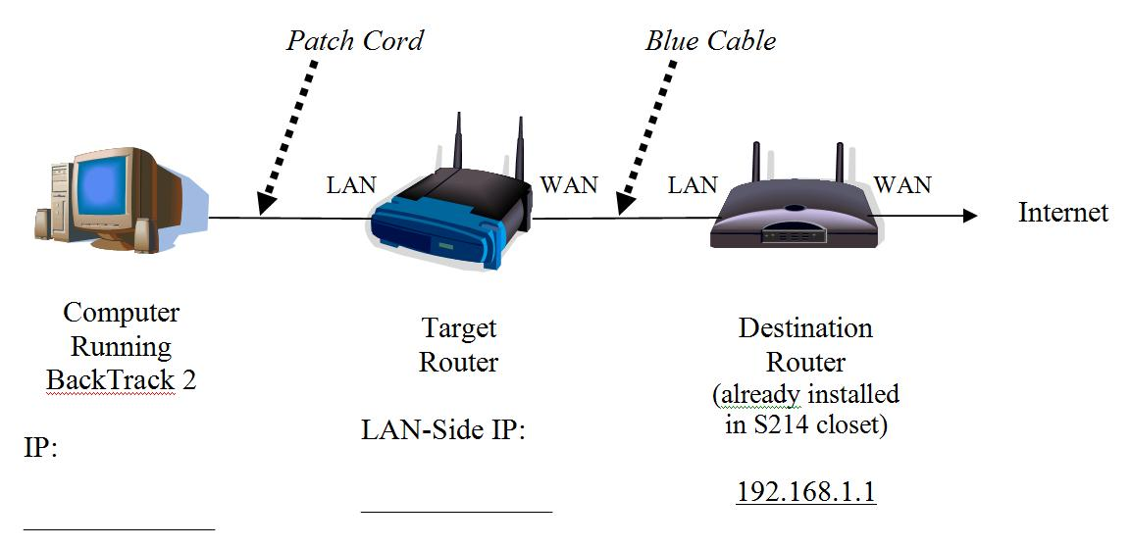

Restoring the Router to Factory Default Settings (Firewall Off)
- Find the reset button on the router, on the back or the bottom. Press the button with a paper clip and hold it in for ten seconds. This resets the router back to its factory default settings. By default, the firewall will be off.

Getting the BackTrack 2 CD
- You need a BackTrack 2 CD. Your instructor handed them out in class. If you are working at home, you download it from
http://www.remote-exploit.org/backtrack.html

Booting the Computer from the BackTrack 2 CD
- Insert the bt2 CD and restart your "Hacker Computer". If it won't boot from the CD, press F2 to enter the BIOS settings page and set it to boot from the CD. If it asks for a BIOS Password, press the Enter key.
- You should see a message beginning ISOLONUX. At the boot: prompt, press the Enter key. Several pages of text scroll by as Linux boots.
- When you see a page with a bt login: prompt, type in this username and press the Enter key:
root
- At the Password: prompt, type in this password and press the Enter key:
toor
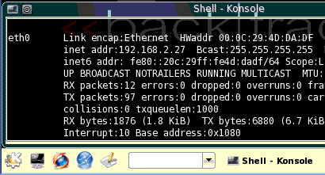
- At the bt ~ # prompt, type in this command and press the Enter key:
Konsole
button
Firefox
button
xconf
- At the bt ~ # prompt, type in this command and press the Enter key:
startx
- A graphical desktop should appear, with a start button showing the letter K on a gear in the lower left, as shown to the right on this page.

Checking the IP Address
- Click the Konsole button, as shown to the right on this page.
- In the "Shell – Konsole" window, type in this command, and then press the Enter key:
ifconfig
- In the results, find the "inet addr" for the eth0 device. This can be any number, but it must not start with 192.168.1. If it does, you are using the Linksys router (see below).
- If you are using the Linksys router, you must do the following steps. If you are using a different router, skip the next section.
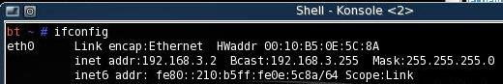

Adjusting the IP Address Range on the Linksys Router
- Disconnect the blue cable from the WAN port on the Linksys router. Leave the patch cord connected, so the BackTrack 2 computer can access the Linksys Router.
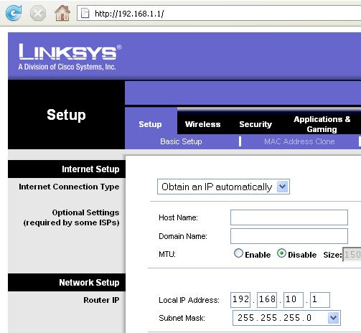
- Click the Firefox button. Go to this address: 192.168.1.1
- A box pops up asking for a user name and password. Leave the User Name blank and enter a password of admin
- In the Linksys page, on the Setup tab, change the Local IP Address to 192.168.10.1, as shown to the right on this page.
- Scroll to the bottom of the page and click the Save Settings button.
- A popup box appears saying “Next time, log in the router with the new IP address”. Click OK.
- Restart the computer from the front panel reset button and boot from the Backtrack CD again. Log in as root with password toor. Enter the xconf and startx commands again.
- Replace the blue cable in the WAN port on the Linksys router.
- Click the Konsole button.

Finding Your IP Address and Default Gateway
- In the "Shell – Konsole" window, type in this command, and then press the Enter key:
ifconfig
- In the results, find the "inet addr" for the eth0 device. This is your computer's IP address—write it in the IP section at the bottom left of the diagram on the first page.
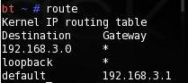
- In the "Shell – Konsole" window, type in this command, and then press the Enter key:
route
- In the results, find the "default" line, as shown to the right on this page. The address shown there is your Default Gateway—write it in the "Target Router LAN-Side IP" section at the bottom center of the diagram on the first page.

Running a traceroute
- In the "Shell – Konsole" window, type in this command, and then press the Enter key:
traceroute 192.168.1.1
- You should see results like those shown to below on this page, reaching the destination in 2 hops. The IP addresses should be the Target Router first, then the Destination Router, in agreement with the diagram on the first page of these instructions. Note: the Destination Router address in the figure is different from the one in S214.
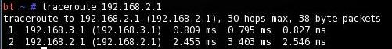

Firewalking with No Firewall On
- In the "Shell – Konsole" window, type in this command, and then press the Enter key:
firewalk –pTCP –S80-90 192.168.10.2 192.168.1.1
Replace 192.168.10.2 with the "Target Router LAN-Side IP" address you wrote at the bottom center of the diagram on the first page. The last address is the Destination Router.
-pTCP specifies that the TCP protocol will be used.
-S80-90 specifies that TCP ports 80 through 90 will be sent.

- You should see results like those below on this page. If you see "0 packets sent" instead, try repeating the traceroute command, and then repeating the firewalk command.
- Your results should show that all ports scanned are Open – that means that the Target Router passed the packets on to the Destination Router. Some of them are labelled "(port listen)" and others are labelled "(port not listen)". The listening status of the ports tells you information about the Destination Router, but it's not the main point of Firewalk to gather that information. The purpose of Firewalk is to find the filtering rules of the firewall on the Target Router, and at the moment the firewall is off so all the ports are Open. The A! indicates that the Destination Router is only one hop past the Target Router.
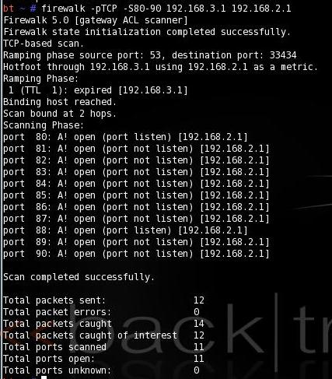

Saving the Screen Image on the Desktop
- On the Hacker Computer, from the Backtrack 2 desktop, click Start, Screenshot.
- In the Screenshot window, click the "Save As…" button.
- In the "Save as – Screenshot" window, in the unlabelled box on the upper right, click the arrow and select /root/desktop.
- In the "Save as – Screenshot" window, in the Location: box, type in a filename of
Yourname-Proj 8a.jpg
- Click the Save button. Your file should appear on the desktop.

Turning On the Firewall – Blocking TCP Ports 85 Through 90
- Click the Firefox button. Type the "Target Router LAN-Side IP" address you wrote at the bottom center of the diagram on the first page into the Firefox address bar. Press the Enter key. You should see a router administration page, sometimes preceded by a login box.
Router Default User Names and Passwords

Linksys: User: none
Password: admin

D-Link: User: admin
Password: none

Buffalo: User: root
(OpenWrt) Password: password
- The following instructions were written for the Belkin router. The other routers have similar screens, but the steps will vary somewhat. For your convenience, I have listed the router user names and passwords in the box to the right.

Steps for the Belkin Router
- You should have a Belkin page open in Firefox. In the upper right, click the “Log in” button.
- A Login screen appears. Leave the Password box empty and click the Submit button.
- On the left side of the screen, click “Client IP Filters”.
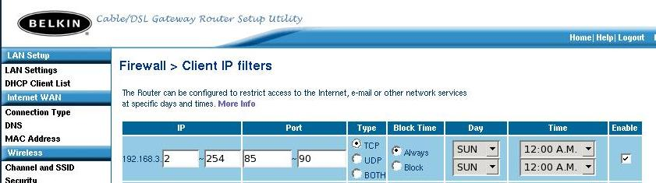
- In the "Firewall > Client IP Filters" screen, configure a filter as shown below on this page, to affect all clients (address 2 through 254), ports 85 through 90, TCP, Always, and check the box at the far right to Enable the rule.

- Scroll to the bottom of the page and click “Apply Changes”.

Firewalking with the Firewall On
- In the "Shell – Konsole" window, type in this command, and then press the Enter key:
firewalk –pTCP –S80-90 192.168.10.2 192.168.1.1
Replace 192.168.10.2 with the "Target Router LAN-Side IP" address you wrote at the bottom center of the diagram on the first page.
- You should see results like those below on this page, showing that ports 80 through 84 are Open, and ports 85 through 90 show no response. This shows the filtering rules you set on the Target Router.
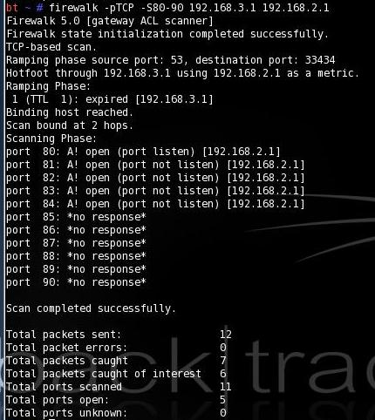

Saving the Screen Image on the Desktop
- On the Hacker Computer, from the Backtrack 2 desktop, click Start, Screenshot.
- In the Screenshot window, click the "Save As…" button.
- In the "Save as – Screenshot" window, in the unlabelled box on the upper right, click the arrow and select /root/desktop.
- In the "Save as – Screenshot" window, in the Location: box, type in a filename of
Yourname-Proj 8b.jpg
- Click the Save button. Your file should appear on the desktop.
Turning in your Project
- In Firefox, go to a Web-based email service you feel comfortable using in S214 – it should be one with a password you don't use anywhere else.
- Email the JPEG images to me as attachments. Send the message to cnit.123@gmail.com with a subject line of Proj 8 From Your Name. Send a Cc to yourself.

Credits
I got a lot of this from "Use Firewalk in Linux/UNIX to verify ACLs and check firewall rule sets", by Lori Hyde, from this URL (link Ch 903 on my Web page):
http://articles.techrepublic.com.com/5100-6350_11-5055357.html
Last modified 8-5-08

