What You Need for This Project
- The DVD containing the virtual machine "Hacme Travel", or a machine you prepared yourself with Hacme Bank and Hacme Travel installed on it (see the Sources section at the end of this project)
- Any computer that can run a virtual machine, with VMware Player or VMware Workstation

Copying the Virtual Machine to the Hard Drive
- You cannot run a virtual machine directly from the CD. Copy the "Hacme" folder from the virtual machine into the folder on the VMs drive with your name on it.
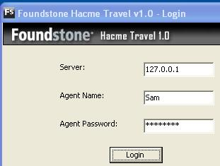
- Start the virtual machine as usual.
Starting the Hacme Travel Web Application
- Click Start, "All Programs", "Foundstone Free Tools", "Hacme Travel 1.0", "Start Foundstone Hacme Travel Server.bat". A Command Prompt window opens and closes again immediately.
- Click Start, "All Programs", "Foundstone Free Tools", "Hacme Travel 1.0", "Hacme Travel Agent v1.0".
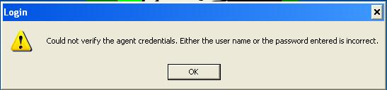
- A login box opens, as shown to the right on this page. Try entering any name and password and click the Login button.
- You get an error message, as shown to the right on this page. Click OK.

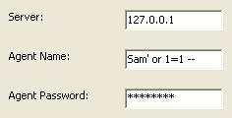
Bypassing the Logon With SQL Injection
- Enter a "Agent Name" of:
Sam' or 1=1 --
- Enter anything in the "Agent Password" field and click the Login button.

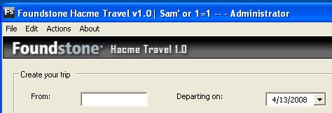
- A page opens titled "Foundstone Hacme Travel v1.0 | Sam' or 1-1 -- - Administrator", as shown to the right on this page. You are now logged in with Administrative privileges.
Creating a New Agent
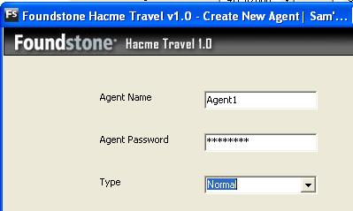
- In the "Foundstone Hacme Travel v1.0 | Sam' or 1-1 -- - Administrator" page, click File, "Create Agent".
- In the "Create New Agent" box, enter an "Agent Name" of Agent1 and a password of password, as shown to the right on this page. Verify that the Type is set to Normal. Click the Create button. A box pops up saying "Successfully created the agent." Click OK.
- In the "Foundstone Hacme Travel v1.0 | Sam' or 1-1 -- - Administrator" page, click File, Exit.
Logging in as Agent1
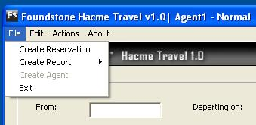
- Click Start, "All Programs", "Foundstone Free Tools", "Hacme Travel 1.0", "Hacme Travel Agent v1.0". A login box opens.
- Enter "Agent Name" of Agent1 and a password of password. Click Login.
- An " Foundstone Hacme Travel v1.0 | Agent1 – Normal" window opens, as shown to the right on this page. The agent account exists, but it's not an Administrator.
- Click the File menu item. Note that the "Create Agent" item is grayed out—this shows that you are not an Administrator.
- Click File, Exit.
Bypassing the Login With SQL Injection Again
- Click Start, "All Programs", "Foundstone Free Tools", "Hacme Travel 1.0", "Hacme Travel Agent v1.0".
- Enter a "Agent Name" of:
Sam' or 1=1 --
- Enter anything in the "Agent Password" field and click the Login button. You are now logged in with Administrative privileges.
Using a Buffer Overflow to Create an Administrator Agent (Privilege Escalation)
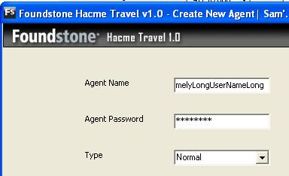
- In the "Foundstone Hacme Travel v1.0 | Sam' or 1-1 -- - Administrator" page, click File, "Create Agent".
- In the "Create New Agent" box, enter an "Agent Name" of ExtremelyLongUserNameLong and a password of password, as shown to the right on this page. Verify that the Type is set to Normal. Click the Create button. A box pops up saying "Successfully created the agent." Click OK.
- In the "Foundstone Hacme Travel v1.0 | Sam' or 1-1 -- - Administrator" page, click File, Exit.
Logging in as ExtremelyLongUserNameLong
- Click Start, "All Programs", "Foundstone Free Tools", "Hacme Travel 1.0", "Hacme Travel Agent v1.0". A login box opens.
- Enter "Agent Name" of ExtremelyLongUserNameLong and a password of password. Click Login.
- The page that opens has "ExtremelyLongUserNameLong – Administrator" in the title bar.
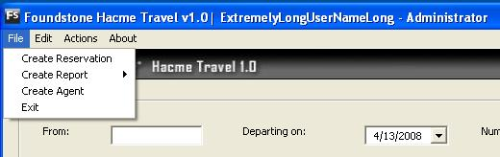
- Click the File menu item. Note that the "Create Agent" item is no longer grayed out, as shown to the right on this page. This shows that the new agent is an Administrator.

Capturing a Screen Image
- Press the PrintScrn key in the upper-right portion of the keyboard.
- click Start, Programs, Accessories, Paint. In the untitled - Paint window, select Edit, Paste from the menu bar.
- In the untitled - Paint window, click File, Save. Select a Save as type of JPEG. Save the document with the filename Your Name Proj 9a.

- In the "Foundstone Hacme Travel v1.0 | ExtremelyLongUserNameLong – Administrator" page, click File, Exit.
Using Malicious Input to Create a Denial of Service
- Click Start, "Control Panel", "Administrative Tools", Services. You should see a "FoundstoneHacmeTravelServer" service with a Status of Started, as shown below on this page. This is the service that the Hacme Travel Agent application connects to.
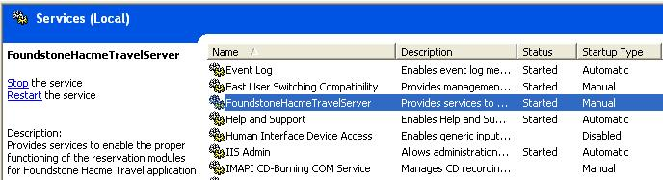
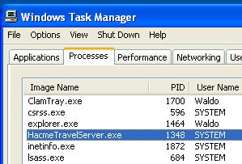
- Here's the plan of the exploit (detailed steps follow): We will use Task Manager to find the Process ID of the "FoundstoneHacmeTravelServer" service. Then we will use netstat to find the port on which the service listens. Then we will send an extremely long request to the service, properly terminated, which will crash the service. That will result in a Denial of Service.
Finding the Process ID and Listening Port
- Press Ctrl+Shift+Esc. Task Manager opens.
- In the Task Manager menu bar, click View, "Select Columns". Check the "PID (Process Identifier)" box. Click OK.
- Find the HacmeTravelServer.exe process, as shown to the right on this page. Write the PID value in the box below on this page. In my example, it is 1348, yours may be different.
- Click Start, Run. Type in CMD and press the Enter key.

Process PID: ______________________

Port: ______________________

- In the Command Prompt window, type this command, and then press the Enter key:
netstat –aon

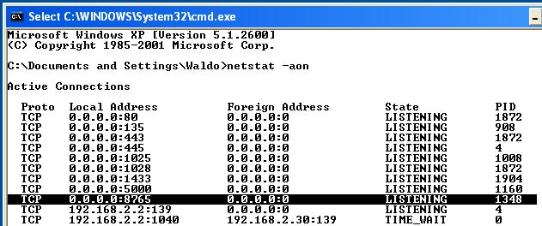
- A list of network connections appears, with the PID shown on the right side. Find the process with status LISTENING and the PID you wrote in the box on the previous page of these instructions, as shown below on this page. In the Local Address column there's an IP address of 0.0.0.0 followed by a colon and the port number. In my example below, the port number is 8765. Write your port number in the box on the previous page of these instructions.

Preparing the Attack String
- Click Start, "All Programs", Accessories, Notepad.
- In the Notepad window, type in this text, and do NOT press the Enter key:
This is garbage text just to fill space
- Press Ctrl+A to select all the text. Press Ctrl+C to copy it to the clipboard. Press Ctrl+V and hold it down until the screen is full of text—at least 32 lines of nonsense, with no carriage returns in it.
- At the end of the text, type in this exact string and DO NOT PRESS the Enter key:
--END OF CLIENT REQUEST--

- Your final attack string should look like the example below on this page.
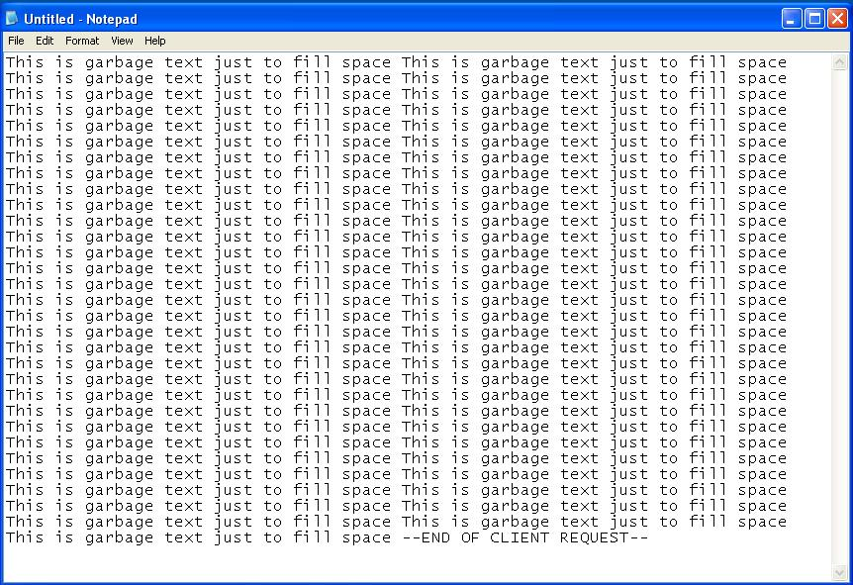
- Press Ctrl+s to save the Notepad file. Save it on the desktop with the filename exploit.txt
- Click Start, Run. Type in CMD and press the Enter key.
- In the Command Prompt window, type this command, and then press the Enter key:
cd desktop
This command makes the desktop your working directory.
- In the Command Prompt window, type this command, and then press the Enter key:
nc 127.0.0.1 8765 < exploit.txt
- Replace 8765 with the port number you wrote in the box on a previous page of these instructions. This command opens a TCP socket to the "FoundstoneHacmeTravelServer" service, and sends the exploit text to it.
- The command seems to hang. Wait five seconds and then press Ctrl+C.

- Click Start, "Control Panel", "Administrative Tools", Services. You should see the "FoundstoneHacmeTravelServer" service with a Status field blank, as shown below on this page. The service has stopped, resulting in a denial of service.
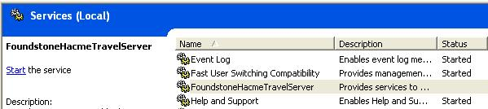

Capturing a Screen Image
- Press the PrintScrn key in the upper-right portion of the keyboard.
- click Start, Programs, Accessories, Paint. In the untitled - Paint window, select Edit, Paste from the menu bar.
- In the untitled - Paint window, click File, Save. Select a Save as type of JPEG. Save the document with the filename Your Name Proj 9b.
Finding Hard-Coded Credentials
- The programmer of the HacmeTravelServer application made a serious error: he or she typed the credentials used to connect to the database directly into the program (this is called hard-coding). This exploit is very simple: we will use the strings tool to extract the ASCII strings from the HacmeTravelServer executable file, revealing those credentials.
- Click Start, Run. Type in CMD and press the Enter key.
- In the Command Prompt window, type this command, and then press the Enter key:
cd "\Program Files\Foundstone Free Tools"
- In the Command Prompt window, type this command, and then press the Enter key:
cd "Hacme Travel 1.0"
These commands change the working directory to the directory containing the HacmeTravelServer.exe file.
- In the Command Prompt window, type this command, and then press the Enter key:
strings HacmeTravelServer.exe
- The strings in the executable file scroll by, many screens full of them. They are hard to use in this form, so we'll put them into a text file.
- In the Command Prompt window, type this command, and then press the Enter key:
strings HacmeTravelServer.exe > str.txt
Although nothing visible happens, this creates a file named str.txt with all those strings in it.
- In the Command Prompt window, type this command, and then press the Enter key:
notepad str.txt
This command opens the str.txt file in Notepad.
- From the Notepad menu bar, click Edit, Find. In the Find box, in the "Find What:" field, type password and then click the "Find Next" button five times.
- You should find text showing the User ID and Password plainly, as shown below on this page. The User ID is HacmeUser, and the password is HacmePassword.
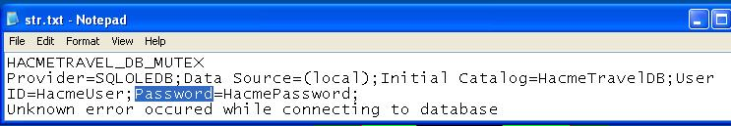

Capturing a Screen Image
- Press the PrintScrn key in the upper-right portion of the keyboard.
- click Start, Programs, Accessories, Paint. In the untitled - Paint window, select Edit, Paste from the menu bar.
- In the untitled - Paint window, click File, Save. Select a Save as type of JPEG. Save the document with the filename Your Name Proj 9c.

Turning in Your Project
- Email the JPEG images to me as attachments to one e-mail message. Send it to: cnit.124@gmail.com with a subject line of Proj 9 From Your Name, replacing Your Name with your own first and last name. Send a Cc to yourself.

Sources
This is just a shortened version of a project from Foundstone. You can find the original materials at these links:

Foundstone Documentation and Installers
http://www.foundstone.com/us/resources-whitepapers.asp (link Ch 12a on my Web page)
http://www.foundstone.com/us/resources/whitepapers/hacmetravel_userguide.pdf (link Ch 12b)
http://www.foundstone.com/us/resources-free-tools.asp (link Ch 12c)

Tools
http://www.vulnwatch.org/netcat (link Ch 12d)
http://www.microsoft.com/technet/sysinternals/Miscellaneous/Strings.mspx (link Ch 12e)
http://technet.microsoft.com/en-us/sysinternals/bb896653.aspx (Process Explorer, link Ch 12f)
http://www.wireshark.org (link Ch 12e)

Last Modified: 8-5-08

