What You Need for This Project
- The DVD containing the virtual machine "Hacme Travel" that you used in the "Hacme Travel project.
- Any computer that can run a virtual machine, with VMware Player or VMware Workstation

Copying the Virtual Machine to the Hard Drive
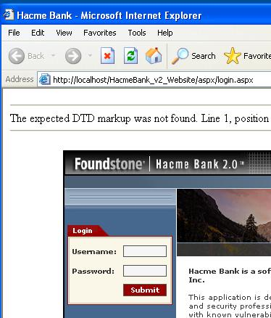
- You cannot run a virtual machine directly from the CD. Copy the "Hacme" folder from the virtual machine into the folder on the VMs drive with your name on it.
- Start the virtual machine as usual.
Starting the Hacme Bank Web Application
- Click Start, "All Programs", "Foundstone Free Tools", "Hacme Bank 2.0", "Hacme Bank WebSite 2.0".
- Internet Explorer opens, showing the Hacme Bank login page, as shown to the right on this page.
- There are three customers already set up:
Username Password
jv jv789
jm jm789
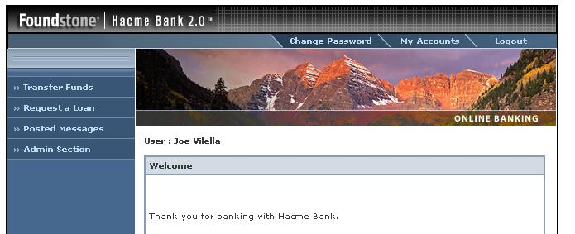
jc jc789

- Enter a valid username and password and click the Submit button. The Web application opens as shown below.
Features of the Web Application
- Click each link and explore the application. Very brief descriptions are given below. For much more complete information, see the Sources section at the end of these instructions.
  - Transfer Funds from one account to another. Each user has at least 2 bank accounts.
  - Request a Loan—all valid requests are automatically approved.
  - Posted Messages—a user forum
  - Change Password
  - My Accounts
  - View Transactions
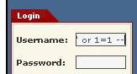
  - Admin Interface—advanced features to customize the application. We won't be using it.
Bypassing the Logon with SQL Injection
- If you are still logged in, click the logout button.
- Enter a "Username" of:
' or 1=1 --
- Leave the Password blank and click the Submit button.
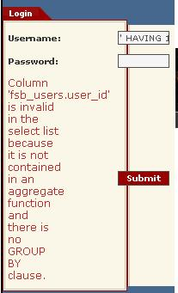
- The Welcome screen shows that we are now logged in as Joe Vilella. Since the SQL injection condition was always true, we just ended up with the first user name in the table.
- Click the Logout button.
Finding a Table and Column Name
- Enter a "Username" of:
' HAVING 1=1 --
- Leave the Password blank and click the Submit button.
- You get an error message saying "Column 'fsb_users.user_id" is invalid…", as shown to the right on this page.. This overly informative error message has just revealed to us these crucial facts:
  - The name of the table storing login information is fsb_users
  - The fsb_users table contains a column named user_id
Finding Additional Column Names (Database Enumeration)
- With some versions of SQL, there is a more complex injection that will actually display all the field names in the table in the error message. But that doesn't work with the version installed in the Hacme virtual machine. There are brute-force tools such as SQLBrute to perform brute-force attacks to find them. But that's all too much work for this project, so I will just tell you the other field names.
Table fsb_users has the columns user_id, user_name, login_id, password, creation_date
Inserting a Record into the fsb_users Table
- In the Hacme virtual machine, click Start, All Programs, Accessories, Notepad.
- Type this text into Notepad without pressing the Enter key:
'; INSERT INTO FSB_USERS (user_name, login_id, password, creation_date) VALUES('HAX0R12', 'HACKME12', 'EASY32', GETDATE());--
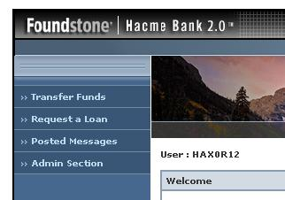
- Click the Submit button. The response is "Invalid Login", but that doesn't matter—it executed the insertion!
- Enter a Username of HACKME12 and a password of EASY32
- Click the Submit button. If you see a "Session Timed Out" message, just log in again with the same name and password. You should see a page showing you logged in as HAX0R32, as shown to the right on this page.

Capturing a Screen Image
- Press the PrintScrn key in the upper-right portion of the keyboard.
- Click Start, Programs, Accessories, Paint. In the untitled - Paint window, select Edit, Paste from the menu bar.
- In the untitled - Paint window, click File, Save. Select a Save as type of JPEG. Save the document with the filename Your Name Proj 10a.

- Click Logout.
Horizontal Privilege Escalation (Accessing Another User's Records)
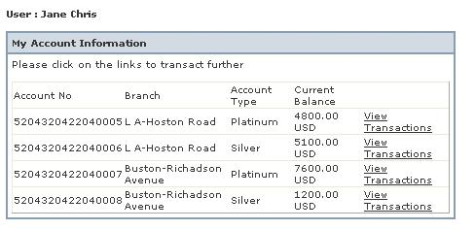
- Enter a Username of jc and a Password of jc789
- Click the Submit button. A Welcome screen opens, showing that you are authenticated as "Jane Chris".
- Click the "My Accounts" tab. The "My Account Information" section shows four accounts, with account numbers ending in 5, 6, 7, and 8, as shown to the right on this page.
- In the first line, with the account number ending in 5, click the "View Transactions" link.
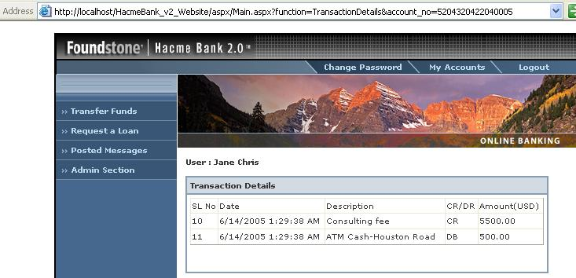
- Notice that the URL now ends with account_no=5204320422040005, as shown below on this page.

- Change the URL so the last digit is 4 instead of 5. Click the Go button.
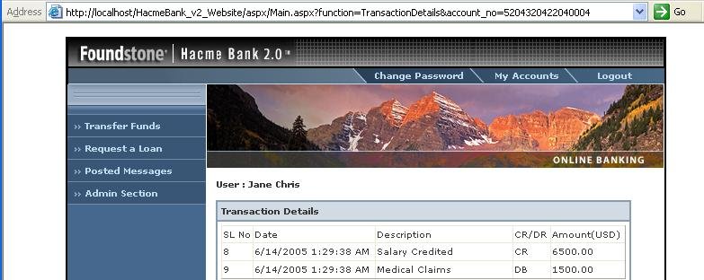
- Now you can see the transactions from another person's account, even though you are still authenticated as "Jane Chris", as shown below on this page.

- Click Logout.
Vertical Privilege Escalation (Becoming Administrator)
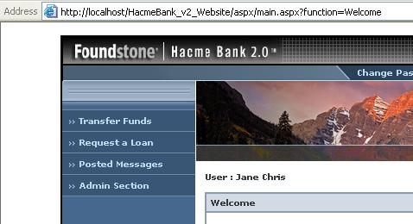
- Enter a Username of jc and a Password of jc789
- Click the Submit button. A Welcome screen opens, as shown to the right on this page.

- Notice the URL—it ends with ?function=Welcome
- Click in the URL and change the word
Welcome
To
admin\Sql_Query
- Click the Go button. If you see a "Session Timed Out" message, just log in again with the same name and password.

- A Sql Query page opens, as shown below on this page. You now have Administrative privileges.
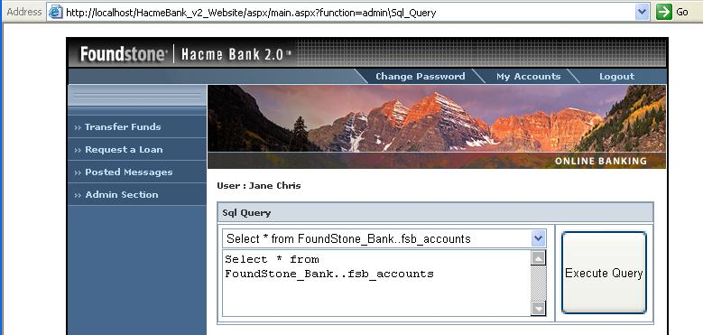

- Click Logout.
Cross-Site Scripting (XSS)
- Enter a Username of jc and a Password of jc789
- Click the Submit button. A Welcome screen opens.
- On the left side, click the "Posted Messages" link.
- Enter any subject, and the following Message Text, as shown below on this page:
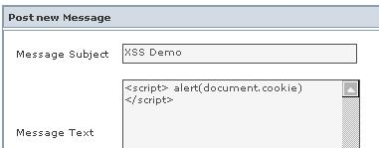
<script> alert(document.cookie)</script>
- Click the "Post Message" button. (If you see a "Session Timed Out" message, just log in again with the same name and password. And re-post the message).

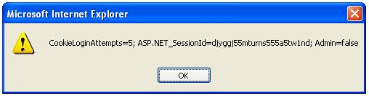
- A box pops up, as shown to the right on this page.

Capturing a Screen Image
- Make sure the CookieLoginAttempts box is visible.
- Press the PrintScrn key in the upper-right portion of the keyboard.
- click Start, Programs, Accessories, Paint. In the untitled - Paint window, select Edit, Paste from the menu bar.
- In the untitled - Paint window, click File, Save. Select a Save as type of JPEG. Save the document with the filename Your Name Proj 10b.
Logging In as a Different User
- Click Logout.
- Enter a Username of jv and a Password of jv789
- Click the Submit button. A Welcome screen opens.
- On the left side, click the "Posted Messages" link. The CookieLoginAttempts box pops up—any user who views the messages will see it. This is a serious vulnerability! Script one user entered is executing on another user's browser. This could be used to take any data visible to the browser and send it to a public location, such as a vulnerable message board on the Internet. Before I put the image CAPTCHA on my page, I think my own comments section was being used for such a purpose.
Installing the Tamper Data Firefox Extension
- Close Internet Explorer.
- Open Firefox. Click Tools, Add-ons. In the lower right corner of the Add-ons box, click "Get Extensions".
- In the "Firefox Add-ons" page, click in the "search for add-ons" box. Type in "Tamper Data" and press the Enter key.
- In the "Tamper Data" section, click the "Add to Firefox" button.
- On the next page, click the "Accept and Install" button.
- In the "Software Installation" box, click "Install Now" button.
- In the Add-ons box, click "Restart Firefox" button.
- When Firefox restarts, click Tools, Options. On the Main tab, at the bottom right, click the "Check Now" button.
- In the "Default Browser" box, click Yes to make Firefox your default browser.
- Close Firefox.
- Click Start, "All Programs", "Foundstone Free Tools", "Hacme Bank 2.0", "Hacme Bank WebSite 2.0". Hacme Bank opens in Firefox.
Stealing Money with a Negative Funds Transfer
- Enter a Username of jc and a Password of jc789
- Click the Submit button. If a "Session Timed-Out" message appears, wait for it to redirect to the home page and log in again. If it hangs, click Start, "Turn Off Computer", "Restart" to restart the virtual machine.
- A Welcome screen opens.
- On the left side, click the "Transfer Funds" link.
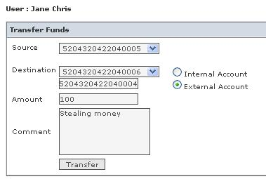
- Notice how the security works here: you can only choose one of your accounts as the Source, but you can enter any account as the Destination if you click the "External Account" radio button. The intention is to allow you to pay others, but not to steal from them.
- Select the account ending in 5 as the Source. Click the "External Account" radio button. Enter 5204320422040004 in the lower Destination field.
- Enter an Amount of 100 and enter a Comment of "Stealing money", as shown to the right on this page.
- From the Firefox menu bar, click Tools, "Tamper Data". In the "Tamper Data – Ongoing requests" box, in the upper left, click "Start Tamper".
- In the Hacme Bank Transfer Funds page, click the Transfer button.
- A box pops up titled "Tamper with request?". Click the Tamper button.
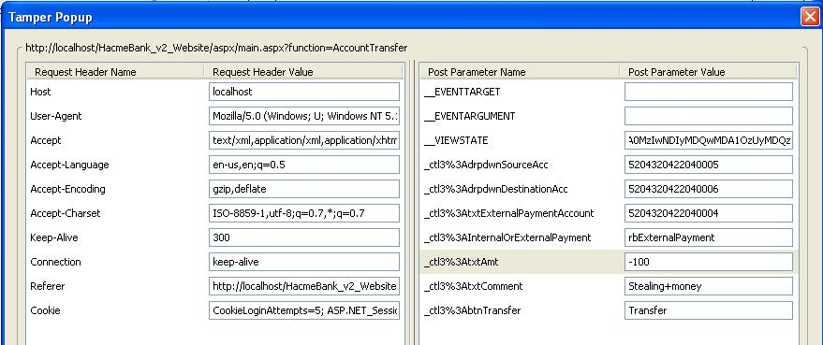
- A large box appears, titled "Tamper Popup". This shows all the fields that are being sent back to the bank application from the HTML form. On the lower right, find the _ctl3%3AtxtAmt field, and change its value to -100, as shown below on this page.

- In the "Tamper Popup" window, click OK.
- A box pops up titled "Tamper with request?". Click the Submit button.
- Another box pops up titled "Tamper with request?". Clear the "Continue Tampering?" box, and then click the Submit button.
- Bring the Hacme Bank page to the front again.
If you see a Login page, your transaction timed out. You will need to repeat all the steps in the "Stealing Money with a Negative Funds Transfer" section again, faster.
- When the transfer succeeds, you will see a red message saying "Funds successfully transferred". There is also a red message saying "Error: Enter positive integer value", but the funds transferred anyway.
- To see the transfer, at the top of the screen, click the "My Accounts" tab.
- In line for the account number ending in 5, click the "View Transactions" link. The last transaction should be a negative amount sent to an account number ending in 4, labeled "Stealing money", as shown below on this page.
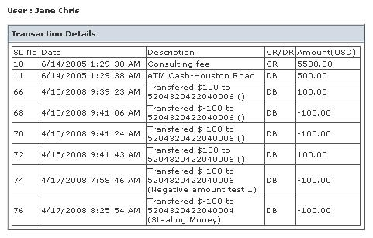

Capturing a Screen Image
- Make sure the "Stealing money transaction is visible.
- Press the PrintScrn key in the upper-right portion of the keyboard.
- Click Start, Programs, Accessories, Paint. In the untitled - Paint window, select Edit, Paste from the menu bar.
- In the untitled - Paint window, click File, Save. Select a Save as type of JPEG. Save the document with the filename Your Name Proj 10c.

Turning in Your Project
- Email the JPEG images to me as attachments to one e-mail message. Send it to: cnit.124@gmail.com with a subject line of Proj 10 From Your Name, replacing Your Name with your own first and last name. Send a Cc to yourself.

Sources
http://www.foundstone.com/us/resources-whitepapers.asp (link Ch 12a on my Web page)
http://www.foundstone.com/us/resources-free-tools.asp (link Ch 12c)
http://www.foundstone.com/us/resources-videos.asp (link Ch 12h)
You can access a 74-page PDF file with much more detailed information and more exercises by clicking Start, "All Programs", "Foundstone Free Tools", "Hacme Bank 2.0", "Foundstone Hacme Bank User and Solution Guide 2.0". You will need to install a PDF reader on the virtual machine, or drag the PDF file to the host system.
Last Modified: 8-5-08

