What You Need for This Project
- A Damn Vulnerable Linux 1.0 or 1.1 ISO file (Put it in the MoreVMs:\Install folder in S214) . You cannot use the latest version, DVL 1.4.
- Any virtual machine
- An Ubuntu machine (real or virtual) to run the Nikto scanner on
Booting a Virtual Machine from the DVL ISO
- Click Start, "All Programs", VMmanager, VMmanager.
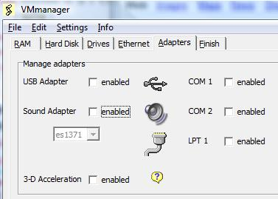
- In the VMmanager window, click the Modify button.
- Navigate to any of your virtual machines, such as the Hacme one.
- In the VMmanager window, click the Drives tab. In the CD-ROM section, select "use ISO image". In the Open box, navigate to the MoreVMs drive. Double-click the Install folder. Double-click the damnvulnerablelinux_1.0.isofile.
- On the Adapters tab, disable the USB and sound adapters, as shown to the right on this page.
- In the VMmanager window, click the Finish tab. Click OK. In the VM Manager box, click OK.
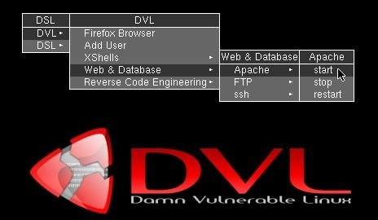
- Launch VMware Player and start your virtual machine. If necessary, press F2 during bootup and set the BIOS to boot from the CD-ROM.
- At the boot: prompt, press the Enter key. Several pages of text scroll by as Linux boots.
Starting the DVL Apache Web Server
- Right click the DVL desktop. From the context menu, click DVL, "Web & Database", Apache, start, as shown to the right on this page.
Finding the DVL Apache Web Server's IP Address
- On the DVL desktop, click the "ATerminal" icon. In the Terminal window, type this command, and then press the Enter key:
ifconfig

Web Server IP: _______________________
- Find the IP address and write it on the box to the right on this page.
Starting the Ubuntu Machine
- Launch an Ubuntu virtual machine. Log in as usual. If it's a machine I provided, the logon name and password are on a folder name in the same directory as the virtual machine files.
- From the Ubuntu desktop, click Applications, Accessories, Terminal.
- In the Terminal window, type this command and then press the Enter key:
ping 192.168.2.40 –c 2
Replace 192.168.2.40 with you’re the Web Server IP address you wrote in the box on the previous page.
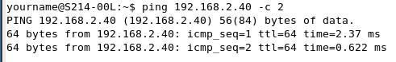
- You should see replies, as shown to the right on this page. If you do not, you need to troubleshoot the Internet connections of the virtual machines before you can proceed further.
Viewing the Web Site from the Ubuntu Machine
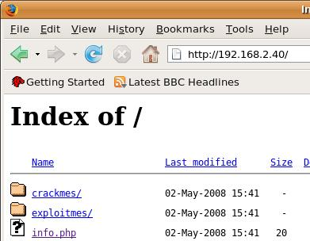
- From the Ubuntu desktop, click Applications, Internet, "Firefox Web Browser". In the Address bar, type the Web Server IP you wrote in a box on the previous page. Press the Enter key.
- You see an Index of / page, as shown below on this page. This shows that the Web server is running, although it's not configured to be pretty (or secure). You are seeing a directory of all the files in the Web server's /opt/wwwroot/htdocs directory.
Installing nikto on the Ubuntu Machine
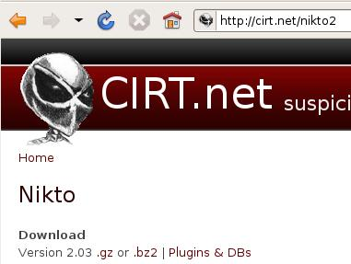
- Nikto is not in the Ubuntu 8.04 repositories when I am writing this (10-17-08), so you have to download it directly. In the Ubuntu machine, open Firefox and go to cirt.net/nikto2
- In the CIRT.net page, click the .gz link, as shown to the right on this page. Save the nikto-current.tar.gz file on your desktop.
- On your desktop, right-click the nikto-current.tar.gz file and click "Open with "Archive Manager"".
- In the nikto-current.tar.gz window, click the Extract button. In the Extract box, click the Extract button. A nikto folder appears on your desktop.
Scanning the DVL Web Server with nikto from the Ubuntu Machine
- On the Ubuntu machine, in the Terminal window, type this command and then press the Enter key:
cd Desktop/nikto
- On the Ubuntu machine, in the Terminal window, type this command and then press the Enter key:
./nikto.pl -h 192.168.2.40
Replace 192.168.2.40 with you’re the Web Server IP address you wrote in the box on the previous page.
- The scan should run, finding several vulnerabilities, as shown below on this page. It takes several minutes to run. Wait until the scan finishes and you see a $ prompt.
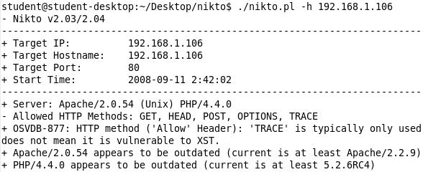

Capturing a Screen Image
- Make sure the Nikto scan is visible.
- Press Ctrl+Alt to release the mouse from the virtual machine.
- Press the PrintScrn key in the upper-right portion of the keyboard.
- On the host Windows system, Click Start, Programs, Accessories, Paint. In the untitled - Paint window, select Edit, Paste from the menu bar.
- In the untitled - Paint window, click File, Save. Select a Save as type of JPEG. Save the document with the filename Your Name Proj 12a.

Viewing the info.php File from the Ubuntu Machine
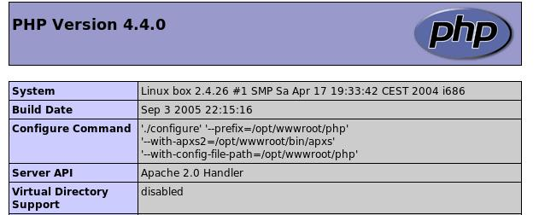
- This is a vulnerability I found with an earlier version of nikto, but it no longer seems to be detected by the newer versions. On the Ubuntu machine, in the Firefox window, click the info.php link. A long page appears, showing the complete configuration settings for the PHP service, as shown to the right on this page. This is an extreme example of an overly informative page—there is no reason to publish all that information to everyone on the Web!

Cross-Site Scripting (XSS) on the DVL Web Server
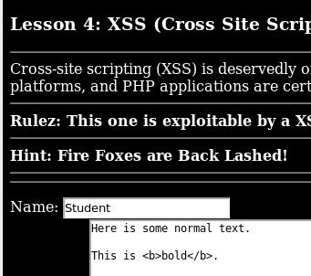
- On the Ubuntu machine, in the Firefox window, in the Address bar, type the Web Server IP you wrote in a box on a previous page. Press the Enter key.
- A list of files and folders appears, as before. Click the lesson004 link.
- A list of files appears, as before. Click the index.php link.
- A Comment form appears, as shown to the right on this page. To see it work, enter a Name of Student, and a couple lines of comments, including a <b> tag. Click the "Add Comment" button.

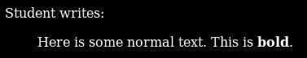
- The result shows that the <b> tag did make text bold. This is a warning sign—it is possible to pass HTML tags to the server.

Using Cross-Site Scripting (XSS) to Make a Pop-Up Box
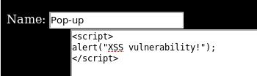
- Formatting tags are harmless. Let's try making a pop-up appear on the viewer's screen.
- In the Firefox window, click the Back button (the leftward-pointing green arrow).
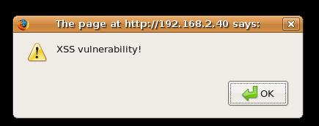
- Enter the name and comment shown to the right on this page—this is a simple Javscript pop-up.
- Click the "Add Comment" button.
- A box pops up with the message "XSS vulnerability!" as shown to the right on this page.

]Capturing a Screen Image
- Make sure the "XSS vulnerability!" box is visible.
- Press Ctrl+Alt to release the mouse from the virtual machine.
- Press the PrintScrn key in the upper-right portion of the keyboard.
- On the host Windows system, Click Start, Programs, Accessories, Paint. In the untitled - Paint window, select Edit, Paste from the menu bar.
- In the untitled - Paint window, click File, Save. Select a Save as type of JPEG. Save the document with the filename Your Name Proj 12b.

Using Cross-Site Scripting (XSS) to Redirect the Web Page
- Let's try the Obama hack—the one that sent viewers of Barak Obama's Web page to Hillary Clinton's page instead a few weeks ago.
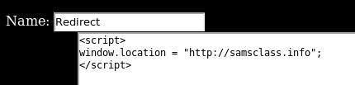
- Click the OK button to close the "XSS vulnerability!" box. In the Firefox window, click the Back button (the leftward-pointing green arrow).
- Enter the name and comment shown to the right on this page—this is a simple Javscript command to redirect the Web page to my page.
- Click the "Add Comment" button. Instead of showing your comment, my Web page opens.

Turning in Your Project
- Email the JPEG images to me as attachments to one e-mail message. Send it to: cnit.124@gmail.com with a subject line of Proj 12 From Your Name, replacing Your Name with your own first and last name. Send a Cc to yourself.
Last Modified: 10-17-08

