What You Need for This Project
Warning: The USB Switchblade is really nasty—people can steal your passwords with it. Don't use it on any computer without permission, or even leave the hacked drive lying around. This is a really scary attack—don't be the victim or offender of anything unethical.
- Any Windows XP (not Vista) computer you have Administrator privileges on. The instructions below assume you are using Windows XP in S214.
- A U3 USB flash drive without any data you need on it. I put some in the white box in the equipment closet in S214—the lab monitor can loan you one in return for an ID card.
- Warning! This project will erase all the data on your USB flash drive, and you might have some difficulty restoring normal U3 functionality, in the worst case. If you don't want to risk your own flash drive, use the ones in S214.
Using the U3 Launchpad Installer to Clean the Drive
- Start the Windows XP machine and log in as gamer with the password gamer
- Plug in the U3 USB flash drive.
- Open a Web browser and go to http://www.sandisk.com/Retail/Default.aspx?CatID=1411
- Click the "Download Installer (.exe)" link. Save the installer on your desktop.
- Double-click the LPInstaller file on your desktop. In the "Open File – Security Warning" box, click Run.
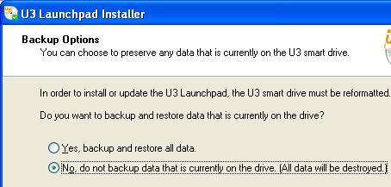
- In the "Welcome to th e U2 Launchpad Installer" box, click Next.
- In the "License Agreement" box, click Accept and click Next.
- In the "Backup Options" screen, click "No, do not backup…", as shown to the right on this page. Click Next.
- In the "U3 Launchpad installer" box, click OK.
- In the "Confirm Installation Options" box, click Next.
- In the "Launchpad Installation Completed" box, click Finish.

Observing the Normal U3 Software Launch
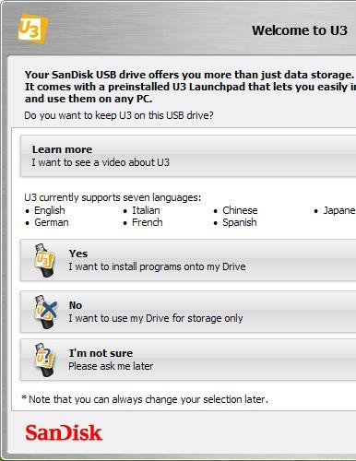
- Plug in the U3 Flash Drive.
- If you see a "Welcome to U3" box, as shown to the right on this page, click Yes, and in the "Welcome to U3 Software" box, click Close.
- If a "Welcome to U3" box appears, click Yes to enable the autorun, so you can install software on the U3 device.
- Look in the lower right corner of your desktop. You should see a square yellow U3 icon, as shown below on this page.

- Click the U3 icon and click Eject. When you see the "Safe to remove U3 device" message, unplug the flash memory stick.
Downloading the PocketKnife and Universal Customizer
- Start the Windows XP machine and log in as gamer with the password gamer
- Disable your virus scanner. The PocketKnife file DOES contain dangerous malware, of course. That's the whole point of the project—we are converting this innocent flash drive into a dangerous hacking tool. In S214, it's sufficient to right-click the McAfee shield icon in the lower right corner and click "Disable On-Access Scan", so the shield displays a red circle-and-slash over it, as shown to the right on this page.
- Open a Web browser and go to samsclass.info
- Click the CNIT 124 link. On the CNIT 124 page, click the Projects link. Scroll down to Project 14, as shown below on this page.
- Click the "Download PocketKnife_v0870" link. Save the file on your desktop.
- Click the "Download Universal Customizer" link. Save the file on your desktop.
- On your desktop, right click the PocketKnife_v0870.zip file and click "Extract All".
- In the "Select a Destination and Extract Files" box, accept the default location and click Extract.
- Repeat the process to extract Universal_Customizer.zip.
Copying the Flash Partition Files to the USB Flash Memory
- On your desktop, double click the PocketKnife_v0870 folder to open it. Double-click the Leapos_Payload_v0870 folder. Double-click the Leapos_Payload_v0870 folder. Double-click the Leapos_Payload_U3 folder. Double-click the "Flash Partition" folder.
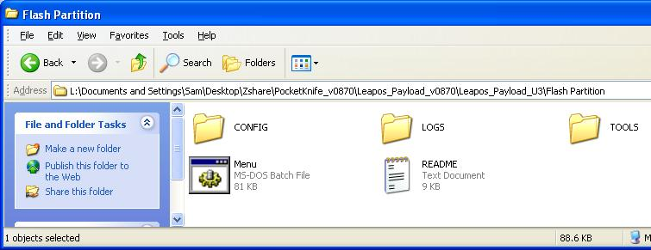
- You should see three folders and two files, as shown below on this page. Highlight all five objects, right click one of them, and click Copy.
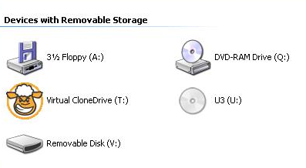
- Click Start, "My Computer". Find the "Removable Disk" volume, as shown to the right on this page, right-click it, and click Paste.

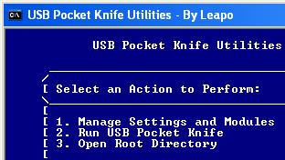
Selecting Payload Options
- In the "My Computer" window, double click "Removable Disk". Double-click Menu.bat.
- The Main Menu opens, as shown to the right on this page.
- From the Main Menu, type 1 to "Manage Settings or Modules" and then press Enter.
- In the next page, type 1 and press Enter, to "Enable or Disable Modules".
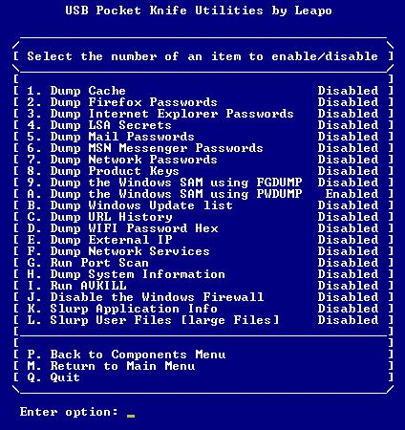
- The next screen lists all the modules included in the package.
- Type a and press Enter to enable Dumping the Windows SAM using PWDUMP, as shown to the right on this page.
- Type Q and press Enter, to quit.

Using the U3 Customizer to Install the PocketKnife Launcher
- On your desktop, double-click the PocketKnife_v0870 folder to open it. Double-click the Leapos_Payload_v0870 folder to open it. Double-click the Leapos_Payload_U3 folder to open it. Right click the U3.ISO file and click Rename. Change the filename to U3CUSTOM.ISO.
- Right click the U3CUSTOM.ISO file and click Copy.
- On your desktop, open the "Universal_Customizer" folder to open it. Double-click the BIN folder to open it. Right-click an empty portion of the folder and click Paste. In the "Confirm File Replace" box , click Yes.
- Return to the "Universal_Customizer" folder. Double-click the Universal_Customizer.exe icon . In the "Open File – Security Warning" box, click Run.
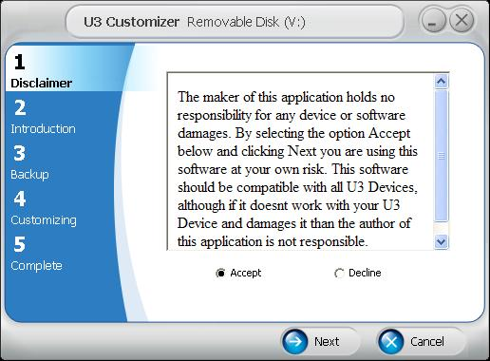
- Plug in the U3 Flash Drive.
- The U3 Customizer opens, as shown to the right on this page. Click Accept and click Next.
- In step 2, click Next.
- In step 3, enter a password of password in both boxes and click Next.
- Wait while the progress bar moves in step 4. When the process is complete, click Next.
- At step 5, the process is done! Click Done.
- Unplug the U3 Flash Drive.
Stealing Password Hashes
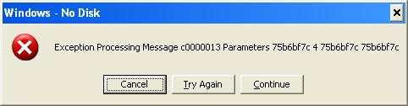
- Plug the drive back into your machine, or into any other Windows XP machine that is logged in with Administrative credentials.
- If you see an error message, as shown to the right on this page, click Continue. That's a bug in the PocketKnife software that happens on some systems, and the developers haven't solved it yet.
- After about 15 seconds, an Explorer window will pop up, showing the contents of the LOGS directory. There will be a folder with your machine's name on it, which should be something like S214-10. Double-click that folder to open it.
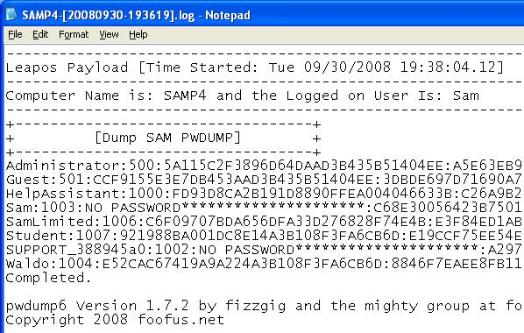
- Inside that folder is a text file with a long name, starting with your machine name. Double-click that file to open it in Notepad, as shown to the right on this page.

Capturing a Screen Image
- Make sure the "Dump Machinename PWDUMP" box is visible, showing at least one password hash, as shown above on this page.
- Press the PrintScrn key in the upper-right portion of the keyboard.
- Click Start, Programs, Accessories, Paint. In the untitled - Paint window, select Edit, Paste from the menu bar.
- In the untitled - Paint window, click File, Save. Select a Save as type of JPEG. Save the document with the filename Your Name Proj 14.

Turning in Your Project
- Email the JPEG images to me as attachments to one e-mail message. Send it to: cnit.124@gmail.com with a subject line of Proj 14 From Your Name, replacing Your Name with your own first and last name. Send a Cc to yourself.

Sources
http://dotnetwizard.net/soft-apps/hack-u3-usb-smart-drive-to-become-ultimate-hack-tool/
http://www.phdcc.com/shellrun/autorun.htm
http://forums.gonzor228.com/index.php?topic=85.0
http://hak5.org/forums/index.php?showtopic=6746&mode=threaded&pid=71631
http://www.sandisk.com/Retail/Default.aspx?CatID=1411

PowerISO is the software that can image the U3 launchpad, as explained here:
http://www.u3community.com/viewtopic.php?p=4053&sid=d7502c2754eba11b19b17736c5425855

Last Modified: 9-30-08

