What You Need for This Project
- Three Windows machines on a LAN. They can be real or virtual machines. Select one machine to the PBX Server. The other machines will be VoIP Clients. The instructions below assume you are using three Vista computers in S214, with several students working together.
- A headset with a microphone would be nice, but not strictly necessary (I have some you can borrow)
Downloading the PBX Server (Do this on your PBX Server computer)
- Open a Web browser and go to 3cx.com
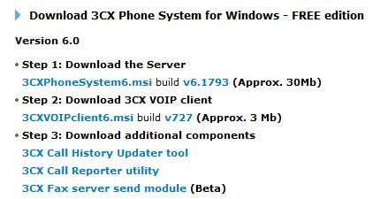
- At the top, click DOWNLOAD. At the bottom of the next page, find the line that says "To download the FREE edition please click here". Click on "here".
- On the next page, fill out the form and click the "Submit & download" button.
- On the next page, in the "Step 1: Download the Server" section, click the link, as shown to the right on this page. Save the 3CXPhoneSystem6.msi file on your desktop.
- Don't bother with "Step 2: Download the 3CX VOIP client". That client won’t work on Vista, as far as I can tell. We'll use a different client.
Installing the PBX Server (Do this on your PBX Server computer)
- The installer doesn't handle Vista's User Account Control properly, so you must launch it from an Administrator Command Prompt with these steps:
- Click Start. Type in CMD and press Shift+Ctrl+Enter. In the "User Account Control" box, press Alt+C or click Continue.
- In the Administrator Command Prompt window, type this command, and then press Enter:
cd \users\yourloginname\desktop
Replace yourloginname with the name you logged in with (usually Student in S214).
- In the Administrator Command Prompt window, type this command, and then press Enter:
3CXPhoneSystem6.msi
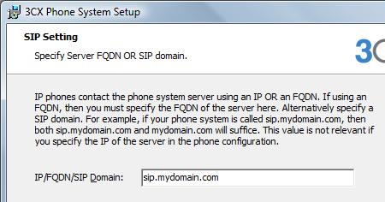
- Click through the installer, accepting the default options for the first several pages. At the SIP Setting page, accept the default of sip.mydomain.com as shown to the right on this page.
- When it asks for an administrator password, use password.
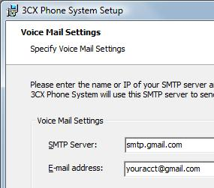
- In the "Voice Mail Settings" page, use an "SMTP Server" of smtp.gmail.com and put your Gmail address in the "E-mail address" field, as shown to the right on this page.
- On the next page, click the Install button. When the installation is complete, click the Finish button.

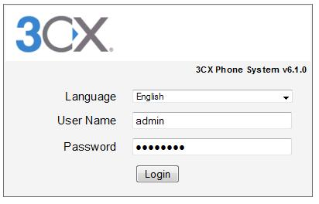
Logging in to the PBX Server
- A Web browser opens, showing the 3CX login page, as shown to the right on this page. Enter a User Name of admin and a password of password and then click the Login button.
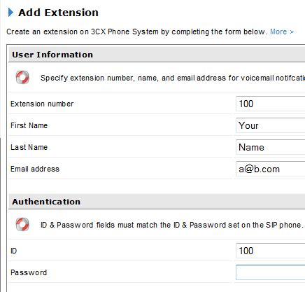
Creating Extensions on the PBX Server
- On the PBX Server computer, in the 3CX page, on the left side, under Extensions, click Add.
- In the Add Extension page, enter an Extension number of 100. Put in your name and any email address. . In the Authentication section, use an ID of 100 and leave the password field empty. Click Next.

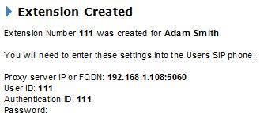
- You should see the "Extension Created" message, as shown to the right on this page. Write the "Proxy server IP or FQDN" value in the box below on this page. Then click Finish.

PBX IP: ______________________________
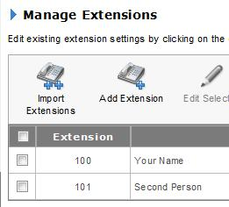
- The Manage Extensions page appears, showing the extensions you have. Click the "Add Extension" button and create another extension so you can have two clients in your local telephone net, as shown to the right on this page. Add enough extensions for all the clients you plan to use.
Installing the X-Lite VoIP Client (do this on all the client computers in your team)
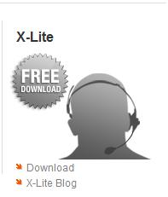
- Open a Web browser and go to counterpath.com
- In the X-Lite section, as shown to the right on this page, click Download.
- On the next page, click "Download X-Lite 3.0 for Windows".
- On the next page, click "Download Now".
- Install the software with the default options.
- When you are prompted to, restart your computer.
- In the "X-Lite Auto Update" box, click No. Don't update to the newest version unless you have trouble with the older one.
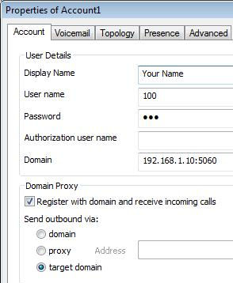
- In the "Call Quality Information" box, click No.
- In the "SIP Accounts" box, click the Add… button.
- In the "Properties of Account1" box, enter these values, as shown to the right on this page:
  - Display name: Your name
  - User Name: Your extension number
  - Password: Anything
  - Domain: The PBX IP you wrote in a box on the previous page of these instructions
- In the "Properties of Account1" box, click the OK button.
- In the "SIP Accounts" box, click the Close button.

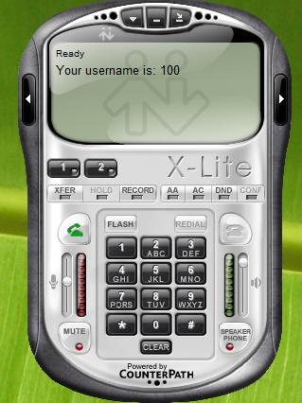
- The X-Lite client launches, as shown to the right on this page. If you see a "Firewall" alert telling you that some features of the program have been blocked, click "Unblock".
- You should see a message in the top portion of the X-Lite panel saying "Ready Your Username is 100" (or some other extension number). If you see an error message, some part of the configuration is wrong—try these troubleshooting ideas:
Troubleshooting
Turn off all firewalls
PING from one computer to another
In the 3CX server console, in the "Phone System" section, click on "Server Status" and you will see status messages that may serve to guide you
Use nmap from the client machines and do a port scan—you should find port 5060 open on the PBX server.

Capturing a Screen Image
- Make sure the X-Lite panel is visible, showing "Ready Your Username is 100" (or some other extension number).
- Press the PrintScrn key in the upper-right portion of the keyboard.
- On the host Windows system, Click Start, Programs, Accessories, Paint. In the untitled - Paint window, select Edit, Paste from the menu bar.
- In the untitled - Paint window, click File, Save. Select a Save as type of JPEG. Save the document with the filename Your Name Proj 16a.
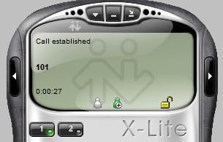
Calling from One Client to Another
- On a client, click the green "Dial" button, on the left side (it looks like a telephone handset being lifted up). Dial the extension number of another client, such as 101, and press the Enter key on the keyboard.
- The other client should show a status of "Incoming Call". On that client, click the green "Dial" button. You should see a status of "Call established", as shown to the right on this page.
- Click the red "Hang Up" button.
Adjusting the Codec (do this on all the client computers in your team)
- Wireshark can’t play back captured RTP streams unless they are encoded with a common codec. By default, X-Lite uses a codec Wireshark can’t decode, so we will set it to use the plain, ordinary, G711 aLaw codec.
Click here
- In the X-Lite panel, click the ▼ button, as shown to the right on this page. In the context menu, click Options.
- In the Options box, in the lower left corner, click Advanced.

- Disable all codecs except G711 aLaw, as shown below on this page. Click OK.
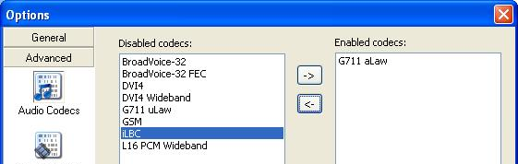

Using Wireshark to Eavesdrop on a Call
- It's best if you have a headset with a microphone for this section, although not necessary.
- On a Client machine, start Wireshark capturing packets from the “Local Area Connection” interface. If Wireshark is not already installed, download and install it. from wireshark.org.
- Dial from that Client to another, just as you did before.
- When you see the "Call Established" status, if you have a microphone, talk into it for a few seconds to make real RTP data.
- Stop the packet capture.

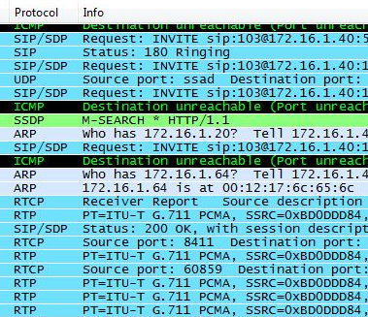
- Look through the packet capture and find these packets, as shown to the right on this page:
  - STP/SDP Request: INVITE sip
  - SIP Status 180 Ringing

- The packets you saw above are SIP (Session Initiation Protocol) packets, which control the call. The INVITE attempts to contact the other phone, and if it is available, it proceeds to RINGING.
- The actual voice data is not in the SIP packets, but in RTP (Real Time Protocol) packets. Scroll down and you will see them, as shown to the right on this page.
- To analyze the RTP packet stream, from the Wireshark menu bar, click Statistics, “VoIP Calls”. You should see a "VoIP Calls" window showing one or more calls, as shown below on this page.
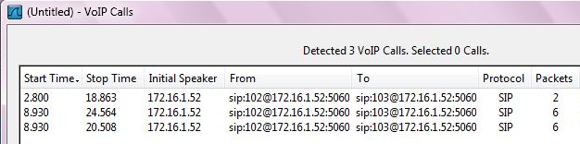

- In the center pane of the "VoIP Calls" window, click a call to highlight it and then click the Player button. In the “RTP Player” window, click the Decode button.

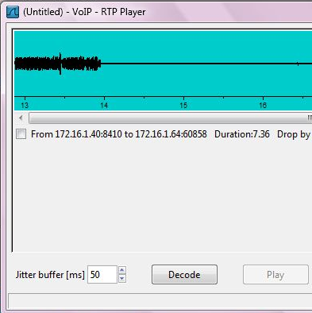
- You should see one or more sound streams, as shown to the right on this page. The line shows the volume of the sound as a function of time.

Capturing a Screen Image
- Make sure the "VoIP – RTP Player" window is visible, showing a voice stream.
- Press the PrintScrn key in the upper-right portion of the keyboard.
- On the host Windows system, Click Start, Programs, Accessories, Paint. In the untitled - Paint window, select Edit, Paste from the menu bar.
- In the untitled - Paint window, click File, Save. Select a Save as type of JPEG. Save the document with the filename Your Name Proj 16b.

Playing the Captured Stream
- In the "VoIP – RTP Player" window, click one of the captured streams, and click the Play button. The stream should play through your headphones or speakers.

Turning in Your Project
- Email the JPEG images to me as attachments to one e-mail message. Send it to: cnit.124@gmail.com with a subject line of Proj 16 From Your Name, replacing Your Name with your own first and last name. Send a Cc to yourself.

Sources
http://sites.google.com/a/3cx.com/3cx-wiki/
http://wiki.wireshark.org/RTP_statistics

Last Modified: 12-18-08

