What You Need for This Project
- A Windows machine with the X-Lite softphone from counterpath.com installed on it, as explained in project 16: Setting up a VoIP Network. It can be a real or virtual machine., running Windows XP or Vista (probably other versions of Windows will work too). The instructions below assume you are using a Vista computer in S214.
Background
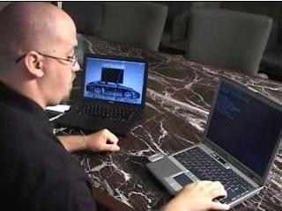
Fuzzing is a very powerful technique for finding vulnerabilities in software. Fuzzers send random data packets to an application, and monitor it to see if it crashes. Each time it crashes, the fuzzer saves the data that caused the crash for later investigation—it may indicate a denial of service vulnerability, a buffer overflow, or some other important flaw. Software designers should fuzz-test their products before marketing them, but there are no legal requirements to do so and may do not.
Motivation
Jon Ellch and David Maynor hacked into a Mac using a buggy Wi-Fi driver in 2006 and made this famous video:
http://blog.washingtonpost.com/securityfix/2006/08/hijacking_a_macbook_in_60_seco.html

They found that exploit with fuzzing.
Installing Python
- VoIPER is written in Python, which is included in Linux but not in Windows. So you need to add Python to Windows.
- Open a Web browser and go to python.org
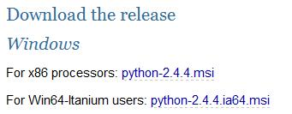
- On the left side of the page, click DOWNLOAD.
- On the next page, click Python 2.4.5.
- On the next page, click Python 2.4.4.
- On the next page, click Python 2.4.4.msi, as shown to the right on this page
- Save the python-2.4.4.msi file on your desktop. You can't run this file directly on Vista because it doesn't properly handle User Account Control, so you need to open an Administrator Command Prompt.
- Click Start, type in CMD and press Shift+Ctrl+Enter. In the "User Account Control" box, press Alt+C or click Continue. An Administrator Command Prompt opens.
- In the Administrator Command Prompt window, type this command, and then press the Enter key:
cd \users\Student\Desktop
Replace Student with your user name.
- In the Administrator Command Prompt window, type this command, and then press the Enter key:
python-2.4.4.msi
- Install the software with the default options.
Installing ctypes
- The ctypes library allows Python scripts to create and mamipulatre C data types. VoIPER requires it.
- Open a Web browser and go to pypi.python.org/pypi/ctypes
- Click the blue link to the right of the words "Download URL:".
- Click the ctypes-1.0.2.win32-py2.4.exe link, as shown below on this page.
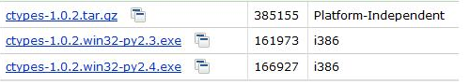
- Save the ctypes-1.0.2.win32-py2.4.exe file on your desktop.
- On your desktop, double click the ctypes-1.0.2.win32-py2.4.exe file. Install the software with the default options.
- If necessary, open an Administrator Command Prompt, by clicking Start, typing in CMD and pressing Shift+Ctrl+Enter.
- In the Administrator Command Prompt window, type this command, and then press the Enter key:
cd \users\Student\Desktop
Replace Student with your user name.
- In the Administrator Command Prompt window, type this command, and then press the Enter key:
ctypes-1.0.2.win32-py2.4.exe
- Install the software with the default options.
Installing wxPython
- wxPython is a GUI toolkit for Python, and it's required to run VoIPER.
- Open a Web browser and go to wxpython.org
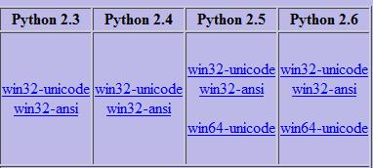
- On the left side of the page, in the Download section, click the Binaries link.
- On the next page, click the Download link.
- On the next page, in the "Python 2.4" section, click the win32-ansi link, as shown to the right on this page.
- Save the wxPython2.8-win32-ansi-2.8.9.1-py24.exe file on your desktop.
- On your desktop, double click the wxPython2.8-win32-ansi-2.8.9.1-py24.exe file. Install the software with the default options.
Installing VoIPER
- Open a Web browser and go to sourceforge.net/projects/voiper
- Click the Download link. On the next page, click the Download link.
- On the next page, click the voiper-0.07.tar.gz link. The .gz link usually indicates Linux software, but VoIPER is written in Python, so it runs on Windows as well as Linux.
- Save the voiper-0.07.tar.gz file on your desktop.
- To extract the file, you will need 7-zip. If it's not already on your machine, download it from 7-zip.com and install it.
- On your desktop, right click the voiper-0.07.tar.gz file and click 7-zip, "Extract Here". A voiper-0.07.tar file appears on your desktop.
- On your desktop, right click the voiper-0.07.tar file and click 7-zip, "Extract Here". A trunk folder appears on your desktop.
Running win_process_monitor to Monitor the X-Lite.exe Process
- There are two parts to VoIPER: the process Monitor and the fuzzer. First we'll start the process monitor, which will detect when the fuzz crashes the application.
- Click Start, type in CMD and press Shift+Ctrl+Enter. In the "User Account Control" box, press Alt+C or click Continue. An Administrator Command Prompt opens.
- In the Administrator Command Prompt window, type this command, and then press the Enter key:
cd \users\Student\Desktop\trunk
Replace Student with your user name.
- In the Administrator Command Prompt window, type this command, and then press the Enter key:
sulley\win_process_monitor.py –c sessions\X-Lite.crashbin
–p X-Lite.exe
Type the command all on one line, and let it wrap naturally, as shown below on this page.
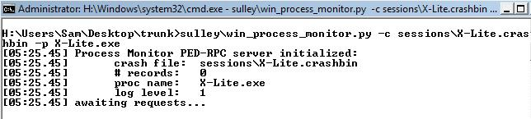
- You should see the "awaiting requests…" message, as shown below on this page.

Finding Your IP Address
- Click Start. In the Search box, type CMD and press Enter.
- In the Command Prompt window, type IPCONFIG and press Enter.
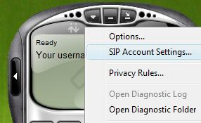
- Scroll back up past all the ridiculous false network adapters Vista pretends to have and find your real network adapter, and its IP address. In S214, it should start with 192.168.1. Write your IP address in the box to the right on this page.

IP: __________________________________
Adjusting X-Lite to Register Elsewhere
- If X-Lite is not open, double-click the X-Lite icon on your desktop.
- At the top left of the X-Lite window, click the ▼ symbol, and click "SIP Account Settings…", as shown to the right on this page.
- In the "SIP Accounts" box, click the Properties button.
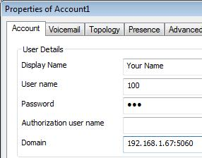
- In the "Properties of Account1" box, in the Domain field, change the IP address to be one larger than your computer's IP address. This will send the registration packets to a random machine, which won't recognize them.
- In the "Properties of Account1" box, click OK.
- In the "SIP Accounts" box, click Close.
- The X-Lite panel should now show "Registration error: 408 – Request Timeout".

Running fuzzer to Fuzz-test the X-Lite.exe Process
- Click Start, type in CMD and press Shift+Ctrl+Enter. In the "User Account Control" box, press Alt+C or click Continue. An Administrator Command Prompt opens.
- In the Administrator Command Prompt window, type this command, and then press the Enter key:
cd \users\Student\Desktop\trunk
Replace Student with your user name.

- In the Administrator Command Prompt window, type this command, and then press the Enter key:
fuzzer.py -f SDPFuzzer -i 192.168.1.66 -p 5060
-a sessions\XL1 -c 3 -r –R 0 -S C:\x.exe
Type the command all on one line, and let it wrap naturally, as shown below on this page. Replace 192.168.1.66 with your machine's IIP address, and replace H: with your Vista system drive letter (usually C:).
Here's what the command-line switches mean:
-f SDPFuzzer Use the SDPFuzzer technique
-i 192.168.1.66 The target is listening on this address
-p 5060 The target is listening on this port
-a sessions\XL1 The log file will be saved here (relative to trunk)
-c 3 Crash detection type 3 (process monitoring)
-r Wait for registration before sending packets
-S C:\x.exe The command line to restart the target process if it stops. I found that X-Lite does not stop and restart properly, so I just put a dummy value here, pointing to a file that does not exist. So if S-Lite crashes, we will only learn about the first packet that made it crash.
-R 0 Prevents the process from ever being restarted
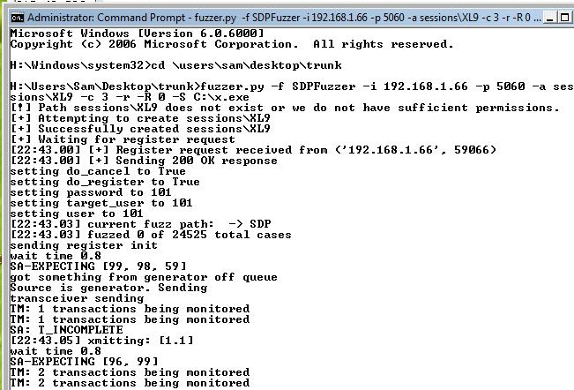
- You should see a "Waiting for register request" message, as shown above on this page.
Adjusting X-Lite to Register With the Fuzzer
- At the top left of the X-Lite window, click the ▼ symbol, and click "SIP Account Settings…".
- In the "SIP Accounts" box, click the Properties button.
- In the "Properties of Account1" box, in the Domain field, change the IP address to your computer's IP address. This will send the registration packets to the fuzzer.
- In the "Properties of Account1" box, click OK.
- In the "SIP Accounts" box, click Close.

- When X-Lite sends registration packets, the fuzzer should detect them, and print a "Sending 200 OK Response" message, as shown below on this page. Then messages about each fuzzing packet sent will scroll by rapidly-in the image below, it is sending packets. Notice the message saying "xmitting: [1, 1]". A series of them will scroll by, saying "xmitting: [1, 2]", "xmitting: [1, 3]", etc.

Simulating a Crash
- If you let the fuzzer go long enough, it will actually find a real vulnerability. But it took about an hour when I did it. If you don't want to wait that long, you can simulate a crash by just closing X-Lite this way:
  - In the X-Lite panel, click the ▼ symbol, and click Exit. Click OK. X-Lite closes.
Viewing the Crash Log
- On your desktop, double-click the trunk folder to open it.
- Double-click the sessions folder to open it.
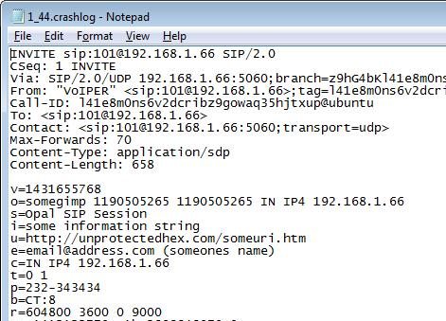
- Double-click the XL1 folder to open it.
- Find a file with a Type of CRASHLOG and double-click it. Mine had a filename of 1_44.crashlog but your name might be different.
- You should see a screen of text starting with INVITE, as shown to the right on this page.

Capturing a Screen Image
- Make sure CRASHLOG file is visible, showing INVITE.
- Press the PrintScrn key in the upper-right portion of the keyboard.
- On the host Windows system, Click Start, Programs, Accessories, Paint. In the untitled - Paint window, select Edit, Paste from the menu bar.
- In the untitled - Paint window, click File, Save. Select a Save as type of JPEG. Save the document with the filename Your Name Proj 17.

Turning in Your Project
- Email the JPEG image to me as an attachment to an e-mail message. Send it to: cnit.124@gmail.com with a subject line of Proj 17 From Your Name, replacing Your Name with your own first and last name. Send a Cc to yourself.

Sources
http://blog.washingtonpost.com/securityfix/2006/08/hijacking_a_macbook_in_60_seco.html
http://www.unprotectedhex.com/voiper-wiki/index.php/VoIPER_Usage_Examples

Last Modified: 10-26-08

