What You Need for This Project
- A Windows 2000 virtual machine – this will be the Target Machine. In the instructions below, I assume you are using one of the Vista machines in S214 with VMware Player.
- The Helix CD ISO image or bootable CD (I will have CDs in class, but you can download it yourself from e-fense.com/helix/Download.html
- A real machine with 1 GB or more of RAM – this will be the Gathering Machine. In the instructions below, I assume you are using one of the machines in S214.
- A Linux CD to boot the Gathering Machine from. In the instructions below, I assume you are using a Backtrack 2 CD.
Starting the Target Machine
- Start VMware Player and open your virtual machine.
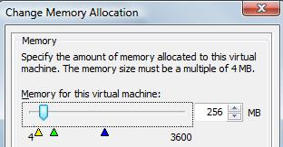
Setting RAM to 256 MB
- From the VMware Player menu bar, click "VMware Player", Troubleshoot, "Change Memory Allocation".
- The memory should be set to 256 MB, as shown to the right on this page. If it is set to a higher amount, adjust it to 256 MB This is not strictly necessary, but it makes the project go faster if there is less RAM to image.
- If you changed the RAM allocation, restart the virtual machine.

Checking the Virtual CD
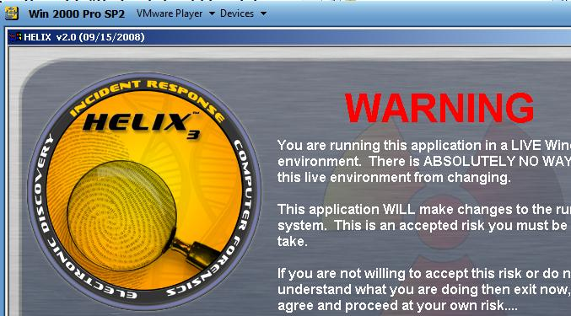
- Insert the Helix CD into the CD drive.
- On the Windows Target Machine desktop, double-click My Computer. Double-click the CD-ROM icon to open it.
- You should see a screen with WARNING in big red letters. That shows that the CD is being read correctly. Close the HELIX window.

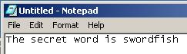
Creating Data to Capture
- In the Windows Target Machine, open Notepad and type in your this phrase, as shown to the right on this page:
The secret word is swordfish
- Save the file on your desktop as secret.txt.
- Close Notepad.
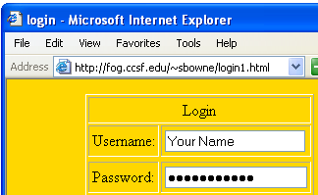
- In the Windows Target Machine, open Internet Explorer and go to this Web address:
tinyurl/fakelogin
- Type in your name for the Username, and type a password of rattlesnake. Click the "Submit Query" button. If Internet Explorer asks whether it should remember the password, click No.
- You should get a message saying Login Approved.
Starting the Gathering Machine
- Boot a machine from the Backtrack 2 CD. Log in as root with a password of toor. Enter the startx command to start the graphical environment.
- Click the Terminal icon on the lower left of the desktop (to the right of the K icon).
- At the # prompt, type this command and then press the Enter key:
ifconfig

Gathering Machine IP: __________________________
- Write your Gathering Machine's IP address in the box to the right on this page.
- At the # prompt, type this command and then press the Enter key:
nc –l –p 8888 > mem.img
Note that the first switch is a lowercase L, not the numeral 1. This command starts a netcat listener, putting all the data it gets into a file in RAM called mem.img.

Launching the Helix Live Tools
- On the Windows Target Machine desktop, double-click My Computer. Double-click the CD-ROM icon to open it. From the menu bar, click View, Details.
- A screen appears with WARNING in big red letters. Click Accept.
- The main Helix Tools window appears, as shown below on this page/ Click the camera icon which appears second from the top on the left. This will "Acquire a "live" image…"
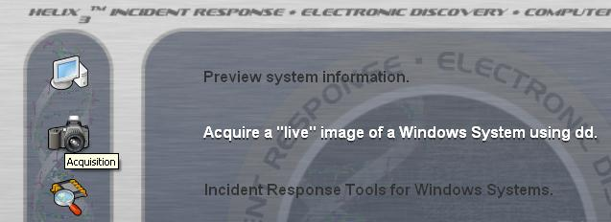

- Accept the default Source of "\\.\PhysicalMemory - [256 MB]".
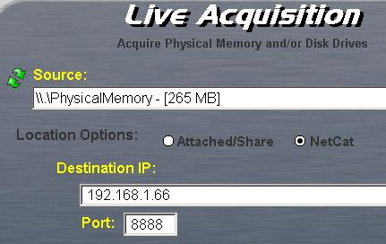
- In the "Location Options" section, click NetCat.
- In the "Destination IP" field, enter the Gathering Machine IP you wrote in the box on a previous page.
- Your "Live Acquisition" screen should look like the example shown to the right on this page.

Capturing a Screen Image
- Make sure the "Live Acquisition" screen is visible.
- Press the PrintScrn key in the upper-right portion of the keyboard.
- On the host Windows system, Click Start, Programs, Accessories, Paint. In the untitled - Paint window, select Edit, Paste from the menu bar.
- In the untitled - Paint window, click File, Save. Select a Save as type of JPEG. Save the document with the filename Your Name Proj 19a.

Acquiring Data
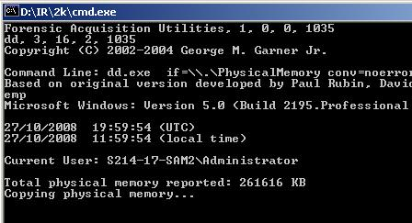
- In the "Live Acquisition" screen , click the Acquire button. In the Notice box, click Yes.
- A Command Prompt window opens, with the message "Copying physical memory…", as shown to the right on this page.
- When the process completes, this box will close, and the netcat session will close on the Gathering Machine. You can tell the session has closed because it will show a new # prompr.
Viewing the Captured Data
- On the Gathering Machine, at the # prompt, type this command and then press the Enter key:
ls -l
Note that the switch is a lowercase L, not the numeral 1.
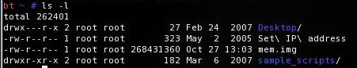
- You should see a file named mem.img which is approximately 256 million bytes in size, as shown below on this page.

- At the # prompt, type this command and then press the Enter key:
strings mem.img | grep '^[a-zA-Z 0-9,.!@#$%^&*()]\+$' > keywords.txt
Note that the | character is typed with Shift+\. This command picks the words out of the memory dump, and puts them in a file named keywords.txt
- At the # prompt, type this command and then press the Enter key:
sort keywords.txt | uniq > dictionary.txt
This command sorts the keywords, removes duplicates, and puts them into a file named dictionary.txt
- At the # prompt, type this command and then press the Enter key:
kwrite dictionary.txt
- The dictionary opens in a text editor.

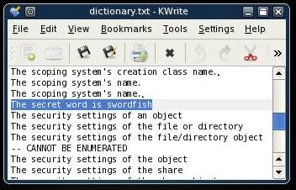
- Press Ctrl+f and search for "swordfish". You should find it, as shown to the right on this page.

Capturing a Screen Image
- Make sure the dictionary.txt window shows the text you captured from notepad is visible.
- Click the K button in the lower left corner of the desktop, and click Screenshot.

- In the Screenshot box, click the "Save As…" button. Give your file a name of Your Name Proj 19b.jpg and save it in the default location, which is /root/.
Firefox
- On the lower left of your desktop, click the Firefox button, as shown to the right on this page.
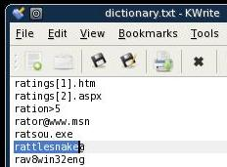
- Email the image to yourself as an email attachment.
Viewing More Captured Data
- Press Ctrl+f and search for "rattlesnake". You should find it, as shown to the right on this page.

Turning in Your Project
- Email the JPEG images to me as attachments to one e-mail message. Send it to: cnit.124@gmail.com with a subject line of Proj 19 From Your Name, replacing Your Name with your own first and last name. Send a Cc to yourself.

Sources
I got this project from Craig Newman in his Computer Forensics class.

Last Modified: 10-27-08

