What You Will Need
- An Attacker Machine, real or virtual, booted from a Backtrack 4 Pre-Final USB, DVD or ISO.
- A Target Machine running Windows XP with no Service Packs (real or virtual)

Getting BackTrack 4 Pre-Final
- You need a BackTrack 4 Pre-Final DVD, ISO, or bootable USB drive. Your instructor handed them out in class. If you don't have one, download it from
http://www.remote-exploit.org/backtrack.html

Starting the Target Machine
- Start the Target machine. Make sure it is connected to the Internet. Click Start, Run, and type in CMD. Press the Enter key. In the Command Prompt window, enter the IPCONFIG command. Find your IP address and write it in the box to the right on this page.

Target IP: _________________________
- Click Start, My Computer. Double-click C: to show the contents of the root of C: and leave that window open.

Booting the Computer with BackTrack 4 Pre-Final
- Insert the bt4 USB, DVD or ISO and restart your computer. If it won't boot from the DVD, press F12 or F2 to select the boot device.
- When you see a list of bootup options, select the first one by pressing the up-arrow key several times.
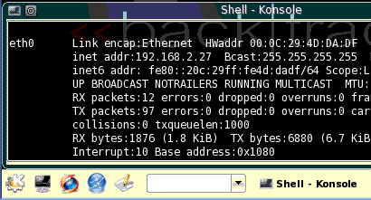
- At the bt ~ # prompt, type in this command and press the Enter key:
Konsole
button
startx
- A graphical desktop should appear.

Starting Networking
- Click Start, Services, NETWORK, Start NETWORK.
- Click the Konsole button, as shown to the right on this page.
- In the "Shell - Konsole" window, type this command and then press the Enter key:
dhclient
(If you are using wireless networking, click Start, Internet, Wicd Network Manager. If you are using an Eee netbook, click, Start, Settings, Regional & Accessibility, Keyboard Layout, and select Asus Laptop.
- In the "Shell - Konsole" window, type this command and then press the Enter key:
ping google.com
If you don’t see replies, you need to troubleshoot the networking. Press Ctrl+C to stop the pinging.

Starting FastTrack
- In the "Shell - Konsole" window, type this command and then press the Enter key:
cd /pentest/exploits/fasttrack
- In the "Shell - Konsole" window, type this command and then press the Enter key:
./ftgui
- On the Fast-Track Main Page, click Autopwn Automation
- Scroll down
- Type in the address of the target machine (on a wireless computer, prefix it with -e wlan0)
- Accept the default "Reverse Payload" Payload Option
- Click the "Metasploit Autopwn" button
- Exploits are attempted and scroll by
- When it finishes, you should see one or more Active Sessions available, as shown below on this page.
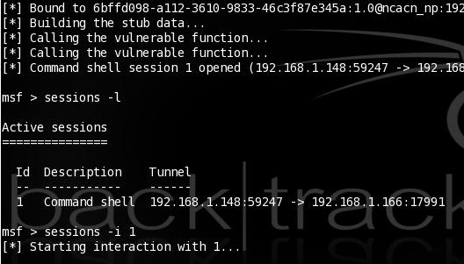

- At the msf> prompt, type this command, and then press the Enter key:
sessions –i 1
- At the meterpreter> prompt, type this command, and then press the Enter key:
execute –i –f cmd
- A Windows Command Prompt appears. Type this command, and then press the Enter key, replacing YOURNAME with your own name:
echo "ha" > C:\YOURNAME.txt
- Look at the target and see the file you created.

Saving the Screen Image on the Desktop
- On the Backtrack desktop, click Start, Screenshot.
- In the Screenshot window, click the "Save As…" button.
- In the "Save as – Screenshot" window, in the unlabelled box on the upper right, click the arrow and select /root/desktop.
- In the "Save as – Screenshot" window, in the Location: box, type in a filename of
Yourname-ProjX2.jpg
- Click the Save button. Your file should appear on the desktop.
Turning in your Project
- In Firefox, go to a Web-based email service you feel comfortable using in S214 – it should be one with a password you don't use anywhere else.
- Email the JPEG images to me as attachments. Send the message to cnit.123@gmail.com with a subject line of Proj X2 From Your Name. Send a Cc to yourself.
Last modified 7-14-09

