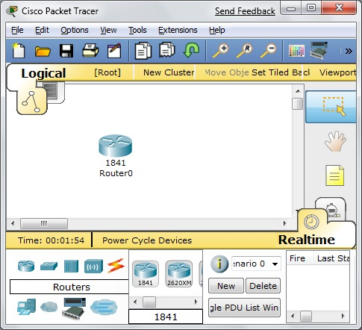
What You Need for This Project
Router icon
1841 icon
- Any Windows computer you have Administrator privileges on. The instructions below assume you are using Windows 7 Beta in S214.
- Packet Tracer, the Cisco router simulator. You can get it from your instructor. I wrote these instructions with Packet Tracer 5.1, but any version should be fine.
Install Packet Tracer
- Install Packet Tracer with the default options.
Simulating a Cisco Router with Packet Tracer
- Launch Packet Tracer.
- In the lower left corner of the “Cisco Packet Tracer” window, click the Router icon, as shown to the right on this page.
- In the lower center of the “Cisco Packet Tracer” window, drag the 1841 icon into the white center pane, as shown to the right on this page.

Adding a Password to the Router
- In the center of the “Cisco Packet Tracer” window, double-click the "1841 Router 0" icon.
- In the "Router0" window, click the CLI tab, as shown in the figure on the next page.
- At the "Continue with configuration dialog? [yes/no]" prompt, press n and then press the Enter key twice.
- You should see a Router> prompt. This is the Cisco IOS, which is a lot like Linux. The > indicates that you are in Unprivileged Mode, like a non-administrative account. To enter Privileged mode, type this command, and then press the Enter key:
enable
- The prompt changes to Router#. You are now in Privileged Mode, like root on a Linux computer. You didn't need a password to elevate your privileges, which is very insecure. To fix that, you must first enter Global Configuration Mode. Type this command, and then press the Enter key:
config t
- The prompt changes to Router(config)#. To require a password of cisco, type this command, and then press the Enter key:
enable password cisco

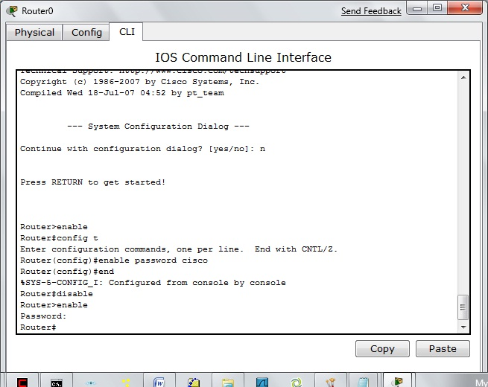
- To exit Global Configuration Mode, type this command, and then press the Enter key:
end
- To exit Privileged Mode, type this command, and then press the Enter key:
enable password cisco
- To exit Global Configuration Mode, type this command, and then press the Enter key:
end
- To exit Privileged Mode, type this command, and then press the Enter key:
disable
- To re-enter Privileged Mode, type this command, and then press the Enter key:
enable
- At the Password: prompt, type a password of cisco and then press the Enter key.
Examining the Configuration File
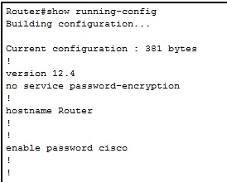
- The router is now password-protected, but how secure is the password storage? To find out, type this command, and then press the Enter key:
show running-config
- The password is clearly visible, as shown to the right on this page.
Removing the Plaintext Password
- Plaintext storage of passwords is very insecure. To remove that stored password, type these commands, pressing the Enter key after each command:
config t
no enable password
end

Setting an Encrypted Password
- Now we will use a really short password of cat to make the password crack fast. To configure an encrypted password, type these commands, pressing the Enter key after each command:
config t
enable secret cat
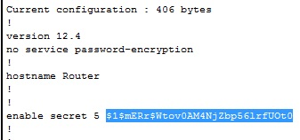
end
- To see the encrypted password, type this command, and then press the Enter key:
show running-config
- The password is now hashed, as shown to the right on this page.
- Highlight the password hash as shown, right-click the highlighted area, and click Copy.
Installing Cain
- If you don't already have Cain installed, download it from oxid.it/cain.html and install it:
- Right-click the Cain shortcut on your desktop and click "Run as Administrator".
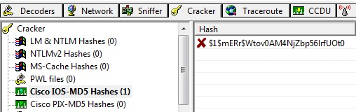
- In the Cain window, click the Cracker tab. In the left pane, click the "Cisco IOS MD5 Hashes" item to highlight it.
- From the Cain toolbar at the top of the window, click the + icon. An "Add Cisco IOS MD5 Hashes" box opens. Paste the hash into the upper box and click OK. The hash should appear in the central pane, as shown to the right on this page.
- In the central pane of the Cain window, right-click the hash and click "Brute-Force Attack". In the "Brute-Force Attack" box, click the Start button.
- The password should be found in a few seconds, as shown on the next page of these instructions.
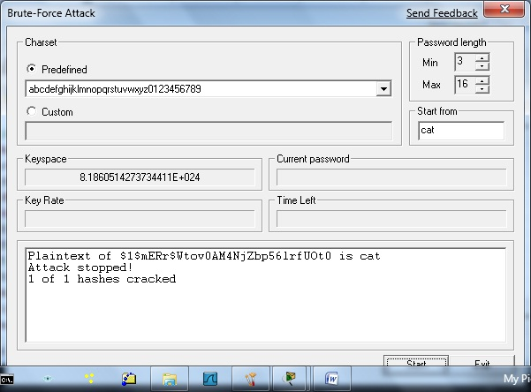

Capturing a Screen Image
- Make sure the plaintext of the password, "cat", is visible, as shown to the right on this page.
- Press the PrintScrn key in the upper-right portion of the keyboard.
- Click Start, Programs, Accessories, Paint. In the untitled - Paint window, select Edit, Paste from the menu bar.
- In the untitled - Paint window, click File, Save. Select a Save as type of JPEG. Save the document with the filename Your Name Proj X4.

Turning in Your Project
- Email the JPEG images to me as attachments to one e-mail message. Send it to: cnit.124@gmail.com with a subject line of Proj X4 From Your Name, replacing Your Name with your own first and last name. Send a Cc to yourself.

Last Modified: 3-12-09

