What You Need for This Project
- Any computer you have Administrator privileges on—Linux, Mac OS X, Windows XP, or Vista. The instructions below assume you are using Vista in S214.
- You cannot do this project all in one sitting. You have to pause for at least an hour between the two portions.
What is Adeona?
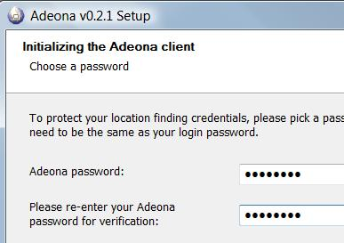
Adeona is software that runs on your computer and reports its IP address back to a distributed storage service on a regular basis. That way, if your computer is stolen, and the thief connects it to the Internet, you can locate it.
Installing Adeona
- Open a Web browser and go to adeona.cs.washington.edu
- From the blue bar near the top of the page, click Downloads.
- Download the appropriate version and install it with the default options.
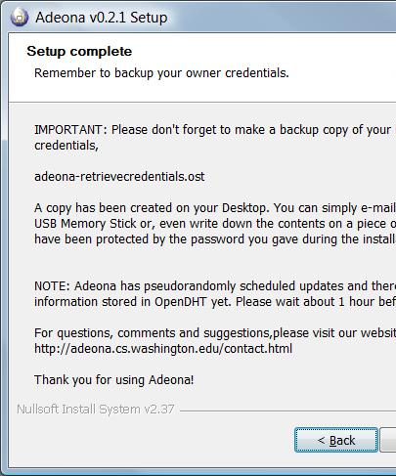
- In the final screen, you must select a password. If you are working in S214, please use a password of P@ssw0rd as shown to the right on this page. If you are using your own computer, use a password of your choice to maintain your privacy.
- When the installer is done, you will see a "Setup complete" box, as shown to the right on this page.

Capturing a Screen Image
- Make sure the "Setup complete" box is visible.
- Press the PrintScrn key in the upper-right portion of the keyboard.
- Click Start, Programs, Accessories, Paint. In the untitled - Paint window, select Edit, Paste from the menu bar.
- In the untitled - Paint window, click File, Save. Select a Save as type of JPEG. Save the document with the filename Your Name Proj X5a.

Stop and Wait
- It will take some time before Adeona records your machine's location, so you should wait at least an hour before doing the next section.
Retrieving your Machine's Location
- Click Start, "All Programs", "Adeona", "Run Adeona Recovery".
- In the "Welcome to the Adeona Recovery Wizard" box, click Next.
- In the Open box, click the Open button.
- In the "When do you want to search?" box, accept the default (from two days ago until now) and click Next.
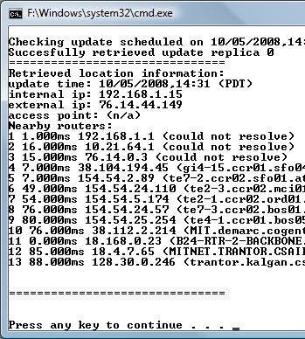
- In the "How many locations should we attempt to find?" box, accept the default of "Find first 1" and click Next.
- In the "Please enter your Adeona password" box, enter your password (which should be P@ssw0rd if you are working in S214) and click Next.
- In the "Clicking next will launch the recovery program" box, click Next.
- A Command Prompt window opens, showing the progress of Adeona as it hunts through update replicas. After a few minutes, it should find a update replica, and show a list of Nearby routers, as shown to the right on this page/

Capturing a Screen Image
- Make sure the list of "Nearby routers" box is visible.
- Press the PrintScrn key in the upper-right portion of the keyboard.
- Click Start, Programs, Accessories, Paint. In the untitled - Paint window, select Edit, Paste from the menu bar.
- In the untitled - Paint window, click File, Save. Select a Save as type of JPEG. Save the document with the filename Your Name Proj X5.

Turning in Your Project
- Email the JPEG images to me as attachments to one e-mail message. Send it to: cnit.124@gmail.com with a subject line of Proj X5 From Your Name, replacing Your Name with your own first and last name. Send a Cc to yourself.
Last Modified: 10-5-08

