Objectives

How security supports organizational mission, goals and objectives

Risk management

Security management

Personnel security

Professional ethics
Organizational Mission, Objectives, and Goals

Mission

Statement of its ongoing purpose and reason for existence.

Usually published, so that employees, customers, suppliers, and partners are aware of the organization’s stated purpose.

Should influence how we will approach the need to protect the organization’s assets.

Example Mission Statements

“Promote professionalism among information system security practitioners through the provisioning of professional certification and training.”

– (ISC)²

Example Mission Statements

“Help civilize the electronic frontier; to make it truly useful and beneficial not just to a technical elite, but to everyone, and to do this in a way which is in keeping with our society's highest traditions of the free and open flow of information and communication.”

– Electronic Frontier Foundation

“Empower and engage people around the world to collect and develop educational content under a free license or in the public domain, and to disseminate it effectively and globally.”

– Wikimedia Foundation

CCSF Mission Statement

Link Ch 1a
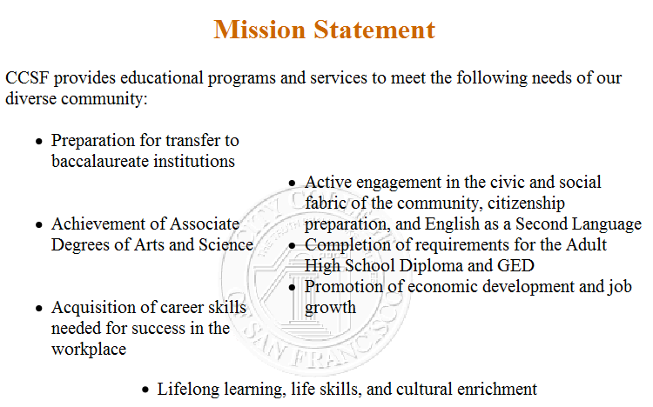

Objectives

Statements of activities or end-states that the organization wishes to achieve.

Support the organization’s mission and describe how the organization will fulfill its mission.

Observable and measurable.

Do not necessarily specify how they will be completed, when, or by whom.

Example Objectives

“Obtain ISO 27001 certification by the end of third quarter.”

“Reduce development costs by twenty percent in the next fiscal year.”

“Complete the integration of CRM and ERP systems by the end of November.”

Goals

Specify specific accomplishments that will enable the organization to meet its objectives.

Measurable, observable, objective, support mission and objectives

Goals and objectives are synonyms (links Ch 1c & 1d)

Security Support of Mission, Objectives, and Goals

Our role is to reduce risk through proper activities and controls that protect assets

Protect the organization and its ability to perform its mission, not just its IT assets (Ch 1e)

Be aware of mission, objectives, goals

We need the support of senior management

To get priorities and resources

To become involved in key activities
Risk Management

Risk Management

“The process of determining the maximum acceptable level of overall risk to and from a proposed activity, then using risk assessment techniques to determine the initial level of risk and, if this is excessive, developing a strategy to ameliorate appropriate individual risks until the overall level of risk is reduced to an acceptable level.”

Two steps

Risk assessments

Risk treatment

Qualitative Risk Assessment

For a given scope of assets, identify:

Vulnerabilities

Threats

Threat probability (Low / medium / high)

Impact (Low / medium / high)

Countermeasures

Example of Qualitative Risk Assessment
Threat | Impact | Initial Probability | Counter-  measure | Residual Probability
Flood damage | H | L | Water alarms | L
Theft | H | L | Key cards, surveillance, guards | L
Logical intrusion | H | M | Intrusion prevention system | L

Quantitative Risk Assessment

Extension of a qualitative risk assessment. Metrics for each risk are:

Asset value: replacement cost and/or income derived through the use of an asset

Exposure Factor (EF): portion of asset's value lost through a threat (also called impact)

Single Loss Expectancy (SLE) = Asset ($) x EF (%)

Annualized Rate of Occurrence (ARO)

Probability of loss in a year, %

Annual Loss Expectancy (ALE) = SLE x ARO

Example of Quantitative Risk Assesment

Theft of a laptop computer, with the data encrypted

Asset value: $4,000

Exposure factor: 100%

SLE = $4,000 x 100% = $4,000

ARO = 10% chance of theft in a year

ALE = 10% x $4,000 = $400

Example of Quantitative Risk Assesment

Dropping a laptop computer and breaking the screen

Asset value: $4,000

Exposure factor: 50%

SLE = $4,000 x 100% = $2,000

ARO = 25% chance of theft in a year

ALE = 25% x $2,000 = $500

Quantifying Countermeasures

Goal: reduction of ALE (or the qualitative losses)

Impact of countermeasures:

Cost of countermeasure

Changes in Exposure Factor (EF)

Changes in Single Loss Expectancy (SLE)

Geographic Considerations

Replacement and repair costs of assets may vary by location

Exposure Factor may vary by location

Impact may vary by location

Risk Assessment Methodologies

NIST 800-30, Risk Management Guide for Information Technology Systems

OCTAVE (Operationally Critical Threat, Asset, and Vulnerability Evaluation)

FRAP (Facilitated Risk Analysis Process) – qualitative pre-screening

Spanning Tree Analysis – visual, similar to mind map

Risk Treatment

One or more outcomes from a risk assessment

Risk Acceptance

“yeah, we can live with that”

Risk Avoidance

Discontinue the risk-related activity -- the most extreme form of risk treatment

Risk Reduction (also called Risk Mitigation)

Using countermeasures such as firewalls, IDS systems, etc., to reduce risks

Risk Transfer

Buy insurance

Residual Risk

After risk treatment, some risk remains

Risk can never be eliminated entirely

The remaining risk is called Residual Risk
Security Management Concepts

Security Management Concepts

Security controls

CIA Triad

Defense in depth

Single points of failure

Fail open, fail closed

Privacy

ISO 27001

Standard for Information Security Management System

Plan-Do-Check-Act cycle

Plan = define requirements, assess risks, decide which controls are applicable

Do = implement and operate the ISMS

Check = monitor and review the ISMS

Act = maintain and continuously improve the ISMS

Documents and records are required

ISO 27001

Security Controls

Detective (records events)

Deterrent (scares evil-doers away)

Preventive (stops attacks)

Corrective (after an attack, prevents another attack)

Recovery (after an attack, restores operations)

Compensating (substitutes for some other control that is inadequate)

(covered in depth in Chapter 2, p. 56ff)

CIA: Confidentiality, Integrity, Availability

The three pillars of security: the CIA Triad

Confidentiality: information and functions can be accessed only by properly authorized parties

Integrity: information and functions can be added, altered, or removed only by authorized persons and means

Availability: systems, functions, and data must be available on-demand according to any agreed-upon parameters regarding levels of service

Defense in Depth

A layered defense in which two or more layers or controls are used to protect an asset

Heterogeneity: the different controls should be different types, so as to better resist attack

Entire protection: each control completely protects the asset from most or all threats

Example: antivirus on the email gateway, and also on the workstations

Defense in depth reduces the risks from

Vulnerability of a single device

Malfunction of a single device

Fail open of a single device

Defense in Depth Example

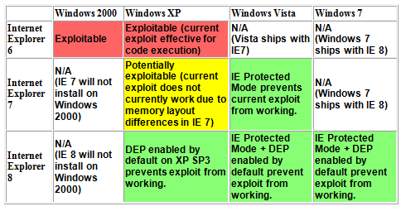
The IE 0day used against Google

From link Ch 1h

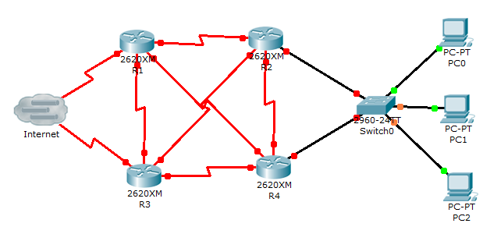

Single Points of Failure

A single point of failure (SPOF)

Failure of a single component results in the failure of the entire system

Fail Open / Fail Closed / Fail Soft

When a security mechanism fails, there are usually two possible outcomes:

Fail open – the mechanism permits all activity

Fail closed – the mechanism blocks all activity

Fail Soft -- shutting down failed systems, preserving some functionality

Example: A server with a UPS and a shutdown script

Principles

Different types of failures will have different results

Both fail open and fail closed are undesirable, but sometimes one or the other is catastrophic

Security devices generally fail closed

Privacy

Defined: the protection and proper handling of sensitive personal information

Requires proper technology for protection

Requires appropriate business processes and controls for appropriate handling

Issues

Inappropriate uses

Unintended disclosures to others

Personally Identifiable Information (PII)

Name

SSN

Phone number

Driver's license number

Credit card numbers

Etc.
Security Management

Security Management

Executive oversight

Governance

Policy, guidelines, standards, and procedures

Roles and responsibilities

Service level agreements

Secure outsourcing

Data classification and protection

Certification and accreditation

Internal audit

Security Executive Oversight

Executives must support security activities

Support and enforcement of policies

Allocation of resources

Prioritization of activities

Support of risk treatment

Governance

Defined: “Security governance is the set of responsibilities and practices exercised by the board and executive management with the goal of providing strategic direction, ensuring that objectives are achieved, ascertaining that risks are managed appropriately and verifying that the enterprise's resources are used responsibly.”

The process and action that supports executive oversight

Steering committee oversight

Resource allocation and prioritization

Status reporting

Strategic decisions

Policies

Constraints of behavior on systems and people

Specifies activities that are required, limited, and forbidden

Example

Information systems should be configured to require good security practices in the selection and use of passwords

Policy Standards

ISO 27002:2005 (link Ch 1f)

SANS Security Policy Project (Ch 1j)

Requirements

Required characteristics of a system or process

Often the same as or similar to the policy

Specifies what should be done, not how to do it

Example

Information systems must enforce password quality standards and reference a central authentication service, such as LDAP or Active Directory.

Guidelines: defines how to support a policy

Example: Passwords must not be dictionary words

Standards: what products, technical standards, and methods will be used to support policy

Examples

All fiber optic cables must be Corning brand

Passwords must be at least 8 characters

Procedures: step by step instructions

Security Roles and Responsibilities

Formally defined in security policy and job descriptions

These need to be defined:

Ownership of assets

Access to assets

Use of assets: employees are responsible for their behavior

Managers responsible for employee behavior

Service Level Agreements

SLAs define a formal level of service

SLAs for security activities

Security incident response

Security alert / advisory delivery

Security investigation

Policy and procedure review

Secure Outsourcing

Outsourcing risks

Control of confidential information

Loss of control of business activities

Accountability – the organization that outsources activities is still accountable for their activities and outcomes

Data Classification and Protection

Components of a classification and protection program

Sensitivity levels

“confidential”, “restricted”, “secret”, etc.

Marking procedures

How to indicate sensitivity on various forms of information

Access procedures

Handling procedures

E-mailing, faxing, mailing, printing, transmitting, destruction

Certification and Accreditation

Two-step process for the formal evaluation and approval for use of a system

Certification is the process of evaluating a system against a set of formal standards, policies, or specifications.

Accreditation is the formal approval for the use of a certified system

for a defined period of time (and possibly other conditions).

Internal Audit

Evaluation of security controls and policies to measure their effectiveness

Performed by internal staff

Objectivity is of vital importance

Formal methodology

Required by some regulations, e.g. Sarbanes Oxley

Links Ch 1k, 1l

Security Strategies

Management is responsible for developing the ongoing strategy for security management

Past incidents can help shape the future

Incidents

SLA performance

Certification and accreditation

Internal audit
Personnel Security

Personnel / Staffing Security

Hiring practices and procedures

Periodic performance evaluation

Disciplinary action policy and procedures

Termination procedures

Hiring Practices and Procedures

Effective assessment of qualifications

Background verification (prior employment, education, criminal history, financial history)

Non-disclosure agreement (NDA)

Non-compete agreement

Intellectual property agreement

Employment agreement

Employee Handbook

Formal job descriptions

Termination

Immediate termination of all logical and physical access

Change passwords known to the employee

Recovery of all company assets

Notification of the termination to affected staff, customers, other third parties

And possibly: code reviews, review of recent activities prior to the termination

Work Practices

Separation of duties

Designing sensitive processes so that two or more persons are required to complete them

Job rotation

Good for cross-training, and also reduces the likelihood that employees will collude for personal gain

Mandatory vacations

Detect / prevent irregularities that violate policy and practices

Security Education, Training, and Awareness

Training on security policy, guidelines, standards

Upon hire and periodically thereafter

Various types of messaging

E-mail, intranet, posters, flyers, trinkets, training classes

Testing – to measure employee knowledge of policy and practices
Professional Ethics

Professional Ethics

(ISC)² code of ethics

Protect society, the commonwealth, and the infrastructure.

Act honorably, honestly, justly, responsibly, and legally.

Provide diligent and competent service to principals.

Advance and protect the profession. Last modified 1-27-10

