Objectives

Controlling Access

Access Control Attacks

Testing Access Controls
Controlling Access

Identification and Authentication

Identification: unproven assertion of identity

“My name is…”

Userid

Authentication: proven assertion of identity

Userid and password

Userid and PIN

Biometric

Authentication Methods

What the user knows

Userid and password

Userid and PIN

What the user has

Smart card

Token

What the user is

Biometrics (fingerprint, handwriting, voice, etc.)

How Information Systems Authenticate Users

Request userid and password

Hash password

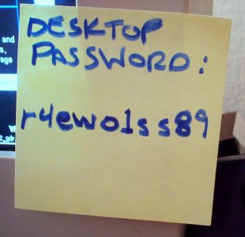
Retrieve stored userid and hashed password

Compare

Make a function call to a network based authentication service

How a User Should Treat Userids and Passwords

Keep a secret

Do not share with others

Do not leave written down where someone else can find it

Store in an encrypted file or vault

Use RofoForm

How a System Stores Userids and Passwords

Typically stored in a database table

Application database or authentication database

Userid stored in plaintext

Facilitates lookups by others

Password stored encrypted or hashed

If encrypted, can be retrieved under certain conditions

“Forgot password” function, application emails to user

If hashed, cannot be retrieved under any circumstance (best method)

Password Hashes

Cain, Cracker top tab, right-click empty space, Add to List

LM hash is weak, no longer used in Win 7

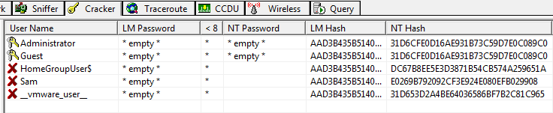
NT hash is stronger, but not salted

Strong Authentication

Traditional userid + password authentication has known weaknesses

Easily guessed passwords

Disclosed or shared passwords

Stronger types of authentication available, usually referred to as “strong authentication”

Token

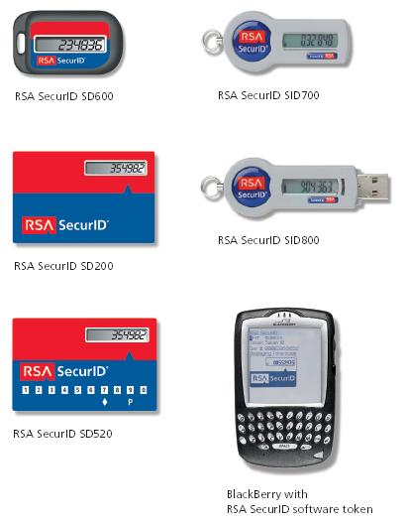
Certificate

Biometrics

Two Factor Authentication

First factor: what user knows

Second factor: what user has

Password token

USB key

Digital certificate

Smart card

Without the second factor, user cannot log in

Defeats password guessing / cracking

Biometric Authentication

Stronger than userid + password

Stronger than two-factor?

Can be hacked

Measures a part of user’s body

Fingerprint

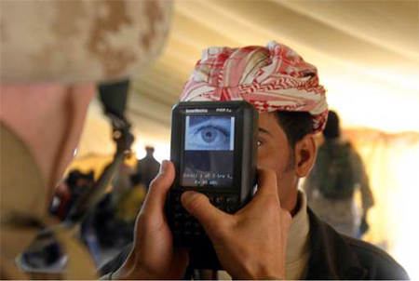
Iris scan

Signature

Voice

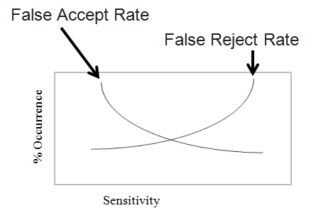
Etc.

Authentication Issues

Password quality

Consistency of user credentials across multiple environments

Too many userids and passwords

Handling password resets

Dealing with compromised passwords

Staff terminations

Access Control Technologies

Centralized management of access controls

LDAP

Active Directory, Microsoft's LDAP

RADIUS

Diameter, upgrade of RADIUS

TACACS

Replaced by TACACS+ and RADIUS

Kerberos

Uses Tickets

Single Sign-On (SSO)

Authenticate once, access many information systems without having to re-authenticate into each

Centralized session management

Often the “holy grail” for identity management

Harder in practice to achieve – integration issues

Reduced Sign-On

Like single sign-on (SSO), single credential for many systems

But… no inter-system session management

User must log into each system separately, but they all use the same userid and password

Weakness of SSO and RSO

Weakness: intruder can access all systems if password is compromised

Best to combine with two-factor / strong authentication
Access Control Attacks

Access Control Attacks

Intruders will try to defeat, bypass, or trick access controls in order to reach their target

Attack objectives

Guess credentials

Malfunction of access controls

Bypass access controls

Replay known good logins

Trick people into giving up credentials

Buffer Overflow

Cause malfunction in a way that permits illicit access

Send more data than application was designed to handle properly

“Excess” data corrupts application memory

Execution of arbitrary code

Malfunction

Countermeasure: “safe” coding that limits length of input data; filter input data to remove unsafe characters

Script Injection

Insertion of scripting language characters into application input fields

Execute script on server side

SQL injection – obtain data from application database

Execute script on client side – trick user or browser

Cross site scripting

Cross site request forgery

Countermeasures: strip “unsafe” characters from input

Data Remanence

Literally: data that remains after it has been “deleted”

Examples

Deleted hard drive files

Data in file system “slack space”

Erased files

Reformatted hard drive

Discarded / lost media: USB keys, backup tapes, CDs

Countermeasures: improve media physical controls

Denial of Service (DoS)

Actions that cause target system to fail, thereby denying service to legitimate users

Specially crafted input that causes application malfunction

Large volume of input that floods application

Distributed Denial of Service (DDoS)

Large volume of input from many (hundreds, thousands) of sources

Countermeasures: input filters, patches, high capacity

Dumpster Diving

Literally, going through company trash in the hopes that sensitive printed documents were discarded that can be retrieved

Personnel reports, financial records

E-mail addresses

Trade secrets

Technical architecture

Countermeasures: on-site shredding

Eavesdropping

Interception of data transmissions

Login credentials

Sensitive information

Methods

Network sniffing (maybe from a compromised system)

Wireless network sniffing

Countermeasures: encryption, stronger encryption

Emanations

Electromagnetic radiation that emanates from computer equipment

Network cabling

More prevalent in networks with coaxial cabling

CRT monitors

Wi-Fi networks

Countermeasures: shielding, twisted pair network cable, LCD monitors, lower power or eliminate Wi-Fi

Spoofing and Masquerading

Specially crafted network packets that contain forged address of origin

TCP/IP protocol permits forged MAC and IP address

SMTP protocol permits forged e-mail “From” address

Countermeasures: router / firewall configuration to drop forged packets, judicious use of e-mail for signaling or data transfer

Social Engineering

Tricking people into giving out sensitive information by making them think they are helping someone

Methods

In person

By phone

Schemes

Log-in, remote access, building entrance help

Countermeasures: security awareness training

Phishing

Incoming, fraudulent e-mail messages designed to give the appearance of origin from a legitimate institution

“Bank security breach”

“Tax refund”

“Irish sweepstakes”

Tricks user into providing sensitive data via a forged web site (common) or return e-mail (less common)

Countermeasure: security awareness training

Pharming

Redirection of traffic to a forged website

Attack of DNS server (poison cache, other attacks)

Attack of “hosts” file on client system

Often, a phishing e-mail to lure user to forged website

Forged website has appearance of the real thing

Countermeasures: user awareness training, patches, better controls

Password Guessing

Trying likely passwords to log in as a specific user

Common words

Spouse / partner / pet name

Significant dates / places

Countermeasures: strong, complex passwords, aggressive password policy, lockout policy

Password Cracking

Obtain / retrieve hashed passwords from target

Run password cracking program

Runs on attacker’s system – no one will notice

Attacker logs in to target system using cracked passwords

Countermeasures: frequent password changes, controls on hashed password files, salting hash

Malicious Code

Viruses, worms, Trojan horses, spyware, key logger

Harvest data or cause system malfunction

Countermeasures: anti-virus, anti-spyware, security awareness training

Access Control Concepts

Access Control Concepts

Principles of access control

Types of controls

Categories of controls

Principles of Access Control

Separation of duties

No single individual should be allowed to perform high-value or sensitive tasks on their own

Financial transactions

Software changes

User account creation / changes

Principles of Access Control

Least privilege

Persons should have access to only the functions / data that they require to perform their stated duties

Server applications

Don't run as root

User permissions on File Servers

Don't give access to others' files

Workstations

User Account Control

Principles of Access Controls (cont.)

Defense in depth

Use of multiple controls to protect an asset

Heterogeneous controls preferred

If one type fails, the other remains

If one type is attacked, the other remains

Examples

Nested firewalls

Anti-virus on workstations, file servers, e-mail servers

Types of Controls

Technical

Authentication, encryption, firewalls, anti-virus

Physical

Key card entry, fencing, video surveillance

Administrative

Policy, procedures, standards

Categories of Controls

Detective controls

Deterrent controls

Preventive controls

Corrective controls

Recovery controls

Compensating controls

Detective Controls


Monitor and record specific types of events

Does not stop or directly influence events

Video surveillance

Audit logs

Event logs

Intrusion detection system

Deterrent Controls

Highly visible

Prevent offenses by influencing choices of would-be intruders

Deterrent Controls (cont.)

A purely deterrent control does not prevent or even record events

Signs

Guards, guard dogs (may be preventive if they are real)


Razor wire

Preventive Controls

Block or control specific events

Firewalls

Anti-virus software

Encryption

Key card systems

Bollards stop cars (as shown)

Corrective Controls

Post-event controls to prevent recurrence

“Corrective” refers to when it is implemented

Can be preventive, detective, deterrent, administrative

Examples (if implemented after an incident)

Spam filter

Anti-virus on e-mail server

WPA Wi-Fi encryption

Recovery Controls

Post-incident controls to recover systems

Examples

System restoration

Database restoration

Compensating Controls

Control that is introduced that compensates for the absence or failure of a control

“Compensating” refers to why it is implemented

Can be detective, preventive, deterrent, administrative

Examples

Daily monitoring of anti-virus console

Monthly review of administrative logins

Web Application Firewall used to protect buggy application

Testing Access Controls

Testing Access Controls

Access controls are the primary defense that protect assets

Testing helps to verify whether they are working properly

Types of tests

Penetration tests

Application vulnerability tests

Code reviews

Penetration Testing

Automatic scans to discover vulnerabilities

Scan TCP/IP for open ports, discover active “listeners”

Potential vulnerabilities in open services

Test operating system, middleware, server, network device features

Missing patches

Example tools: Nessus, Nikto, SAINT, Superscan, Retina, ISS, Microsoft Baseline Security Analyzer

Application Vulnerability Testing

Discover vulnerabilities in an application

Automated tools and manual tools

Example vulnerabilities

Cross-site scripting, injection flaws, malicious file execution, broken authentication, broken session management, information leakage, insecure use of encryption, and many more

Audit Log Analysis

Regular examination of audit and event logs

Detect unwanted events

Attempted break-ins

System malfunctions

Account abuse, such as credential sharing

Audit log protection

Write-once media

Centralized audit logs

Last modified 2-1-10

