Objectives

Types of applications

Application models and technologies

Application threats and countermeasures

Security in the software development life cycle

Application security controls

Databases and data warehouses
Types of Applications

Agents

Standalone programs that are part of a larger application

Examples:

Anti-virus

Patch management

Configuration management

Windows 7's "Network discovery" agent

Applets

Software programs that run within the context of another program

Example: media players within browser

Client-server

Separate programs on clients and servers communicate via networks and work together

Client can be weak, even a "thin client" with no hard drive

Example: Client tools connect to database on server

Connection protocols: ODBC or Oracle's Net8 (called SQL*Net prior to Oracle8)

Few developed now but many are in use

Distributed

Software components run on several systems

User workstations, application server, records server, mapping server, databases…

Two-tier, three-tier, multi-tier

Reasons: scalability, performance, geographical

Web Applications

Web browser as client, application server back-end

Client software nearly universal

Application software centralized

Immensely popular and important

OWASP (Open Web Application Security Project) link Ch 3a
Application Models and Technologies

Application Models and Technologies

Control flow languages

Structured languages

Object oriented languages

Knowledge based languages

Control Flow Languages

Linear, sequential

Use of “if – then – else”

Branching with “go to”

Examples:

BASIC, COBOL, Cold Fusion, FORTRAN, Perl, PHP, Python, VBScript

Structured Languages

Nested, heavy use of subroutines and functions

Little or no “go to”

Examples:

C

Pascal

Object Oriented Languages

Utilize concepts of object programming

Classes, objects, instances, and inheritance

Methods, instantiations

Encapsulation, abstraction, polymorphism

Examples

C++, Java, Ruby, Simula, Smalltalk

Distributed Object Oriented Systems

Modules on different systems communicate with an Object Request Broker (ORB), such as

CORBA, Enterprise Java Bean, DCOM, or JRMI

Knowledge Based Applications

Knowledge-based systems

Artificial Intelligence

Used to forecast weather, stock prices, etc.

Neural networks

Modeled after biological reasoning processes

Artificial neurons that store pieces of information

Given cases about situations and outcomes, can predict future outcomes

Expert systems

Inference engine and knowledge base of past situations and outcomes

Accumulate experience and learn to work better
Threats to Applications

Reasons for attacks

Industrial espionage

Vandalism and disruption

Denial of service

Political / religious

Buffer overflow attacks

Disrupt a software application by providing more data to the application than it was designed to handle

Types

Stack buffer overflow

NOP sled attack

Heap overflow

Jump to register attack

Examples: Morris worm, ping of death, code red worm, Slammer, Blaster, Sasser

Buffer overflow attack countermeasures

Use safe languages and libraries

Executable space protection

Microsoft's Data Execution Prevention

Stack smashing protection

Uses a "canary" value to detect oveflows

Address Space Layout Randomization

Application firewalls

Malicious software

Types: viruses, worms, Trojan horses, rootkits, bots, spam, pharming, spyware, key loggers

Purpose

Steal, corrupt, or destroy information

Remote control

Denial of service

Types of malware

Virus: human assisted replication, embed in programs, files, master boot records

Worm: self replicating, scan for victims, rapid spread

Mass mailing, Port scanning

Trojan horse: claims one function, but is malware

Rootkit: hide within or beneath the operating system

Hides files, processes, and network connections

Bot: remote control zombie

Spam: unsolicited e-mail

Pharming: attack on DNS to redirect traffic to phishing Web site

Spyware: collect information about usage, forward to central server

Key logger: logs keystrokes and mouse movements, forwards to central server

Malware countermeasures

Anti-malware

Patches

Firewalls and application firewalls

Hardened systems

Intrusion detection systems

Decreased privilege levels

Penetration testing

Input attacks

Buffer overflow

Script injection

Cross site scripting

Cross site request forgery

Countermeasures

Input field filtering, application firewall, application vulnerability scanning, software developer training

Vulnerability Scanners?

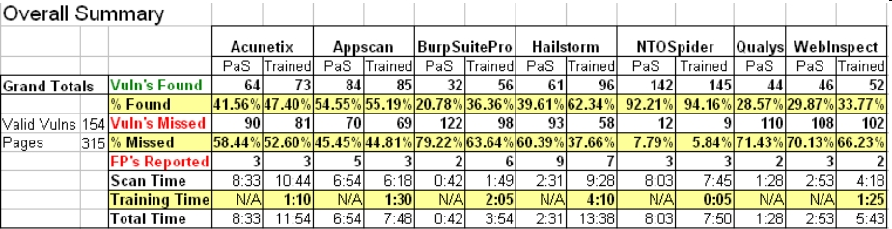
They miss 49% of the vulnerabilities they are looking for

Link Ch 6b

Object reuse

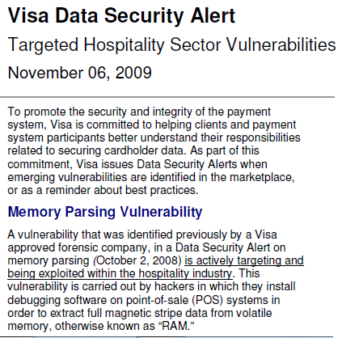
Use of a resource belonging to another process, including:

Memory, databases, file systems, temporary files, and paging space

Object reuse countermeasures

Application isolation

Server virtualization

Developer training

Link Ch 3c

Mobile code

Code from one system that executes on another system

Active Web content

ActiveX, Javascript, Flash

Downloaded software

Can be useful but some is malicious

Mobile code countermeasures

Anti-malware

Reduced user privileges

Don't surf the Web as administrator

Mobile code access controls

Don't let unauthorized users execute code

Restricting mobile code on workstations

Browser settings, NoScript, etc.

Social engineering

Attack on personnel to gain secrets

People are vulnerable because they want to help

Pretexting is pretending to be someone else

Social engineering countermeasures

Security awareness training that includes accountability

Back door / maintenance hook

Access holes deliberately planted by a developer

To facilitate easier testing during development

To facilitate production access

To facilitate a break-in

Back door countermeasures

Code reviews

Source code control

Logic bombs

Deliberate malfunction that causes harm

Time bombs

Malfunction on a given date and time

Event bombs

Malfunction on a specific event

Logic bomb countermeasures

Software source code review, external audits
Security in the Software Development Life Cycle

Security in the Software Development Life Cycle (SDLC)

SDLC

The entire collection of processes used to design, develop, test, implement, and maintain software

Security must be included in each step of the SDLC

Conceptual

Requirements and specifications development

Application design

Threat risk modeling

Coding

Testing

Security in the conceptual stage

Presence of sensitive information must be identified

Information flows

Access controls (users, administrators, third parties)

Regulatory requirements

Application dependencies

Security application requirements and specifications

Every detail of the software should be specified, down to individual input forms and fields

Security requirements

Roles, access controls, audit logging, configuration management

Security in application design

Adhere to all requirements and specifications

Published design documents

Design reviews

Reviewed by all stakeholders including security

Threat risk modeling

Identify threats and risks prior to development

Possible changes to specs, req’s, or design

Security in application coding

Develop safe code

Free of common vulnerabilities

Use safe libraries that include safe functions for input validation

1-10-100 rule

It costs 10 times as much to secure an application after it has been developed

It costs 100 times as much to secure an application after it has been implemented

OWASP Top Ten Web Application Risks

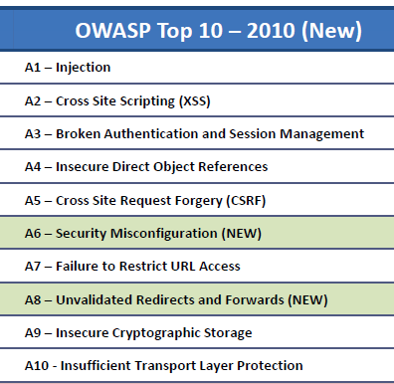
Link Ch 6d

Great OWASP Presentation

Linked as an extra lecture on my CNIT 125 page

Security in testing

Testing should verify correct coding of every requirement and specification

Use vulnerability scanners

Protect the SDLC itself

Source code access control

Protect source code

Don't trust it to remain secret, though

Record version changes

Protection of software development and testing tools

Protect from unauthorized modifications

Protection of software development systems

Prevent introduction of malware, back doors, logic bombs
Application Environment and Security Controls

Controls that must be present in a developed application

Authentication

Limiting access to only legitimate, approved users

Authorization

Limiting access only to approved functions and data

Audit logging

Logging of all actions in the application
Databases and Data Warehouses

Database Concepts

Database

Ordered collection of data, such as employee records

Data Warehouse

A database used for decision support and research

May contain all customer transactions

Business intelligence tools analyze the data to find trends

Example: Google's ad-targeting data

Database Architectures

Hierarchical databases: tree structure like DNS (no longer produced)

Network databases: complex tree structure (no longer produced)

Object-oriented databases: OO, methods stored with data

Not common yet, see link Ch 3e

Distributed databases: physically distributed, any type

Relational databases (RDBMS): in widest use today

Data is stored in tables, records and fields

Tables have relationships

Oracle, SQL Server, DB2, MySQL, etc.

Database Transactions

Records retrieval

Records update

Records creation

Transactional integrity

Nested or complex transactions executed as a unit

Begin work… <transactions> …end work

Database Security Controls

Access controls

Userids, passwords

Table / row / field level access control

Read-only or read/write

Views

Virtual tables that are a subset of individual tables, or a “join” between tables

Permission given to views just like “real” tables

Last modified 2-10-10

