Objectives

Applications and uses of cryptography

Encryption methodologies

Cryptanalysis

Management of cryptography

Key management
Applications and Uses of Cryptography

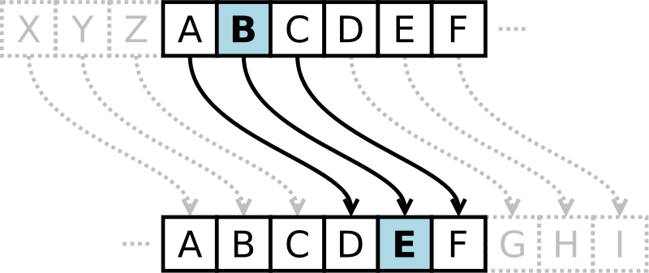
What Is Cryptography

Cryptography is the science of hiding information in plain sight, in order to conceal it from unauthorized parties.

Substitution cipher first used by Caesar for battlefield communications

Encryption Terms and Operations

Plaintext – an original message

Ciphertext – an encrypted message

Encryption – the process of transforming plaintext into ciphertext (also encipher)

Decryption – the process of transforming ciphertext into plaintext (also decipher)

Encryption key – the text value required to encrypt and decrypt data
Encryption methodologies

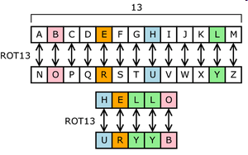
Substitution Cipher

Plaintext characters are substituted to form ciphertext

“A” becomes “R”, “B” becomes “G”, etc.

Character rotation

Caesar rotated three to the right (A > D,
B > E, C > F, etc.)

A table or formula is used

ROT13 is a Caesar cipher

Image from Wikipedia (link Ch 5a)

Subject to frequency analysis attack

Transposition Cipher

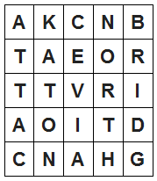
Plaintext messages are transposed into ciphertext

Plaintext: ATTACK AT ONCE VIA NORTH BRIDGE

Write into columns going down

Read from columns to the right

Ciphertext:

AKCNBTAEORTTVRIAOITDCNAHG

Subject to frequency analysis attack

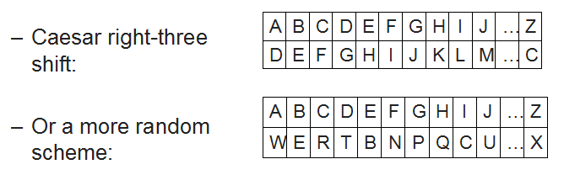
Monoalphabetic Cipher

One alphabetic character is substituted or another

Subject to frequency analysis attack

Polyalphabetic Cipher

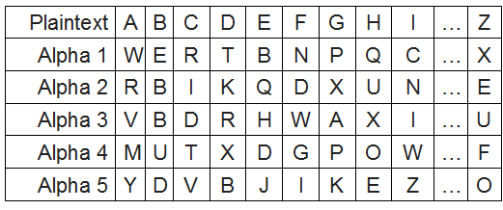
Two or more substitution alphabets

CAGED becomes RRADB

Not subject to frequency attack

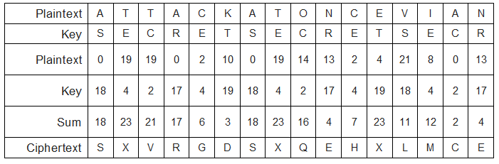

Running-key Cipher

Plaintext letters converted to numeric (A=0, B=1, etc.)

Plaintext values “added” to key values giving ciphertext

Modulo arithmetic is used to keep results in range 0-26

Add 26 if results < 0; subtract 26 if results > 26

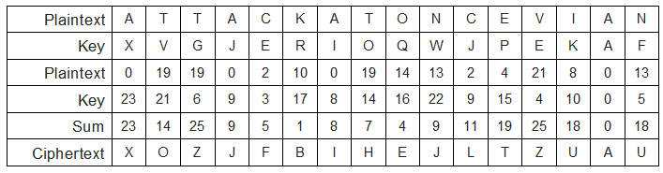
One-time Pad

Works like running key cipher, except that key is length of plaintext, and is used only once

Highly resistant to cryptanalysis

Types of Encryption

Block cipher

Encrypts blocks of data, often 128 bits

Stream cipher

Operates on a continuous stream of data

Block Ciphers

Encrypt and decrypt a block of data at a time

Typically 128 bits

Typical uses for block ciphers

Files, e-mail messages, text communications, web

Well known encryption algorithms

DES, 3DES, AES, CAST, Twofish, Blowfish, Serpent

Block Cipher Modes of Operation

Electronic Code Book (ECB)

Cipher-block chaining (CBC)

Cipher feedback (CFB)

Output feedback (OFB)

Counter (CTR)

Initialization Vector (IV)

Starting block of information needed to encrypt the first block of data

IV must be random and should not be re-used

WEP wireless encryption is weak because it re-uses the IV, in addition to making other errors

Block Cipher: Electronic Code Book

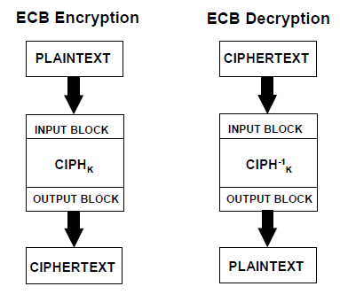
Simplest block cipher mode

Each block encrypted separately

Like plaintext encrypts to like ciphertext

Vulnerable to a dictionary attack

WEP does this

Microsoft made this error in their password hashes

Microsoft also made this error in Microsoft Office document encryption

Images from NIST (link Ch 5d)

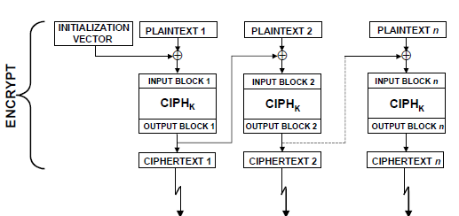

Block Cipher: Cipher-block Chaining (CBC)

Ciphertext output from each encrypted plaintext block is used in the encryption for the next block

First block encrypted with IV (initialization vector)

Block Cipher: Cipher Feedback (CFB)

Plaintext for block N is XOR’d with the ciphertext from block N-1.

In the first block, the plaintext XOR’d with the encrypted IV

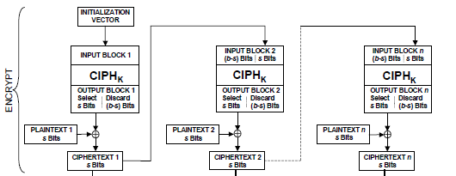

Block Cipher: Output Feedback (OFB)

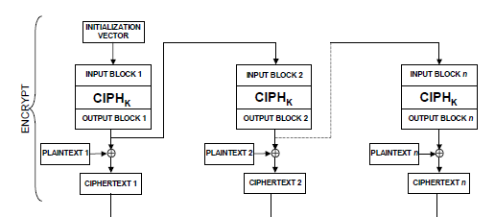
Plaintext is XOR’d with the encrypted material in the previous block to produce ciphertext

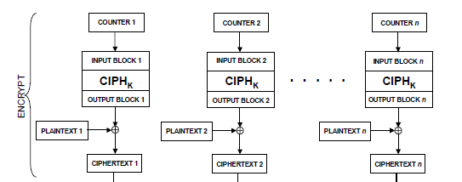
Block Cipher: Counter (CTR)

Uses a “nonce” (a random number that is used once) that is concatenated with a counter or other simple function, to create a series of keys

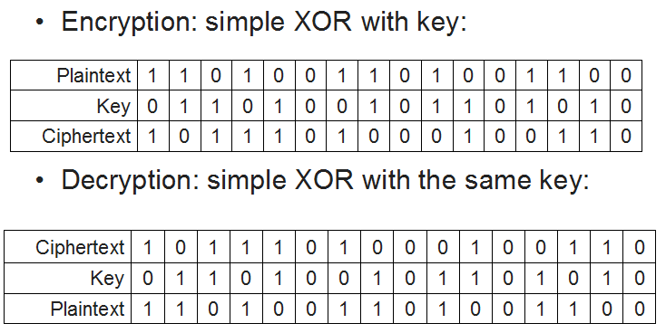
Allows parallel computation

Stream Ciphers

Used to encrypt a continuous stream of data, such as an audio or video transmission

A stream cipher is a substitution cipher that typically uses an exclusive-or (XOR) operation that can be performed very quickly by a computer.

Most common stream cipher is RC4

Other stream ciphers

A5/1, FISH, Phelix1, ISAAC, MUGI, Panama, Phelix, Pike, Sapphire-II. SEAL, SOBER-128, and WAKE

Types of Encryption Keys

Symmetric key

A common secret that all parties must know

Difficult to distribute key securely

Used by DES, 3DES, AES, Twofish, Blowfish, IDEA, RC5

Asymmetric key

Public / private key

Openly distribute public key to all parties

Keep private key secret

Anyone can use your public key to send you a message

Used by RSA. El Gamal, Elliptic Curve

Asymmetric Encryption Uses

Encrypt message with recipient's public key

Only recipient can read it, using his or her private key

Provides confidentiality

Sign message

Hash message, encrypt hash with your private key

Anyone can verify the signature using your public key

Provides integrity and non-repudiation (sender cannot deny authorship)

Sign and encrypt

Both of the above

Diffie-Hellman Key Exchange

Length of Encryption Keys

For symmetric algorithms, use at least 128 bits

For RSA, use at least 2048 bits

1024 bits no longer recommended by NIST

Link Ch 5e

Protection of Encryption Keys

Symmetric keys

Must be restricted to as few people as possible

Protected by a strong password, or encrypted again if needed

Asymmetric keys

Private key requires protection similar to symmetric key

Public keys can be published, even on the Internet

Protecting Keys in Applications

More difficult to protect keys that applications must be able to access directly

Hardening techniques

Separation of duties

Key value known only to operators, not developers or support

Store keys in hardware

Such as Trusted Platform Module

Use of a key encrypting key
Cryptanalysis

Cryptanalysis

Frequency analysis

Analyzing frequency of characters in ciphertext

Birthday attacks

Collisions in a hash function can be found in approximately sqrt(N) attempts, where N is the number of possible hash values

So SHA-1, 160 bits long, will have a collision in 2^80 values

Cryptanalysis

Ciphertext only attack

Attacker has only ciphertext

Chosen plaintext attack

Attacker is able to see encryption of selected plaintext

Chosen ciphertext attack

Known plaintext attack

Man in the middle attack

Effective against Diffie-Hellman Key Exchange

Real public key is replaced by fake one

Replay attack

Effective against SMB, any non-secure cookie-based authentication, almost all Web 2.0 sites
Applications and Management of Cryptography

Uses for Cryptography

File encryption

PGP and GPG

WinZip (version 9 uses AES)

EFS (encrypting file system) for Windows

Crypt tool for Unix

Encrypted volumes and disks

Truecrypt for Windows, Mac, Unix

Bitlocker for Windows Vista

PGP Disk

SafeBoot

E-mail

PGP / GPG – asymmetric key (public key crypto)

S/MIME (Secure / Multipurpose Internet Mail Extensions) – certificate based

PEM (Privacy Enhanced Mail) – not widely used, requires a single global PKI (which was never implemented)

MOSS (MIME Object Security Services) – not widely used

Protecting network communications

SSH

Replacement for telnet, rsh, rlogin

Secure FTP

IPsec

Encrypts all packets between established pairs of hosts

Used for VPNs (Virtual Private Networks)

SSL/TLS

Protects web browser traffic

Web browsing – protects session contents from eavesdropping

SSL / TLS (Secure Sockets Layer / Transport Layer Security)

https: in URL

40-512 bit encryption with secure key exchange

Server authentication common, client authentication rare

SET (Secure Electronic Transaction)

Not widely used
Key management

Key Management

Key creation

Process and results must be protected

Key protection and custody

Secured keys in control by the fewest number of persons

Key rotation

Periodic update of encryption keys

Key destruction

Securely destroy, to protect encrypted data to be retired

Key escrow

Keys held by a trusted third party

Message Digests and Hashing

Message digest or hash

The result of a one-way function on a file or message

Fixed-length result regardless of message size

Impossible (or very difficult) to derive original message from digest

No other message should produce the same digest (such pairs are collisions)

Algorithms

MD-5, SHA-1, HMAC

Error in Textbook

The book says MD5 is stronger than SHA on page 179—that is ridiculous

MD5 is weaker than SHA-1, but neither is considered secure any longer

Official government recommendation: use SHA-2 Instead

Links Ch 5f, 5g

Digital Signatures

Message digest that is cryptographically combined with signer’s private key

Requires public key cryptography

Verifies message integrity

Verifies identity of signer

Algorithms: DSA, El Gamal, Elliptic Curve DSA

Non-repudiation

Inability for a user to repudiate (deny) an action, because of the methods used to permit or authorize the action

Digital signature

Verifies integrity of transaction

Verifies identity of person performing transaction

Password required to use digital signature

Public Key Infrastructure (PKI)

Online facility

Storage of users’ public encryption keys

Fast lookup via an API that makes use automatic

PKI platforms

LDAP

Microsoft Active Directory

Encryption Alternatives

Steganography

Data hidden in image files, subtle changes that the eye won’t see; can be encrypted as well

Many “stego” tools available

Watermarking

Like a digital signature – a visible or invisible mark that claims ownership

Last modified 3-1-10

