Objectives

Applying security concepts to computer and business operations

Records management security controls

Backups

Anti-virus software and other anti-malware controls

Remote access

Administrative management and control of information security

Resource protection

Incident management

High availability architectures

Vulnerability management

Change management and configuration management

Operations attacks and countermeasures
Applying Security Operations Concepts

Security Operations Concepts

Need to know

Least privilege

Separation of duties

Job rotation

Monitoring of special privileges

Records management controls

Backups

Anti-virus and anti-malware

Remote access

Flow of Control

From chapter 1

Policy

Guidelines

Processes

Procedures

Recordkeeping

Need to Know

Individual personnel should have access to only the information that they require in order to perform their stated duties

Independent of security clearance

This reduces risk, but can be an administrative burden

Least Privilege

Users should have the fewest or lowest number of privileges required to accomplish their duties

Independent of security clearance

Separation of Duties

High-value or high-risk tasks require two or more different individuals to complete

Examples

Open a bank vault

Issue an arrest warrant

Provision a privileged-access computer account

Change a firewall rule

Job Rotation

Move individual workers through a range of job assignments

Reduces monotony, risk

Reduces likelihood that employees will perform inappropriate or illegal actions if they fear being caught when next job rotation occurs

Monitoring of Special Privileges

Privileged users have more power

Mistakes have greater impact

Record activities

Network administrator

System administrator

Database administrator

Application administrator

Records Management Controls

Data classification

Access management

Records retention

Backups

Data destruction

Data Classification

Establish sensitivity levels

Establish handling procedures for each level

Creation, storage, transmittal, destruction

Access Management

Policies, procedures, and controls that determine how information is accessed and by whom

User account provisioning

Privilege management

Password management

Review of access rights

Secure log on

Records Retention

Policies that specify how long different types of records must be retained (minimums and maximums)

Manage risks related to business records

Risk of compromise of sensitive information

Risk of loss of important information

E-Discovery

Regulation

Backups

Protection against loss due to malfunctions, failures, mistakes, and disasters

Activities

Data restoration

Protection of backup media

Off-site storage of backup media

Data Restoration

Periodic testing to ensure that data that is backed up can be restored

Same computer

Different computer

Best way to prove that backups are being performed properly

Protection of Backup Media

Backup media contains sensitive information

Requires same level of control as original information

Keep in locked cabinets

Least privilege and need to know

Offsite Storage of Backup Media

Reduce risk of loss of backup media in the event of a disaster that destroys data center

Fire, flood, sabotage

Factors

Distance from business location

Security of transportation

Security of storage center

Resilience of storage center against disasters

Data Destruction

Purpose: ensure that discarded information is truly destroyed and not salvageable by either employees or outsiders

Once information has reached the end of its need, its destruction needs to be carried out in a manner that is proportional to its sensitivity

Degaussing

Shredding

Wiping

Anti-virus and Anti-malware

Effects of uncontrolled malware

Loss of business information

Disclosure or compromise of business information

Corruption of business information

Disruption of business information processing

Inability to access business information

Loss of productivity

Apply defense in depth to protect assets

Central anti-malware management

Remote Access

Connectivity to a network or system from a location away from the network or system, usually from a location apart from the organization’s premises

Usually through a VPN

Improves productivity by permitting employees to access business information from any location

Risk mitigation

Encryption, strong authentication, anti-malware, firewall

Administrative Management and Control

ISO 27001

Widely accepted model for top-down security management

Define scope and boundaries

Establish a security policy

Risk assessments

Establish control objectives and activities

Security awareness and training

Allocate resources

Internal audits

Monitor and review the security program

Enact continual improvement

Types of Controls

Technical

Such as firewalls and antivirus software

Physical

Locks, guards, etc.

Administrative

Such as policies and audits

See link Ch 7a for a good discussion, and link CISSP 12 for good whitepapers on all ten CISSP domains

Categories of Controls

Detective

Deterrent

Preventive

Corrective

Recovery

Compensating
Employing Resource Protection

Resource Protection

Facilities

Water and sewage

Electricity

Fire alarms and suppression

Environmental controls

Communications

Security controls

Hardware

Servers

Workstations

Network devices

Wireless networks

Printers, copiers

Cabling

Software requires control and management

Licensing

Access control

Source code (preventing disclosure)

Intellectual property

Security

Source code control

Software development lifecycle

Documentation

May contain trade secrets and sensitive information

Processes, procedures, and instructions

Version control

Access control
Incident Management

Incident

An Incident is

An unexpected event that results in an interruption of normal operations

A Security Incident is

An event in which security policy has been violated

OR

Unauthorized access to a system or information

OR

An event that prevents legitimate access to a system or information

Incident Management

Incident declaration

Triage

Investigation

Analysis

Containment

Recovery

Debriefing

See chapter 6 for details

High Availability Architectures

Fault Tolerance

Makes devices less prone to failure

Multiple power supplies

Multiple network interfaces

Multiple processor units

RAID (Redundant Array of Inexpensive / Independent Disks)

Clustering

A group of two or more servers that operate functionally as a single logical server

Active-active mode

Active-passive mode

Failover: when active status is transferred

Geo-cluster – servers located at great distances from one another

Replication

Data changes are transmitted to a counterpart storage system

An adjunct to clustering, makes current data available to all cluster nodes

Business Continuity Management

A management activity where analysis is performed to better understand the risks associated with potential disaster scenarios, and the steps that can be taken to reduce the impact of a disaster should one occur
Vulnerability Management

Vulnerability Management

Penetration testing

Application scanning

Patch management

Code reviews

Penetration Testing

A scan of many or all TCP / IP “ports” on one or more target systems

Followed by locating and exploiting vulnerabilities

Mimics the actions of a hacker who scans a system or network for active, exploitable ports and services

Application Scanning

The process of performing security tests on an application (usually, but not always, a web-based application) in order to find vulnerabilities in the application code itself

The ‘new’ OWASP Top Ten (2010 rc1)
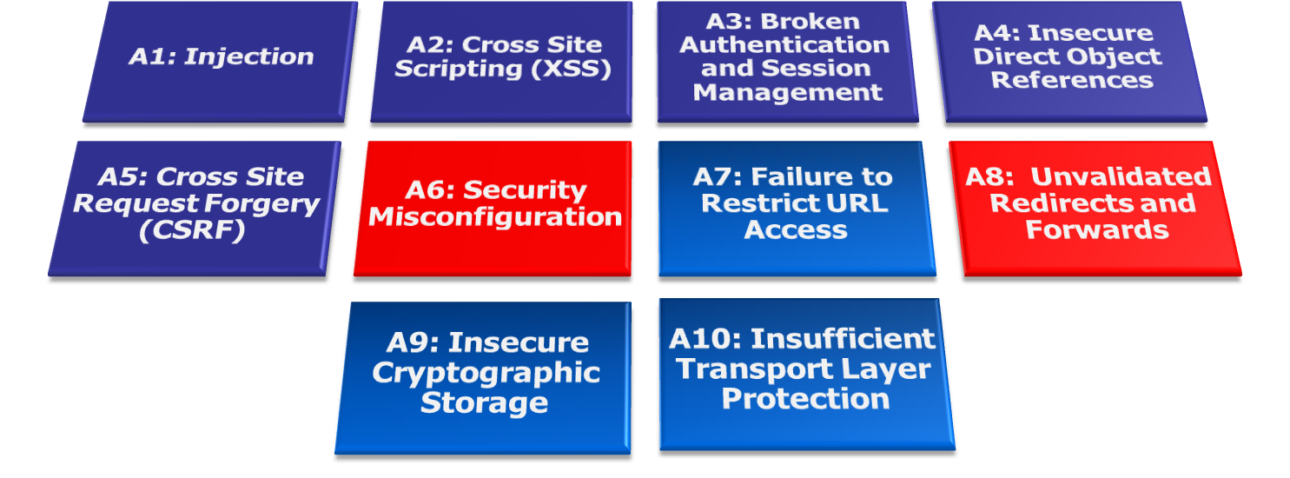

Code Reviews

Manual and automated inspections of software source code

Examine and validate approved changes

Detection of inappropriate changes, unsafe code, security issues

Patch Management

The process – usually assisted with management tools – to manage the installation of patches on target systems

Reduces risks associated with malware, hacking attacks that exploit weaknesses

Don't just put on all available patches

Analyze and test them first and only put on the ones that pass a risk analysis

Change Management

Change Management

Prepare the change

Circulate and review the change

Discuss and agree to the change

Perform the change

Recordkeeping
Configuration Management

Configuration Management

Configuration of hardware, software components

Configuration management database (CMDB)

Automated tools
Operations Attacks and Countermeasures

Attacks on Operations

Social engineering

Sabotage

Theft and Disappearance

Extortion

Bypass

Circumventing security measures

Denial of service

Last modified 4-7-10

