Objectives

Site access controls including key card access systems, biometrics, video surveillance, fences and walls, notices, and exterior lighting

Secure siting: identifying and avoiding threats and risks associated with a building site

Equipment protection from theft and damage

Environmental controls including HVAC and backup power
Site Access Security

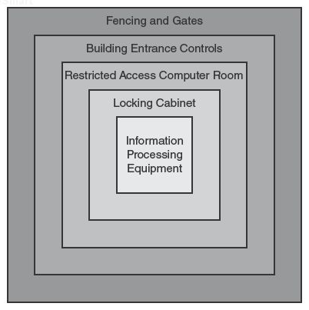
Site Access Controls

Purpose

To restrict the movement of people, so only authorized personnel enter secure areas

To record movements of people

Defense in Depth

Layers

Categories of Controls

Detective

Deterrent

Preventive

Corrective

Recovery

Compensating

See chapter 2

Key Card System
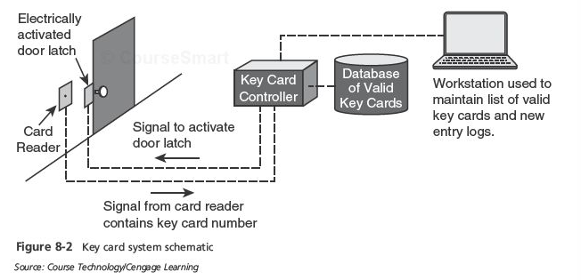

Site Access Controls

Key cards

Centralized access control consists of card readers, central computer, and electronic door latches

Pros: easy to use, provides an audit record, easy to change access permissions

Cons: can be used by others if lost, people may "tailgate"

Better if combined with a PIN

Biometric Access Controls

Based upon a specific biometric measurement

Greater confidence of claimed identity

Fingerprint, iris scan, retina scan, hand scan, voice, facial recognition, others

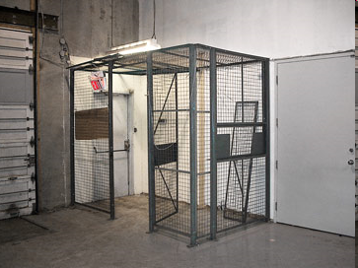
More costly than key card alone

Metal Keys

Pros: suitable backup when a key card system fails

Uses in limited areas such as cabinets

Best to use within keycard access areas

Cons

Easily copied, cannot tell who used a key to enter, many locks can be opened with bump keys

Man Trap

Double doors, where only one can be opened at a time

Used to control personnel access

Manually operated or automatic

Only room for one person

Guards

Trained personnel with a variety of duties:

Checking employee identification, handling visitors, checking parcels and incoming/outgoing equipment, manage deliveries, apprehend suspicious persons, call additional security personnel or law enforcement, assist persons as needed

Advantages: flexible, employ judgment, mobile

Guard Dogs

Serve as detective, preventive, and deterrent controls

Apprehend suspects

Detect substances

Access Logs

Record of events

Personnel entrance and exit

Visitors

Vehicles

Packages

Equipment moved in or out

Fences and Walls

Effective preventive and deterrent control
Height | Effectiveness
3-4 ft | Deters casual trespassers
6-7 ft | Too difficult to climb easily
8 ft plus 3 strands of barbed or razor wire | Deters determined trespassers

Keep unwanted persons from accessing specific areas

Better when used with motion detectors, alarms, and/or surveillance cameras

Video Surveillance

Supplements security guards

Provide points of view not easily achieved with guards

Locations

Entrances

Exits

Loading bays

Stairwells

Refuse collection areas

Camera types

CCTV, IP wired, IP wireless

Night vision

Fixed, Pan / tilt / zoom

Hidden / disguised

Recording capabilities

None; motion-activated; periodic still images; continuous

Intrusion, Motion, and Alarm Systems

Automatic detection of intruders

Central controller and remote sensors

Door and window sensors

Motion sensors

Glass break sensors

Alarming and alerting

Audible alarms

Alert to central monitoring center or law enforcement

Visible Notices

No Trespassing signs

Surveillance notices

Sometimes required by law

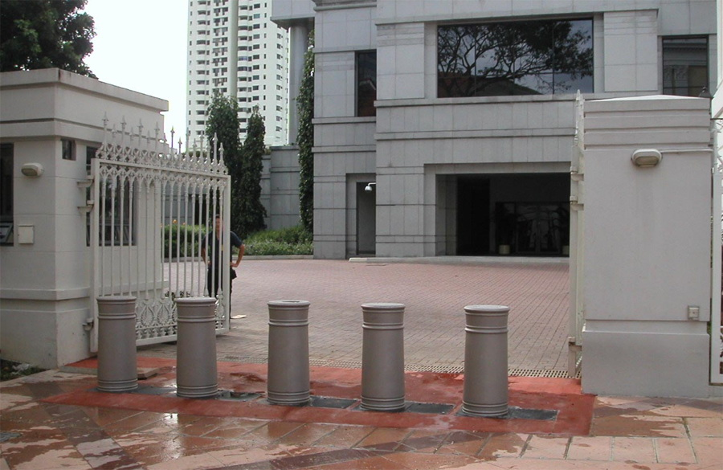
Surveillance monitors

These are deterrent controls

Exterior Lighting

Discourage intruders during nighttime hours, by lighting intruders’ actions so that others will call authorities

NIST standards require 2 foot-candles of power to a height of 8 ft

This is a deterrent control

Other Physical Controls

Bollards

Crash gates

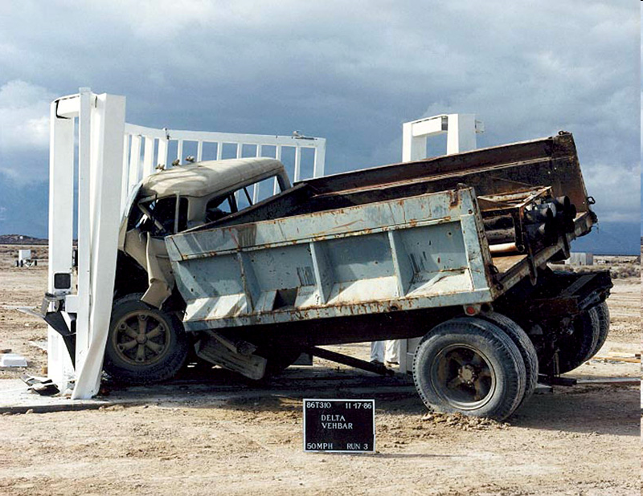
Prevent vehicle entry

Retractable

Some are so strong they can stop a truck at 50 mph

Link Ch 8b
Secure Siting

Secure Siting

Locating a business at a site that is reasonably free from hazards that could threaten ongoing operations

Identify threats

Natural: flooding, landslides, earthquakes, volcanoes, waves, high tides, severe weather

Man-made: chemical spills, transportation accidents, utilities, military base, social unrest

Other siting factors

Building construction techniques and materials

Building marking

Loading and unloading areas

Shared-tenant facilities

Nearby neighbors
Protection of Equipment

Asset Protection

Laptop computers

Anti-theft cables

Defensive software (firewalls, anti-virus, location tracking, destruct-if-stolen)

Strong authentication such as fingerprint

Full encryption

Training

Servers and backup media

Keep behind locked doors

Locking cabinets

Video surveillance

Off-site storage for backup media

Secure transportation

Secure storage

Protection of sensitive documents

Locked rooms

Locking, fire-resistant cabinets

“Clean desk” policy

Reduced chance that a passer-by will see and remove a document containing sensitive information

Secure destruction of unneeded documents

Equipment check-in / check-out

Keep records of company owned equipment that leaves business premises

Improves accountability

Recovery of assets upon termination of employment

Damage protection

Earthquake bracing

Required in some locales

Equipment racks, storage racks, cabinets

Water detection and drainage

Alarms

Fire protection

Fire detection: smoke alarms, pull stations

Fire extinguishment

Fire sprinklers

Inert gas systems

Fire extinguishers
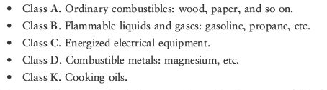

Sprinkler Systems

Wet pipe - filled with pressurized water

Dry pipe - fills with water only when activated

Deluge - discharges water from all sprinklers when activated

Pre-Action - Dry pipe that converts to a wet pipe when an alarms is activated

Foam water sprinkler - Uses water and fire-retardant foam

Gaseous fire suppression - displaces oxygen

Cabling security – on-premises

Place cabling in conduits or away from exposed areas

Cabling security – off-premises (e.g. telco)

Select a different carrier

Utilize diverse / redundant network routing

Utilize encryption

Environmental Controls

Environmental Controls

Heating, ventilation, and air conditioning (HVAC)

Vital, yet relatively fragile

Backup units (“N+1”) recommended

Ratings

BTU/hr

Tons (link Ch 8c)

Also regulates humidity

Should be 30% - 50%

Electric power

Anomalies

Blackout. A total loss of power.

Brownout. A prolonged reduction in voltage below the normal minimum specification.

Dropout. A total loss of power for a very short period of time (milliseconds to a few seconds).

Inrush. The instantaneous draw of current by a device when it is first switched on.

Noise. Random bursts of small changes in voltage.

Sag. A short drop in voltage.

Surge. A prolonged increase in voltage.

Transient. A brief oscillation in voltage.

Electric power protection

Line conditioner – filters incoming power to make it cleaner and free of most anomalies

Uninterruptible Power Supply (UPS) – temporary supply of electric power via battery storage

Electric generator – long term supply of electric power via diesel (or other source) powered generator

Redundant Controls

Assured availability of critical environmental controls

Dual electric power feeds

Redundant generators

Redundant UPS

Redundant HVAC

Redundant data communications feeds

Last modified 4-14-10

