Ch 1: (ISC)^2 and the CISSP Certification

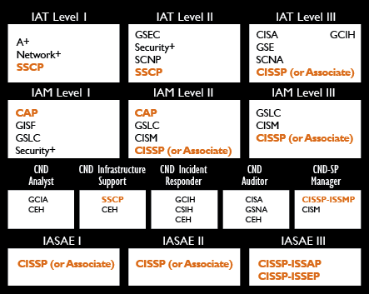
Jobs Requiring a CISSP

DoD Approved Baseline Certifications

Link CISSP 12

(ISC)^2 and the CISSP Certification

A mile wide and an inch deep

Ten domains

Access Control

Telecommunications and Network Security

Information Security Governance and Risk Management

Software Development Security

Cryptography

Security Architecture and Design

Security Operations

Business Continuity and Disaster Recovery Planning

Legal, Regulations, Investigations and Compliance

Physical (Environmental) Security

Experience Requirements

Five years of full-time work in two or more domains

One year waiver for

Four-year college degree

Advanced degree in information security from a CAEIAE

Security+ or other credential on the approved list

Exam costs $600 from VUE

GI Bill pays it all

6 hours, 250 questions

Preparing for the Exam

This class is NOT enough

You will need to go through an intensive review session before taking the exam

Options

Study groups

Review sessions (ISSA)

Link CISSP 19

Practice exams

Don't use brain dumps for ethical reasons

How I Prepared for the CISSP Exam

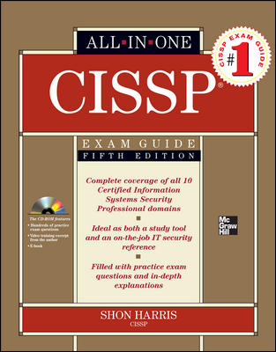
A textbook like yours

Transcender practice exam

Shon Harris' book

It took me 5 days to prepare (including a day of rest)

Link CISSP 16

After the Exam

You need an endorsement from a qualified third party

A CISSP or your employer or a professional

Must re-take exam every 3 years or submit CPEs, and pay annual $85 fee

If you are an Associate of (ISC)^2, you must:

Pay $35 per year

Earn 20 CPEs per year

You have only six years to complete the CISSP requirements

Link CISSP 14

Ch 2: Common Body of Knowledge (CBK)

The ten domains

Access Control

Access control systems include

File permissions such as Create, Reed, Edit, Delete, Execute

Update or Delete rights for databases

Concepts, methodologies, and techniques of access control

Risks, Vulnerabilities, and Attacks

Effectiveness of access controls

Provisioning identity and access throughout the information life cycle

Telecommunications and Network Security

Network architecture and design

Network components

Securing communications channels

Guarding against, and responding to, network attacks

Information Security Governance and Risk Management

Developing and implementing

Policies

Standards

Procedures

Guidelines

Documentation

Managing the information life cycel

Software Development Security

Software Development Life Cycle (SDLC)

Application controls

Change controls

Data warehousing

Data Mining

Cryptography

Public-key and private-key algorithm applications and uses

Digital signatures

Public Key Infrastructure (PKI)

Security Architecture and Design

Security models

Bell-LaPadula (no read up)

Biba (no read down)

Clarke-Wilson

Security Operations

Protecting resources

Incident response

Patch management

Change management

Fault tolerance

Business Continuity and
Disaster Recovery Planning

Business Continuity Planning

Business Impact Assessment

Disaster Recovery Plan

Legal, Regulations, Investigations, and Compliance

Professional ethics

Compliance

Investigations and Forensics

Advanced Persistent Threats

Physical (Environmental) Security

Choosing a secure site

Perimeter security

Environmental controls

Power

HVAC

Fire detection and suppression

Emergency procedures
Ch 3: Putting Your Certification to Good Use

Ethics, Giving Back, Next Steps

After your CISSP

You Must

Practice the Code of Ethics

Maintain your certification with ongoing training (CPEs) and annual fee

You May

Be active in (ISC)^2, ISSA, or other security orgs

Give public talks on security (e. g. at cons)

Help others learn

Earn other certificates

Code of Ethics Canons

Protect society, the commonwealth, and the infrastructure.

Act honorably, honestly, justly, responsibly, and legally.

Provide diligent and competent service to principals.

Advance and protect the profession. (See link CISSP 6)

Objectives of the Code of Ethics

Encourage right behavior such as

Research

Teaching

Identifying, mentoring, and sponsoring candidates for the profession

Valuing the certficate

Discourage behavior such as

Raising unnecessary uncertainty (FUD)

Giving unwarranted comfort or reassurance

Consenting to bad practice

Attaching weak systems to the public network

Professional association with non-professionals, amateurs, or criminals

Keeping your Certification Current

Pay your Annual Maintenance Fee

$85 for CISSP, $35 for Associate of (ISC)^2

Earn CPEs (Continuing Professional Education)

120 CPEs required per 3-year cycle

Attending conferences or courses

Training others

Attending chapter meetings

Publishing articles or books

More details at link CISSP 20

Active (ISC)^2 Membership

Vote in (ISC)^2 Elections

Attend meetings and events

Volunteer

Write certification exam questions

Speak at events

Safe and Secure Online program (speak at schools)

Security Organizations

ISSA

ISACA

InfraGard

Electronic Crimes Task Force

OWASP (Open Web Application Security Project)

ASIS International

HTCIA (High Technology Crime Investigation Association)

Other Certifications

Associate of (ISC)^2

Passed the CISSP test but don't have the experience

SSCP (Systems Security Certified Practitioner)

Halfway to the CISSP

Being a Successful Agent of Change

Identify and promote only essential changes

Promote only those changes that have a chance to succeed

Anticipate sources of resistance

Distinguish resistance from well-founded criticism

Involve all affected parties the right way

Don't promise what you can't deliver

Use sponsors, partners, and collaborators as co-agents of change

Change metrics and rewards to support the changed world

Provide training

Celebrate all successes

Earning Other Certifications

Other (ISC)^2 Certifications

CSSLP (Certified Secure Software Lifecycle Professional) – for software developers

CISSP Concentrations

ISSAP, ISSEP, ISSMP

Non-(ISC)^2 Vendor-Neutral Certifications

CISA (Certified Information Systems Auditor)

PSP (Physical Security Professional)

CIPP (Certified Information Privacy Professional)

PMP (Project Management Professional)

GIAC (Global Information Assurance Certification)

Vendor Certifications

CCSP and CCIE (Cisco)

MCSA: Security and MCSE: Security (Microsoft)

C|EH (Certified Ethical Hacker)

CSFA (CyberSecurity Forensic Analyst)

RHCSS (Red Hat Certified Security Specialist)

Group Project Ideas

Make Hacking Videos

ATTACKS: RA Flood, SockStress

DEFENSE: Test firewalls v. IPv6 attacks

FORENSICS: Demonstrating Flaws in Tools

Cold Calls to SQLi Sites

ADVICE AND HELP

Vulnerability Scans at CCSF

Performance Monitor of CCSF Servers

URGENT, MUST BE PRETTY

Test any security or hacking tool

Report the results with a class presentation and/or video

Investigate current ethical or legal issues

Make a report or video

Topics: Copyright, Hacking prosecutions, Cyberwar, SCADA, etc.

Make training videos

Basic security advice for Internet users

Subnetting, binary, hexadecimal

Port scans, any other topic, any level

Last modified 1-25-13

