Topics

Administrative Management and Control

Security Operations Concepts

Threats and Countermeasures

Security Controls

Security Auditing and Due Care

Monitoring
Administrative Management and Control

Policies about People


Job requirements and qualifications

Background checks and verification

Criminal convictions

Citizenship

Verify resumes

Separation of Duties

Require two people to approve critical acts, such as signing checks, reducing

Opportunities for fraud or abuse


Mistakes

Dependence on individuals

Job rotation and mandatory vacations provide similar benefits

Need-to-Know

Security Clearance is required, but not enough

Need-to-know is required as well

This would have decreased the harm done by Bradley Manning

Ch 10b

Least Privilege

People should have only enough privileges to do their jobs

Most users aren’t administrators, and can’t install software

One failure of least privilege is accumulation of privileges as people move from job to job

User Monitoring

Direct observation

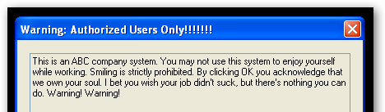
Analyzing logs

Attendance records

Call logs

Login warning (Link Ch 10c)

Termination of Employment

Disable user account immediately
Security Operations Concepts

Avoid Single Points of Failure

Reliable systems design

High-availability

Clustering

Mirroring

Virtualization

Protect systems, networks, and processes

Handling sensitive information

Data Labels: CONFIDENTIAL, SECRET, etc.

Handling: transport, transmit, and use

Storage and backup

Destruction

Records retention
Threats and Countermeasures


Errors and Omissions

Error: doing something wrong

Omission: Failure to perform an action

Many businesses require Errors and Omissions Insurance

Fraud

Deceptive or misrepresented activity that results in illicit gain

Writing bad checks


Lying to obtain a product or service

Controls attempt to confirm information

Fraud detection system

Analyzes transactions to find suspicious ones

Hackers and Crackers

Criminal gangs

Industrial espionage

Loss of Physical and Infrastructure Support

Fire, flood, power outage

Link Ch 10d
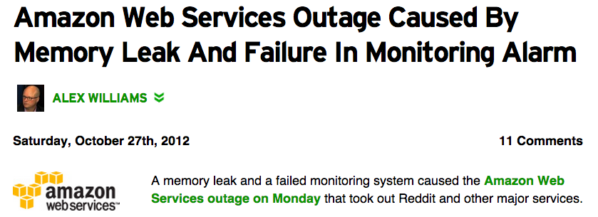

Malware

Adware

Backdoors: bypass authentication

Bootkits: Kernel-mode rootkit, defeat full-disk encryption

Logic bombs: triggered by a condition

Rootkits: Hide portions of a system

Spyware: collects information

Malware

Trojan: masquerades as legitimate program

Virus: Attaches to executable file

Worm: travels through network

Bot: controlled by a criminal via malware

Botnet: A group of bots

APT (Advanced Persistent Threat)

Targeted attack, long time-frame, often nation-state sponsored

Sabotage & Theft

Sabotage

Deliberate destruction of property

Theft

Data theft is difficult to detect because original copy remains
Security Controls

Types of Controls

Preventive

Detective

Corrective or Recovery

Reverses or minimizes impact after an incident

Automatic v. Manual

Operations Controls

Processes and procedures

Resource protection

Privileged entity controls

Change controls

Media controls

Administrative controls

Trusted recovery

Resource Protection

Protect information assets and infrastructure

Communications hardware and software

Routers, switches, firewalls, servers, etc.

Computers and storage systems

Business data

System data

OS, ID & passwords, audit trails, configuration files

Backup media

Software

Privileged Entity Controls

Restrict important actions to privileged users

Part of the OS

Change Controls

Formal process of proposal, design, review, approval, implementation, recordkeeping

Change management

Assures that only approved changes are implemented

Configuration management

Records all the approved configuration changes to settings and files that are made

Patch Management

Perform risk analysis on advisories

Test patches

Deploy

Verify

Update

Media Controls

Mark storage media according to its sensitivity

Control handling, storage, transmission, and disposal

Administrative Controls

Least privilege

Separation of duties

Rotation of duties

Trusted Recovery

Protect confidentiality and integrity of stored data

During recovery, system may be in single-user mode

Disables software privilege controls
Security Auditing and Due Care

Auditing

Examining systems and/or business processes to ensure they are working properly

Often performed by third parties

Ensures that a business is in compliance with business or security policies

Including laws, regulations, contracts, best practices

Due Care

Requires that an organization operates using good business practices

Up to standards set by trade groups

If it is not exercising due care, it may be liable for damages

Audit Trails

Records created which make audits easier

Reasons for audit trails

Enforcement of accountability

Investigation

Event reconstruction

Problem identification

Types of Audit Trails

Log files, such as sendmail and syslog files

Often they lack consistency of format

Difficult to combine and assemble into a coherent record

Time synchronization makes audit trails easier to combine

Looking for Trouble

Difficult to tell normal activity from events that indicate real trouble

Random sampling can help

When you find something suspicious

Determine whether it indicates genuine trouble or is a false positive

Conduct a root-cause analysys

Protecting Audit Logs

Retaining audit logs – unclear how long is required

Integrity of audit logs is essential

Subject to sabotage

Usually they are simple text files, easily altered

Writing them to read-only media or copying them over a network to another system can help protect them

DoS on audit logs—create many false positives to cover tracks
Monitoring

Monitoring

Penetration Testing

Intrusion Detection

Violation Analysis

Keystroke Monitoring

Traffic and Trend Analysis

Facilities Monitoring

Penetration Testing

Port scanning

Vulnerability scanning

Packet sniffing

War dialing & wardriving

Emanation monitoring

Dumpster diving

Eavesdropping & shoulder surfing

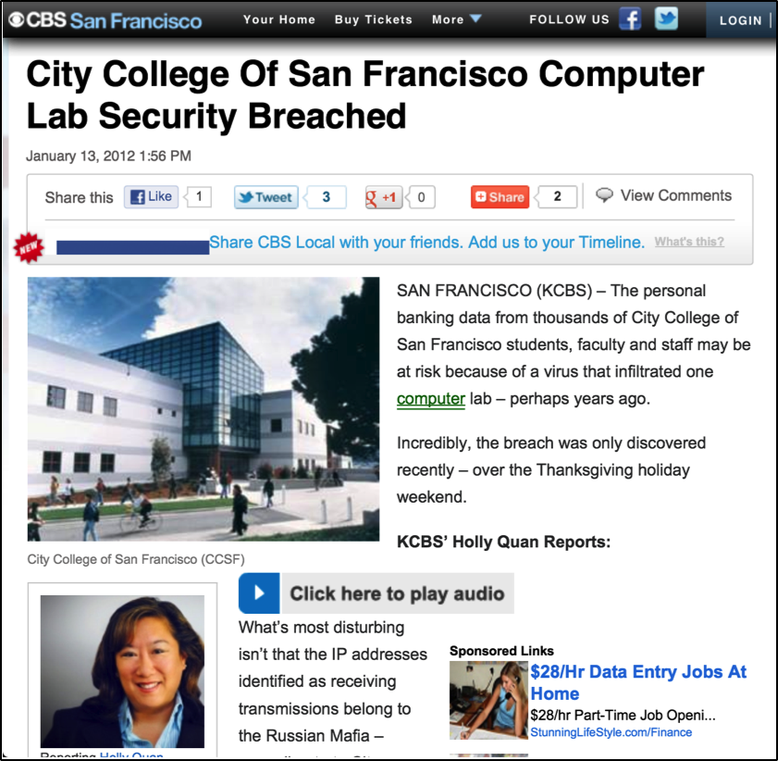
Social engineering

Intrusion Detection

Network-based Intrusion Detection System (NIDS)

A hardware device that protects a whole LAN

Host-based Intrusion Detection System (HIDS)

Protects only a single host

Signature-based

Compares traffic with attack signatures

Can be bypassed by altering attack

Requires frequent update of signature files

Anomaly-based

Detects deviations from normal traffic

High volume of false positives

Intrusion Detection and Intrusion Prevention

Intrusion Detection System

Reports attacks but does not stop them

Intrusion Prevention System

Stops attacks in progress

Often by adjusting firewall rules


Violation Analysis

Examining activity and audit logs to find inappropriate activities

Clipping levels are thresholds that differentiate events from non-events

Example:

A user who enters an incorrect password more than four times would be a violation

Keystroke Monitoring

Records every keystroke

May be a privacy violation

Use with care, perhaps only during investigations

Traffic and Trend Analysis

Measures amount of data sent & received

Doesn’t look at the contents of the packets

Can detect suspicious activities like Bittorrent

Encryption does not prevent traffic analysis

Facilities Monitoring

Physical monitoring

Watching logs from card-access doors to see if doors are propped open

Closed-circuit TV (CCTV) cameras

Security guards at key locations

Alarm sensors on doors and windows

Motion sensors

Responding to Events

Also called Incident management or Problem management

Advance planning should cover:

Monitoring personnel detect an event

Initial response

Confirmation

Notification

Escalation

Resolution

Event reporting

Event review

Security violations should be documented

Root-cause analysis

Determine if change in processes or technology are needed

Case Histories

Incident Response
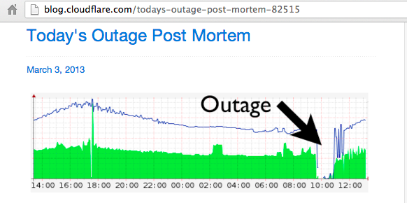

CloudFlare

Link Ch 10e

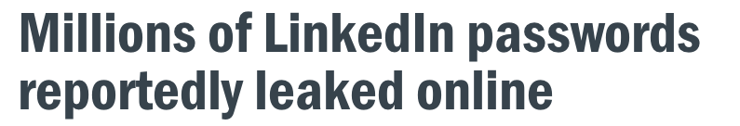

LinkedIn

Links Ch 10f, 10g

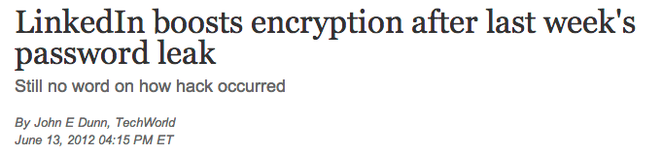

Last modified 4-14-13

