Topics

Categories and Types of Laws

Categories of Computer Crime

Laws Relevant to Computer Crimes

Investigations, Forensics, and Incident Response
Categories and Types of Laws

Common Law (aka Case Law)

Derived from previous decisions by judges

Three types

Criminal

Civil

Administrative (or Regulatory)

Criminal Law

Crimes against society

Punishment may include prison

Burden of proof

Prosecution must prove guilt beyond a reasonable doubt

Two types of crimes

Felony: Serious, prison terms > 1 year

Misdemeanor: Less serious, fines or sentences < 1 year

Civil Law (also called Tort)

Damage to an individual or business

Civil penalties:

Compensatory damages – actual damages to victim

Punitive damages – to punish offender

Statutory damages – assessed for violating the law

Civil Law

Burden of proof

Guilt based upon the preponderance of the evidence

Liability and Due Care

If cost of safeguard is less than estimated loss from threat, then a liability may exist if the safeguard is not implemented

Senior officers may be personally liable

Prudent Person Rule

Officers required to perform their duties:

In good faith

In the best interests of the enterprise

With the care and diligence that ordinary, prudent people in a similar position would exercise

Due Care

The conduct that a reasonable person exercises

Typically at the worker level

Failure to do so is negligence

Implementing security best practices

Due Diligence

Prudent management and execution of due care

Typically at the management level

Researching a company before acquiring it

Risk identification and risk management

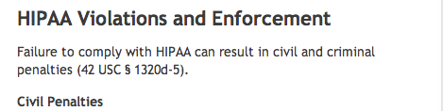
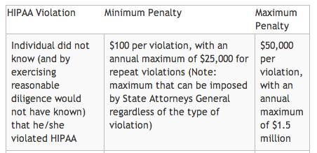
Culpable negligence

An organization fails to follow due care

May increase jury awards and decrease insurance payouts

Administrative Law

Also called regulatory law

Regulations cover major industries

Like banking, energy, and healthcare

Enforced by government agencies

Violations may result in fines or imprisonment

HIPAA Civil Penalties

Link Ch 11a

HIPAA Criminal Penalties

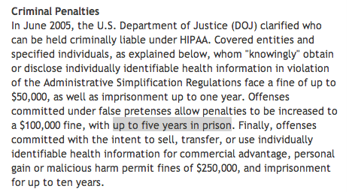
International Law

Many obstacles

Lack of cooperation

Different laws

Different rules of evidence

Low priority

Outdated laws and technology

Extradition
Categories of Computer Crime

Difficulties

Lack of understanding of technology

Inadequate laws

Multiple roles of computers in crime

Target, instrument, support

Lack of tangible assets

Rules of evidence

Evidence is considered hearsay

Attribution

Who’s really behind that IP address?

Definition of loss

Attacking across national boundaries

Criminal profiles may include juveniles and insiders

Types of Attacks

Business

Financial

“Fun”

Grudge (easier to prosecute)

Ideological

Military and intelligence

Terrorist
Laws Relevant to Computer Crimes

Intellectual Property

Four classifications

Patents

Trademarks

Copyrights

Trade secrets

Patents

Grants to the inventor the right to exclude others from making, using, selling, or importing the invention

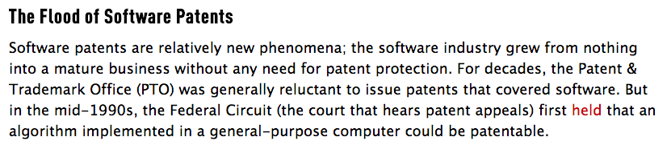
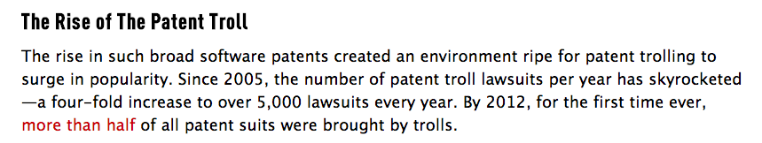
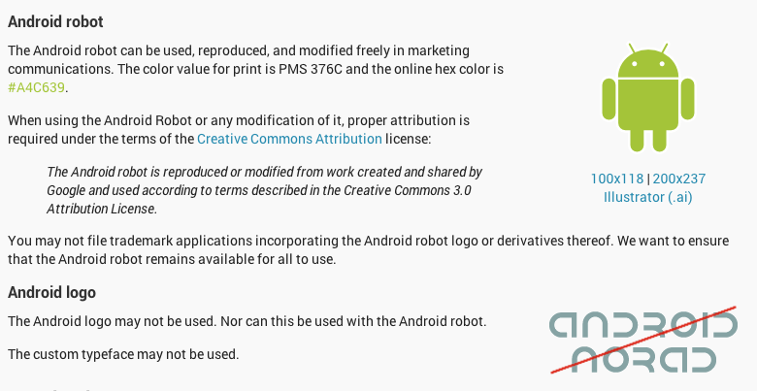
Invention must be novel, useful, and not obvious

An idea cannot be patented

Patent Trolls

Link Ch 12b

Trademark ™

A word or symbol used to identify a product

Copyright ©

Granted to original author, published or not

Applies from the time work is created in tangible form

Don’t need to be registered

Lasts for the lifetime of the author plus 70 years

Trade Secret

Must be genuine and not obvious

Must provide a competitive advantage and therefore have value to the owner

Must be reasonably protected from disclosure

Ex: software source code

Privacy and Data Protection Laws

E. U is much more strict than the USA

Personal data may only be used for the purposes for which it was originally collected

Can’t be disclosed to other organizations

US Federal Privacy Act of 1974

Protects records maintained by the US Gov’t about citizens and permanent residents

May not disclose record without consent

HIPAA

US Health Insurance Portability and Accountability Act of 1996

Since April 2003, enforces privacy of:

Health plans

Healthcare clearinghouses (they process health information)

Health providers (hospitals, doctors, etc.)

Since April 2009, security breaches must be reported

HITECH

US Health Information Technology for Econimoc and Clinical Health Act of 2009

Broadens HIPAA to include business associates like

Third-party administrators

Pharmacy benefits managers

Claims processing/billing/transcription companies

Legal, accounting, and administrative workers

Required Data Protection

Unsecured PHI (Public Health Information)

Data that is not secured by technology that renders it unreadable to unauthorized individuals

Breaches must be reported

Data destruction and encryption are recommended security measures

US Gramm-Leach-Bliley Financial Services Modernization Act

Requires financial institutions to protect PII (Personally Identifiable Information) with three rules

Financial privacy rule

Must inform customers about PII protection

Safeguards rule

Requires a formal security plan to protect PII

Pretexting protection

Requires precautions against social engineering

UK Data Protection Act

Protects “sensitive data” in the UK

PCI DSS Payment Card Industry Data Security Standard

Not a law, industry self-regulation

Compliance is enforced by AmEx, Visa, Mastercard, etc.

Requires

Annual self-assessment and network scan, or

On-site PCI data security assessments and quarterly network scans

Requirements depend on number of transactions per year and previous data loss incidents

PCI DSS 2 (Oct 2010)

Build and Maintain a Secure Network

1: Install and maintain a firewall

2: Do not use default passwords, etc.

Protect Cardholder Data

3: Protect stored data

4: Encrypt public-network transmissions

Maintain a Vulnerability Management Program

5: Use anti-virus

6: Use secure systems and applications

Implement Strong Access Control Measures

7: Restrict by need to know

8: Use unique IDs for each person

9: Restrict physical access to data

Regularly Monitor and Test Networks

10: Log all access to resources and data

11: Regularly test systems and processes

Maintain an Information Security Policy

12: Must address infosec for all personnel

Disclosure Laws

Require public disclosure of security breaches

California passed the first such law in 2003

Now 46 states have similar laws

A federal law would replace all of them, but it has not yet passed

U.S. Computer Crime and Information Security Laws

Computer Fraud and Abuse Act (CFAA)

Electronic Communications Privacy Act (ECPA)

PATRIOT Act

Sarbanes-Oxley Act

CAN-SPAM Act

Computer Fraud and Abuse Act (CFAA)

The final form, after many amendments, establishes seven computer crimes

Unauthorized access to a protected computer

For fraud

Disclosing US national defense information

To obtain any information

That affects the use of that computer

Causing damage or transmitting malware

Trafficking in computer passwords

Threatening to damage a protected computer for extortion

Protected computers are

Used by financial institution or government, or

Used in interstate or foreign commerce or communication

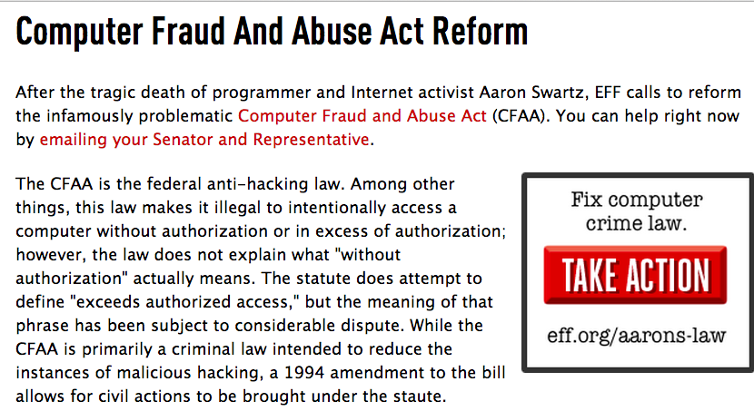
Link Ch 12d

Electronic Communications Privacy Act (ECPA)

Prohibits eavesdropping on communications

Except by network providers for legitimate business purposes

PATRIOT Act

Greatly increases law enforcement’s access to data

Sarbanes-Oxley Act

A response to the ENRON scandals

Established the Public Company Accounting Oversight Board

Identifies the responsibility of Chief Information Officer (CIO) who must secure systems at companies

CAN-SPAM Act

Establishes standards for sending commercial email
Investigations, Forensics, and Incident Response

Terms

Computer forensics

Finding evidence on computers (often for use in court)

Investigation

To determine what happened and who is responsible, and collect evidence

Incident Response

To determine what happened, contain and assess damage, and restore normal operations

Evidence Rules

Best evidence rule

Accepts computer printouts as “best evidence”

Hearsay rule

Evidence not based on personal, first-hand knowledge

Inadmissible in court

Computer records often treated as hearsay in court

But there is a business records exception

Business Records Exception

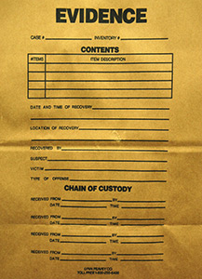
Must meet these criteria:

Made at or near the time the act occurred

Made by a person who has knowledge of the business process

Made and relied on for regular business

Kept for motives that tend to assure their accuracy

In the custody of the witness on a regular basis

Chain of Custody

Evidence must be marked, and a person responsible to protect it must be specified at all times

Image from link Ch 12e

Conducting Investigations

Detect and contain a computer crime

Notify management

Preliminary investigation

Was this a crime or just a mistake?

Determine whether organization should disclose that the crime occurred

Disclosure may be required by law

Conduct investigation

Report findings

Incident Response

Determine whether security incident has occurred

Notify appropriate people

Contain the incident

Assess the damage

Recover normal operations

Evaluate incident response effectiveness

(ISC)^2 Code of Ethics Canons

Protect society, the commonwealth, and the infrastructure.

Act honorably, honestly, justly, responsibly, and legally.

Provide diligent and competent service to principals.

Advance and protect the profession.

See link CISSP 6

Last modified 4-29-13

