Topics

Physical security threats

Site and facility design

Physical (environmental) security controls
Physical Security Threats

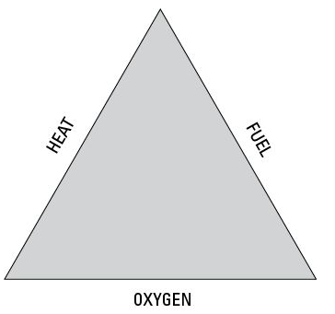
Fire

Saving lives is the top priority

Fire needs 3 elements

Classes of Fires

A Paper, wood, etc.

Extinguish with water or soda acid

B Gas or oil

Extinguish with CO2, soda acid, or Halon

C Electrical

Extinguish with CO2 or Halon (power off first)

D Flammable metals like sodium

Extinguish with dry powder

NOTE: Book is wrong about class D

Water, Earthquakes, Weather

Water

Water can harm computers

Can electrocute people

Earthquakes

Buildings may collapse or become unsafe

Severe weather

Hurricanes, storms

May cause fires, wter damage, flooding, loss of communication and utilities

Electricity

Electrostatic discharge (ESD)

When humidity is low

Humidity should be 40% - 60% in computer rooms

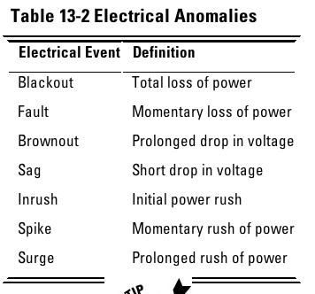
Electrical noise

Electromagnetic Interference (EMI) and Radio Frequency Interference (RFI)

Fluorescent lights cause EFI

Electrical Anomalies

Lightning and Sabotage

Lightning

Sabotage/terrorism/war/theft/vandalism

Increase security during labor disputes or other risky times (Link Ch 13a)

Failures, Outages, Personnel Loss

Equipment failure

Maintenance agreements, spare parts, and redundant systems help mitigate this risk

Loss of communications and utilities

Due to disaster or human error

Personnel loss

Through illness, death, resignations, …

Can be mitigated through documented procedures, job rotation, cross-training, and redundant functions
Site and Facility Design

Crime Prevention Through Environmental Design (CPTED)

Unobstructed areas

Creative lighting

Functional landscaping

Make it difficult for a criminal to

Hide, gain access, escape, etc.

Three basic strategies

Natural Access Control

Natural Surveillance

Territorial Reinforcement

Natural Access Control

Restrict movement

Differentiate between public, semi-private, and private areas

Target hardening

Window and door locks

Alarms

Photo ID requirements

Sign in/sign out procedures

Natural Surveillance

Make intruder activity more observable and easily detected

Windows overlook streets and parking areas

Landscape to eliminate hidden areas

Open railings on stairs

Numerous low-intensity lighting fixtures to eliminate shadows and reduce blind spots

Territorial Reinforcement

Create a sense of pride and ownership

Maintenance: pick up trash, fix broken bulbs, …

Assign responsibility to individuals

Add amenities like benches, water fountains

Choosing a Secure Location

Climate and natural disasters

Local neighborhood

Crime rate, nearby airports, railways, …

Visibility

A low profile without external markings is best

Accessibility

Transit, emergency vehicles, nearby housing

Utilities

Joint tenants

Link Ch 13c

Designing a Secure Facility

Exterior walls

Reduce electronic emanations

Windows should be barred & not open

Interior walls

Extend from floor to ceiling

Fire ratings if adjacent to storage areas

Doors

Strong to resist forcible entry

Need fire rating equal to adjacent walls

Emergency exits

Labeled

Unlocked from inside

Fail open during emergency

Hinges on outside must be secured

Plenums

Wiring

Fire codes require plenum rating for wiring in air-handling region between above drop ceiling

Burning cables may release toxic gases
Physical (Environmental) Security Controls

Physical Access Control

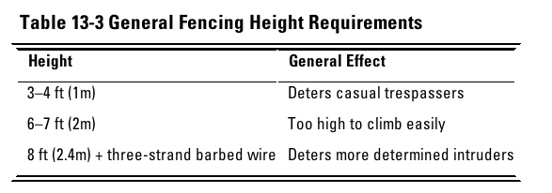
Fences

Security Guards

Dogs

Locks

Storage areas

Security badges

Biometric access controls

Fences

Mantraps

Double door

Unauthorized people end up trapped between the doors

Image from link Ch 13d

Security Guards

Guards cannot be replaced by technology because they have

Discernment

Visibility

Multiple functions

Disadvantages of guards

Unpredictability

Imperfections

Cost

Dogs

Highly visible deterrent, response, and control

More loyal and reliable than humans

Disadvantages

Limited judgment

Cost and maintenance

Potential liability

Locks

Preset

The most common type

Requires a particular key to open

Programmable

Mechanical (dial combination or five-key pushbutton)

Electronic (cipher lock or keypad)

Shoulder surfing attack

Electronic

Like modern car locks

Storage areas

Should be locked and controlled

Be aware of hazardous materials and environmental factors

Security Badges

Photo ID or “dumb card”

No technology, must be examined by a guard

Smart cards

Integrated chip

Magnetic stripe

Optical code

Proximity card

Passive

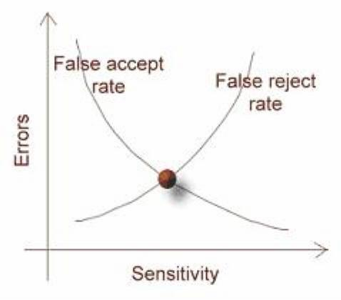
No battery or active electronics

Just an antenna to reflect power back to reader

Field-powered

Has electronics powered by the reader

Transponder

Has a battery, like a garage door opener

Biometric access controls

Finger scan

Hand geometry

Retina pattern

Iris pattern

Voice recognition

Signature dynamics

Biometric access controls

False Reject Rate (FRR)

False Accept Rate (FAR)

Crossover Error Rate (CER)

The point where FRR=FAR (Image from link Ch 13e)

Technical Controls

Surveillance

Intrusion detection

Alarms

Surveillance

When used to monitor or record live events, they are detective

If the camera is visible, it’s a deterrent control also

Intrusion Detection (Physical)

Photoelectric sensors

A grid of visible or IR light

Dry contact switches and metallic tape

Sound alarm when door is opened or tape is broken

Motion detectors

Wave pattern

Capacitance

Audio (high false alarm rate)

Alarms

Should have separate circuitry and a backup power source

Line supervision detects attempts to tamper with alarm systems

Five Types of Alarms

Local system

Sounds audible alarm

Requires local response capability –someone to call the police/fire dept.

Central station system

Operated nd monitored by private security organizations

Connected directly to the protected site via leased or dial-up lines

Proprietary Systems

Like central station systems but operated and monitored directly on the premises

Auxiliary station systems

Contact police or fire departments directly

Require prior authorization

Typically used along with central station systems

Remote station system

Calls police or fire and plays a recorded message

Environmental and Life Safety Controls

Electrical Power

HVAC (Heating, Ventilation, and Air Conditioning)

Fire Detection and Suppression

Electrical Power

Physical access controls at electrical distribution panels and circuit breakers

Emergency Power Off (EPO) switch

Near major systems and exit doors

Backup power source

Diesel or natural-gas generator

Natural gas cannot be stored locally, so it relies on gas mains

Only for critical facilities, like emergency lighting, fire detection and suppression, servers, HVAC, physical access control, and telephones

Controls for Electrostatic Discharge (ESD)

Maintain humidity at 40% - 60%

Proper grounding

Anti-static floors, carpets, floor mats

Controls for Electrical Noise

Power line conditioners

Proper grounding

Shielded cables

Controls for Electrical Anomalies

Uninterruptible Power Supply (UPS)

Only enough power for 5-30 min.

Surge protectors provide only minimal protection

A UPS is much better

HVAC (Heating, Ventilation, and Air Conditioning)

Ideal temperature for computers is 50 – 80 degrees F

Humidity 40% - 60%

Close doors and side panels on racks

For both physical security and cooling

Fill empty spaces in racks with blanking panels

Fire Detection and Suppression

Three detection systems

Heat-sensing

Flame-sensing

Detect flickering IR

Smoke-sensing

Smoke-Sensing

Photoelectric

Variations in light intensity

Beam

Sense when smoke interrupts a beam of light

Ionization

A tiny radioactive source ionizes air; smoke ionizes differently

Aspirating

Draws air into a sampling chamber to detect smoke

Fire Suppression Systems

Two types

Water sprinkler systems

Gas discharge systems

Water Sprinkler Systems

Wet-pipe (or closed-head)

Pipes are always full of water

A fusible link in the nozzle melts or ruptures

Can flood when nozzles or pipes fail

Frozen pipes in cold weather may break

Dry-pipe

No water in pipes until system is activated

Less efficient than wet-pipe but lower risk of accidental flooding

Deluge

Like a dry-pipe system but delivers a lot of water rapidly

Not typically used in computer-equipment areas

Preaction

Pipes are initially dry

Heat sensor fills pipes and sounds alarm

Water isn’t discharged until a fusible link melts

Recommended for computer-equipment areas

Reduces risk of accidental discharge

Gas Discharge Systems

CO2

Replaces air, depriving the fire of oxygen

Best on class B and C fires

Can be lethal to humans

Also used in portable extinguishers

Soda acid

Most effective against class A and B fires

Chemicals are corrosive, so not good for class C

Gas-discharge

Most effective against class B and C fires

Inert gases don’t damage computer systems

Halon used to be the gas of choice

Now prohibited to save the ozone

Modern substitutes: FM-200, CEA-410, CEA-308, NAF-S-III, FE-13, Argon or Argonite, and Inergen

Administrative Controls

Restricted areas

Clearly marked

Authorized personnel need to be also marked

Visitors

Required to present proper ID when entering

Need visible “Visitor” badges

Badge should indicate whether escort is required

Personnel privacy

Clearly define policies

Employees should know and consent to network monitoring

Safety

Must protect employees at work and when travelling

When travelling, kidnapping, terrorism, etc. may be a significant risk

Audit trails and access logs

Detective controls

Asset classification and control

Inventory and label company devices

Emergency procedures

Including BRP/DRP

Housekeeping

Reduces fire hazards

Less dust in computer systems

Pre-employment and post-employment procedures

Background and reference checks

Security clearances

Granting access

Termination procedures

Last modified 5-6-13

