Topics

Access Control Concepts

Identification and Authentication Techniques

Access Control Services and Categories

Testing Access Control Mechanisms
Basic Concepts

Access Control

Permits management to define and control which resources a user has access to

Ability to permit or deny the use of an object by a subject

Object

A passive entity, such as a system or file

Subject

Active entity, such as a user or process
Control Types and Purposes

Preventive controls

Reduce risk

Detective controls

Identify violations and incidents

Corrective controls

Remedy violations and incidents

Improve existing preventing and detective controls

Examples: Audit logs, backup and recovery

Deterrent controls

Discourage violations

Recovery controls

Restore systems and information

Compensating controls

Provide alternate ways to do task

Control Categories

Administrative

Technical

Physical

Administrative Controls

Policies, standards, guidelines, and procedures

Security awareness training

Asset classification and control

Employment policies & personnel practices

Background checks

Job rotation

Separation of duties

Account administration

Account, log, and journal monitoring

Review of audit trails

Preventive Technical Controls

Encryption

Access control mechanisms

Biometrics, smart cards, tokens

Access control lists

Remote access authentication protocols

Detective Technical Controls

Violation reports

Audit trails

Network monitoring and intrusion detection

Physical controls

Preventive physical controls

Security perimeters

Fences, locked doors

Guards and dogs

Detective physical controls

Motion detectors

Video cameras
Access Control Services

Three Essential Services

Authentication

Authorization

Accountability

Authentication

Two step-process

Identification

Username

Authentication

Password

Authorization

Defines rights & permissions granted

To a user account or process

Accountability

The capability to associate users (and processes) with their actions

Audit trails

System logs

Non-repudiation

A user cannot deny what they did

No sharing accounts or passwords

Required for prosecution or discipline
Categories of Access Control

Two Categories

System access controls

Protect the entire system

The first line of defense

Data access controls

System Access Controls

Hard and crunchy outside of a system

Primary issue: Authentication

Three Factors of Authentication

Something you know

Password or PIN

Something you have

Smart card or token

Something you are

Fingerprint, iris scan

Two-factor Authentication

Using only a single factor is weak authentication

Using two of the factors is strong authentication

Identification and Authentication

Identification

Claiming a specific identity

Authorization

Verifying your identity

Passwords and Passphrases

Passphrases are sequences of characters or words

Stronger than passwords

Some systems don't allow passphrases

Some command-line interfaces don't allow spaces in passphrases

Outlook: 16 chars

Yahoo: 32 chars

Gmail: 200 chars

As of Aug., 2012 (Link Ch 4a)

Password Insecurities

Human nature

Choosing simple or obvious passwords

Birthday, dog's name.

Writing passwords down

Transmission and storage

FTP & Telnet send passwords in the clear

Easily broken

Brute-force or dictionary attacks

Inconvenient

Users put them in browser storage

Leave stations logged on

Refutable

Lacks non-repudiation

Password Controls

Length

Longer is better

Complexity

Lowercase, UPPERCASE, Numbers, and symbols

Aging

Force password resets periodically

Don't allow users to change password back

History

Remembers old passwords (often five)

Cannot be re-used

Limited attempts

Counter threshold

Number of failed logins before account lockout

Counter reset

Duration of lockout

Limited Time Periods

Only allow login at certain times of day

System Messages

Login banner

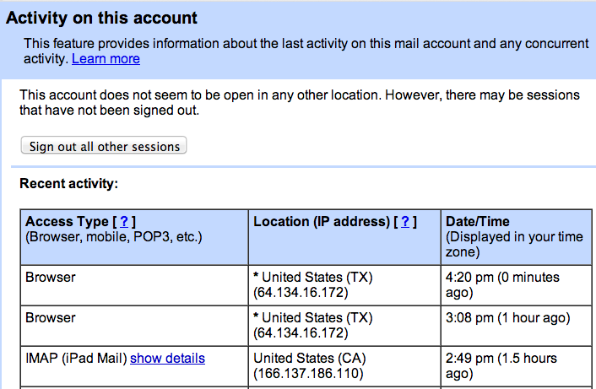
"Authorized Users Only"

Last username

Safer to disable automatic presentation of the last username

Last successful logon

Useful to detect intrusion

Gmail

Password Guidelines

Use a mixture of uppercase, lowercase, numbers, symbols

Do not include your name, spouse, address, birthday, etc.

Replace letters with numbers

Use nonsense phrases, misspellings, etc,

Combine two words with a special character

BaCON+eGGs

Don't use repeating patterns for passwords

Don't re-use passwords

Don't use same password for work and personal accounts

Don't use passwords that are too difficult to remember

Don't use passwords you see in a book

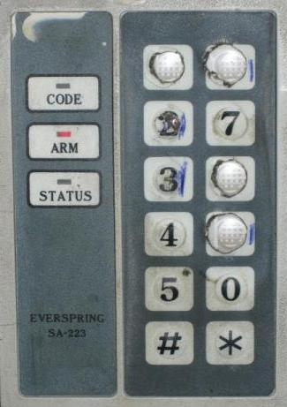
Personal Identification Numbers (PINs)

Usually 4 digits (weak)

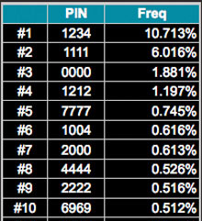
Most ATMs confiscate your card after three incorrect PIN attempts

Image from link Ch 4b

Common PINs

Link Ch 4c

Biometrics and Behavior

Biometrics

Physiological characteristic

Fingerprints, hand geometry, retina scan, etc.

Behavior

Derived from an action

Voice, signature, keystroke patterns

Biometrics and Behavior

Seemed foolproof at first

There are ways to spoof them

Xerox of a fingerprint

Fake thumb made of Jello or silly putty

Photo of face

etc.

Biometric Identification

One-to-many search

Identifying a person from all the people in the world from biometrics is difficult

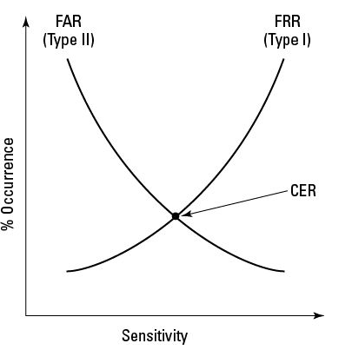
Such as fingerprints at a crime scene

Choosing the best match from a small set of possible users is easier

Company directory of employee thumbprints

One-to-one search

User enters a username or PIN for identification

Biometric scan used for authentication

Much simpler

Accuracy of Biometrics

False Accept Rate

Accepting unauthorized users

False Reject Rate

Denying authorized users

Crossover Error Rate

Measures quality of system

Speed and Throughput

Standards

Less than 5 seconds speed

Throughput rate of 6-10 per minute

Enrollment time less than 2 minutes

Time to create a biometric file for a new user

Other Biometric Quality Measures

Data storage requirements

Reliability

Acceptability

Privacy and ethics issues

Reluctance to use eye scanners

Common Biometric Systems

Fingerprint recognition

Most common

Fingerprint recognition stores entire fingerprint as an image

Finger scan stores sample points or unique features of a fingerprint

Cannot reconstruct the entire fingerprint

Hand geometry

Retina pattern

Fears of eye damage from laser

Some health problems cause retina to change

Iris pattern

Most accurate

Scanners are expensive

Voice recognition

Usually require user to repeat a standard phrase

Subject to replay attack

Signature dynamics

Sign on a tablet

Can be forged

Keystroke dynamics

Dwell time

How long a key is held down

Seek time or flight time

Time before pressing a key

One-Time Passwords

Used only once

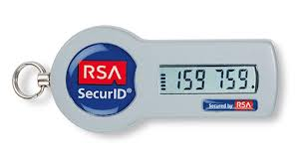
Tokens

S/Key protocol (will be in chapter 8)

One-time credit card numbers

Link Ch 4d

Tokens

Key fob, smart card, phone app

Static password tokens

Store a password or digital certificate

Synchronous dynamic password tokens

Typically generate a new passcode every 60 seconds, or when a button is pressed

Asynchronous (challenge-response) dynamic password tokens

User enters a challenge string to get passcode

Image from Link Ch 4e

Software Support

RADIUS and TACACS+ both support various token products

Tokens can be used for

One-time passwords

Single-factor authentication

Two-factor authentication

Password and token's passwode

Single Sign-On (SSO)

Users sign on once, and gain access to many resources

Users don't have to remember as many passwords

Less irritation and delay

Kerberos

SSO system for Windows domains

Ticket-based

User's password is never sent to the server

Password is used to generate a secret key on both the server and client

Secret key used to decode the Session Key

Uses Ticket Granting Ticket and Service Ticket

SESAME (Secure European System and Applications in a Multi-vendor Environment)

Uses tickets, like Kerberos

Uses symmetric and asymmetric encryption, and hashing

Has serious security flaws

KryptoKnight

Developed by IBM

Uses tickets

Doesn't require clock synchronization like Kerberos
Centralized Access Controls

LDAP

RAS

RADIUS

DIAMETER

TACACS

Centralized Access Controls

LDAP (Lightweight Directory Access protocol)

Microsoft domains, IBM SecureWay, Novell eDirectory, and more

RAS (Remote Access Service)

Uses PPP (Point-to-Point Protocol) with

PAP

CHAP

EAP

PAP, CHAP, and EAP

PAP (Password Authentication Protocol)

Sends cleartext passwords

Subject to sniffing and replay attacks

CHAP (Challenge Handshake Authentication Protocol)

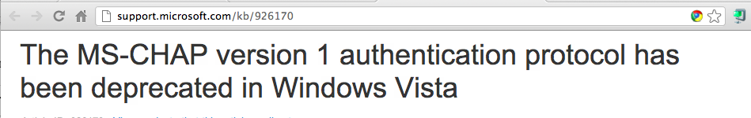
Client and server must have shared secret stored in plaintext

Server sends challenge, client hashes the challenge with the password, sends hash over the wire

Remote Access Authentication Methods

MS-CHAPv2

More secure than MS-CHAP

Seriously broken by Moxie Marlinspike at Defcon 2012 (Link Ch 1c)

He recommends using certificate authentication instead

EAP (Extensible Authentication Protocol)

Allows various authentication mechanisms

MD5-challente

S/Key

Generic token card

Digital certificates

Used in WPA and WPA2 wireless networks

Link Ch 4g

RADIUS (Remote Authentication Dial-In User Service)

AAA server

Authentication, Authorization, and Accountability

Open-source

Uses UDP

Used for RAS, VPN, and wireless networks

User logs on to RADIUS client with PAP or CHAP

RADIUS client encrypts password and sends it to RADIUS server

DIAMETER

Improves upon RADIUS

More secure but not widely implemented

Uses TCP

Uses IPSec or TLS

TACACS (Terminal Access Controller Access Control System)

Most common version is TACACS+

Uses TCP port 49

Supports many authentication mechanisms

PAP, CHAP, MS-CHAP, EAP, Token cards, Kerberos, etc.

Developed by Cisco (Link Ch 4g)

Decentralized Access Controls

Multiple domains and trusts

Called a 'Forest' in Microsoft networks

Trust Relationships or Trust Models connect the domains

Database Management System

Views are used to limit user access

Data Access Controls

Access Control Techniques

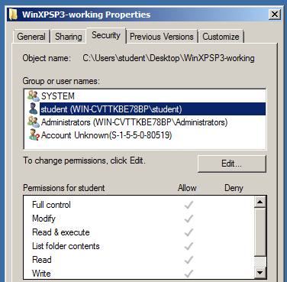
Discretionary Access Control

Role-Based Access Control

Mandatory Access Control

Rule-Based Access Control

Lattice-Based Access Control

Discretionary Access Control

File and Data Ownership

Owner of a resource determines its access policy

Access rights and permissions

Read, Write, Execute

Access Control Lists

Role-Based Access Control

Groups like Administrators, Users

Windows 7 Access Control List

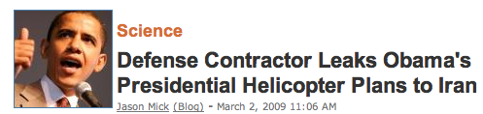
Disadvantages of Discretionary Access Control

No central administration

Security depends on resource owners

Often defaults to Full Control for Everyone

Difficult to audit

Mandatory Access Control

Sensitivity labels

Subjects and objects need labels, such as

Secret, Top Secret, Classified, Unclassified

Data import and export

Must control data moving from one sensitivity level to another

Mandatory Access Control

Rule-Based Access Control

All Mandatory Access Control systems use rules

Further rules can be added

Lattice-Based Access Control

A mathematical structure with lower and upper bounds for elements

Disadvantages of Mandatory Access Control Models

Lack of flexibility

Difficulty in implementing and programming

User frustration
Access Control Models

Access Control Models

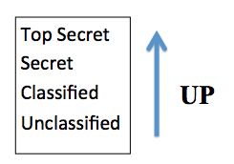
Bell-LaPadula

Biba

Clark-Wilson

Noninterference

Access Matrix

Information Flow

Bell-LaPadula

Published in 1973

Confidentiality model

Information can't flow downward

No Read Up

No Write Down

Biba

Published in 1977

Integrity model

Unauthorized users can't modify data

No Read Down

No Write Up

Clark-Wilson

Published in 1987

Designed for commerce, like banking

Address all three: Confidentiality, Integrity, and Availability

Clark-Wilson

Unconstrained Data Item (UDI)

Uncontrolled data, like user input

Constrained Data Item (CDI)

Data inside the control area, integrity must be preserved

Integrity Verification Procedure

Checks validity of CDIs

Transformation Procedure

Maintains integrity of CDIs

Noninterference Model

Ensures that upper-level actions are invisible to low-level users

Very difficult to achieve in practice, because information flows down side-channels

Timing attacks

Electromagnetic emanations

Power consumption

Access Matrix Model

Object access rights

Read, Write, Execute

Access Control Lists

Capability Lists

Used in Discretionary Access Models

Information Flow Model

Each object is assigned a security class and value

Security policy controls direction of flow of objects

Access Control Attacks

Brute-Force or Dictionary Attack

Attacker tries to guess password, passphrase or PIN, using

Dictionary of common passwords

Faster but may fail

Brute-force: every possible combination of characters

Will always succeed, given enough time

Buffer Overflow

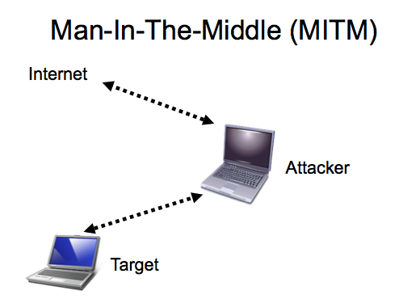
Stack-based is most common

User inputs more data than space is allocatd for

New data is executed as code

May cause DoS or remote execution

Teardrop attack sends malformed TCP packets which overlap when reconstructed, causing DoS

Link Ch 4i

Sniffing and Hijacking

Sniffing

Collect passwords from network traffic

Easier with unencrypted protocols

Session Hijacking

Impersonate a user, commonly with a spoofed cookie or TCP sequence number

Social Engineering

Trick users

Phishing, Dumpster diving, Shoulder surfing, Raiding cubicles for Post-Its, Asking for secrets

Countermeasures to Access Control Attacks

Threat modeling

Asset valuation

Vulnerability analysis

Access aggregation

Locate all access permissions in a single place, so they can be controlled
Evaluating and Testing Access Controls

Penetration Testing

Port scanning

Application scanning

Black box testing

White box testing

Gray box testing

Host scanning (finding hosts)

OS detection

Identity and Access Provisioning Lifecycle

Creating accounts

Temporary employees, partners, auditors, etc.

Account review

Disabling accounts when no longer needed

Last modified 1-31-13

