Topics

OSI Model and TCP/IP Model

Securing wired and wireless networks

Securing e-mail, Internet, Fax, and phone lines

Network attacks and countermeasures

In other words, Net+ or CCNA
Data Network Types

LAN and WAN

Local Area Network (LAN)

Small geographic area

One building, or a few nearby buildings

Inexpensive to set up and maintain

PCs, switches, router, WAPs, printers

Wired, wireless, or both

High speed

Wired: 10 Mbps, 100 Mbps, 1 Gbps, or 10 Gbps

Wireless: 11 Mbps, 54 Mbps, or approx. 300 Mbps

MBps v Mbps

Mbps: Megabit per second

MBps: Megabyte per second (rarely used)

Wide Area Network (WAN)

Connect multiple LANS over a larger geographic area

Metropolitan Area Network (MAN)

Internet

Expensive to set up and maintain

Routers, CSU/DSU, firewalls, VPN concentrators, etc.

Low speed

WAN Links

Dial-up or POTS: 56 Kbps

DSL: 128 Kbps to 3 Mbps or faster

T1: 1.544 Mbps

T3: 45 Mbps

OC-12: 622 Mbps

OC-255: 13 Gbps

WAN Types

Internet

Whole globe

Intranet

Private WAN of company locations

Extranet

Includes a company and its business partners

Other Network Types

Personal Area Network (PAN)

Devices carried on a person: cell phone, PDA, Bluetooth headset, etc.

Storage Area Network (SAN)

Large hard drives connected in a network

Use: SCSI, iSCSI, Fibre Channel, FCoE (Fibre Channel over Ethernet)

Scalable, enable virtualization, migration, and snapshots

Facilitate disaster recovery

Reduce cost for large data storage

Other Network Types

Virtual Local Area Network (VLAN)

Devices connected to different physical switches but traffic delivered as if they shared layer 2 connectivity

Wireless Local Area Network (WLAN)

Campus Area Network (CAN)

Metropolitan Area Network (MAN)

Other Network Types

Value-Added Network (VAN)

Extranet that allows businesses to share information

e.g. Electronic Data Interchange (EDI) for financial documents
The OSI Model

Open Systems Interconnection (OSI) Model

Adopted in 1984 by the International Organization for Standardization (ISO)

Reduces complexity of networking by separating functions into layers

Promotes interoperability

Facilitates troubleshooting

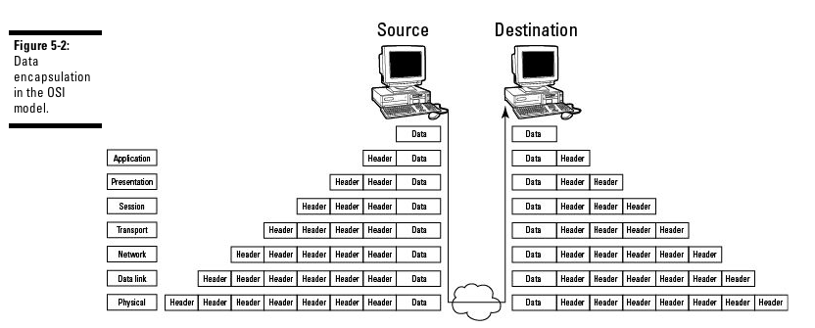
Please Do Not Throw Sausage Pizza Away
All People Seem To Need Data Processing

7: Application

6: Presentation

5: Session

4: Transport

3: Network

2: Data Link

1: Physical

Data Encapsulation
Layer 1: Physical

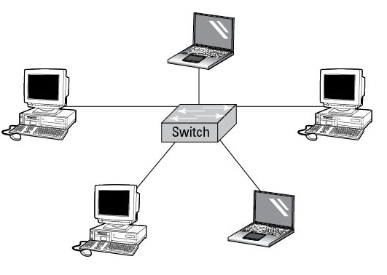
Four Network Topologies

Star

Mesh

Ring

Bus

Star Topology

Ethernet

Single point of failure in center

MeshTopology

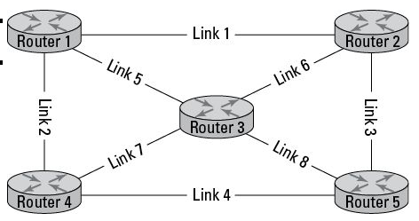
Full-mesh

Partial-mesh

Internet

Eliminates single point of failure

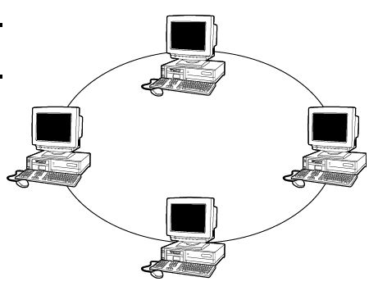

Ring Topology

Token Ring

FDDI

SONET

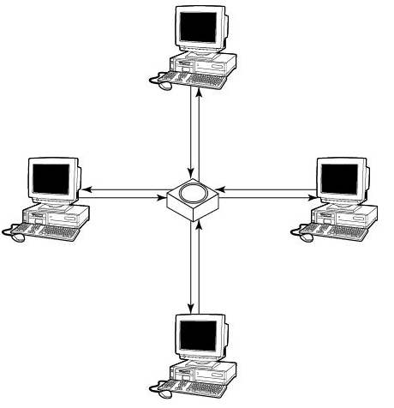

Lower image

Logical ring

Physical star

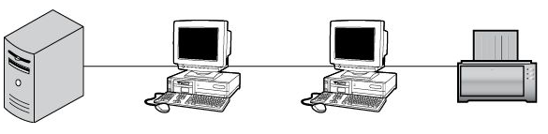
Bus Topology

Backbone

A single break isolates portions of the network

Rare on LANs, common on simple WLANS

Cables and Connectors

Analog v. Digital

Asynchronous v. Synchronous

Baseband v. Broadband

Four cable types

Coaxial

Twinaxial

Twisted-pair

Fiber optic

Analog v. Digital

Analog

Continuously varying

Subject to distortion, loses information each time it is copied

Digital

Uses pulses meaning 0 or 1

Allows for error-correction

Can be copied without loss of data

Asynchronous v. Synchronous

Asynchronous

Start and stop bits demarcate frames

Speed negotiated to match the slowest device

No clock signal required

Synchronous

Clock signal required

Used by serial links

Baseband v. Broadband

Baseband

Wire is dedicated to one signal

Used with twister-pair wiring

Broadband

Many channels over same medium

Each signal gets a share of the bandwidth

Used on coaxial cables or wireless links

Four cable types

Coaxial

Thicknet: RG8 or RG11 (obsolete)

Thinnet: RG58 with BNC connector (common)

Twinaxial

Two cores

Used in 10 Gb Ethernet for short links (10 m)

SANs and high-speed core switches

Twisted-pair

Cat 3, 5, 5e, 6, 6a

STP v. UTP

TEMPEST was a US Military project to study electromagnetic emissions from computers

Fiber optic

Singlemode v. Multimode

SC, ST, or LC connectors

IEEE Ethernet Designations

10Base-T

10 Mbps, Baseband, Twisted Pair

100Base-TX

100 Mbps, Baseband, Twisted Pair

100Base-F

100 Mbps, Baseband, Fiber Optic

1000Base-T/GbE

Gigabit Ethernet over twisted pair

Interface Standards

EIA/TIA-232 (formerly RS-232)

Up to 115,200 bps

EIA/TIA-449

Up to 2 Mbps

HSSI (High Speed Serial Interface)

Up to 52 Mbps

Networking Equipment

Physical layer

NIC

Cables (media)

Repeaters

Hubs
Layer 2: Data Link

Data Link Layer

Delivers frames to the proper device across a physical network link

Uses MAC addresses

Sublayers

Logical Link Control (LLC)

Control, sequencing, and acknowledgement of frames

Timing and flow control

Media Access Control (MAC)

Framing

Error control with CRC

Identifies MAC addresses

Controls media access with contention, token-passing, or polling

Contention

Each device must compete to use physical link

Ethernet uses CSMA/CD (Carrier Sense Multiple Access/Collision Detection)

Wireless networks use CSMA/CA (Carrier Sense Multiple Access/Collision Avoidance)

These networks cannot really operate at their maximum rated speed under normal conditions

Token-Passing

Token frame determines which device may send data

Deterministic

Can run right up to maximum speed

Lost in the marketplace; Token Ring is obsolete

Polling

Primary host polls secondary hosts to see if they have data to send

Used in mainframe environments

LAN Protocols

Ethernet

Most common, up to 100 Gbps

Token Ring

4 or 16 Mbps; obsolete

FDDI (Fiber Distributed Data Interface)

100 Mbps

ARP (Address Resolution Protocol)

Finds MAC address from IP Address

Ubiquitous on modern LANs

RARP (Reverse ARP)

Finds IP Address from MAC Address

Rare, replaced by DHCP

Unicast, Multicast, Broadcast

Unicast

Single source, single destination

Multicast

Single source, a group of destination devices

Broadcast

Single source to all devices on a LAN

WLAN Standards

802.11a

54 Mbps, 5 GHz

802.11b

11 Mbps, 2.4 GHz

802.11g

54 Mbps, 2.4 GHz

802.11n

600 Mbps, 2.4 GHz or 5 GHz

WLAN Encryption

WEP

Easily broken, unsafe to use

WPA and WPA2

Much safer thn WEP

Weakest version of WPA is TKIP

TKIP isn't broken yet, but has some troubling weaknesses

WAN Technologies and Protocols: Point-to-Point Links

L2F (Layer 2 Forwarding)

An old Cisco tunneling protocol

No encryption

L2TP (Layer 2 Tunneling Protocol)

Used for VPNs

Derived from L2F and PPTP

Uses UDP 1701

No encryption, commonly paired with IPSec

PPTP (Point-to-Point Tunneling Protocol)

From Microsoft

Very commonly used for VPNs

A tunneling protocol, no authentication or encryption included in the specification

Uses MS-CHAP in most configurations

Considered broken, no longer recommended by Microsoft

SLIP (Serial Line IP)

Predecessor of Point-to-point Protocol

Encapsulation, not encryption


WAN Technologies and Protocols: Circuit-Switched Networks

Circuit Switching

Dedicated physical path connects sender and receiver

Used in old analog phone networks

Image from www.guardian.co.uk

xDSL (Digital Subscriber Line)

Uses analog lines for broadband digital traffic

Must be close to a main phone switching station (within 3 miles)

ADSL (Asynchronous DSL)

Up to 12 Mbps down, 3.5 Mbps up

SDSL (Single-line DSL) (1.544 Mbps up & down)

HDSL (High-rate DSL)

Up to 52 Mbps down, 1,544 Mbps up

VDSL (Very high Data-rate DSL)

Up to 52 Mbps down, 2.3 Mbps up

DOCSIS (Data Over Cable Services interface Specification)

Cable Internet

ISDN (Intgrated Services Digital Network)

Data over analog phone lines

BRI (Basic Rate Interface)

One 16-Kbps D-Channel and two 64-Kbps B-channels (128 Kbps)

PRI (Primary Rate Interface)

One 64-Kbps D-Channel and 23 64-Kbps B-channels (1.544 Mbps)

WAN Technologies and Protocols: Packet-Switched Networks

Packet Switching

Devices share bandwidth of a each line

Much more efficient than circuit switching

ATM (Asynchronous Transfer Mode)

High-speed, low latency

Uses fixed-size 53-byte cells

Best for fiber-optic networks with bursty traffic

Frame Relay

Handles multiple virtual circuits

Uses HDLC encapsulation

MPLS (Multi-Protocol Label Switching)

High-speed and versatile

Can carry IP, ATM, SONET, or Ethernet frames

Specified at Layers 2 and 3

Uses labels and Label Switch Routers (LSRs)

SONET (Synchronous Optical Network) and SDH (Synchronous Digital Hierarchy)

High-availability, high-speed, multiplexes, low-latency

Runs on fiber optics

Data rates specified by OC levels

Common Telecommunications Circuits

DS0 64 Kbps

DS1 1.544 Mbps (T1)

2.048 Mbps in Europe (E1)

DS3 44.7 Mbps (T3)

OC-1 51.84 Mbps

OC-3 155.52 Mbps

OC-12 622 Mbps

OC-48 2.488 Gbps

OC-192 9.9 Gbps

WAN Technologies and Protocols: Packet-Switched Networks (continued)

SMDS (Switched Multimegabit Data Service)

High-speed, connectionless, datagram-based

X.25

The first packet-switched network

Being replaced by Frame Relay

Other WAN Protocols

HDLC (High-level Data Link Control)

Bit-oriented, synchronous

Default for serial links on Cisco routers

Various vendor implementations are incompatible

SDLC (Synchronous Data Link Control)

Bit-oriented, full-duplex, serial

Developed by IBM

Uses polling

Networking Equipment at Layer 2

Bridge

Repeater that connects two network segments

They may use different layer 2 protocols

Switch

A multiport bridge

Learns MAC addresses from traffic

Separates collision domains

Implements VLANs

DTE (Data Terminal Equipment)

Generic term for devices at the user end of a user-to-network link

e.g. Workstation, NIC, Modem, CSU/DSU

Connects to DCE (Data Communications Equipment) at the network end (ISP)

Layer 3 (Network)

Layer 3

Routing

Directing packets to the destination computer

Dynamic Routing

Uses routing protocols to exchange information between routers

RIP, OSPF, BGP

Logical Addressing (IP addresses)

Routing Protocols


Static Routing

Administrator manually enters and updates routes

Cannot automatically route around congestion or outages

Only practical for small networks

Dynamic Routing

Finds best route automatically

Redirects traffic around outages or congested links

Distance-Vector Routing Protocols

RIP, RIPv2, and RIPv3

Routers only know distance and direction of networks

Can be slow to converge

Image from www.rgbstock.com

Link-State Routing Protocols

OSPF

Every router has the complete network map

Each link's state is sent to every router whenever it changes

Requires more computation at each router

Converges rapidly

Path-Vector Protocol

Border Gateway Protocol

Similar to distance-vector but scales better

RIP (Routing Information Protocol)

Distance-vector

Uses hop count as metric

Hop limit 15

Has a problem with routing loops which is reduced by

Split horizon

Route poisoning

Holddown timers

RIP uses UDP port 520

RIP Security

RIPv1 has no authentication

RIPv2 can use plaintext or MD5 authentication

RIPng supports IPv6 but not authentication

RIP is very old and simple, but in common use on small networks because it's easy to configure

OSPF (Open Shortest Path First)

Link-state

Widely used in large networks

Doesn't use TCP or UDP, but its own protocol 89

Allows various authentication measures

OSPFv1 is obsolete, everyone uses OSPFv2

OSPFv3 allows IPv6 but no authentication

(IS-IS) Intermediate System to Intermediate System

Link-state

Used in large service-provider backbone networks

BGP (Border Gateway Protocol)

Path-vector

Used on the Internet backbone

IP Addressing

Consists of four bytes, like 147.144.20.1

Two components

Network address

Host address

Neither portion may be all 1s or all 0s

Classes

Class A

Class B

Class C

Class A

First byte is reserved for network address

Last three bytes are for host address

Supports more than 16 million host computers

Limited number of Class A networks

Reserved for large corporations and governments (see link Ch 2b)

Format: network.node.node.node

Class B

First two bytes are reserved for network address

Last two bytes are for host address

Supports more than 65,000 host computers

Assigned to large corporations and Internet Service Providers (ISPs)

Format: network.network.node.node

CCSF has 147.144.0.0 – 147.144.255.255

Class C

First three bytes are reserved for network address

Last byte is for host address

Supports up to 254 host computers

Usually available for small business and home networks

Format: network.network.network.node

Subnetting

Each network can be assigned a subnet mask

Helps identify the network address bits from the host address bits

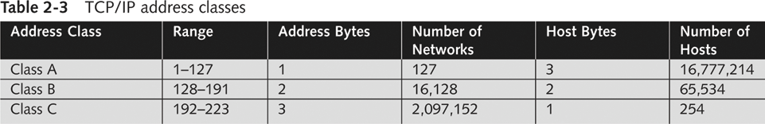
Class A uses a subnet mask of 255.0.0.0

Also called /8

Class B uses a subnet mask of 255.255.0.0

Also called /16

Class C uses a subnet mask of 255.255.255.0

Also called /24

Planning IP Address Assignments

Each network segment must have a unique network address

Address cannot contain all 0s or all 1s

To access computers on other networks

Each computer needs IP address of gateway

TCP/IP uses subnet mask to determine if the destination computer is on the same network or a different network

If destination is on a different network, it relays packet to gateway

Gateway forwards packet to its next destination (routing)

Packet eventually reaches destination

IPv6

128-bit addresses in hexadecimal

2001:db8:1:2:3:4:5:acdc

Not widely deployed yet

ICMP (Internet Control Message Protocol)

Reports errors

Used by Ping and Traceroute

Regarded as a layer 3 protocol

Networking Equipment at Layer 3

Routers

Forward data packets to logical addresses (IP)

Gateways

Connect dissimilar networks

IP-to-voice

Exchange-to-Lotus Notes (email)
Layer 4 (Transport)

Flow Control

Windows size and acknowledgements allow the receiving device to control the rate of data transmission

Multiplexing

Traffic for many services share a single physical link

Virtual circuit management

Error checking and recovery

TCP (Transmission Control Protocol)

Connection-oriented and reliable, but slow

Begins with handshake

SYN, SYN/ACK, ACK

UDP (User Datagram Protocol)

Connectionless, best-effort (unreliable), fast

No handshake

No re-sequencing

No error-checking or recovery

SSL/TLS (Secure Sockets Layer / Transport Layer Security)

Session-based

Encrypted

Authentication provided with certificates
Layer 5: Session

Three Stages of a Session

Connection establishment

Simplex, half-duplex, or full-duplex

Data transfer

Connection release

Session Layer Protocols

NetBIOS

Microsoft LANs

NFS (Network File System)

Unix shared resources

RCP (Remote Procedure Call)

Client-server redirection tool

SSH and SSH-2 (Secure Shell)

Alternative to Telnet

Session Initiation Protocol (SIP)

Used for IP telephony
Layer 6: Presentation

Layer 6 Tasks

Data representation

Character conversion

Data compression

Data encryption

Layer 6 Protocols

ASCII

EBCDIC

GIF

JPEG

MPEG

Layer 7 (Application)

Layer 7 Tasks

Provides interface to the user

Identifying and establishing availability of communication partners

Determining resource availability

Synchronizing communication

Application Layer Protocols

FTP

HTTP

HTTPS

IMAP

POP3

PEM (Privacy Enhanced Mail)

SET (Secure Electronic Transaction)

S-HTTP

S/MIME (Secure Multipurpose Internet Mail Extensions)

S-RPC

SMTP

SNMP

Telnet

TFTP

Last modified 2-7-13

